Forest Regeneration – An Evaluation of Seedling Mortality, Growth and Stand Development

NCSR curriculum modules are designed as comprehensive instructions for students and supporting materials for faculty. The student instructions are structured in a "generic format" designed to facilitate adaptation in a variety of settings. Where appropriate, the generic version is augmented by a specific instructional module taught in the Pacific Northwest. The purpose of these specific versions is to provide those who are adapting modules greater insight into how the materials are used in a teaching/learning environment. In addition to the instructional materials for students, the modules contain separate supporting information in the "Notes to Instructors" section. The modules may also contain other sections which contain additional supporting information.

Author contact information

Wynn W. Cudmore, Ph.D., Principal Investigator
Northwest Center for Sustainable Resources
Chemeketa Community College
P.O. Box 14007
Salem, OR 97309
E-mail: wynn.cudmore@chemeketa.edu
Phone: 503-399-6514

Acknowledgements:

We thank Sue Hutchins and Harry Hutchins of Itasca Community College in Grand Rapids, Minnesota and Steve Resh of Allegany College in Cumberland, Maryland for their thoughtful reviews. Their comments and suggestions greatly improved the quality of this module.
TABLE OF CONTENTS

Forest Regeneration - An Evaluation of Seedling Mortality, Growth and Stand Development - Module Description 4
Module Procedure 5
Introduction 5
Objectives 5
Procedure 5
Analysis 7
Data Sheet - Seedling Mortality 12
Data Sheet - Seedling Growth 14
Notes to Instructors 15
Sample Data Sheet – Causes of Seedling Mortality 18
Detailed Description of Forest Regeneration Laboratory 20
Forest Regeneration - An Evaluation of Seedling Mortality, Growth and Stand Development in Western Oregon 21
Introduction 21
Study Site Information 22
Background 22
Vegetation 22
Management Goals 22
Management Activities 23
Original Planting 25
Procedure 25
Analysis 27
Data Sheet - Seedling Mortality 30
Data Sheet - Seedling Growth 32
Answer Key - Analysis (Updated With 2006 Data) 33
Supporting Information 39
Seedling Mortality Lab - 2006 Student Data Summary 40
Biological Characteristics of Seedlings 42
The Study Site 44
Regional Resources for Plant Identification and Vegetation Classification 48
General Resources for Vegetation Classification 48

Forest Regeneration - An Evaluation of Seedling Mortality, Growth and Stand Development - Module Description

This module describes a field-based laboratory that evaluates tree seedling growth and mortality and stand development as part of a reforestation project. This long-term project requires students to apply skills that are commonly used in forest management. As a long-term study, each class has the opportunity to contribute new information and the benefit of evaluating accumulated data. The activity also incorporates an understanding of basic ecological principles such as ecological succession, range of tolerance, nutrient cycling and competition and engages students in an authentic data interpretation activity.

The module includes:

- A generalized procedure for the laboratory that can be adapted to any field site
- Notes to instructors including some ideas for expanding the activity
- A detailed description of the laboratory for a western Oregon site that could be used as a model. This description includes a site-specific procedure, data sheets, a suggested key to student questions, sample data, student handouts, photographs and site maps.

Module Procedure

Introduction

In areas that have been deforested either by timber harvesting or as a result of natural events such as wildfires, the rapid and successful re-establishment of trees is often a primary management objective. Once trees are growing again on the site, other values such as erosion control, timber value, wildlife habitat and esthetic appeal tend to increase. Management activities that occur before, during and after harvest have a great influence on the ecological, esthetic and economic value of the future forest.

In today's laboratory we will examine a forest regeneration project that attempts to implement reforestation practices that are consistent with an ecosystem-based management approach. We will evaluate the success of seedling planting and attempt to determine the cause of mortality for seedlings. Successful establishment of seedlings may depend upon a number of factors such as soil characteristics, slope, exposure, elevation, climatic conditions, diseases present, and the population density of herbivorous mammals and the control of competing vegetation. Studies such as these are completed routinely to determine the best methods for reforestation in a region. The procedures described in this activity are broadly applicable and could be used to monitor the success of a Christmas tree plantation, an industrial forest operation or an ecological restoration project. The success of a tree planting effort should be evaluated regardless of landowner objectives.

Objectives

Upon successful completion of this activity students should be able to:

1. Implement a sampling procedure that evaluates tree seedling mortality and growth
2. Evaluate trends in tree seedling mortality and growth data
3. Apply ecological principles to predict future forest conditions
4. Make recommendations to achieve specific management goals

Procedure

In today's lab we will attempt to locate every seedling in the study area whether planted or naturally regenerating. To accomplish this, the site has been subdivided into five sampling areas. Each group of students will be assigned to an area. Seedlings will be located, identified by species, and the heights of a representative subsample of each species will be measured.

You should be familiar with the identification characteristics for each of the species that were planted. Your instructor will show these characteristics. Once you are familiar with the identification of seedlings and the boundaries of your study area, your group (2-4 students per group) will begin sampling.

1. Begin at one end of your sampling area and methodically search your entire area, carefully looking for seedlings. Your goal is to find every seedling within your assigned area. Both “live” and “dead” seedlings will be counted and recorded separately on the data sheet. Other groups will be doing the same and we will combine data later.

NOTE: Seedlings can be easily overlooked or counted more than once. Develop a method within your group that minimizes this source of error. You will be provided with a length of nylon rope which can be used to mark off small sub- areas for counting.

2. As each seedling is encountered, determine the species and whether it is a planted seedling or a naturally regenerated seedling. This distinction can usually be made on the basis of size, with naturally regenerated seedlings generally much smaller than planted seedlings. If seedlings have been planted in rows, alignment may also be used. Planted seedlings will usually be found at a predetermined spacing, whereas naturally regenerated seedlings will be located randomly.

3. Record all data on the attached "Data Sheet - Seedling Mortality".

4. While counting the seedlings in your study area, measure the height (to the nearest centimeter) of live, planted seedlings in your sampling area (omit naturally regenerated seedlings for this portion of the exercise). For species with "drooping leaders", total height should include the extended leader.

Measure a representative sample of 50 individuals for each of the seedling species that have been planted in your sampling area. If less than 50 individuals are present for any species, just measure all of them.

5. Record your measurements on the attached "Data Sheet - Seedling Growth".

6. Calculate average heights and record at bottom of data sheet.

Analysis

Data from all groups will be combined and used to determine rates of seedling mortality for each species. Use all background information available to you (i.e., site information and biological requirements of seedlings) to answer the following questions. Put all of your typed answers on a separate sheet.

1. Use class data to complete the following table for the entire study area:

 | Species #1  Name: _________ | Species #2  Name: _________ | Species #3  Name: _________ | Species #4  Name: _________ | Species #5  Name: _________
# of Seedlings Originally Planted
# of Planted Seedlings Detected (alive + dead)
# of Planted Seedlings Alive
% Planted Seedlings Alive
# of Planted Seedlings Dead
% of Planted Seedlings Dead
# of Naturally Regenerated Seedlings

2. How do the numbers of seedlings detected (in the table above) compare to the numbers that were actually planted? What explanations can you offer for any differences?

3. Which seedling species show the highest survivability rate (i.e., lowest mortality rate) for this site? What explanations can you offer?

4. Which seedling species show the lowest survivability rate (i.e., highest mortality rate) for this site? What explanations can you offer?

5. Which species has the greatest number of naturally regenerated seedlings? What explanation can you offer for this?
6. Complete the table below by entering the average seedling heights (to the nearest 0.1 cm) for each species and calculating the average rate of growth for each species.

Year of Inventory | Species #1  Name: _________ | Species #2  Name: _________ | Species #3  Name: _________ | Species #4  Name: _________
Rate of growth (cm/yr)

Use your results to describe how rates of growth can be used to predict future forest composition.

7. In what ways will the future forest at this site differ from a forest that was allowed to regenerate "naturally" (i.e., without human intervention). Explain your rationale.

8. In what ways will the future forest at this site differ from an intensively managed plantation forest? Explain.

9. What types of interventions will be required to meet the management goals stated in the introduction? Address each goal separately.

10. Based on the information you have now (number of each seedling planted, seedling survivability, knowledge of the biology of the tree species on site, site characteristics, etc.), predict the species mix of dominant trees at the following time intervals after planting. Assume that there will be minimal disturbance on the site (e.g., no catastrophic, stand-replacing fires). Enter a % for each of the species indicated across the top of the table. Percentages for each species prior to planting (i.e., remnant trees left behind after logging) are given at "0 years".

 | Species #1  Name: _________ | Species #2  Name: _________ | Species #3  Name: _________ | Species #4  Name: _________ | Species #5  Name: _________
0 years

Seedlings planted

5 years

10 years

50 years

200 years

500 years

Explain the trends you have indicated in the table above and your reasons for them.

Data Sheet - Seedling Mortality

SAMPLING AREA: ________ DATE: ________ OBSERVERS: ___________________

Enter a "" for each live seedling encountered and an "X" for each dead seedling encountered in your study area. If the seedling is naturally regenerating, draw a circle around the "" or "X"; e.g.,.
Species #1  Name: _________ |  |  |  |  | Species #2  Name: _________ |  |  |  |  | Species #3  Name: _________ |  |  |  |  | Species #4  Name: _________

When completed, enter your totals on the next page

TOTAL NUMBERS OF SEEDLINGS ENCOUNTERED

RECORD YOUR SAMPLING AREA HERE ___________

 | Species #1  Name: _________ | Species #2  Name: _________ | Species #3  Name: _________ | Species #4  Name: _________
Live, planted
Dead, planted
Live, naturally regenerated
Dead, naturally regenerated
Total # seedlings

Data Sheet - Seedling Growth

SAMPLING AREA: ________ DATE: ________ OBSERVERS: ___________________

Measure the height (to the nearest centimeter) of live, planted seedlings in your sampling area (omit naturally regenerated seedlings for this portion of the exercise). For species with "drooping leaders", total height should include the extended leader.

Measure a representative sample of 50 of each seedling species (if available) in your sampling area. Record your measurements in the table below. Calculate average heights and record at bottom of data sheet.
Species #1  Name: _________ |  |  |  |  | Species #2  Name: _________ |  |  |  |  | Species #3  Name: _________ |  |  |  |  | Species #4  Name: _________
Average height: _____ cm |  |  |  |  | Average height: _____ cm |  |  |  |  | Average height: _____ cm |  |  |  |  | Average height: _____ cm

Notes to Instructors

This laboratory requires two sessions - a 3-hour field session for data collection and a 1-hour analysis session to evaluate data. An understanding of ecological succession and the biological characteristics of the species under study (especially, shade tolerance, soil and moisture requirements) is assumed. The laboratory introduces students to some of the knowledge and skills required to reestablish a forest after harvest. Students evaluate the success of planted seedlings and attempt to identify the various causes of seedling mortality. These skills directly apply to the workplace and also provide an opportunity for students to think about the ecological aspects of reforestation.

The selection of an appropriate field site is a first priority. Any recently harvested (or otherwise disturbed) forest site (public or private) that is being or has been reforested would be suitable. The same site may be used by successive classes of students, thus providing an opportunity to monitor forest succession as it proceeds. In addition to educational benefits, there may be direct, tangible benefits to the land owner as such studies are completed routinely to determine the best methods for reforestation in a region.

After a field site is identified, the area will need to be subdivided into smaller areas that can be reasonably evaluated in the allocated time. As the module is described here, a complete sampling method is employed (i.e., all seedlings within the study area are counted.) I use sub-areas that are approximately 0.75 acre (3000 m²) in size, each of which is evaluated by a group of 3 or 4 students. Boundaries between sub-areas should be clearly marked with flagging. Once in the field, students should be assigned sub-areas for sampling and the identifying characteristics for the seedlings under study should be described.

In study sites where complete sampling is impractical due to time or area constraints, a sub-sampling method should be devised in which students measure/count only those seedling that occur in sample plots. Transects (e.g., 100 m x 2 m or 50 m x 2 m) or circular plots (e.g., .01 acre) are commonly used for this purpose. Plot centers (or origins, for transects) should be either systematically or randomly located and the sampling effort should be representative of the site as a whole. When sampling is complete, seedling numbers may be converted to a "per acre" or "per hectare" basis. If desired, permanent plots could be established. These are particularly useful for monitoring vegetation changes over time.

In preparation for the first session, the following should be prepared by the instructor and provided to students:

 A handout that describes the biological and identification characteristics of the tree seedlings under study
 Information on predicted stages of ecological succession
 Background information on the study site including a site map, site history, management objectives and vegetation characteristics

Samples of these documents are provided with this module.

Accurate seedling counts are essential for this activity. Seedlings can be easily overlooked or counted more than once. To minimize this source of error, each group should be provided with a length of nylon rope to mark off sub-areas. Once seedlings are counted or measured within this sub-area, the rope can be moved. Alternatively, individual seedlings may be marked as "counted" or "measured" with toilet paper.

Seedling height is only one measure of "seedling health" and as discussed later, may not be the best predictor of future forest composition (see "Answer Key", question #6, p. 38). For a more detailed evaluation, instructors may choose to add additional measures such as stem caliper (diameter) or quality of foliage to the activity.

When the field portion of the exercise is completed, the instructor should collect individual data sheets and prepare a summary data sheet (see sample on p. 43) for all sub-areas. Analysis is based on summarized class data. I usually dedicate approximately one hour of class time to analysis. During this time I review the biological characteristics (range, ecological requirements, etc.) of the species under study as well as site characteristics of the study area (site aspect, slope, elevation, average rainfall, soil types, surrounding vegetation, etc.). Alternatively, instructors may decide to have students seek out this information on their own using available resources such as the county soil survey. I also review the data sheets with them, discuss any sources of error and address any questions they may have. Questions are answered by students individually outside of class and submitted approximately one week after students have access to the summarized data. Alternatively, students could work in groups and an entire 3-hour laboratory could be dedicated to analysis.

There are a number of ways to expand this activity. Here are two suggestions:

- Have students attempt to determine the causes of seedling mortality in addition to seedling survivability and growth. I have used the following categories and descriptions:

- Girdled by mice - check base of seedling and look for areas where mice have removed bark
- Browsed by deer - seedling has been broken off, typically at the leader, with a rough, irregular break
- Rabbit/hare – seedling has been cleanly clipped at a 45º angle
- Roots eaten by gophers - gophers have burrowed at the base of the seedling and a dirt mound is apparent
- Out-competed by other vegetation - seedling is covered by competing vegetation
- Other - if none of the above conditions pertain, cause for mortality is unknown (may include drought, disease or insects)

Causes for mortality and identifying characteristics should be customized to your study site. Additional causes such as insect infestation or disease may be added to those included here. A data sheet should be designed to record causes of seedling mortality by tree species (see sample on following page). Students should summarize these data (as percents) and compare causes of mortality by tree species. Additionally, causes of mortality frequently change with the age of the stand, so comparisons with data from previous years may also prove to be interesting.

- Establish permanent photo points

While this laboratory emphasizes seedling counts and measurements as an indication of ecological change over time, other methods may be used as well. A photographic record of the study site taken at set time intervals, for example, allows students to visualize past conditions and to document current conditions (see example on p. 46). Digital photography makes this a particularly easy method for monitoring the study site over time.

Photo points should be established and permanently marked with a steel fence post or some other relatively durable marker. A map of the photo points should be constructed that indicates the location of each point and the direction of the photograph. The number of photos required will vary with the characteristics of the study site but should be sufficient in number to capture the on-site variability. The scale of photo may also vary depending on the goals of the study. Close-ups are useful to document changes in soil surface or the amount of ground surface covered by vegetation and organic litter.

Sample Data Sheet – Causes of Seedling Mortality

SAMPLING AREA: DATE: OBSERVERS:

For each dead seedling encountered in your study area, enter and "X" under the suspected "cause of death" (see procedures section for details).

Douglas-fir |  |  |  |  | Grand fir |  |  |  |  | Western hemlock |  |  |  |  | Western redcedar
Mice  Mice | Deer | Rabbit | Gopher | Veg. | Mice  Mice | Deer | Rabbit | Gopher | Veg. | Mice | Deer | Rabbit | Gopher | Veg. | Mice  Mice | Deer | Rabbit | Gopher | Veg.
Materials and Equipment

6 rolls Flagging - (to mark study areas)
6 Meter sticks
6 Folding fiberglass metric rules (2 m)
12 100-foot lengths of nylon rope
12 Clipboards
6 Seedling identification guides

Detailed Description of Forest Regeneration Laboratory

The following pages describe an example of this activity for a specific field site in western Oregon. Obviously, the details will change depending on location, but the major concepts should be quite consistent from one site to another. This module should be useful as instructors develop activities that are specific to their own location. The description that follows represents the fourth year that this laboratory has been conducted with students. As a result, data generated by previous classes are included in the analysis.

Forest Regeneration - An Evaluation of Seedling Mortality, Growth and Stand Development in Western Oregon

Introduction

In areas that have been deforested either by humans or as a result of natural events such as wildfires, the rapid and successful re-establishment of trees is often a primary management objective. Once trees are growing again on the site, other values such as erosion control, timber value, wildlife habitat and esthetic appeal tend to increase. Management activities that occur before, during and after harvest have a great influence on the ecological, esthetic and economic value of the future forest.

Until recently, most Douglas-fir forests in western Oregon that were managed for timber production were treated as follows:

- Clearcut - all or most marketable and non-marketable trees and snags removed
- Pile slash (limbs, logs, snags, etc.) - bulldozers push slash into piles
- Burn slash piles - in spring or fall

NOTE: Alternatively, depending on site characteristics, a site could be "broadcast burned" in which slash is burned without piling

- Herbicide application to control competing vegetation (e.g., blackberries, buckbrush)
- Plant Douglas-fir genetically matched to elevation and geography

Such management typically resulted in single-species, even-aged plantations which maximized timber production but probably did not allow other values to reach their full potential. More recently, often under the management philosophy of ecosystem management, some of these practices have been modified, particularly on public lands. The retention of "biological legacies" (living trees, snags, logs, etc.) during a logging operation, for example, may accelerate the regeneration of a forest as well as provide habitat for plant and animal species that may not occur in stands that have all material removed. Planting a variety of tree species may also provide some benefits as compared to single-species plantings of Douglas-fir.

In today's laboratory we will examine a small forest regeneration project that attempts to implement ecosystem management practices. We will evaluate the success of seedling planting and attempt to determine the cause of mortality for seedlings. Such studies are completed routinely to determine the best methods for reforestation in a region. Successful establishment of seedlings may depend upon a number of factors such as soil characteristics, slope, exposure, elevation, climatic conditions, diseases present, population density of herbivorous mammals and the control of competing vegetation.

Study Site Information

Background
The study site is a 4-acre stand located in the foothills of the Coast Range approximately 15 miles west of Salem, Oregon at an elevation of approximately 800 feet above sea level. The site is a north exposure and slopes range from 0 - 25%. In June of 1999 the site was logged - nearly all Douglas-fir (Pseudotsuga menziesii) greater than 10-inch diameter were removed. Some Garry oak (Quercus garryana) were cut and removed for firewood but many oaks, including some dominant trees were left behind. Logs were removed with a skidder and piled on the eastern edge of the property adjacent to Orchard Knob Road. Although some slash was pushed around during skidding, no distinct piles were formed and most of the slash was left scattered throughout the site.

In preparation for planting, the site was cleared primarily by hand. Slash was pulled and piled and approximately half of these piles were burned in fall 2001. Larger diameter slash was cut for firewood yielding 12 cords. The remaining slash was piled and will be left on site.

Vegetation

Prior to logging in 1999, the site was dominated by a typical Douglas-fir-Garry oak forest with dominant trees averaging 30" in diameter. In addition to these two tree species, a few domestic cherry trees were present on site. Large shrubs included, in approximate order of abundance, California hazelnut, Indian-plum, Scotch broom, serviceberry, cascara buckthorn, oceanspray, black hawthorn, red elderberry, Oregon ash, bigleaf maple, grand fir and Pacific dogwood. Small shrubs were dominated by trailing blackberry, snowberry, Himalayan blackberry, evergreen blackberry, poison oak, thimbleberry, Nootka rose, black raspberry and tall Oregon-grape. Sword fern is scattered throughout the site and in open areas bracken fern dominates. Small snags of Garry oak and Douglas-fir are scattered throughout the site presumably due to self thinning of the site. There are no remnant large logs, snags or stumps (3' +) from previous stands here; however, as a result of the logging operation, there were a few relatively large (18-24") Douglas-fir left behind as logs. These were probably trees with some defect and will be left on site as decaying logs. Smaller logs of Garry oak and some Douglas-fir are also left on site.

For the year following logging, the site remained untouched and, predictably, weedy species flourished. Herbaceous vegetation was dominated by bull thistle, Canadian thistle and St. John's wort. Trailing blackberry, Himalayan blackberry and evergreen blackberry proliferated in and around slash creating impenetrable tangles. Most of the shrub species listed above also did well but did not dominate the site as the blackberries did.

Management Goals

A. To establish a diverse, multi-aged, multi-species forest that develops late successional characteristics on the quickest timetable possible
B. To create a forest that is esthetically pleasing with accessible view points to the north and northwest
C. To create a forest that provides nesting, roosting and foraging habitat for a variety of native vertebrate animals
D. To create a forest that can be used recreationally for hiking, wildlife viewing and cross country skiing
E. To create a forest that will occasionally be used for extraction of firewood and perhaps marketable timber for the landowner

Management Activities

The site was logged in June 1999 and remained untouched for 1 1/2 years until December 2000 when site preparation for planting began. Removal of competing vegetation was a priority and a variety of methods were used including grazing by a small herd of Angora goats, herbicide application and physical removal. Each summer (July/August) 2002-2005 seedlings were "released" (competing vegetation around each seedling was removed manually). Also, seedlings were watered twice each summer 2002-2004. In November 2005, seedling guards were placed around each Western redcedar seedling to reduce deer browse. Management activities concentrated on re-establishing a forest on this site and are summarized in the table on the following page.

Site Management Activities

 | 12/00 | 1/01 | 2/01 | 3/01 | 4/01 | 5/01 | 6/01 | 7/01 | 8/01 | 9/01 | 10/01 | 11/01 | 12/01 | 1/02
Goat grazing
Clearing and piling slash
Clearing brush/mowing
Burning slash
Herbicide application
Cutting firewood
Planting trees

Original Planting

Nearly 1400 conifer seedlings of four different species were planted in December 2001 and January 2002. The table below indicates the number of each species planted.

 | Douglas-fir | Grand fir | Western hemlock | Western redcedar
Number planted | 980 | 200 | 100 | 100
Percent | 71.1 | 14.5 | 7.2 | 7.2

Shade-tolerant species (grand fir, western hemlock and western redcedar) were planted primarily along the margins of the property and in areas that are partially shaded by existing trees. Douglas-fir seedlings were planted primarily in more open areas. See attached "Planting Plan" diagram. Most, but not all, of the non-Douglas-fir species have been marked with small stake flags to facilitate their location. In 2005, seedling guards were placed around each Western redcedar to reduce browsing by black-tailed deer. Bamboo stakes were placed around each Western hemlock to reduce deer scraping.

Procedure

In today's lab we will attempt to locate every seedling in the study area whether planted or naturally regenerating. To accomplish this, the site has been subdivided into five areas (see attached "Sampling Area" diagram). Each group of students will be assigned to an area. Seedlings will be located, identified by species, and the heights of a representative subsample of each species will be measured.

You should be familiar with the identification characteristics for each of the four conifer species that were planted. Your instructor will show these characteristics. Once you are familiar with the identification of seedlings and the boundaries of your study area, your group (2-4 students per group) will begin sampling.

1. Begin at one end of your sampling area and methodically search your entire area, carefully looking for seedlings. Your goal is to find every seedling within your assigned area. Other groups will be doing the same and we will combine data later.

NOTE: Seedlings can be easily overlooked or counted more than once. Develop a method within your group that minimizes this source of error. You will be provided with a length of nylon rope which can be used to mark off small sub-areas for counting.

2. As each seedling is encountered, determine the species and whether it is a planted seedling or a naturally regenerated seedling. Western hemlock and western redcedar are not naturally regenerating on site so all of these seedlings were planted. A few Douglas-fir and grand fir are regenerating naturally on site but they can be distinguished from planted seedlings at this stage on the basis of size (i.e., the smallest seedlings are naturally regenerating). Most planted seedlings have grown to at least 50 cm (20 inches), so any smaller than 50 cm (20 inches) should be recorded as "naturally regenerated."

3. Record all data on the attached "Data Sheet - Seedling Mortality".

4. After you have counted every seedling in your study area, measure the height (to the nearest centimeter) of live, planted seedlings in your sampling area (omit naturally regenerated seedlings for this portion of the exercise). For species with "drooping leaders" (western hemlock and some western redcedar), total height should include the extended leader.

Measure a representative sample of 30 each of grand fir, western hemlock and western redcedar (if available) and 50 Douglas-fir in your sampling area.

5. Record your measurements on the attached "Data Sheet - Seedling Growth".

6. Calculate average heights and record at bottom of data sheet.

Analysis

Data from all groups will be combined and used to determine rates of seedling mortality for each species. Use all background information available to you (i.e., site information and biological requirements of seedlings) to answer the following questions. Put all of your typed answers on a separate sheet.

1. Use class data to complete the following table for the entire study area:

 | Douglas-fir | Garry oak | Grand fir | Western  hemlock | Western redcedar
# of Seedlings Originally Planted | 980 | 0 | 200 | 100 | 100
# of Planted Seedlings Detected (alive + dead) |  | 0
# of Planted Seedlings Alive |  | NA
% Planted Seedlings Alive |  | NA
# of Naturally Regenerated Seedlings |  |  |  | 0 | 0

2. How do the numbers of seedlings detected (in the table above) compare to the numbers that were actually planted ? What explanations can you offer for any differences?

3. Which seedling species show the highest survivability rate (i.e., lowest mortality rate) for this site? What explanations can you offer?

4. Which seedling species show the lowest survivability rate (i.e., highest mortality rate) for this site? What explanations can you offer?

5. Which species has the greatest number of naturally regenerated seedlings? What explanation can you offer for this?
6. Complete the table below by entering the 2006 average seedling heights (to the nearest 0.1 cm) for each species and calculating the average rate of growth since planting for each species.

 | Douglas-fir | Grand fir | Western  hemlock | Western redcedar
2003 | 57.4 | 42.3 | 40.7 | 45.5
2004 | 83.1 | 55.2 | 53.3 | 62.4
2005 | 123.0 | 74.8 | 81.0 | 85.4
2006
Average rate of growth 2003-2006 (cm/yr)

Use your results to describe how rates of growth can be used to predict future forest composition.

7. In what ways will the future forest at this site differ from a forest that would have been allowed to regenerate "naturally" (i.e., without human intervention). Explain your rationale.

8. In what ways will the future forest at this site differ from an intensively managed plantation forest? Explain.

9. What types of interventions will be required to meet the management goals stated in the introduction? Management goals are re-listed below. Address each one separately.

A. To establish a diverse, multi-aged, multi-species late successional forest
B. To create a forest that is esthetically pleasing with accessible view points
C. To create a forest that provides habitat for a variety of native vertebrate animals
D. To create a forest that can be used recreationally for hiking, wildlife viewing and cross country skiing
E. To create a forest that will be used for firewood and perhaps marketable timber

10. Based on the information you have now (number of each seedling planted, seedling survivability, knowledge of the biology of the tree species on site, site characteristics, etc.), predict the species mix of dominant trees at the following time intervals after planting in 2001. Assume that there will be minimal disturbance on the site (e.g., no catastrophic, stand-replacing fires). Enter a % for each of the species indicated across the top of the table. Percentages for each species prior to planting (i.e., remnant trees left behind after logging) are given at "0 years".
 | Douglas-fir (%) | Garry oak (%) | Grand fir (%) | Western hemlock (%) | Western redcedar (%)
0 years  (2001) | 50.7 | 48.1 | 0.2 | 0.0 | 0.0
Seedlings planted | 71.1 | 0.0 | 14.5 | 7.2 | 7.2
2 years  (2003) | 72.3 | NA | 13.5 | 6.6 | 7.6
3 years  (2004) | 75.1 | NA | 11.5 | 5.8 | 7.6
4 years  (2005) | 78.6 | NA | 9.9 | 4.4 | 7.2
5 years
(2006)
10 years
(2011)
50 years
(2051)
200 years
(2201)
500 years
(2501)
Change in Species Composition of Dominant Trees after Planting

Explain the trends you have indicated in the table above and your reasons for them.

Data Sheet - Seedling Mortality

SAMPLING AREA: ________ DATE: ________ OBSERVERS: ___________________

Enter a "" for each live seedling encountered and an "X" for each dead seedling encountered in your study area. If the seedling is naturally regenerating (<50 cm), draw a circle around the "" or "X"; e.g., .

Douglas-fir |  |  |  |  |  |  |  |  | Grand fir |  |  |  | Western hemlock |  |  |  | Western redcedar
When completed, enter your totals on the next page

TOTAL NUMBERS OF SEEDLINGS ENCOUNTERED

RECORD YOUR SAMPLING AREA HERE ___________

 | Douglas-fir | Grand fir | Western hemlock | Western redcedar
Live, planted
Dead, planted
Live, naturally regenerated
Dead, naturally regenerated

Data Sheet - Seedling Growth

SAMPLING AREA: ________ DATE: ________ OBSERVERS: ___________________

Measure the height (to the nearest centimeter) of live, planted seedlings in your sampling area (omit naturally regenerated seedlings for this portion of the exercise). For species with "drooping leaders" (western hemlock and some western redcedar), total height should include the extended leader.

Measure a representative sample of 30 each of grand fir, western hemlock and western redcedar (if available) and 50 Douglas-fir in your sampling area. Record your measurements in the table below. Calculate average heights and record at bottom of data sheet.

Douglas-fir |  |  |  |  | Grand fir |  |  | Western hemlock |  |  | Western redcedar
Average height: cm |  |  |  |  | Ave. Ht.: |  |  | Ave Ht.: |  |  | Ave. Ht.:

Answer Key - Analysis (Updated With 2006 Data)

Data from all groups should be combined and submitted to students as soon as possible after sampling is conducted. These combined data should then be used by students in conjunction with the background information provided to answer those questions in the analysis portion of the activity. Some possible answers to the specific activity I have conducted as well as some suggested point totals are given below. These should give you some idea of the major concepts addressed by the activity.

1. (1 point) Use class data (2006) to complete the following table for the entire study area:

 | Douglas-fir | Garry oak | Grand fir | Western  hemlock | Western redcedar
# of Seedlings Originally Planted | 980 | 0 | 200 | 100 | 100
# of Planted Seedlings Detected (alive + dead) | 910 | 0 | 101 | 46 | 92
# of Planted Seedlings Alive | 907 | NA | 93 | 46 | 91
% Planted Seedlings Alive | 92.6 | NA | 46.5 | 46.0 | 91.0
# of Naturally Regenerated Seedlings | 43 | 0 | 73 | 0 | 0

2. (1 points) How do the numbers of seedlings detected (in the table above) compare to the numbers that were actually planted ? What explanations can you offer for any differences?

In some cases there may be large discrepancies with fewer seedlings detected than actually planted. These may be due to sampling errors (e.g., missed seedlings, failure to record, etc.) or perhaps, to undetected seedling mortality.

3. (1 point) Which seedling species show the highest survivability rate (i.e., lowest mortality rate) for this site? What explanations can you offer?

Douglas-fir shows the highest survivability rate when this parameter is calculated as "# alive detected/number planted". Based on background information provided as well as observation, Douglas-fir is best adapted to conditions at this site. The site falls within the center of the geographic distribution for this species, soil conditions are ideal, elevation requirements, rainfall and site exposure are all within the species' range of the optimum. Additionally, surrounding forests are dominated by Douglas-fir and the species is shade intolerant suggesting that it does well under relatively open conditions.

4. (1 point) Which seedling species show the lowest survivability rate (i.e., highest mortality rate) for this site? What explanations can you offer?

Grand fir or western hemlock generally show the lowest survivability rate. The site is well within the geographic range for grand fir but as a shade tolerant species, seedlings may be prone to drying out or suffering damage to foliage during summer drought. Western hemlock is also shade tolerant and in addition is probably at the fringe of its range at this elevation. It is predominantly a higher elevation species at this latitude.

5. (1 point) Which species has the greatest number of naturally regenerated seedlings? What explanation can you offer for this?

Both Douglas-fir and grand fir are naturally regenerating at this site. In the first two years after planting Douglas-fir seedlings outnumbered grand fir by about 10 to 1. Douglas-fir is relatively shade intolerant and reproduces better under the open conditions of this site. Additionally, many dominant trees in surrounding forests are Douglas-fir providing a readily available seed source. Some grand fir are present in adjacent forests but at a lower number. In more recent years, naturally regenerating grand fir seedlings have outnumbered Douglas-fir by about 2 to1. Although the reason for this is not completely understood, one explanation may be a phenomenon known as “stress coning” in which stressed trees sometimes produce an unusually large number of cones. Survivability of these grand fir seedlings is expected to be quite low since this species survives better under somewhat more shaded conditions. It is expected that as succession proceeds and the canopy closes, grand fir reproduction will increase while Douglas-fir reproduction will decline.

6. (1 point) What are the average heights attained by each species at this point in time? How can rates of growth since planting be used to predict future forest composition?

 | Douglas-fir | Grand fir | Western  hemlock | Western redcedar
2003 | 57.4 | 42.3 | 40.7 | 45.5
2004 | 83.1 | 55.2 | 53.3 | 62.4
2005 | 123.0 | 74.8 | 81.0 | 85.4
2006 | 183.5 | 101.3 | 119.9 | 124.7
Average rate of growth 2003-2006 (cm/yr) | 42.0 | 19.7 | 26.4 | 26.4

Students report average heights from their measurements and are also given data from previous years to estimate seedling growth rates. Average growth rates since planting may be calculated for each species by subtracting the 2003 height from the 2006 height and dividing by the total number of growing seasons (3, in this case). For example, the average growth rate for Douglas-fir would 183.5 - 57.4 = 126.1 /3 = 42.0 cm. Growth rates for each growing season may also be calculated simply by noting the average height for any year and subtracting the average height for the previous year. Using this method, the change in growth rates over time may be monitored for each species. Those species with the greatest growth rates (Douglas-fir at this early stage) would be expected to be more dominant in the immediate future. It is important to recognize, however, that seedling growth rates may not be a good predictor of future forest composition (particularly, later stages of ecological succession). This is especially true for shade tolerant species, which may grow slowly for decades after a disturbance. In the early stages of ecological succession, these species put energy into root density and other maintenance rather than seedling height. At later stages of succession, however, these shade tolerant species may dominate. In the Great Lakes region, for example, sugar maple persists as a slow growing, 3-6" seedling for over 40 years after a disturbance. By 100-300 years, it often makes up the majority of individuals in the mid-canopy and canopy.

7. (2 points) In what ways will the future forest at this site differ from a forest that was allowed to regenerate "naturally" (i.e., without human intervention). Explain your rationale.

In the forest at this site, the early stages of ecological succession are “collapsed” as trees, shrubs and herbaceous species all appear in the first few years after disturbance due to management activities. Succession in the "naturally regenerating" forest will proceed more slowly as shrubs (particularly invasives such as Himalayan blackberry and Scotch broom) dominate tree seedlings for several years. A "natural" forest would also be less likely to include western redcedar or western hemlock which are not regenerating naturally and few seed sources are available in this area.

8. (2 points) In what ways will the future forest at this site differ from an intensively managed plantation forest? Explain.

An intensively managed plantation forest would likely be a dominated by of a single species (probably Douglas-fir). These trees would be regularly spaced in rows and would be the same size and genetic make-up. Once canopy closure occurred little sunlight would reach the forest floor and as a result stratification of vegetation would be minimal. Biological legacies (remnant large trees, shrubs, snags, logs, etc.) would be absent from this type of forest. By contrast the study forest has been planted with a variety of species and includes both planted and naturally regenerating individuals thus enhancing the diversity at both the species and the genetic level. Seedlings have been placed in microsites that are predicted to be best matched to their biological requirements and this results in a random or patch distribution more reminiscent of a natural forest. Some biological legacies have been intentionally retained enhancing wildlife habitat and below ground processes.

9. (1 point) What types of interventions will be required to meet the management goals stated in the introduction?

NOTE: Instructors may choose to provide more guidance to students on this question depending on their depth of understanding of forest management practices.

Removal of exotic species will probably need to continue for several years to prevent seedlings from being overrun. Trails will need to be maintained. Depending on seedling success, thinning may need to be done at various times to provide access to viewpoints and to create gaps that allow development of multiple levels of vegetation. Although some trees removed during thinning operations may be used for firewood, the majority will be left on site to add to coarse woody debris on the forest floor.

10. (4 points) Based on the information you have now (number of each seedling planted, seedling survivability, causes of mortality, knowledge of the biology of the tree species on site, site characteristics, etc.), predict the species mix of dominant trees at the following time intervals after planting in 2001. Enter a % for each of the species indicated across the top of the table. Percentages for each species prior to planting (i.e., remnant trees left behind after logging) are given at "0 years".

Change in Species Composition of Dominant Trees after Planting

 | Douglas-fir | Garry oak | Grand fir | Western hemlock | Western redcedar
0 years  (2001) | 50.7 | 49.1 | 0.2 | 0.0 | 0.0
Seedlings planted | 71.1 | 0.0 | 14.5 | 7.2 | 7.2
5 years  (2006) | 76 | 2 | 10 | 5 | 7
10 years  (2011) | 77 | 5 | 8 | 4 | 6
50 years  (2051) | 76 | 5 | 8 | 5 | 6
200 years  (2201) | 64 | 1 | 15 | 10 | 10
500 years  (2501) | 35 | 0 | 25 | 20 | 20

Explain some of the trends indicated in the table above and your reasons for them.

5 years - Douglas-fir predominates since more seedlings were planted and site is relatively open favoring this species. Seedling mortality is quite low and there are also some remnant trees left in the stand producing seeds, thus natural reproduction of Douglas-fir is occurring at a high rate during this time period. Larger Garry oak remain in the stand and there is some Garry oak reproduction occurring so this species still contributes significantly to the community at this stage. Percentages of other trees reflect their proness to mortality in the first year under less than ideal (relatively open) conditions.

10 years - Five more years of similar conditions to those described above for Douglas-fir and Garry oak. Some mortality of shade tolerant species but those that have made it this far should be successful.

50 years - Minimal changes in species composition. Douglas-fir and Garry oak natural reproduction has stopped at this point since canopy is closed. Perhaps some reproduction of shade tolerant species.

200 years - Although Douglas-fir continues to dominate the canopy, some shade tolerant species have reached canopy and out-compete Douglas-fir. As a result, multiple size classes are developing. A few Garry oak may remain but the majority have been shaded out and are now snags or logs on the forest floor. Conifer reproduction is minimal and exclusively shade tolerants. Stand has not lost many dominant trees at this point and there are few gaps in canopy.

500 years - Some dominant trees (especially Douglas-fir) have died and are now large snags or logs in various stages of decay. Gaps are created by fallen dominant trees and most of these gaps are filled with shade tolerants that occur in understory and shrub layer. Shade tolerant trees, especially grand fir, have become more dominant in canopy. Canopy is now multi-aged and multi-species and the stand has most typical old growth forest characteristics. Garry oak has disappeared entirely.

11. (5 points) Data Submission - all data sheets properly completed and submitted in a timely manner

Supporting Information
The following pages include sample data summaries, student handouts, site maps and photographs taken at photo points established on the western Oregon study site. They are included to serve as examples of what faculty might prepare as they adapt this activity for their own study site.

Seedling Mortality Lab - 2006 Student Data Summary
TOTAL NUMBERS OF SEEDLINGS ENCOUNTERED IN SAMPLING AREA IA

 | Douglas-fir |  | Grand fir |  | Western hemlock |  | Western redcedar
 | AM | PM | AM | PM | AM | PM | AM | PM
Live, planted | 201 | 181 | 25 | 22 | 14 | 12 | 41 | 36
Dead, planted | 0 | 0 | 0 | 1 | 0 | 0 | 1 | 1
Live, naturally regenerated | 16 | 16 | 5 | 2 | 0 | 0 | 0 | 0
Dead, naturally regenerated | 1 | 0 | 1 | 0 | 0 | 0 | 0 | 0

TOTAL NUMBERS OF SEEDLINGS ENCOUNTERED IN SAMPLING AREA IB

 | Douglas-fir |  | Grand fir |  | Western hemlock |  | Western redcedar
 | AM | PM | AM | PM | AM | PM | AM | PM
Live, planted | 98 | 104 | 8 | 8 | 1 | 0 | 3 | 2
Dead, planted | 0 | 0 | 0 | 0 | 0 | 0 | 0 | 0
Live, naturally regenerated | 1 | 0 | 0 | 0 | 0 | 0 | 0 | 0
Dead, naturally regenerated | 0 | 0 | 0 | 0 | 0 | 0 | 0 | 0

TOTAL NUMBERS OF SEEDLINGS ENCOUNTERED IN SAMPLING AREA II

 | Douglas-fir |  | Grand fir |  | Western hemlock |  | Western redcedar
 | AM | PM | AM | PM | AM | PM | AM | PM
Live, planted | 259 | 248 | 24 | 18 | 16 | 17 | 30 | 25
Dead, planted | 0 | 2 | 0 | 1 | 0 | 0 | 0 | 0
Live, naturally regenerated | 3 | 2 | 1 | 1 | 0 | 0 | 0 | 0
Dead, naturally regenerated | 0 | 0 | 0 | 0 | 0 | 0 | 0 | 0

TOTAL NUMBERS OF SEEDLINGS ENCOUNTERED IN SAMPLING AREA IIIA

 | Douglas-fir |  | Grand fir |  | Western hemlock |  | Western redcedar
 | AM | PM | AM | PM | AM | PM | AM | PM
Live, planted | 129 | 107 | 6 | 8 | 8 | 9 | 5 | 5
Dead, planted | 0 | 0 | 0 | 1 | 0 | 0 | 0 | 0
Live, naturally regenerated | 5 | 5 | 4 | 8 | 0 | 0 | 0 | 0
Dead, naturally regenerated | 0 | 0 | 0 | 0 | 0 | 0 | 0 | 0

TOTAL NUMBERS OF SEEDLINGS ENCOUNTERED IN SAMPLING AREA IIIB

 | Douglas-fir |  | Grand fir |  | Western hemlock |  | Western redcedar
 | AM | PM | AM | PM | AM | PM | AM | PM
Live, planted | 158 | 244 | 33 | 32 | 6 | 5 | 16 | 15
Dead, planted | 3 | 1 | 6 | 6 | 0 | 0 | 0 | 0
Live, naturally regenerated | 21 | 14 | 63 | 60 | 0 | 0 | 0 | 0
Dead, naturally regenerated | 0 | 0 | 1 | 1 | 0 | 0 | 0 | 0

AVERAGE SEEDLING HEIGHTS (IN CM)

 | Douglas-fir | Grand fir | Western hemlock | Western redcedar
AM | 178.7 | 101.8 | 121.4 | 119.5
PM | 188.3 | 100.7 | 118.3 | 129.9

Biological Characteristics of Seedlings

The following descriptions of the five tree species under study will be useful as you answer questions in the analysis portion of this laboratory. Biological characteristics such as preferred soils, elevation limits, shade tolerance and associated species as well as range maps are included. This information can be used to predict seedling success and the species composition of this forest in the future.

Douglas-fir (Pseudotsuga menziesii)

Soils: Grows on a wide variety of soils but in this region does best on deep, moist sandy loams.

Elevation: Sea level to 7200 feet.

Shade tolerance: Only slightly tolerant of shade becoming less so with age.

Uses: Structural lumber and timbers, veneer, plywood, flooring and pulp; produces more saw timber than any other species in the U.S.

Community associates: Most conifers and hardwoods that occur below 7000'

Remarks: A large, commercially important tree that grows from 100' to 250' and 3' to 6' in diameter depending on site characteristics

Grand fir (Abies grandis)

Soils : Usually found on moist soils on mountain slopes and valley floors; widely distributed and the only true fir (Abies spp.) found below 1500 feet in Oregon

Elevation: Sea level to 6000 feet.

Shade tolerance: More tolerant of shade than Douglas-fir but less than western hemlock or western redcedar

Uses: Structural lumber, general construction, boxes and pulp

Community associates: Douglas-fir, western hemlock, Garry oak, bigleaf maple

Remarks: A large conifer 125' to 250' tall and a diameter of 2' to 6' although it is commonly attacked by Indian paint fungus before maximum size is achieved.

Western hemlock (Tsuga heterophylla)

Soils: Grows best in deep, moist well-drained soils; it does not tolerate long periods of frozen soil in the root zone.

Elevation: Sea level to 6000 feet

Shade tolerance: Very tolerant of shade at all ages

Uses: Structural lumber, pulp, veneer and plywood

Common associates: At lower elevations - Douglas-fir, western redcedar, grand fir, and Pacific silver fir

Remarks: Western hemlock is the climax species of the "Western Hemlock Zone" of the Coast Range and the Cascades where it grows from 125' to 200' in height, 2' to 4' in diameter and reaches a maximum age of at least 400 years. Very intolerant of fire due to thin bark.

Western redcedar (Thuja plicata)

Soils: Found on moist sites along river bottoms, riparian areas, flat areas and mountain slopes; occasionally found on dry slopes

Elevation: Sea level to 4000 feet

Shade tolerance: Very tolerant of shade at all ages

Uses: Slow decay rates make this wood ideal for exposed uses - lumber for siding, interior finish, fencing, boat building, sash and doors, shingles and shakes

Common associates: Western hemlock, grand fir, Douglas-fir

Remarks: A large tree 150' to 200' in height with a diameter of 3' to 10'. Like western hemlock, this species is intolerant of fire.

Garry oak (Quercus garryana)

Soils: Grows on dry to moist, well-drained soils

Elevation: Sea level to 4000 feet

Shade tolerance: Intolerant of shade

Uses: Fuel, some potential for flooring, furniture and interior finish

Common associates: Douglas-fir, Oregon ash, madrone, bigleaf maple and Ponderosa pine

Remarks: Trees grow slowly to a height of 40' to 80' and a diameter of 2' to 3'. More tolerant of fire than most conifers.

The Study Site
This site is found in the foothills of the western slopes of the Coast Range. As a result it is found
in a transition zone between the Willamette Valley to the east and the Coast Range to the west.
The Coast Range is characterized by a western hemlock-Douglas-fir-western redcedar community
while the Willamette Valley is dominated by Garry oak with Douglas-fir, bigleaf maple, grand fir
and Pacific madrone commonly associated. Since the site is located between these two forest types
it might be expected to have elements of each. It is on a north-facing slope at 800 feet above sea
level and thus has a slightly cooler and more moist microclimate than other exposures at this
elevation. It does not however, have any permanent streams that would provide habitat for plant
and animal species that require very moist soil . Annual rainfall averages 60 inches (152 cm) per
year which is higher than the Willamette Valley floor (35-40 inches/89-102 cm) but lower than the
Coast Range to the west (70-120 inches/178-305 cm). Soils are well-drained silty clay loams which
are well-suited to Douglas-fir production.

Forest managers estimate the potential for a site to grow trees with a measure called the site index.
The site index value assigned to a site corresponds to the expected height (in feet) of dominant trees
after a prescribed amount of time, usually 100 years in the West and 50 years in the East. The site
index for this site is 160 which is somewhat above the Polk County average of 151 (range = 80-193).
Seedling mortality and plant competition are the primary concerns in reforestation.

Ecological succession has been studied extensively in the Willamette Valley. The most likely scenario
for the valley floor appears to be the following:

Grassland  Garry oak (savannah)  Garry oak (forest)  Douglas-fir  Grand fir

Open grasslands and Garry oak savannahs were probably maintained by fires set by native Americans. The closed canopy Garry oak forests that replaced them originated around 1850. This date coincides with the European settlement of the Willamette Valley and the end of frequent fires. The successional path from this point is expected to involve a conversion to conifers. Garry oak does not reproduce in its own shade. Large oaks often provide sufficient shade for the cooler and more moist conditions required for Douglas-fir reproduction. Old Garry oak snags are often found in Douglas-fir forests on the valley floor suggesting that that the oaks succumbed to Douglas-fir seedlings they once sheltered. Douglas-fir itself is relatively shade intolerant and thus would be expected to eventually be replaced by more shade tolerant species such as grand fir perhaps mixed with bigleaf maple which is also shade tolerant.

Ecological succession in the Coast Range typically proceeds as follows:

Grass/Herb community  Shrubs  Douglas-fir  Western hemlock/Western redcedar

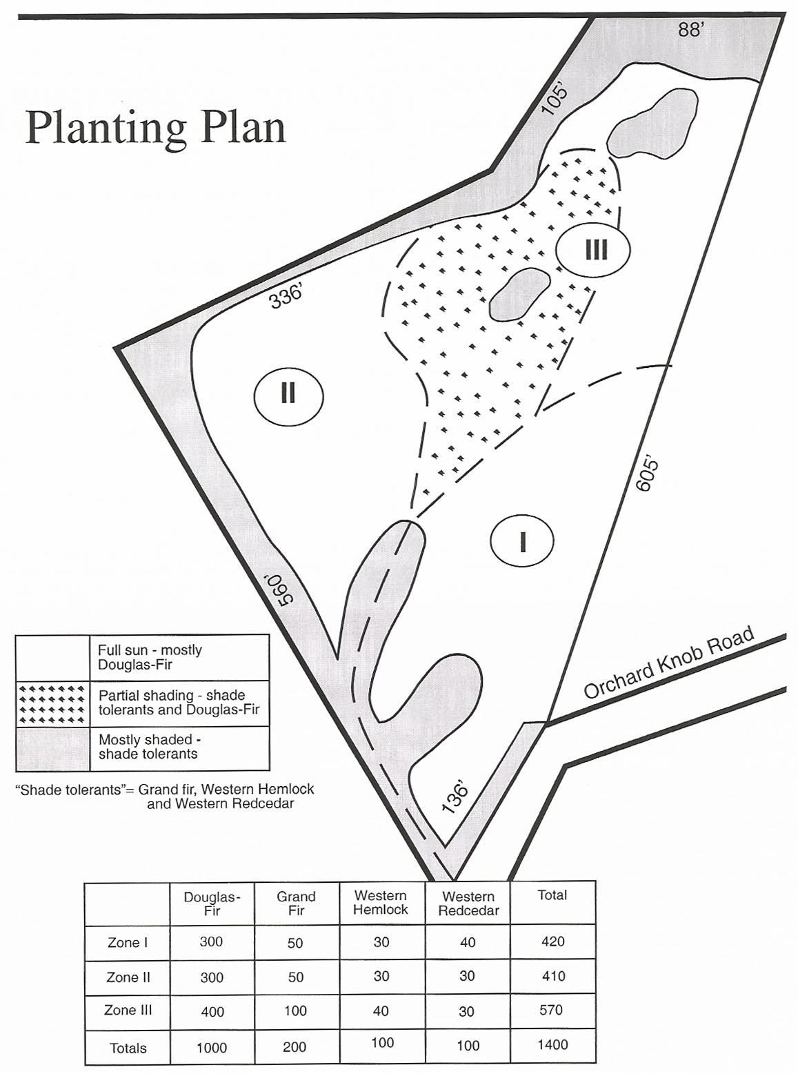
Figure 2. A planting plan was developed prior to planting seedlings at the western Oregon study site. The plan was based on desired seedling densities (approximately 400 per acre) and the biological requirements (especially relative shade tolerance) for the four tree species that were planted. Three zones were established using readily identifiable site features.

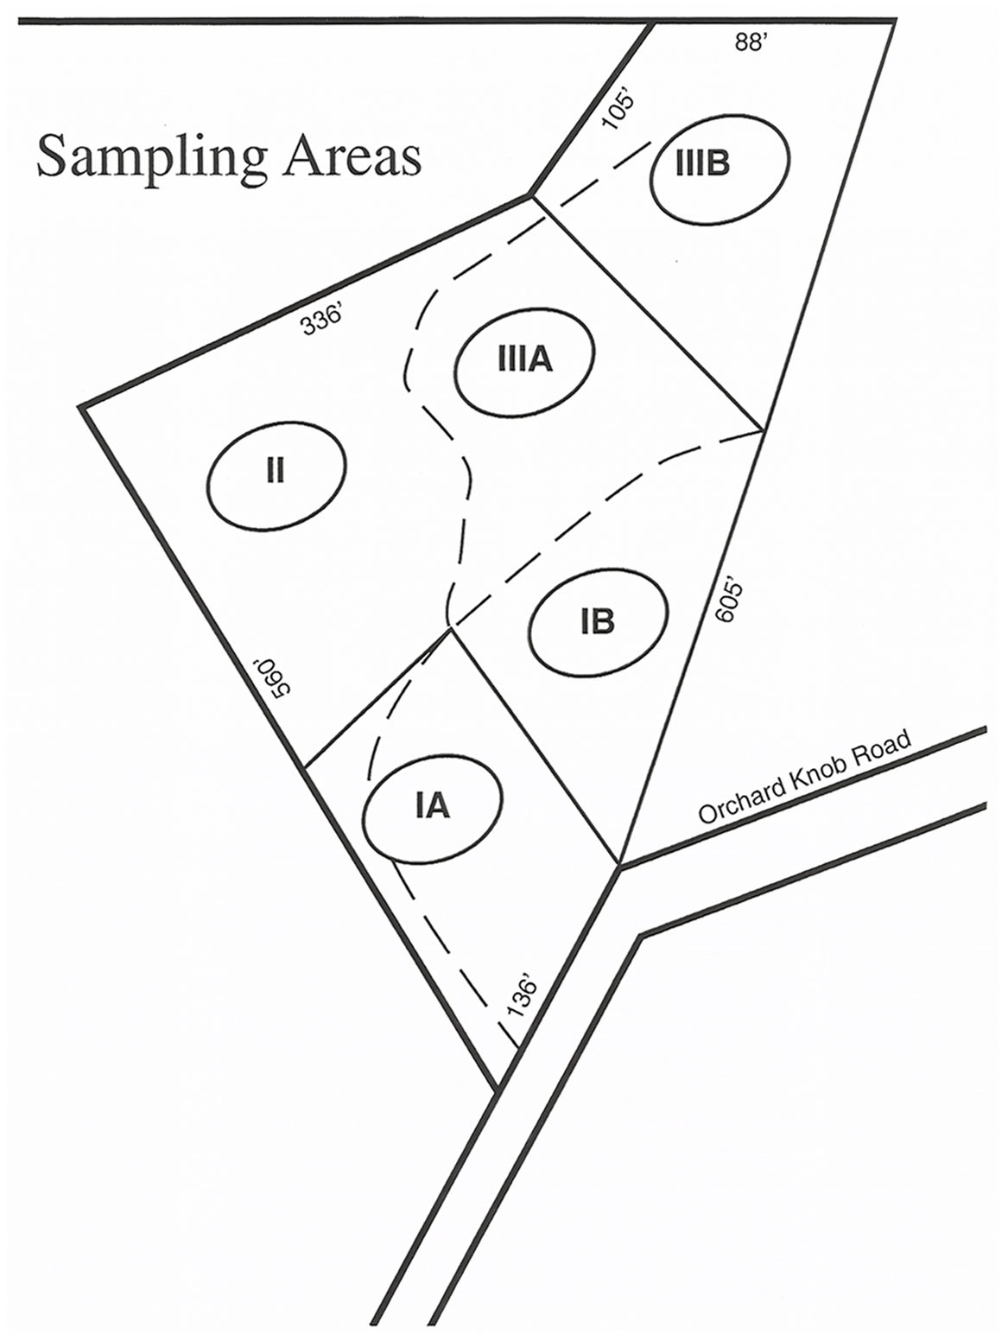
Figure 3. Five sampling areas were established on the study site. Each student group was assigned a sampling area for measurement. Data were later combined for analysis. Boundaries of sampling areas were established in the field using existing roads, fences and flagging.

General Resources for Vegetation Classification

There have been a number of efforts in recent years to develop vegetation classification systems for the United States. The following resources are representative of some of these publications. Instructors will find them useful to determine predicted vegetation patterns on a broad scale.

Anderson, M., et al. 1998. International classification of ecological communities:
terrestrial vegetation of the United States. Volume II. The National Vegetation
Classification System: list of types. The Nature Conservancy, Arlington, Virginia, USA

Bailey, R.G. 1995. Descriptions of the ecoregions of the United States. U.S. Forest
Service Misc. Publ. 1391 (revised), with separate map at a scale of 1:7,500,000. Washington, D.C., USA.

Ecoregion descriptions and downloadable maps are available at:

www.fs.fed.us/institute/ecoregions

Burns, R.M. and B.H. Honkala, tech. cords. 1990. Silvics of North American: 1. Conifers; 2. Hardwoods. Agriculture Handbook 654. U.S. Department of Agriculture, Forest Service, Washington, D.C. vol. 2, 877 pp.
www.na.fs.fed.us/spfo/pubs/silvics_manual/table_of_contents.htm

This comprehensive document describes the silvical characteristics of most commercially-important forest tree species in North America. Habitat characteristics including native range, climate, soils, topography and associated species are discussed. Life history characteristics such as reproduction, growth, reaction to competition and damaging agents such as insects and disease are also described. A comprehensive glossary of forestry terms is also provided. Instructors will find this to be an invaluable resource as they adapt this activity for their particular area.

Cleland, D.T., et al. 1997. National Hierarchical Framework of Ecological Units.
Published in Bryce, M.S. and A. Haney, eds. 1997. Ecosystem management applications for sustainable forest and wildlife resources. Yale Univ. Press, New Haven, CT. pp. 181-200.

http://ncrs.fs.fed.us/gla/reports/hierarchy.pdf

The National Hierarchical Framework of Ecological Units was developed to provide a scientific basis for ecosystem management. In this classification system, the units in the hierarchy are designed to delineate areas with different biological and physical characteristics. They are arranged in hierarchical fashion with categories as large as 100,000s of square miles (“Domains” and “Divisions”) to less than 100 acres (“Land types” and “Landtype Phase Units”).

Comer, P., D. et al. 2003. Ecological Systems of the United States: A working
classification of U.S. terrestrial systems. NatureServe, Arlington, Virginia

Grossman, et. al. 1998. International classification of ecological communities:
terrestrial vegetation of the United States. Volume I. The National Vegetation Classification System: development status and applications. The Nature Conservancy, Arlington, Virginia, USA.
www.natureserve.org/library/usEcologicalsystems.pdf

Kuchler, A.W. 1964. Potential natural vegetation of the coterminous United States. Map
and illustrated manual. American Geographical Society, New York, NY.

Ricketts, T.H., et al. 1999. Terrestrial ecoregions of North America: a conservation
assessment. World Wildlife Fund U.S. and Canada. Island Press, Washington, D.C. 485 pp.

Regional Resources for Plant Identification and Vegetation Classification

Instructors will also find it useful to consult more specific guides to identify plants and to predict which plant communities will occur on their specific study site. These resources are widely available and the following are provided as examples. Instructors will need to seek out resources specific to their locality.

Cleary, B.D., R.D. Greaves and R.K. Hermann (eds.). 1986. Regenerating Oregon's Forests. Oregon State University Extension Service. Corvallis, Oregon 286 pp.

Franklin, J.F. and C.T. Dyrness. 1973. Natural vegetation of Oregon and Washington. USDA Forest Service Gen. Tech. Rep. PNW-8. Pacific Northwest Forest and Range Experiment Station. Portland, Oregon. 417 pp.

Knezevich, C.A. 1982. Soil Survey of Polk County, Oregon. USDA Soil Conservation Service. 250 pp.

The U.S. Department of Agriculture Natural Resource Conservation Service (formerly, USDA Soil Conservation Service) publishes and distributes soil surveys for every county in the United States. These surveys include detailed information on soils and applications that may be relevant to this activity. Many soil surveys are now available on-line at:

http://soils.usda.gov/survey/printed_surveys/

Others may be requested from the state or local offices of the NRCS.

NRCS has recently developed a new web-based soil survey. See "How to use it" for instructions.

http://websoilsurvey.nrcs.usda.gov/app/

Meacham, J.E. and E.B. Steiner (eds.). 2002. Atlas of Oregon CD-ROM. University of Oregon
Press.

Minnesota Dept. of Natural Resources. 2006. Ecological Classification System

www.dnr.state.mn.us/ecs/index.html

Ecological classification systems (ECS) such as this one developed by the Minnesota Department of Natural Resources and the U.S. Forest Service, are used to identify, describe and map progressively smaller areas of land with increasingly uniform features. The system is based on the National Hierarchical Framework of Ecological Units (described above) and incorporates both biological (vegetation) and physical (climate, geology, topography, soils, hydrology) factors. Since ECS helps explain the ecological potential of vegetation on any site, it is a useful guide for natural resource managers. Also, instructors and students will find this to be a useful resource as they attempt to make predictions about the future conditions at a study site.

Preston, R.J. 1961. North American trees. The M.I.T. Press, Cambridge, MA. 395 pp.

Randall, W.R. and R.F. Keniston. 1974. Manual of Oregon trees and shrubs. Oregon State University Book Stores. Corvallis, Oregon 277 pp.

Ross, C.R. 1978. Trees to know in Oregon. Oregon State University Extension Service. Corvallis, Oregon 96 pp.

Photo Points

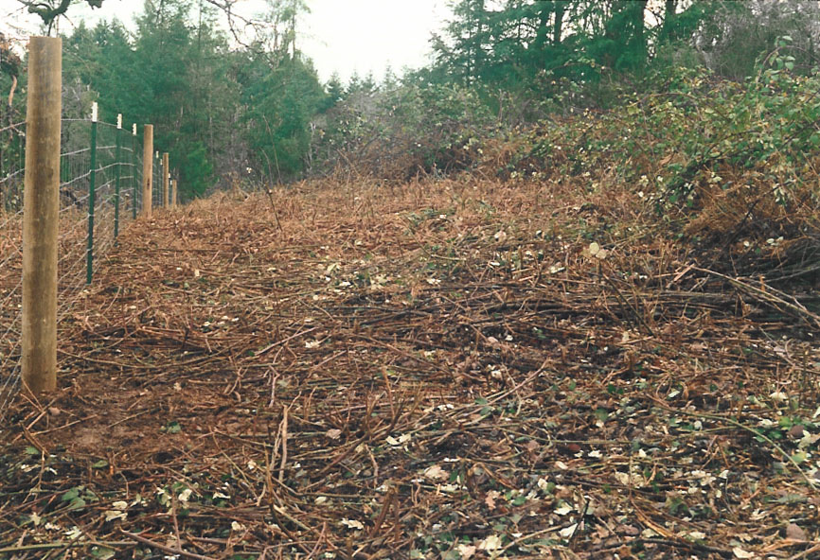

Photo A

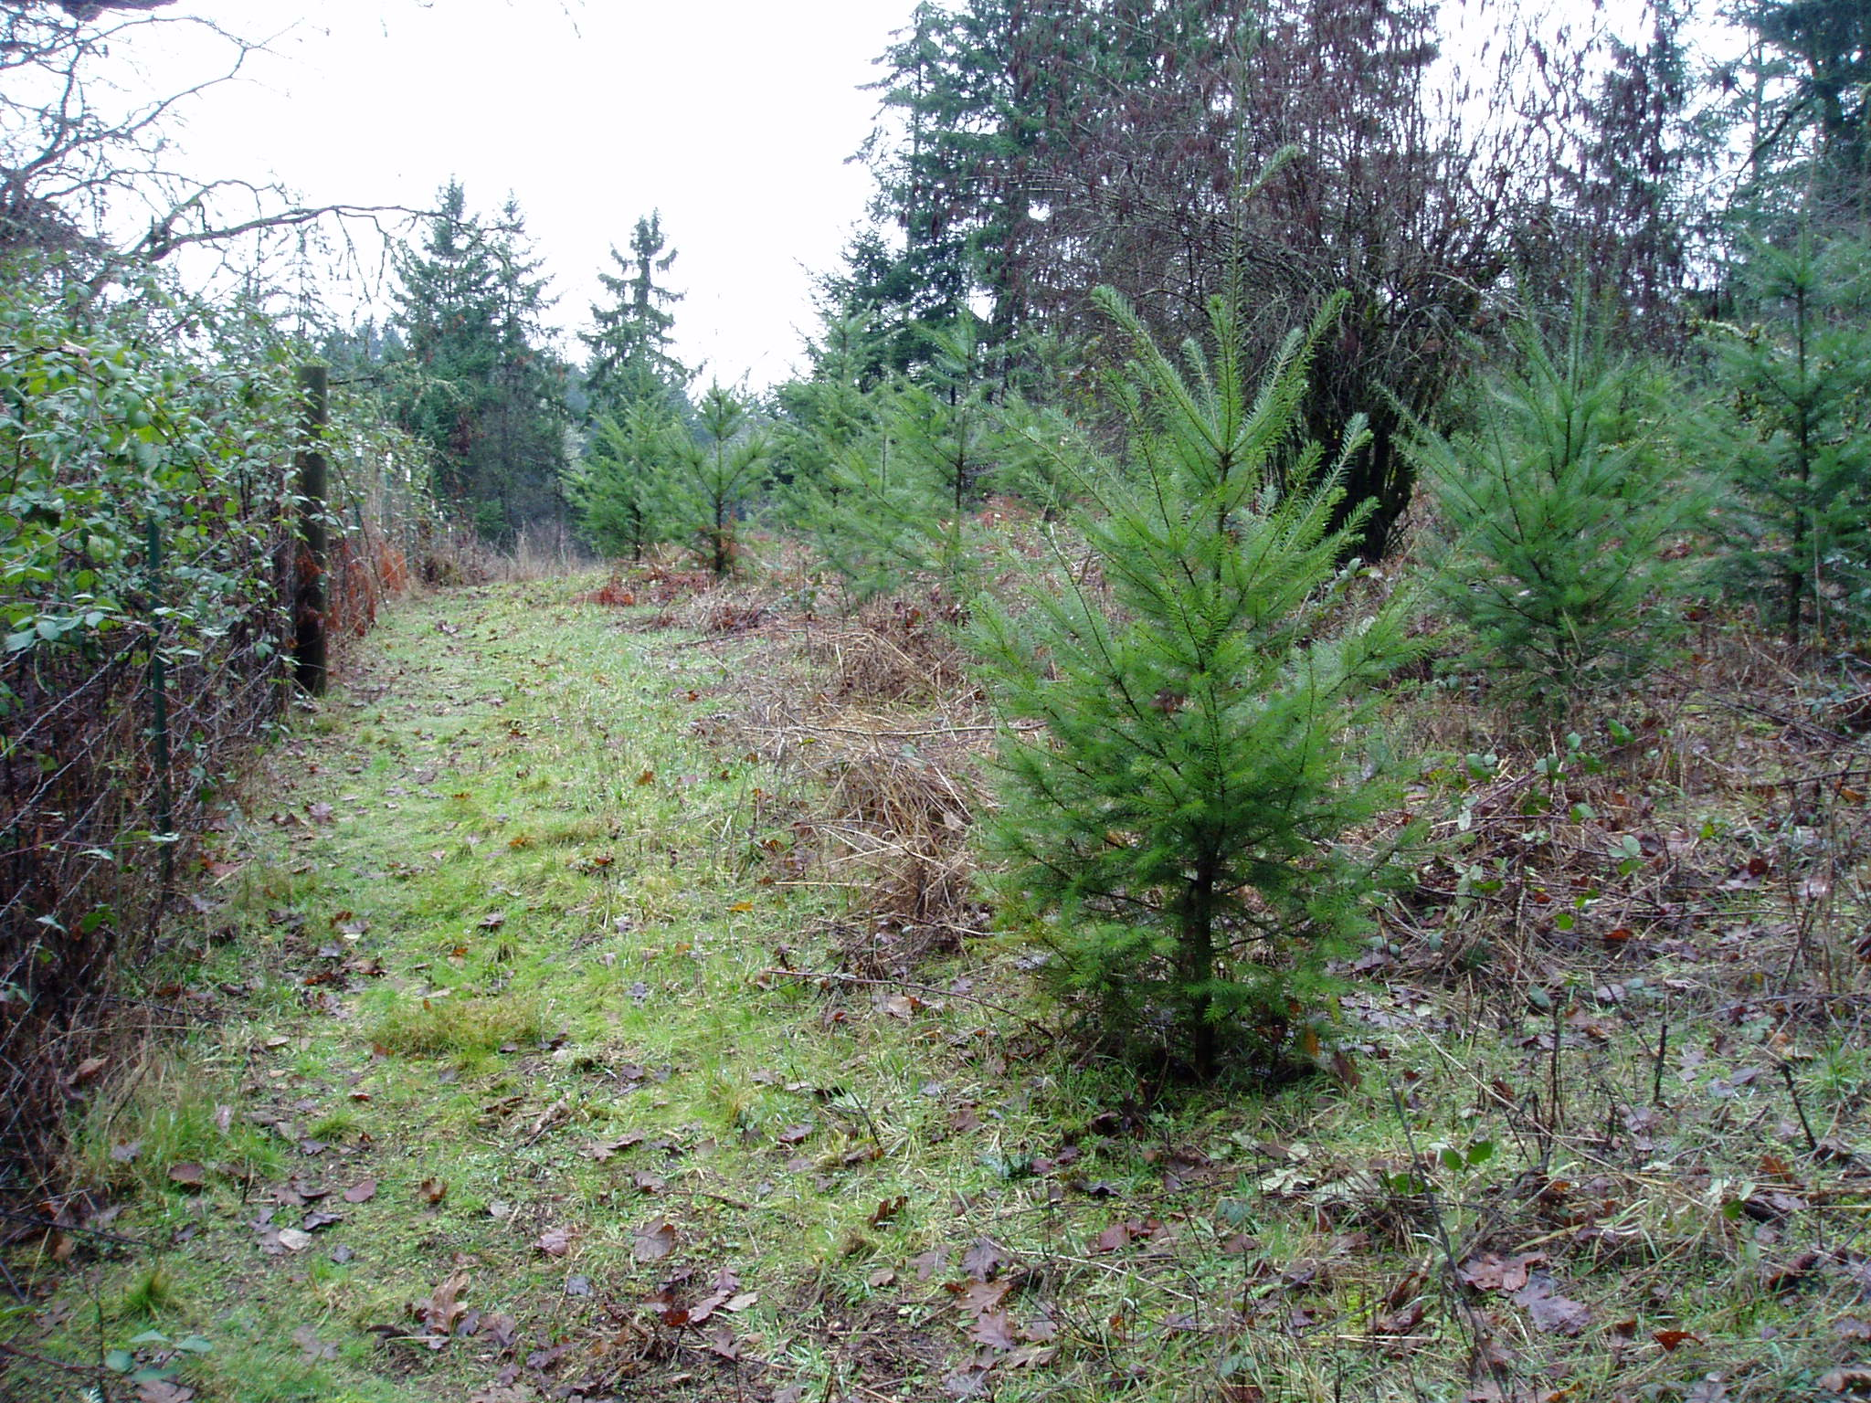

Photo B

Photo point photographs for a western Oregon study site prior to planting in January 2001 (A) and five years after planting in January 2006 (B).

