Amp Meter System Design and Testing

DC/AC Circuits

Student Name: ___________________________________________________

Acknowledgements
Subject Matter Expert: Roy Brixen, College of San Mateo, CA.

Purpose
This lab activity brings together all the principles and laws of parallel circuits. The primary purpose of the lab is to design, construct, and test a multi-range ammeter. In the process of doing this lab activity, the principles of Ohm's Law, Watt's Law, Kirchhoff's Parallel Circuit Laws, and the basic operation of an analog and a digital meter movement will be reviewed and emphasized. The interrelationships between various parts will be highlighted and a basic amperage measurement system will be constructed and tested.

Systems Rationale
Being able to quickly and accurately move from basic Ohm's Law and Watt's Law principles to understanding the relationships between resistance, voltage, current, and power in a parallel circuit is an everyday skill needed by technicians on the job.

System Concepts
This system covers the following system concepts (signified by an X):
_ _ S1. A system can be defined in terms of its functional blocks i.e., a “structured functional unit.”
_X_ S2. A system has a purpose, transforms inputs into outputs to achieve a goal.
_ _ S3. A system is defined by the flow of materials, energy and information, between its functional units.
_ _ S4. A system may be open or closed. In an open system additional inputs are accepted from the environment.
_X_ S5. A system is more than the sum of its parts. Individual components can never constitute a system.
_X_ S6. A system provides feedback to the operator and services to the user. Some system functions may involve operator action.
__ S7. Systems have unique problems.

Student Learning Outcomes
Appropriate SLOs for the lab activity are below. For a complete list of course SLOs visit: http://www.esyst.org/Courses/DC-AC/_delivery/index.php
9. Make common circuit measurements such as voltage, current and resistance with a multimeter.
10. Explain meter loading and define precision and accuracy, and calculate accuracy and error.

Prerequisite Knowledge & Skills
- Solve basic algebra equations
- Use a calculator to solve Ohm's Law, Watt's Law, and Kirchhoff's Parallel Circuit Laws
- Solve basic Ohm's Law problems
- Solve basic Watt's Law problems
- Apply and solve Kirchhoff's Parallel Circuit Laws
- Use a voltmeter to measure potential difference
- Use and amp meter to measure current flow
- Use a RCL meter to measure component values

Learning Objectives
Relevant knowledge (K) or skill (S) student learning outcomes include:
K1. Describe the operation of moving-coil analog meter movement.
K2. Define meter coil resistance, full-scale current, and meter coil voltage drop.
K3. Describe and define the concept of a shunt resistor.
S1. Use Ohm's Law, Watt's Law, and Kirchhoff's Parallel Circuit Laws to calculate the value of various shunt resistors needed to extend base amp meter range.
S2. Select appropriate parts to construct a multi-range amp meter system.
S3. Perform calibration checks using a lab standard digital multimeter (DMM) as a reference.

Process Overview
- Determine the value and size of the resistors you need to extend the measurement range of a typical meter movement.
- Using parallel resistance connections to build the values you needed.
- Follow the schematic and wire the system to construct. You will build the amp meter on a breadboard using selected resistors, an analog meter movement, a DC power supply, and the digital multimeter.
- Apply and measure a test current with a lab standard.
- Measure the test current with your unit under test and compare it with your calculated values.
- Determine the accuracy of your unit under test and compare its performance with the specification listed on the meter's data sheet.
- Complete component calculations, described measurements, tolerance computations, and answer wrap-up questions.

Time Needed
Lab Performance:
It should take students approximately 3 hours to work through the entire lab, in groups of two or three students.

Lab Deliverables:
It should take students approximately 3 hours of homework time to create the final lab report described at the end of this lab.

Equipment & Supplies
Item | Quantity
Class Resistor Pack | 1
0-1 mA. Analog Meter Movement (Simpson Type 25 movement typical) | 1
Breadboard System | 1
4 1/2 Digit DMM | 1
5k Ohm Potentiometer | 1
12 Volt DC Power Supply (or battery pack) | 1

Special Safety Requirements
There are no special safety requirements associated with this lab.

Lab Preparation
- Read the Introduction section of this lab.
- Obtain the necessary parts as detailed in the equipment and supplies list.
- Obtain a specification sheet for the Model 25 Simpson meter movement. This can be accomplished with a Google search or visit www.simpsonelectric.com.

Introduction
Since the 1880s, the moving-coil analog meter movement has been the mainstay of electrical/electronic measurement. The movement can be configured to measure current, voltage, power, and resistance. The d'Arsonval moving-coil meter movement is the most common type of analog measuring instrument.

Historical Note: Jaques-Arsène d’Arsonval and Marcel Deprez introduced the Deprez-d’Arsonval galvanometer. Referred to as the mobile circuit galvanometer, this invention was a new galvanometer developed in 1880. Instead of a magnetized needle moving when electrical current flows through a surrounding wire coil the Deprez-d'Arsonval galvanometer has a fixed magnet and moveable coil. If a pointer is attached to the coil it can move over a suitably calibrated scale.

In the d'Arsonval meter movement, a small coil is wound on a form called the armature, which is suspended by pivots between the poles of a permanent magnet.

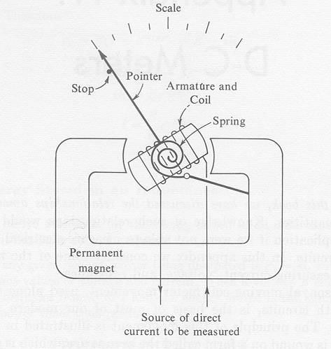
The spiral spring holds the coil and the pointer attached to it against a stop on the left when the movement is not in use. The armature around which the coil is wound is made of a magnetic material of very low retentivity so that when there is no current in the coil there is no magnetic field from it. When direct current passes through the coil, an electromagnetic field of constant north-south polarity is produced.

This field interacts with the strong, fixed north-south field of the permanent magnet because like magnetic poles repel and unlike magnetic poles attract. Thus, a turning force called torque is developed and causes the coil, the armature, and its attached pointer to begin to rotate clockwise. If there is sufficient current to produce a strong electromagnetic field, the forces of magnetic attraction and repulsion will produce sufficient torque to overcome the resisting torque of the coiled spring. The armature thus rotates further clockwise and the pointer moves to the right across the scale--the more current, the larger the electromagnetic field, the greater the forces of attraction and repulsion, the greater the torque, and the farther the pointer moves. The pointer rotation in degrees is proportional to the current in the coil. The scale is calibrated in terms of this current. Thus, the pointer indicates on the scale how much current there is in the coil.

The current measured by this type of meter passes through its moving coil. The coil has resistance, which is called the internal resistance of the meter, abbreviated R_{m}. Another important characteristic of the movement is its full-scale current rating--referred to as full-scale deflection current of I_{FSD}. This rating takes into account the design of the coil, its inductance, the mechanical design and strength of the magnet, and is the value of the current through the coil, which is necessary to make the point read exactly at the highest mark on the scale. Note that lower currents would result in proportionally less deflection. If a 100 mA. meter passes only 50 mA., its pointer is deflected to the half-scale position.

Finally, since the meter movement has resistance and a current rating, Ohm's Law makes it possible to compute the DC voltage needed to push enough current through the meter armature to create sufficient torque to drive the pointer to full scale deflection. V_{m} is the abbreviation used to represent the DC voltage drop of the meter movement.

When selecting a DC meter movement, all three values can be obtained from the manufacture's catalog and are necessary to extend the range of the meter movement.

The schematic symbol for the d'Arsonval meter movement is shown in figure 1 below:
Figure 1: d’Arsonval Meter Schematic

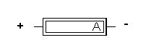
The meter movement used for this application lab is a Type 25 Simpson movement. The meter has an internal resistance of 43 ohms, a full scale deflection current value of 1 mA., and a voltage drop of 43 mV. These ratings mean that when 43 mV. is applied to the 43 ohms coil of the meter's armature, 1 mA. of current will flow through the coil. That current produces an electromagnetic field around the coil large enough to produce enough torque to rotate the armature to full-scale deflection. It is thus accurate to say that either a current flow of 1 mA. through the coil of the armature OR 43 mV. applied across the armature will produce movement to full scale. Thus a d’Arsonval meter movement can be used to measure current or voltage.

In this lab, the Simpson Type 25 0-1 mA. meter movement will be used as a multi-range amp meter. Remember, the electrical characteristics of the meter movement include a full scale deflection current value of 1 mA., a DC resistance of 43 ohms, and a DC voltage drop of 43 mV.

When the meter movement is used to measure current, the lowest current that can be measured is established by the design of the movement and the printing on the meter scale—in our case, 0 to 1 mA. This is called full-scale deflection current or I_{FSD}. If you need to measure smaller amounts of current then you must obtain a meter movement with a lower value of full-scale deflection current. Meter movements with 100 uA. and 50 uA. full scale deflections are available.

However, the meter’s ranging can be extended above the established 0 to 1 mA. range by adding bypass or shunt resistors in PARALLEL with the meter movement. The purpose of the shunt or bypass resistor is to provide a low resistance path for all current flow above the 1 mA. actually needed by the wire coil of the meter movement.

Thus, if you wanted to expand the range of this meter movement to 0 to 10 mA., you would need to bypass 9 mA. around the meter movement while only 1 mA. flows through the movement.

The system works like this: A 10 mA. input current would cause 1 mA to flow through the meter movement and deflect the pointer to full scale while 9 mA. was bypassed through the shunt. A 5 mA. input current wold cause .5 mA. to flow through the meter movement and reflect the pointer to 1/2 scale while 4.5 mA. was bypassed through the shunt.

This proportional division of current occurs because Ohm's Law is a linear equation--a drop in current levels causes a proportional reduction in the current flowing in the meter and the current flowing through the shunt resistor. In addition to adding the shunt resistor, the scale printed on the meter would have to be reworked so that it read 0 to 10 mA. The extended range amp meter circuit is shown in Figure 2, below:
Figure 2: Extended Range Amp Meter Circuit Schematic
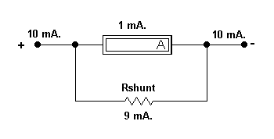
To solve for the shunt resistor, you need to know two things—the full-scale voltage drop across the meter movement and the full-scale current needed by the meter. In the case of the TYPE 25 0-1 mA. meter movement, the voltage drop is 43 mV. and the full scale deflection current is 1 mA. Thus, the shunt resistor has 43 mV. applied to it (it’s in parallel with the meter movement) and 9 mA. must flow through it (10 mA. – 1 mA. = 9 mA.). Ohm’s Law tells us the resistance of the shunt must be 4.778 ohms. The general formula is listed below:

R_{SHUNT} = V_{FSD} / (I_{INPUT} - I_{FSD})

Now, the general shunt resistor can be replaced by a resistor equal to 4.778 ohms. A Watt's Law computation based on current squared times resistance will reveal the correct wattage of the resistor. Compute the resistor wattage and be sure to round the wattage up to a commonly available value. Add those values to the 10 mA. meter schematic, shown in Figure 3, below:

Figure 3: 10 mA. Meter Schematic

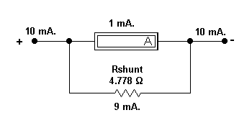
How would you make a 4.778 ohm resistor? Using resistors connected in parallel, start with a large value and connect a small value in parallel. Select the small value resistor such that it is just a bit larger in value that the value of Rshunt. Select the larger value such that it is over 20 times the value of the smaller resistor. Start with 100 ohms connected in parallel with 5 ohms. Use the two-resistor parallel circuit equation to find the total resistance. Using this method produces 4.76 ohms.

You could also get a selection of 4.7 ohm resistors and measure each one until you found the one closest to the needed value. In this case, you would need to search for a value above the indicated color code value.

What size shunt resistor would be needed to extend the range of the meter movement from 0-1 mA. to 0-100 mA.? Attach your calculation sheet to the back of this lab. Add those values to the 100 mA. meter schematic, shown in Figure 4, below:
Figure 4: 100 mA. Meter Schematic
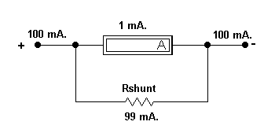
Now, compute the required shunt resistor for a 0-1000 mA., a 0-10 Amp, and a 0-100 Amp range. Attach your calculation sheet to the back of this lab. Add those values to the 1000 mA. meter schematic, shown in Figure 5, below:

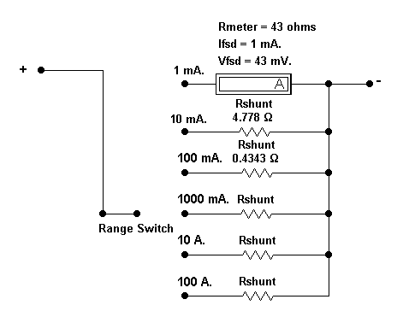
Figure 5: 1000 mA. Meter Schematic

Task
Your task is to determine the values of five shunt resistors needed for an amp meter. Construct the resistors using only parallel circuit rules. Finally, you’ll build and test the 0-10 mA. circuit for upscale as well as downscale accuracy.

Performance
- Collect or manufacture the necessary shunt resistor for your amp meter design for just the 10 mA. range. Follow the suggestions in the Introduction. DO NOT make shunts for the 100 mA., 1 A., or the 10 A. ranges. Since this lab activity is highlighting parallel circuit rules, build the small value shunt resistors by placing bigger value resistors in parallel. No pots or rheostats are allowed. Be as accurate as possible. Use the RCL meter to measure your shunt.

- Following the documented schematic diagram identified as Figure 3, build the 0-10 mA. measurement circuit.

- Construct the lab test circuit schematic shown in Figure 6, below. Be sure that the 5k-ohm rheostat is at maximum value before you start. The DMM is the 4 1/2-digit lab multimeter set for the 10 mA. range. The device under test is the 0-10 mA. meter you just constructed.

Figure 6: Lab Test Circuit Schematic
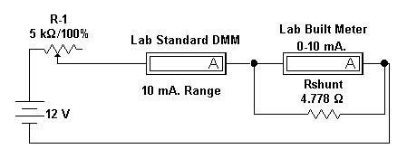
- Connect your circuit to the power supply. Adjust the rheostat such that the DMM reads the current values listed below. Once an adjustment has been made, read the scale pointer on your lab-constructed amp meter and record both the DMM reading and the Lab Built Amp Meter reading in the chart below.

DMM Current Reading Lab Built Amp Meter Reading

0.00mA. __________________ ________________________
2.5 mA. __________________ ________________________
5.0 mA. __________________ ________________________
7.5 mA. __________________ ________________________
10.0 mA. __________________ ________________________
7.5 mA. __________________ ________________________
5.0 mA. __________________ ________________________
2.5 mA. __________________ ________________________
0.0 mA. __________________ ________________________

- Compute the percent accuracy of your lab built amp meter for each input current value. Attach your computations sheet to the back of this lab. In the equation, the DUT Readings or Device Under Test readings are those obtained from the lab built amp meter while the DMM readings are those obtained from the lab standard measurement device. Include accuracy in both directions.

Formula:

% Accuracy = ((DUT Reading - DMM Reading) / DMM Reading) x 100

Input Current Percent Error Upscale Percent Error Downscale

0.0 mA. ___________ ___________
2.5 mA. ___________ ___________
5.0 mA. ___________ ____________
7.5 ma. ___________ ____________
10.0 ma. ___________ ____________

- Make sure to put everything you used back, in the same condition and location where you found it.

Deliverable(s)
When you complete this lab, your lab report should include the following things:

      - A statement of the objectives of the lab.
      - A detailed summary of the steps you went through to determine the value of each resistor and to construct resistor values. Include all math involved.
      - A detailed summary of your test findings including a discussion of any significant errors (defined as greater than plus or minus 5%) and their possible causes.
      - Citation of any and all reference materials used.
5. Often times very small value resistors cannot be constructed using conventional carbon composition, carbon film, or metal film technologies. Instead, the industry turns to other materials whose resistance properties are well known--copper wire is an example.

To make a small value resistor, one simply picks a small diameter of copper wire, like #28 AWG, determines the number of ohms/1000 feet of wire from the AWG Data Table, and computes the number of feet necessary to create the necessary resistance. Then, exactly the computed amount of wire is wound onto a wooden or plastic bobbin, glued down for stability, and connected in the shunt position.

For example, #28 AWG copper wire has a resistance of 64.90 ohms/1000 feet. In order to wind a shunt resistor for the 0-10 mA. range on the lab built amp meter, you would need 13.58 feet of wire wound onto a bobbin. (Divide 64.90 ohms/1000 feet by 4.778 ohms.) Finally, check to be sure that #28 AWG wire can carry a maximum of 9 mA. before burning up--that information can be found in the AWG Data Table as well.

Using the above information, compute the necessary amount of copper wire needed to wind a shunt for the 0-1 A. range on the lab built amp meter. Use data for #24 AWG because thick copper wire is necessary to carry the 999 mA. of shunt current. Include a copy of the data table you used and your computations.

For extra credit, ask your instructor for the wire and a wooden or plastic bobbin. Wind the shunt resistor and use the test circuit to check your work.

6. Revisit the Simpson web site (www.simpsonelectric.com) and find the DC amperage meter movement with the lowest value full scale deflection. Look in the amp chart, the milliamp chart, and the microampere chart to be sure you do not miss a possible choice. List the model number of the movement, its FSD, its meter resistance, and compute the full-scale voltage drop. Download, print, and highlight the model on the data sheet. Attach the data sheet to this lab.

7. Briefly explain how the test circuit used in this lab functions. Be sure to indicate which of Kirchhoff's Laws were used to make the circuit function as a test bed for the amp meter project.

8. Summarize the four parallel circuit laws used in this application lab to design, build, and test an amp meter.

Model Deliverable Example(s)

As you prepare your lab report, follow the established lab report standard for this class.

Grading
Your instructor will let you know how this lab will be graded.

