Voltmeter System Design and Testing

DC/AC Circuits

Student Name: ___________________________________________________

Acknowledgements
Subject Matter Expert: Roy Brixen, Professor, College of San Mateo, CA

Purpose
The purpose of this lab is to bring together all the principles and laws of series circuits. In this lab you will design, construct, and test a multi-range voltmeter. In the process of doing this lab activity, the principles of Ohm's Law, Watt's Law, Kirchhoff's Series Circuit Laws, and the basic operation of an analog and a digital meter movement will be reviewed and emphasized. The interrelationships between various parts will be highlighted and a basic voltage measurement system will be constructed and tested.

Systems Rationale
Being able to quickly and accurately move from basic Ohm's Law and Watt's Law principles to understanding the relationships between resistance, voltage, current, and power in a series circuit is an everyday skill needed by technicians on the job.

System Concepts
This system covers the following system concepts (signified by an X):
_ _ S1. A system can be defined in terms of its functional blocks i.e., a “structured functional unit.”
_X_ S2. A system has a purpose, transforms inputs into outputs to achieve a goal.
__ S3. A system is defined by the flow of materials, energy and information, between its functional units.
_ _ S4. A system may be open or closed. In an open system additional inputs are accepted from the environment.
_X_ S5. A system is more than the sum of its parts. Individual components can never constitute a system.
_X_ S6. A system provides feedback to the operator and services to the user. Some system functions may involve operator action.
_ _ S7. Systems have unique problems.

Student Learning Outcomes
Appropriate SLOs for this lab activity are below. The complete list of course SLOs can be found at: http://www.esyst.org/Courses/DC-AC/_delivery/index.php

- Apply Ohm’s and Kirchhoff’s laws to solve series, parallel, and series-parallel circuit problems as well as loaded and unloaded voltage divider problems.
- Describe the properties of magnetic fields and materials, explain electromagnetism, electromagnetic induction and relate to the operation of common magnetic devices.
- Make common circuit measurements such as voltage, current and resistance with a multimeter.
- Explain meter loading and define precision and accuracy, and calculate accuracy and error.

Prerequisite Knowledge & Skills
- Solve basic algebra equations.
- Given a calculator, solve basic Ohm's Law, Watt's Law and Kirchhoff's Law equations.
- Solve basic Ohm's Law problems.
- Solve basic Watt's Law problems.
- Apply and solve Kirchhoff's Series Circuit Laws.
- Given a voltmeter, measure potential difference.

Learning Objectives
Relevant knowledge (K) or skill (S) student learning outcomes include:
K1. Describe the operation of moving-coil analog meter movement.
K2. Define meter coil resistance, full-scale current, and meter coil voltage drop.
K3. Describe and define the concept of a multiplier resistor.
S1. Use Ohm's Law, Watt's Law, and Kirchhoff's Series Circuit Laws to determine the value of various multiplier resistors needed to extend base range.
S2. Select appropriate parts to construct a multi-range voltmeter system.
S3. Perform calibration checks using a lab standard digital multimeter (DMM) as a reference.

Process Overview
In the process of completing this lab, you will:
- Determine the value and size of the resistors needed to extend the measurement range of a typical meter movement.
- Using series resistance connections, you will build the five values needed.
- Follow the schematic to build wire the system.
- Construct a test system on a breadboard using selected resistors, an analog meter movement, a DC power supply, and the digital multimeter.
- Apply a test voltage, measure the test voltage with a lab standard, and then measure the test voltage with your unit under test.
- Determine the accuracy of the unit under test and compare its performance with the specification listed on the meter's data sheet.
- Complete component calculations, described measurements, tolerance computations, and answer wrap-up questions.

Time Needed
Lab Performance:
It should take you approximately 3 hours to work through the entire lab.

Lab Deliverables:
It should take you approximately 3 hours of homework time to create the final lab report.

Equipment & Supplies
Item | Quantity
Class resistor pack | 1
0-1 mA. Analog meter movement (Simpson Type 25 movement typical) | 1
Breadboard system | 1
4 1/2 Digital multimeter | 1
0-1000 volt DC power supply | 1

Special Safety Requirements
Caution should be used during the testing phase of this lab activity because of the use of a high voltage DC power supply. Use caution when the DC supply to operated above 50 volts DC. This caution includes making sure that all test and clip leads are completely covered with protective insulation boots and that you NEVER get near the functioning circuit with both hands at the ready. When taking voltage measurements, move the meter clips one at a time. NEVER use both hands. You do not want to create a pathway so that DC voltage can drive a DC current across your chest from one hand to the next. This current can flow right through your heart and cause damage. It is best to place your non-dominate hand in your back pocket or at your side.

Lab Preparation
- Obtain the necessary parts as detailed in the equipment and supplies list.
- Following the example in the Introduction section of this lab, compute the value of each necessary resistor.
- Using the class resistor pack and following the example in the Introduction section of this lab, build the needed resistors.
- Using your simple and series circuit wiring experience follow the schematic diagram and wire the final circuit.
- Perform a calibration test by applying a DC voltage to each range of the meter system (device under test) and record the voltage value displayed on both the device under test as well as a lab standard voltmeter.
- Determine the tolerance or accuracy value and compare with published values.

Introduction
Since the 1880s, the moving-coil analog meter movement has been the mainstay of electrical/electronic measurement. The movement can be configured to measure current, voltage, power, and resistance. The d'Arsonvol moving-coil meter movement is the most common type of analog measuring instrument.

Historical Note: The Deprez-d'Arsonvol galvanometer was introduced by Jaques-Arsène d'Arsonvol and Marcel Deprez. Referred to as the mobile circuit galvanometer, this invention was a new galvanometer developed in 1880. Instead of a magnetized needle moving when electrical current flows through a surrounding wire coil the Deprez-d'Arsonvol galvanometer has a fixed magnet and moveable coil. If a pointer is attached to the coil it can move over a suitably calibrated scale.

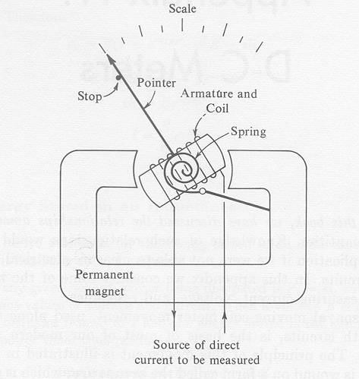
In the d'Arsonvol meter movement, a small coil is wound on a form called the armature, which is suspended by pivots between the poles of a permanent magnet, shown in figure 1 below.
Figure 1: d’Arsonvol Meter

The spiral spring holds the coil and the pointer attached to it against a stop on the left when the movement is not in use. The armature around which the coil is wound is made of a magnetic material of very low retentivity so that when there is no current in the coil there is no magnetic field from it. When direct current passes through the coil, an electromagnetic field of constant north-south polarity is produced.

This field interacts with the strong, fixed north-south field of the permanent magnet because like magnetic poles repel and unlike magnetic poles attract. Thus, a turning force called torque is developed and causes the coil, the armature, and its attached pointer to begin to rotate clockwise. If there is sufficient current to produce a strong electromagnetic field, the forces of magnetic attraction and repulsion will produce sufficient torque to overcome the resisting torque of the coiled spring. The armature thus rotates further clockwise and the pointer moves to the right across the scale--the more current, the larger the electromagnetic field, the greater the forces of attraction and repulsion, the greater the torque, and the farther the pointer moves. The pointer rotation in degrees is proportional to the current in the coil. The scale is calibrated in terms of this current. Thus, the pointer indicates on the scale how much current there is in the coil.

The current measured by this type of meter passes through its moving coil. The coil has resistance, which is called the internal resistance of the meter, abbreviated R_{m}. Another important characteristic of the movement is its full-scale current rating--referred to as full-scale deflection current of I_{FSD}. This rating takes into account the design of the coil, its inductance, the mechanical design and strength of the magnet, and is the value of the current through the coil which is necessary to make the point read exactly at the highest mark on the scale. Note that lower currents would result in proportionally less deflection. If a 100 mA. meter passes only 50 mA., its pointer is deflected to the half-scale position.

Finally, since the meter movement has resistance and a current rating, Ohm's Law makes it possible to compute the DC voltage needed to push enough current through the meter armature to create sufficient torque to drive the pointer to full scale deflection. V_{m} is the abbreviation used to represent the DC voltage drop of the meter movement.

When selecting a DC meter movement, all three values can be obtained from the manufacture's catalog and are necessary to extend the range of the meter movement.

The schematic symbol for the d'Arsonvol meter movement is shown in figure 2 below:
Figure 2: d’Arsonvol Meter Schematic

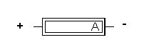
The meter movement used for this application lab is a Type 25 Simpson movement. The meter has an internal resistance of 43 ohms, a full scale deflection current value of 1 mA., and a voltage drop of 43 mV. These ratings mean that when 43 mV. is applied to the 43 Ω coil of the meter's armature, 1 mA. of current will flow through the coil. That current produces an electromagnetic field around the coil large enough to produce enough torque to rotate the armature to full scale deflection. It is thus accurate to say that either a current flow of 1 mA. through the coil of the armature OR 43 mV. applied across the armature will produce movement to full scale. Thus a d'Arsenval meter movement can be used to measure current or voltage.

By painting over the word milliamps and the abbreviation mA. with white paint, one can use the existing meter scale to measure amps, milliamps, volts, millivolts, watts, or ohms. Just be sure your range ends with a decade multiple of 1. For example, if we choose volts and millivolts, then we could design and construct a meter that will measure 0 to 100 mV., 0 to 1 volt, 0 to 10 volts, 0 to 100 volts, and 0 to 1000 volts. One does not need to stop here, but for safety reasons we will.

Task
In this lab, you will learn how to use Ohm's law to determine the required amount of resistance needed in a circuit. You will also learn to compute the expected heat dissipation or wattage of that resistance so you can select the correct physical size. Next, you will use resistors from your class kit to manufacture appropriate multiplier resistors. Then, you will learn how to apply a test voltage to a system and record both the value of the test voltage displayed on a lab standard AND the value of the test voltage displayed on the unit under test. Finally, you will use the standard tolerance or accuracy equation to determine the percent error in the unit under test and compare the accuracy of your unit under test to the published standard.

Performance
- In order to extend the volt range of the meter, a multiplier resistor needs to be placed in series with the meter movement to drop the excess voltage. For example, using the basic specification for the Model 25 meter movement, it is possible to extend the range from 0 to 43 mV. to 0 to 1 volt. A new meter circuit must be constructed with the series multiplier resistor, as shown in figure 3 below:
Figure 3: Series Multiplier Resistor Schematic
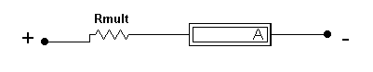
The following formula is used to determine the value of the multiplier resistor:

R_{mult =} (V_{range -} V_{FSD}) / I_{FSD}

where R_{mult} is the value of the multiplier resistor, V_{range} is the maximum new extended range value, V_{FSD} is the required full scale deflection value of the meter movement, and I_{FSD} is the required full scale deflection current value of the meter movement. Solving produces:

R_{mult} = (V_{range} - V_{FSD}) / I_{FSD}

= (1.00 V. - 43 mV.) / 1 mA.

= (.957 V.) / 1 mA.

= 957 Ω
Thus, the complete circuit is shown in figure 4 below:
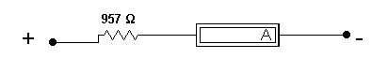
Figure 4: Complete Circuit Schematic
A power calculation needs to be done in order to physically size the resistor. Use the V² / R version of Watt's Law to be sure the resistor wattage is correct. .957 volts squared divided by 957 Ω reveals that 957 microwatt will be dissipated by the multiplier resistor. Therefore, a resistance equal to 957 Ω made from 1/4-watt resistors will work just fine.

How does one make a 957 Ω resistor? Try placing a 910 Ω resistor in series with a 47 Ω resistor and then add the combination. 910 Ω plus 47 Ω equals 957 Ω. Just be sure both resistors are a minimum of 1/4-watt in physical size.

Now, in a similar fashion, compute the required multiplier resistor for a 100 mV., 10 volt, 100 volt, and 1000 volt range. Include a wattage calculation for each resistor. Attach your calculations sheet to the back of this lab. Add those values to the final meter schematic, as shown in figure 5 below:
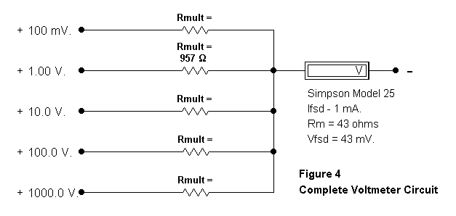
Figure 5:
- Collect or manufacture the necessary multiplier resistors for your voltmeter design. Since this lab activity is highlighting series circuit rules, build the large value multiplier resistors by placing smaller value resistor in series. No adjustable resistors, precision resistors, or series-parallel combinations are allowed. Be as accurate as possible. On your final meter schematic, figure 4 (found above), identify the values used to make each multiplier resistor.
- Following your documented schematic diagram, build the complete circuit.
- Using the lab power supply as a voltage source for Vin and using the 3-1/2 digit DMM as your reference lab standard, complete the following calibration test. Remember; as you apply each of the values of Vin be sure to move the positive lead of the power supply to the appropriate range--the 50 mV. value is applied to the 100 mV. range, the .5 volt value is applied to the 1 volt range, the 5 volt value is applied to the 10 volt range, the 50 volt value is applied to the 100 volt range, and the 500 volt value is applied to the 1000 volt range.
Note: These tests only drive the meter movement to 50% deflection. This is done to help safeguard the meter from "pegging" at full scale if you have selected or wired a wrong value.

Vin Lab Standard Reading Lab Built Voltmeter Reading

50 mV. ________________ _______________________
.5 V. ________________ _______________________
5 V. ________________ _______________________
50 V. ________________ _______________________
500 V. ________________ _______________________

- Now, repeat the tests using the full range value of Vin. This time you will take four voltage readings. Use the DMM to adjust the input voltage, to read the voltage drop across the multiplier resistor, and the voltage drop across the meter movement. Also record the reading on the analog lab built voltmeter. Be sure to move the Vin power supply lead to the appropriate range of the lab built voltmeter.

Vin Lab Standard Reading Voltage across RMULT Voltage across Meter Lab Built Voltmeter
Reading

100 mV. ____________ ____________ __________ _____________
1.00 V. ____________ ____________ __________ _____________
10.0 V. ____________ ____________ __________ _____________
100.0 V. ____________ ____________ __________ _____________
1000 V. ____________ ____________ __________ _____________
- Using the standard error equation, compute the accuracy of your lab built voltmeter for each range.

% Accuracy = ((DUT Reading - DMM Reading) / DMM Reading) x 100

Range Percent Accuracy

100 mV. __________
1 V. __________
10 V. __________
100 V. __________
1000 V. __________
- Make sure to put everything you used back, in the same condition and location where you found it.

Deliverable(s)
When you complete this lab, your lab report should include the following things:

      - A statement of the objectives of the lab.
      - A detailed summary of the steps you went through to determine the value of each resistor and to construct resistor values. Include all math involved.
      - A detailed summary of your test findings including a discussion of any significant errors (defined as greater than plus or minus 5%) and their possible causes.
      - Citation of any and all reference materials used.

Model Deliverable Example(s)

As you prepare your lab report, follow the established lab report standard for this class.

Grading
Your instructor will let you know how this lab will be graded.

