Operation of Full Adder and Subtractor Using Xilinx ISE 9.2i Project

Navigator and Spartan 3E FPGA Development Board with Schematic and VHDL

Digital Fundamentals

Acknowledgements
Subject Matter Expert: Developed by Bassam Matar, Engineering Faculty at Chandler-Gilbert Community College, Chandler, Arizona and Ui Luu from Glendale College, Glendale, Arizona. Funded by NSF.

Purpose
The purpose of this lab is to introduce the student to Xilinx software, Spartan 3E FPGA board, how to program in VHDL and create the hardware connections between the development board and your PC.

Systems Rationale
A widening gap exists between of what is being taught in schools and skills currently utilized by the workforce. The job of the future are not labor intensive, they are brain intensive. Technicians and engineers no longer wire circuits or assemble a chip from scratch; they use software to run modern equipment. Traditionally, hardware digital circuits require at least five or six TTL ICs. The wiring is often very complex and messy. Digital test equipment is usually needed to make the system functional. TTL ICs technology is over thirty years old. An FPGA design minimizes the amount of electrical wiring and eliminated the use of complicated test equipment. This type of technology allows students to concentrate on digital principles and not on the electrical wiring. Larger and more complex projects can be undertaken now that the tedious manual procedures are automated. We will cover FPGAs in detail later in the digital course. However, in general, an FPGA is a chip that allows you to reconfigure it with any design. Thus, if you make a mistake in your design, you don’t need to replace wires or chips, as you might have in your previous labs using TTL ICs. Instead, you simply reconfigure the FPGA with each updated design.

System Concepts
This system covers the following system concepts (signified by an X):
_X_ S1. A system can be defined in terms of its functional blocks i.e., a “structured functional unit.”
_X_ S2. A system has a purpose, transforms inputs into outputs to achieve a goal.
_ _ S3. A system is defined by the flow of materials, energy and information, between its functional units.
_ _ S4. A system may be open or closed. In an open system additional inputs are accepted from the environment.
_ _ S5. A system is more than the sum of its parts. Individual components can never constitute a system.
_ _ S6. A system provides feedback to the operator and services to the user. Some system functions may involve operator action.
_X_ S7. Systems have unique problems.

Learning Outcomes
For a full course SLOs, click the link and click SLO tab.
http://www.esyst.org/Courses/Digital/_delivery/index.php
- Represent quantities in binary codes, convert between the decimal and binary number systems. Convert between the hex and binary codes.
- Perform basic math operations such as add, subtract, multiply and divide in binary.
- Explain how binary values are represented with electronic signals.
- Name and identify the basic logic operations such as AND, OR, NAND, NOR, XOR and inverter, show the logic symbol, write the Boolean expression, write the truth table and draw input and output signal diagrams.
- Explain the operation and application of the most common combinational logic circuits such as decoders, encoders, multiplexers, demultiplexers, adders, and code converters.
- Define PLD and name the basic types (like (PAL, GAL, CPLD, FPGA), show the internal organization of each, explain its operation, and state how each is programmed.
- Identify the three basic ways digital functions are implemented (discrete logic, embedded controller and CPLD/FPGA) and explain the advantages and disadvantages of each.
Laboratory
- Implement logic functions by programming a CPLD or FPGA.

Prerequisite Knowledge & Skills
Review your PLD lecture from your class.

Learning Objectives
- Getting familiar with Spartan 3E FPGA board. The advantage of this board is programmed through USB port. JTAG port is used to program previous versions.
- Design the full adder schematic and VHDL using Xilinx® ISE 9.2i, compile and simulate for Xilinx Spartan 3E FPGA.
- Develop a User Constraint File “ucf” that maps the input and output signals to the Spartan 3E FPGA.
- Learn how to program the full Adder into the FPGA Spartan 3E board.
- Test the Results.
- Repeat the same process for Full Adder with VHDL instead of Schematic.
- Test your understanding by applying what you learned in programming a 4-bits Adder/Subtractor.

Process Overview
In this lab activity, students will 1) use the software application Xilinx Project Navigator (ISE9.2i) to download a schematic of full adder and then program it to the Spartan 3E FPGA device, 2) be able to implement the same circuit using hardware language programming (VHDL) and 3) apply their understanding of VHDL to implement a 4-bits Adder/Subtractor with Spartan 3E FPGA development board. These 3 activities will allow students to observe the difference between TTL, Xilinx schematic capture and VHDL implementation.

Instructional Setting
This lab has been designed to take place in a regular computer lab.

Time Needed
Instructor Setup/Cleanup:
This will vary depending on the particular lab room arrangement and storage systems available at your institution.

Student Lab Performance:
It should take students approximately 3-4 hours to work through the entire lab.

Materials, Equipment, & Supplies Needed
Each team of students will need the test equipment, tools, and parts specified below. Students should work in teams of two or three.

Test Equipment and Power Supplies | Quantity
The following items from the Xilinx:  - free software ISE WebPACK (www.xilinx.com) that can be installed on your personal computer or full version of Xilinx in your classroom  - Spartan-3E Starter Kit, including download cable and power supply | 1
Switch Module | 2
ESD Anti-static Wrist Strap | 1

Additional References:
1. Xilinx Spartan 3E FPGA Reference Manual and Schematic from:
http://www.digilentinc.com/Products/Detail.cfm?Prod=S3EBOARD&Nav1=Products&Nav2=Programmable

2. Four slide-switch Peripheral Module
http://www.digilentinc.com/Products/Detail.cfm?Prod=PMOD-SWITCH&Nav1=Products&Nav2=Peripheral

Special Safety Requirements
No serious hazards are involved in this laboratory experiment, but be careful to connect the components with the proper polarity to avoid damage.

Lab Preparation
- Review your PLD lecture from your class.
- Read the lab and the attached appendix to gain familiarity with the FPGA development board.

Quick Tips
- Make sure students have ESD Anti-static Wrist Strap.

Introduction
In previous labs, you became familiar with TTL technology and bread boarding. In this lab, you will get familiar with modern way of digital technology using one of the leading digital design software “Xilinx” and interfacing with Spartan 3E FPGA development board. Combinational Logic Circuits are used to make decisions based on a series of true statements that can be laid out in a truth table. In previous years the 74/54xx, family (TTL) circuits were used to design and build basic combinational logic circuits. In this lab activity, we will 1) use the software application Xilinx Project Navigator (ISE9.2i) to download a schematic of full adder and then program it to the Spartan 3E FPGA device. 2) You will be able to implement the same circuit using hardware language programming (VHDL) and 3) you will apply your understanding of VHDL to implement a 4-bits Adder/Subtractor with Spartan 3E FPGA development board.

Task
- Get familiar with Spartan 3E FPGA board. The advantage of this board is programmed through USB port. JTAG port is used to program previous versions.
- Implement the full adder schematic, VHDL and User Constraint File “ucf” that maps the input and output signals to the Spartan 3E FPGA using Xilinx® ISE 9.2i, compile and simulate for Xilinx Spartan 3E FPGA.
- Test the Results.
- Test your understanding by applying what you learned in implementing a 4-bits Adder/Subtractor.

Performance
Task 1: Implement Full Adder schematic using Xilinx ISE 9.2i tools for Spartan 3E FPGA board:

Part 1:
  - We need to set up our project correctly to reflect Spartan 3 FPGA board.

Open Xilinx ISE 9.2 edition software
a. Select Start
b. All Programs
c. Xilinx ISE 9.2 edition
d. Project Navigator

Or double click on the desktop icon:

1. The starting windows should look like this | 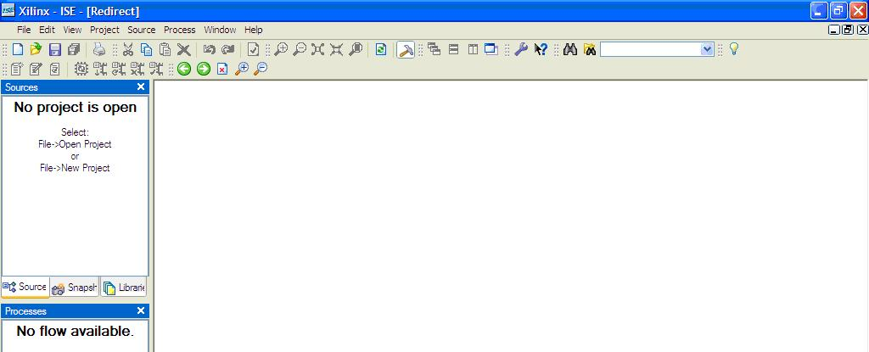
Figure 1: Xilinx Starting Window

2. Create a new project by selecting:  File from the main menu  New Project  - In the New Project window, name your project Full_Adder in the project name text box.  - In the Project Location selection box, enter the folder or directory where your project will be saved. Use your name as for Student_Name and locate the place where you want to save all your files (i.e C:\)  - Under Top-Level Source Type, select Schematic and click Next as shown in figure 1-3 | 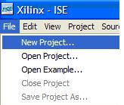  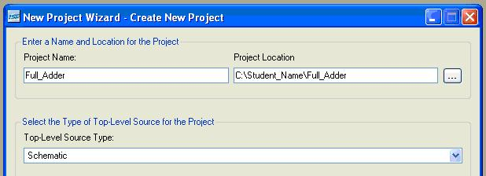
Figure 2: New Project Window

3. We will design our full adder for a particular device “Spartan 3E FPGA”.  Product Category: General Purpose  Device Family: Choose Spartan 3E, the device we will be using.  Device: XC3500E, the specific Spartan 3E device we use. This is actually printed (very small) on the FPGA core.  Package: FG320, this is the package type of our device (Ball Grid Array, 320 pins)  Speed Grade: The speed grade for this device is -4. | 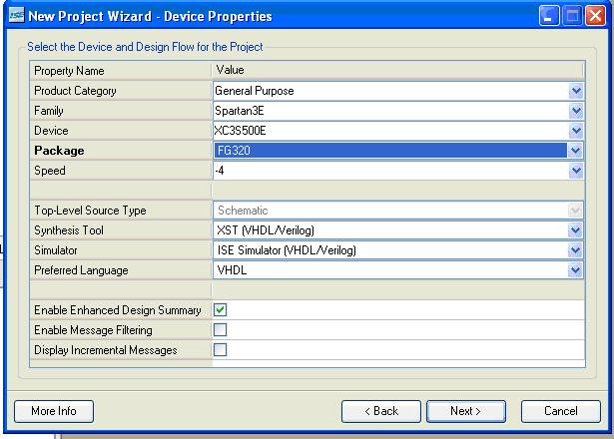
Figure 3: Device Properties

Hit the Next button twice to go the next menu as shown in step 4.
4. Select Add Source and add the attached following existing files: Full_Adder.sch  Full_Adder_Wave.tbw  Full_adder.bit  And Full_adder.ucf  as shown and then click Next. | 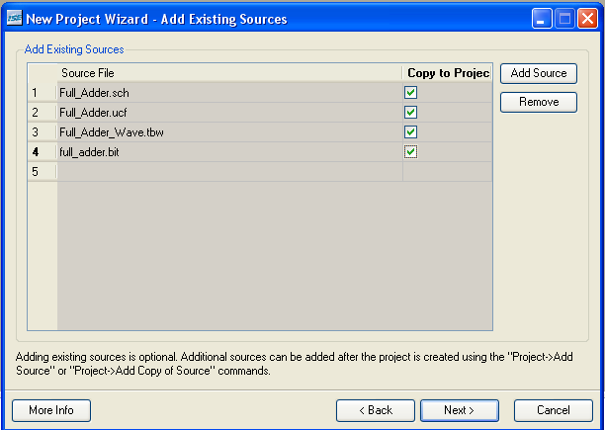
You should get the following green checkmark if you selected the files correctly. | 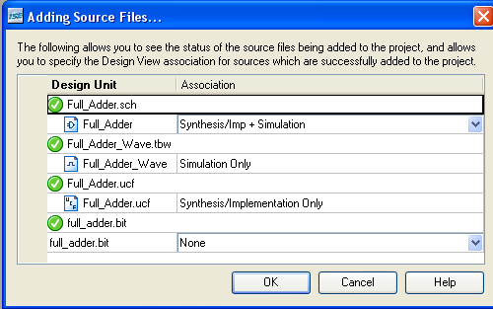
5. Just review the information listed in the figure and make sure it matches the information in the window.  Then click Finish to complete the process and verify the file name and type. Click Next once again to proceed and finish. |  | 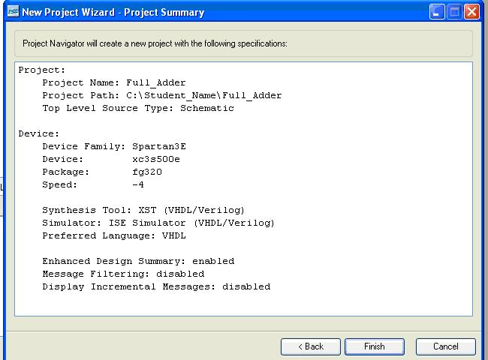
Figure 4: Project Summary

Part 2: Program Full Adder into the FPGA Spartan 3 board
Attach your power and the USB cable to the board. Make sure your USB is connected properly. (See appendix)

- Double click on “Configure Device (iMPACT)” under the implement design on the left hand side. If all goes well, you should get green check marks on “Programming File Generation Report” as shown. | 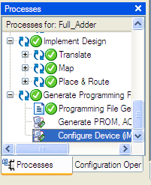
Figure 5: Generate Programming File

3. You should be prompted with the following screen.  As you can see there are two devices listed in the window. One is xc3s500e FPGA and the xcf04s serial flash ROM. We will need to program only the (FPGA xc3s500e). We will do this by selecting full_adder.bit file from the window and click on open. | 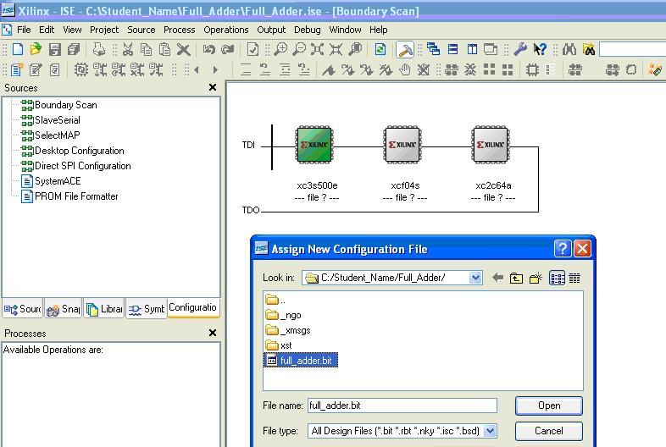
Figure 6: Full_Adder-bit

Go ahead and cancel the second window to program the flash ROM. We will not use the Flash ROM for this lab.
4. Right Click on the left most device and select “Program…”: | 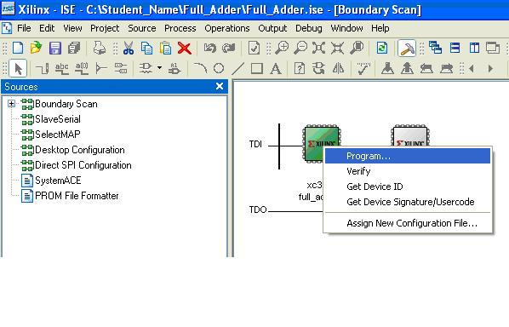
Figure 7: Program the FPGA

The program gets downloaded to the FPGA board. There are a couple of additional choices that are available that are not necessary at this point. Click OK

At this point the FPGA should be programmed and ready for test. Test it by sliding the programmed switches up and down for ON and OFF. See if the appropriate LEDs for the two outputs turn on. Here is a truth table that should guide you with your test.

SW(0) (A)  L13 | SW(1) (B)  L14 | SW(2) (Cin)  H18 | LD0 (SUM)  F12 | LD1 (Cout)  E12
0 | 0 | 0 | OFF | OFF
0 | 0 | 1 | ON | OFF
0 | 1 | 0 | ON | OFF
0 | 1 | 1 | OFF | ON
1 | 0 | 0 | ON | OFF
1 | 0 | 1 | OFF | ON
1 | 1 | 0 | OFF | ON
1 | 1 | 1 | ON | ON
Figure 8: Hardware Truth Table Results

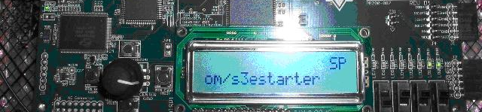
Figure 9: Hardware Display of Full Adder
When all three Switches are ON, both outputs are High (SUM and Cout).

As you can see with this approach, you do not need to replace wires and ICs if you make mistake as you might have done in previous labs with TTL. Instead, you will have to reconfigure the FPGA with the updated design.

This type of technology allows you to concentrate on digital principles and not on the electrical wiring. Larger and more complex projects can be undertaken now that the tedious manual procedures are automated. Task 3 of this lab demonstrates the design of a large design.

Task 2: Implement Full Adder with (VHDL) using Xilinx ISE 9.2i tools for Spartan 3E FPGA board:
VHDL is an acronym inside of an acronym. The ‘V’ stands for Very High Speed Integrated Circuit (VHSIC) and ‘HDL’ stands for Hardware Descriptive Language. VHDL is a powerful language with numerous language constructs that are capable of describing very complex behavior needed for today’s programmable devices.

Part 1:
Close the previous project, and create a new one
Create a new project by selecting:  File from the main menu  New Project  - In the New Project window, name your project Full_Adder_VHDL in the project name text box.  - In the Project Location selection box, enter the folder or directory where your project will be saved. Use your name for Student_Name and locate the place where you want to save all your files (i.e C:\)  - Under Top-Level Source Type, select HDL instead of schematic and click | 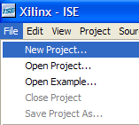  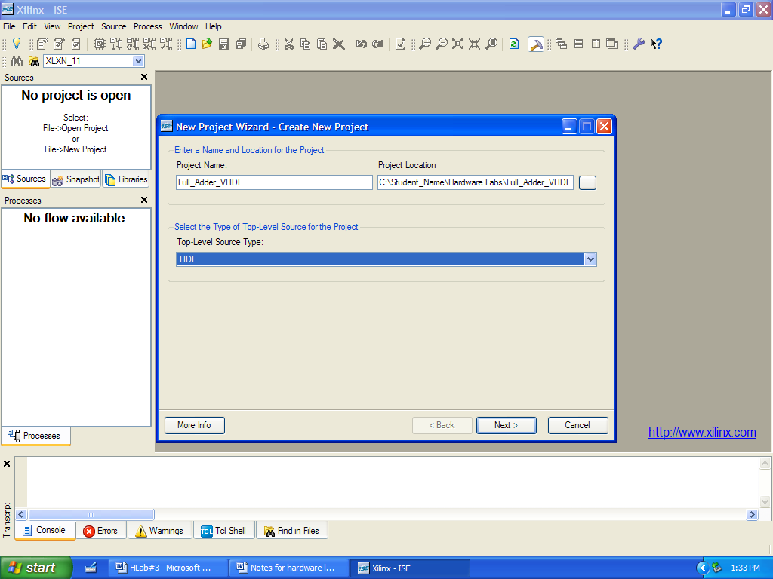
4. Select Add Source and add the attached following existing files: Full_Adder.vhd  Full_adder.bit  And Full_adder.ucf  as shown and then click Next. | 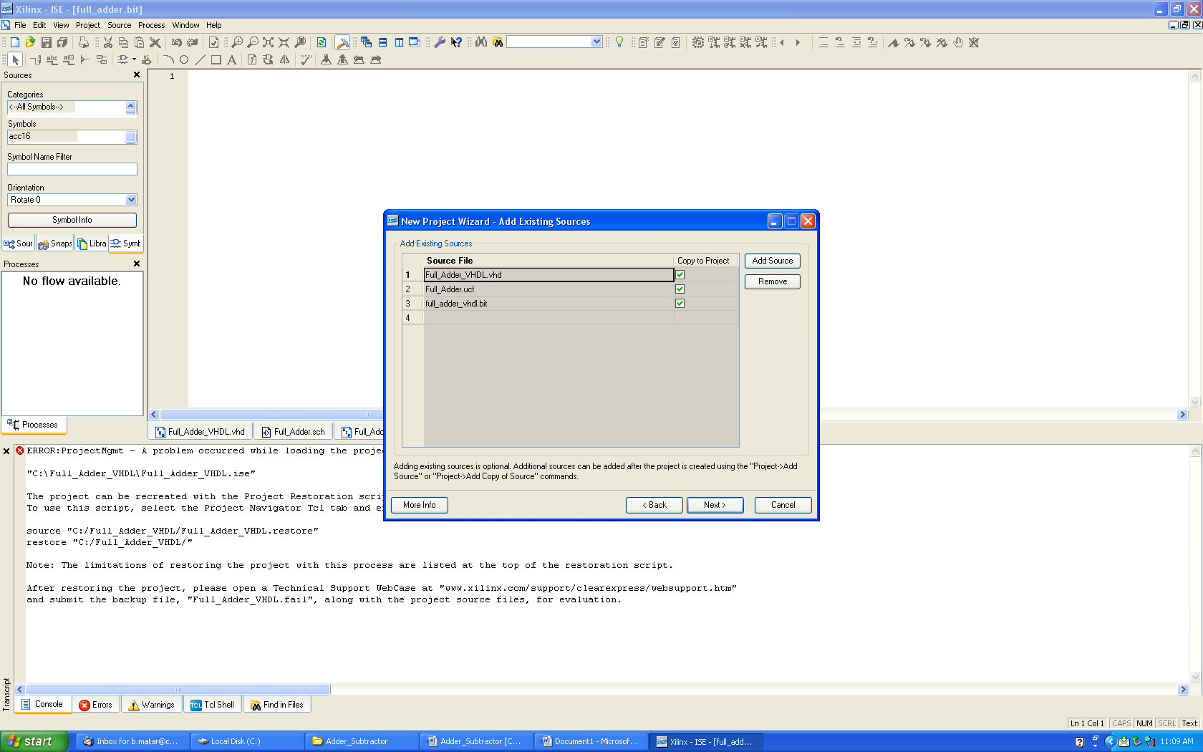
Figure 17: VHDL Module setup

We replaced the full adder schematic with VHDL file. The Full_Adder_VHDL file contains the following two lines of code:

SUM <= A XOR B XOR Cin;
Cout <= ((A XOR B) AND Cin) OR (A AND B);

Demo your working hardware to your instructor and observe the difference between TTL, Xilinx schematic and VHDL implementation.

TASK 3: Test your Knowledge
Implement the following 4-bits adder/subtractor schematic using Xilinx ISE 9.2i tools for Spartan 3E FPGA board.

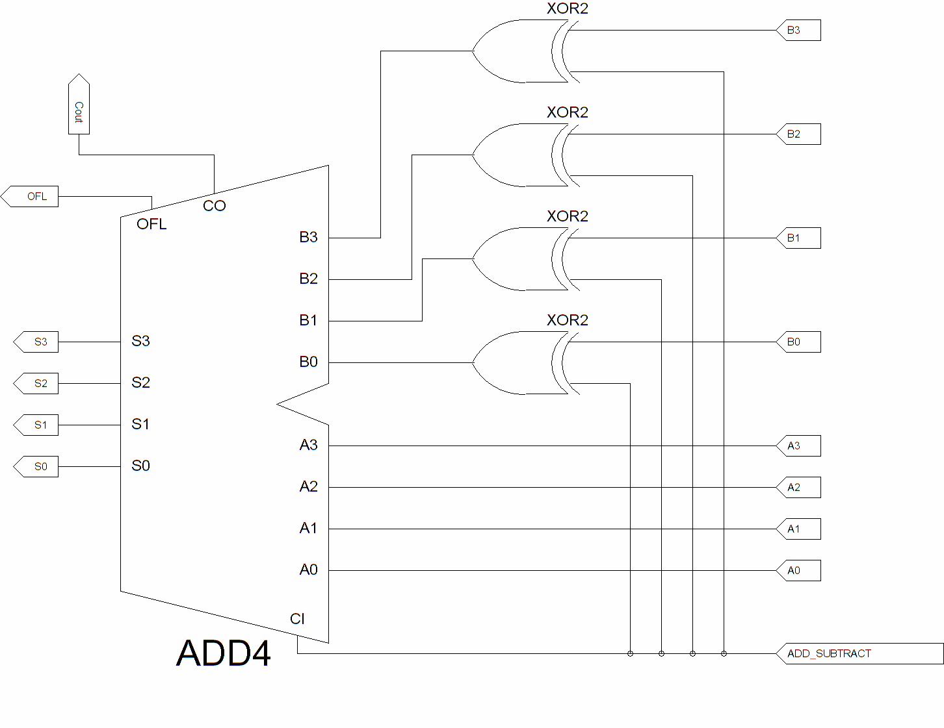
Figure 22: Adder/Subtractor Schematic

            - Select a new project and add the following sources to your project:

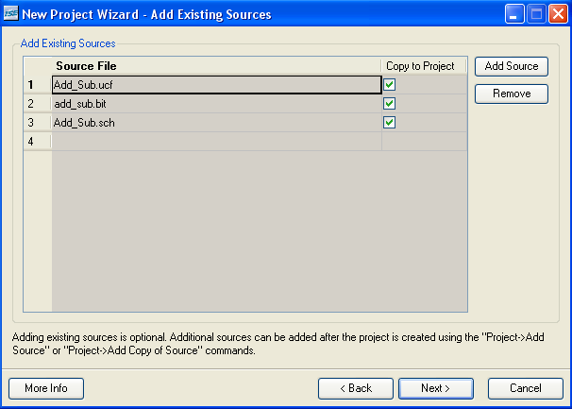

Note: Ask your instructor for the additional set of switches (Switch Module) to meet the need of your inputs.
The Digilent PmodSWT Switch Module Board has four slide switches that can be used to provide “on and off” inputs to a circuit.

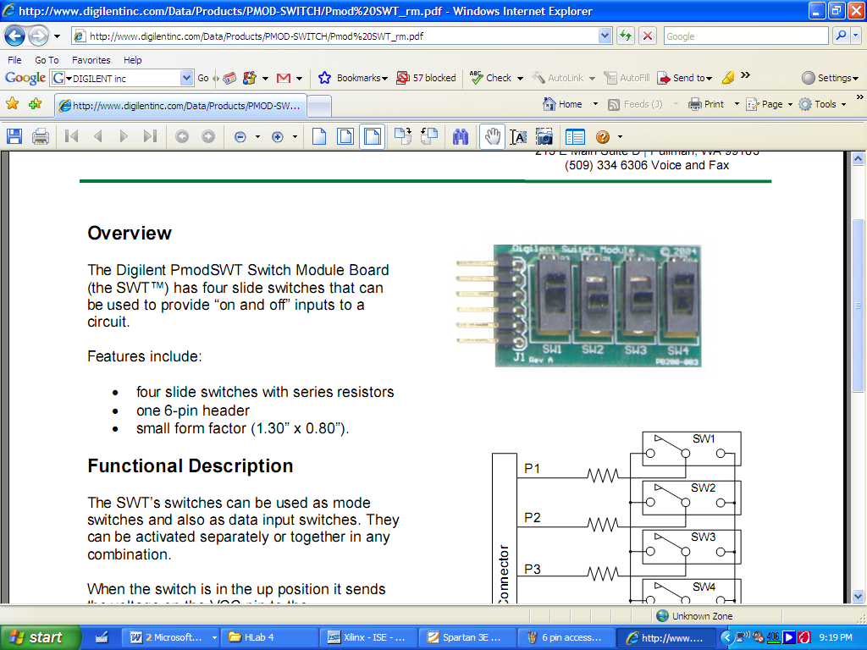

Insert the module here

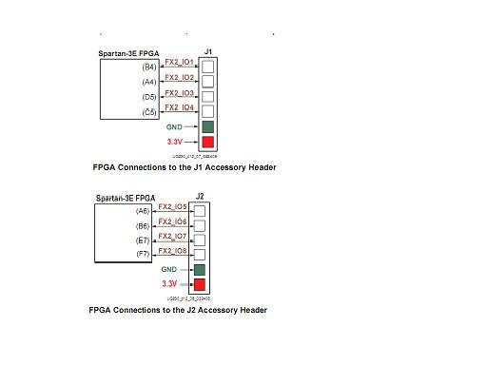
6 pin accessory header
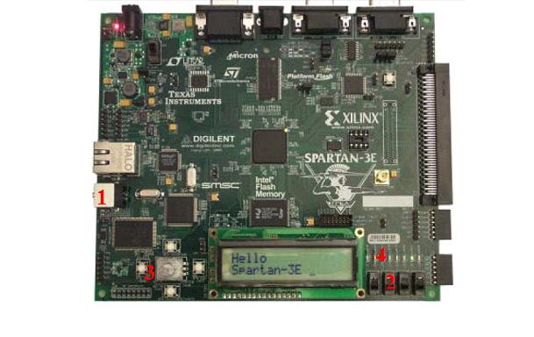

            - Program your circuit in Spartan 3E FPGA.

            - Demo your circuit to your instructor and complete the following truth table by observing the LEDs output.

ADD/SUBTRACT | B3 B2 B1 B0 | A₃ A₂ A₁ A₀ | S₃ S₂ S₁ S₀ | OFL (yes/no) | Cout
1 | 0 1 0 1 | 1 0 0 1
0 | 0 1 0 1 | 1 0 0 1

Assessment & Grading
It is the instructor’s decision as to how students’ learning will be assessed and how this activity is graded. No specific assessment or grading information is included in the student lab guide. You may choose to integrate the sample assessment & grading guide below:

LAB REPORT GRADE SHEET
Operation of Full Adder and Subtractor
Using Xilinx ISE 9.2i Project Navigator and
Spartan 3E FPGA Development Board with Schematic and VHDL

Name_______________________________________

Instructor Assessment
Grading Criteria | Max.  Points | Points
Report Writing | 15
Complete Title Page | 1
Organization, Neatness, Clarity and Concision | 10
Statement of Learning Objectives and Outcomes | 4
Description of Assigned Tasks, Work Performed & Outcome Met | 75
Task 1: Load, debug and demonstrate the operation of Full adder schematic in Xilinx and Spartan 3E FPGA board. Demo your work. | 20
Task 2: Load, debug and demonstrate the operation of Full adder VHDL in Xilinx and Spartan 3E FPGA board. Demo your work. | 20
Task 3: Load, debug and demonstrate the operation of a 4 bits adder/subtractor schematic in Xilinx and Spartan 3E FPGA board. Simulate your circuit and exhaustively test all possible input combinations. Demo your work. | 35
Conclusion Include technical comments and observations which answer the objectives of the lab experiment. | 10
Lab Score | 100

Report Writing Comments:

- Title Page: Include Your name, Course Number, Laboratory Experiment Number and Title, Date Performed, and Date Submitted in all reports.
- Include Truth Tables or Function Tables as required to explain how circuits work and as proof of circuit tests.
- Label all figures or circuits. (e.g. Figure 1. Schematic of….., Figure 2….., etc.)
- Refer to all circuits or figures that you include in the text of your report.

Materials Reproduced from Student Guide
Implement the following 4-bits adder/subtractor schematic using Xilinx ISE 9.2i tools for Spartan 3E FPGA board.

Demo your circuit to your instructor and complete the following truth table by observing the LEDs output.

ADD/  SUBTRACT | B3 B2 B1 B0 | A₃ A₂ A₁ A₀ | S₃ S₂ S₁ S₀ | OFL (yes/no) | Cout
1 | 0 1 0 1 | 1 0 0 1
0 | 0 1 0 1 | 1 0 0 1

Answer Key

Full adder
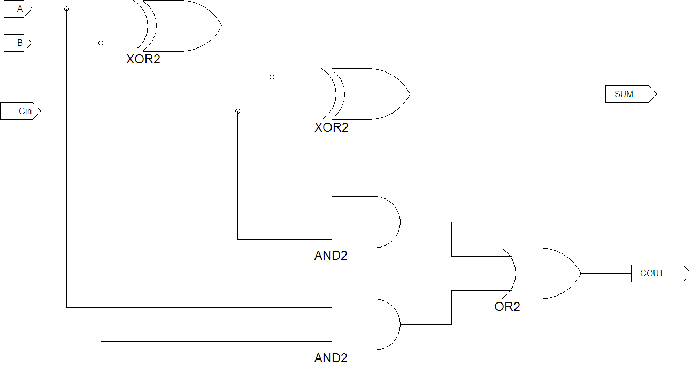

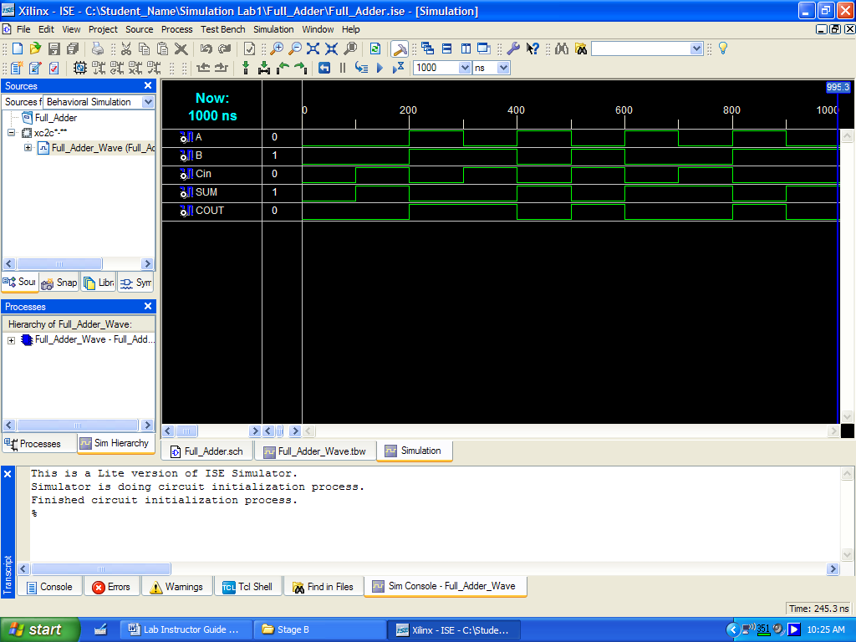

User Constraint File “UCF” file for Full adder I/O
We need to add the appropriate Spartan 3E FPGA pins to the I/O makers of our design. Let us choose the switches instead of pushbutton for now. We will assign the pins as follows:

NET "A" LOC = "L13"; # Switch 0 (SW0)
NET "B" LOC = "L14"; # Switch 1 (SW1)
NET "Cin" LOC = "H18"; # Switch 2 (SW2)

# Outputs
NET "SUM" LOC = "F12"; # LED 0 for SUM
NET "COUT" LOC = "E12"; # LED 1 for Cout

ADDER/SUBTRACTOR
Here is the User Constraint File “ucf” that maps the input (A3..0, B3..0 and ADD/SUB) and output signals (S3..0, Cout and OFL) to the Spartan 3E FPGA.

# Inputs: USING TWO Switch Modules
# ==== A's 4 inputs ====
NET "A0" LOC = "B4";
NET "A1" LOC = "A4";
NET "A2" LOC = "D5";
NET "A3" LOC = "C5";

# ==== B's 4 inputs ====
NET "B0" LOC = "A6";
NET "B1" LOC = "B6" ;
NET "B2" LOC = "E7";
NET "B3" LOC = "F7";

# Using the standard input switches on Spartan 3E
NET "ADD_SUBTRACT" LOC = "L13"; # ADD/SUBTRACT SWITCH

# Outputs:
NET "S0" LOC = "F11"; # LD 3 for SUM0
NET "S1" LOC = "E11"; # LD 2 for SUM1
NET "S2" LOC = "E12"; # LD 1 for SUM2
NET "S3" LOC = "F12"; # LD 0 for SUM3

NET "Cout" LOC = "C11"; # LD 4 for CARRY OUT
NET "OFL" LOC = "D11"; # LD 5 for OVERFLOW

Here is the timing diagram.

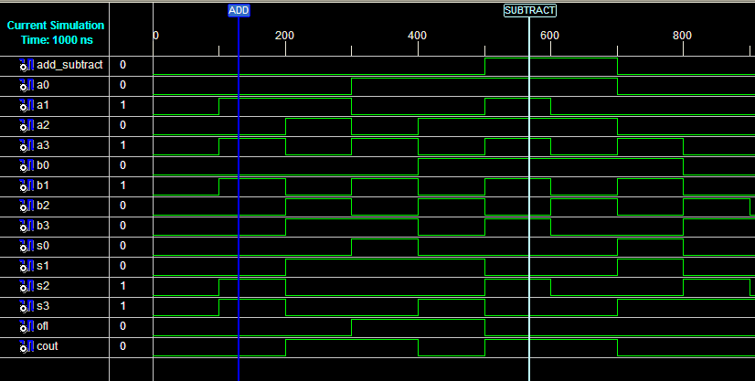
Adder/Subtractor Sample Timing Diagram

Appendix

Getting to know FPGA Spartan-3E starter board
The Spartan-3E Starter Kit board is more advanced and complex compared to other Spartan development boards. The advantage of this board is that it is programmed through USB port. JTAG port is used to program previous versions. A list of the key features and their location on the board is listed below:
On-Board 50 MHz Oscillator
CLK_50MHz: (C9)
PS/2 mouse/keyboard port
Two RS-232 serial ports
Power In
VGA Display Port

Expansion connectors
USB Connector

Power On indicator LED
Power Switch
6-pin DAC Header (J5)
DONE Pin LED. Lights up when FPGA successfully configured
RJ-45 Ethernet Connector (J19)
6 pin accessory header
Figure 1: FPGA Spartan 3E Board

8 LEDs [ld(7:0)]
Push-Button Switches

4 Toggle Switches [sw(3:0)]

Item 1: USB Connector  The board comes with power supply and USB cable. The standard USB Type A/Type B cable, similar to the one shown in Figure 1-2. The actual cable color might vary from the picture.  The wider and narrower Type A connector fits the USB connector at the back of the computer. After installing the Xilinx software, connect the square Type B connector to the Spartan-3E Starter Kit board, as shown. The USB connector is on the left side of the board, immediately next to the Ethernet connector. When the board is powered on, the Windows operating system should recognize and install the associated driver software. | 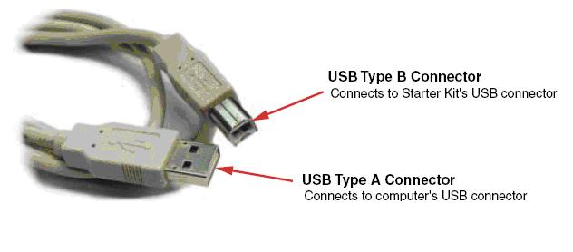  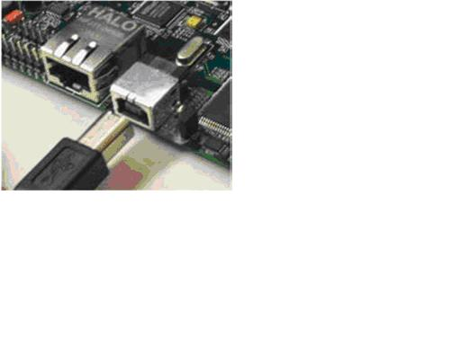
Figure 2: USB Connection

When the USB cable driver is successfully installed and the board is correctly connected to the PC, a green LED lights up, indicating a good connection.
Item 2 Slide Switches  Locations and Labels  The Spartan-3E Starter Kit board has four slide switches, as shown in Figure 1-3. The slide switches are located in the lower right corner of the board and are labeled SW3 through SW0. Switch SW3 is the left-most switch, and SW0 is the right-most switch.  Operation  When in the UP or ON position, a switch connects the FPGA pin to 3.3V, a logic High. When DOWN or in the OFF position, the switch connects the FPGA pin to ground, a logic Low. | 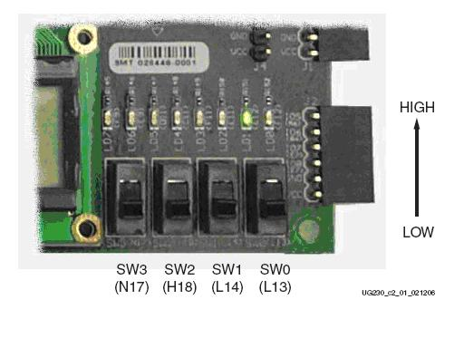
Figure 3: Input Switches

UCF Location Constraints
The UCF constraints for the four slide switches are listed below, including the I/O pin assignment and the I/O standard used. The PULLUP resistor is not required, but it defines the input value when the switch is in the middle of a transition. Verify the location of the switches on the board.

NET "SW<0>" LOC = "L13"
NET "SW<1>" LOC = "L14"
NET "SW<2>" LOC = "H18"
NET "SW<3>" LOC = "N17"

Item 3 Push-Button Switches  Locations and Labels  The Spartan-3E Starter Kit board has four momentary-contact push-button switches, as shown. The push buttons are located in the lower left corner of the board and are labeled BTN_NORTH, BTN_EAST, BTN_SOUTH, and BTN_WEST. The FPGA pins that connect to the push buttons appear in parentheses. | 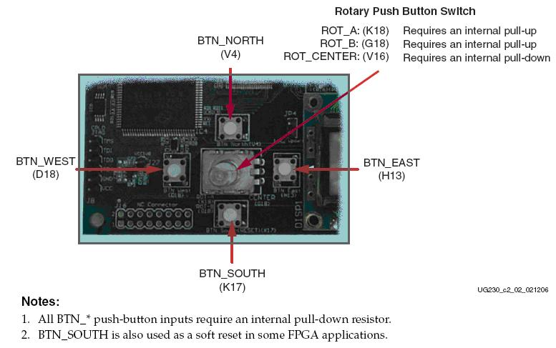
Operation  Pressing a push button connects the associated FPGA pin to 3.3V, as shown. Use an internal pull-down resistor within the FPGA pin to generate a logic Low when the button is not pressed. There is no active debouncing circuitry on the push button. | 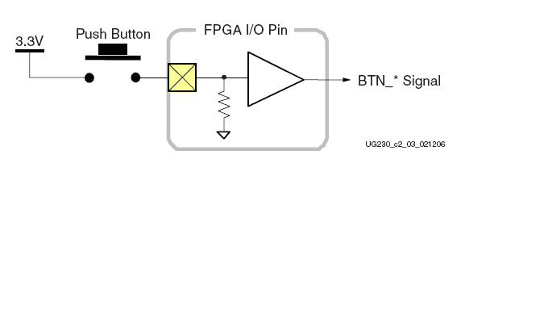
Figure 4: Push Button Switches

UCF Location Constraints
These are the UCF constraints for the four push-button switches, including the I/O pin assignment and the I/O standard used, and defines a pull-down resistor on each input.

NET "BTN_EAST" LOC = "H13"
NET "BTN_NORTH" LOC = "V4"
NET "BTN_SOUTH" LOC = "K17"
NET "BTN_WEST" LOC = "D18"

Item 3 Rotary Push-Button Switch  Locations and Labels  The rotary push-button switch is located in the center of the four individual push-button switches, as shown. The switch produces three outputs. The two shaft encoder outputs are ROT_A and ROT_B. The center push-button switch is ROT_CENTER. | 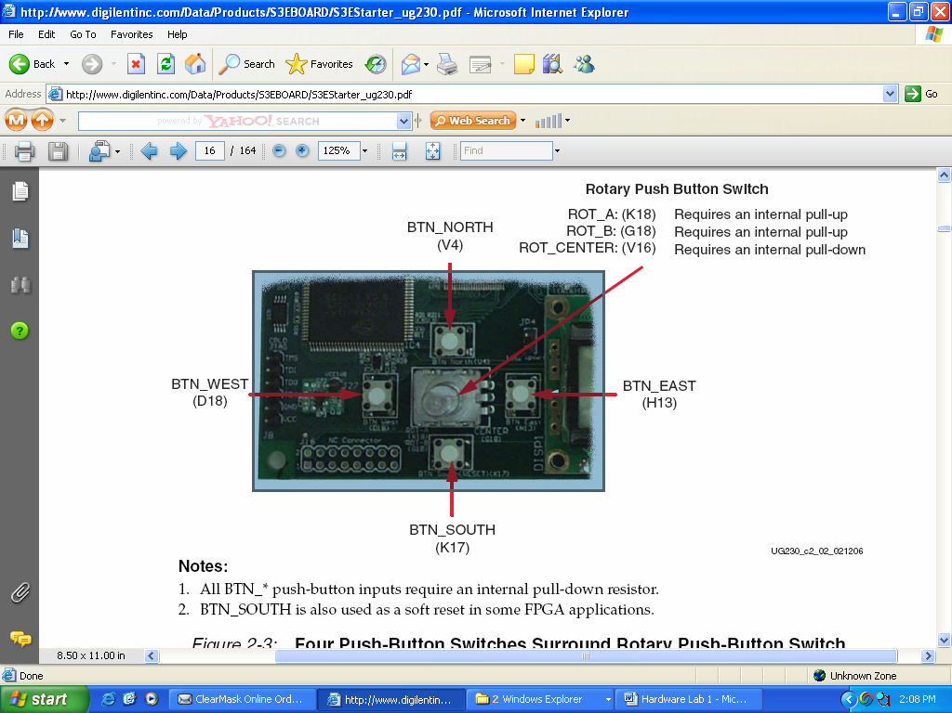
Operation  The rotary push-button switch integrates two different functions. The switch shaft rotates and outputs values whenever the shaft turns. The shaft can also be pressed, acting as a push-button switch.  Push-Button Switch Pressing the knob on the rotary/push-button switch connects the associated FPGA pin to 3.3V, as shown. | 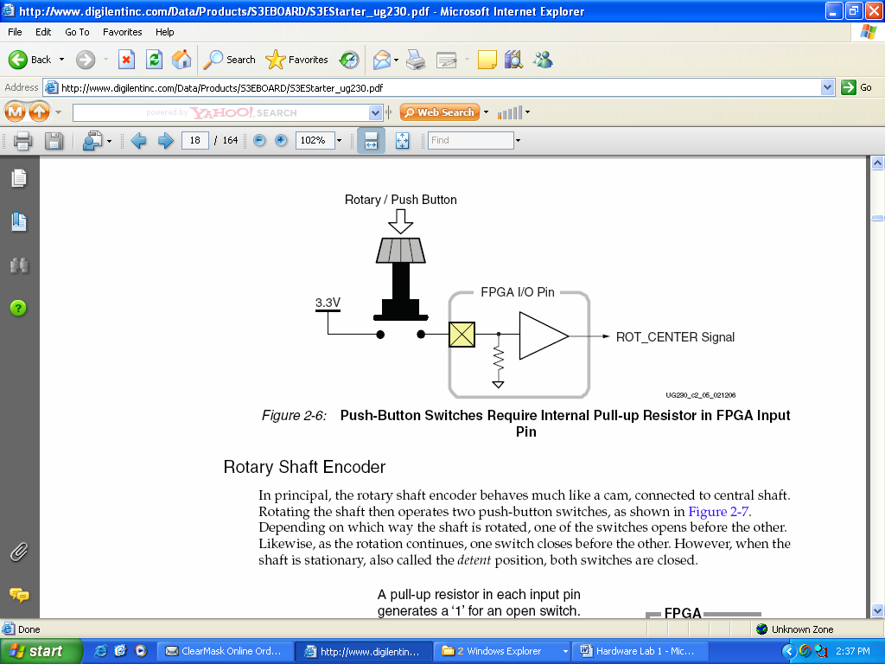
Figure 5: Rotary Push Button Switch

UCF Location Constraints
The UCF constraints for the four push-button switches, including the I/O pin assignment and the I/O standard used, and defines a pull-down resistor on each input.

NET "ROT_A" LOC = "K18"
NET "ROT_B" LOC = "G18"
NET "ROT_CENTER" LOC = "V16"

Item 3 Discrete LEDs  Locations and Labels  The Spartan-3E Starter Kit board has eight individual surface-mount LEDs located above the slide switches as shown. The LEDs are labeled LED7 through LED0.  LED7 is the left-most LED, LED0 the right-most LED.  Operation  Each LED has one side connected to ground and the other side connected to a pin on the Spartan-3E device via a 390Ω current limiting resistor. To light an individual LED, drive the associated FPGA control signal High. | 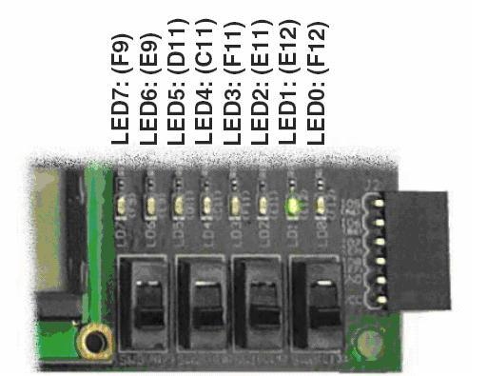
Figure 6: Output LEDs

UCF Location Constraints
The UCF constraints for the four push-button switches, including the I/O pin assignment, the I/O standard used, the output slew rate, and the output drive current.

NET "LED<7>" LOC = "F9"
NET "LED<6>" LOC = "E9"
NET "LED<5>" LOC = "D11"
NET "LED<4>" LOC = "C11"
NET "LED<3>" LOC = "F11"
NET "LED<2>" LOC = "E11"
NET "LED<1>" LOC = "E12"
NET "LED<0>" LOC = "F12"

Please refer the reference manual for any additional information:
http://www.digilentinc.com/Products/Detail.cfm?Prod=S3EBOARD&Nav1=Products&Nav2=Programmable

