Wire and Cable Characteristics

DC/AC Circuits

Student Name: ___________________________________________________

Acknowledgements
Subject Matter Expert: Wayne Phillips, Professor, Chabot College, CA

Purpose
The purpose of this lab is to collect data on measurements, observe skin effect in wires and propagation delay in a cable, and summarize your findings.

Systems Rationale
Wires and cables (two or more wires bundled together) are often neglected when evaluating electronic systems. A technician may assume that whatever signal is applied at one end of a wire will appear unaltered at the other end. Many times this is not true.

System Concepts
This system covers the following system concepts (signified by an X):
_ _ S1. A system can be defined in terms of its functional blocks i.e., a “structured functional unit.”
_ _ S2. A system has a purpose, transforms inputs into outputs to achieve a goal.
_X_ S3. A system is defined by the flow of materials, energy and information, between its functional units.
_ _ S4. A system may be open or closed. In an open system additional inputs are accepted from the environment.
_ _ S5. A system is more than the sum of its parts. Individual components can never constitute a system.
_ _ S6. A system provides feedback to the operator and services to the user. Some system functions may involve operator action.
_X_ S7. Systems have unique problems.

Student Learning Outcomes
Appropriate SLOs for the lab activity are below. For a complete list of course SLOs visit: http://www.esyst.org/Courses/DC-AC/_delivery/index.php

DC Circuits or Circuit Analysis I
- Define conductor, insulator and semiconductor materials.
- Apply Ohm’s and Kirchhoff’s laws to solve series, parallel, and series-parallel circuit problems as well as loaded and unloaded voltage divider problems.

AC Circuits or Circuit Analysis II
- Define and identify a sine wave and determine frequency, period, peak, peak-to-peak (pp) and root mean square (rms) values of a sine wave.
- Measure AC voltage, current, impedance, frequency, period, duty cycle, rise/fall time, pulse width and phase angle with an oscilloscope and function generator.
- Name the most common types of wire and cable, state where each is used, and make basic wire/cable tests and measurements.

Prerequisite Knowledge & Skills
- Describe the basic operation of the function generator, including setting frequency, waveform, and amplitude.
- Given a digital oscilloscope, trigger and measure voltage and time of waveforms.
- Given the voltage divider formula, calculate series voltage drops.
- Calculate attenuation (logarithms).
- Given spreadsheet software, enter data and create charts.
- Given presentation software, create a presentation.

Learning Objectives
Relevant knowledge (K) or skill (S) student learning outcomes include:

K1. Identify situations where wire and cable can have a significant effect on the operation of an electronic system.
S1. Use an oscilloscope, to measure and record voltage, phase, and waveform, readings.
S2. Compare measured data with the preparatory calculations and describe how the data show the effects of resistance and inductance in wires, as well as propagation time and impedance in cables.
S3. Prepare a presentation with a table and chart to show resistive and skin effects in multiple wires and a summary of the effects of frequency and termination impedance on signals transmitted through cables.

Process Overview
In the first half of the lab, wire skin effect, you will:
- Calculate the DC resistance of wires of multiple gauges.
- Calculate the resulting voltage drop.
- Predict the expected frequency that skin effect will be visible.
- Measure voltage drops across several gauges of wire.
- Record your data in a spreadsheet.
- Create a chart to document your results.
The second half of the lab, cable transmission lines, you will:
- Observe the effect of cable impedance on high-frequency signals.
- Measure the effects of termination resistance and standing waves on signal transmissions through a typical communications cable.
This lab is best accomplished in teams of two persons, alternating between taking measurements of the circuits with entering and charting the data in an Excel spreadsheet.

Time Needed
Lab Performance:
It should take you approximately 3 hours to work through the entire lab. Additional time may be required if you are not familiar with the required functions of the test equipment or Excel.

Lab Deliverables:
It should take you approximately 2 hours of homework time to create the Excel tables and charts, conduct the analysis, and write a lab report.

Equipment & Supplies
Item | Quantity
Digital oscilloscope – Tek 2014, TDS2004B, or equivalent | 1
Function generator – Tek AFG 310, Wavetek 271, or similar capable of sine and square wave output to 10 MHz, 10 Vpp, 50 Ω output. | 1
BNC-to-Clip test cable | 1
10x Scope probes | 3
100 feet Cat 5e cable | 3
51 Ω, 0.25 watt resistor | 1
100 Ω, 0.25 watt resistor | 1
2-foot lengths of each of the following solid wire gauges: 12, 20, 22 AWG (optional: 28 or 30 AWG wire-wrap wire) | 1 of each
Computer with spreadsheet software | 1

Special Safety Requirements
Remember to keep the 100-foot cable away from anywhere that may become a tripping hazard.

Lab Preparation
- Gather the equipment and supplies mentioned above.
- Locate an American wire gauge table that lists the milliohms per foot resistance and diameter for solid conductors. An easy place to find such a table is at Wikipedia (http://en.wikipedia.org/wiki/American_wire_gage).
- For each of the 2-foot lengths of wire, calculate the resistance in milliohms (thousandths of an ohm) and calculate the frequency where skin effect will add approximately 10% to the total impedance using the following formula (derived from Terman, F. E. Radio Engineers' Handbook. New York: McGraw-Hill, 1943) $\text{freq}={\left(\frac{\text{200}\text{mm}}{\text{Dw}}\right)}^{2}$, where Dw is the wire diameter, in millimeters.
- Refer to the test circuit schematic in figure 1, shown below.
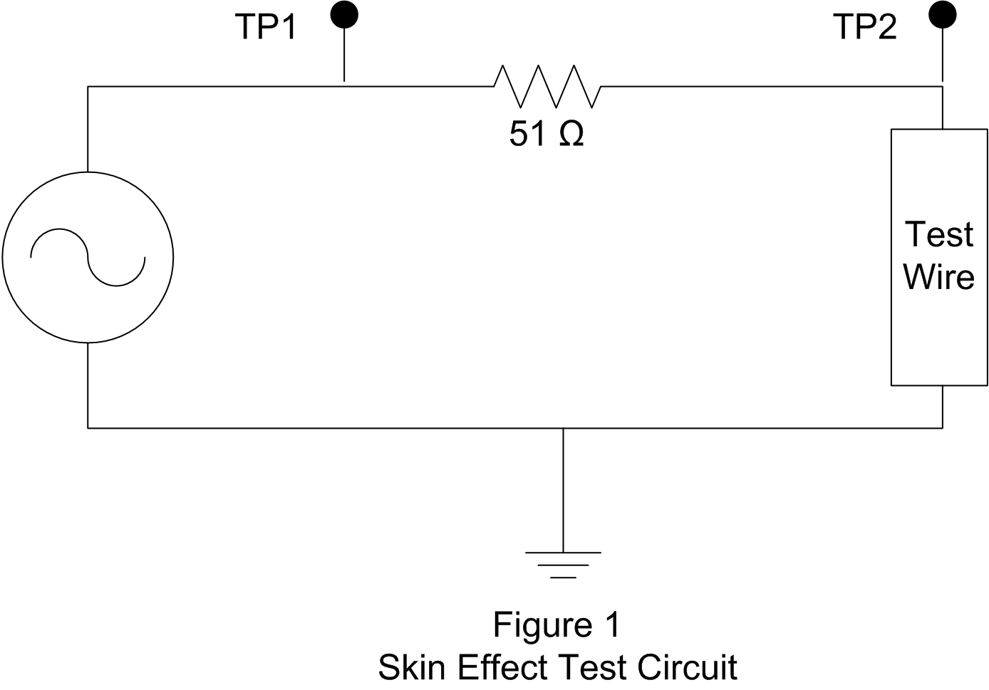
Using the voltage divider formula, calculate the expected voltage drop across the wire under test (TP2 to ground) when a low-frequency 10 V_{PP} sine wave is applied, as measured at TP1.
Wire Gauge | Resistance | Skin Effect Freq. | Resistive V drop

Introduction
When we first learned about electric circuits, we learned that the solid lines on the schematic diagram represented wires, all points connected by a wire were always at the same voltage potential, and current flowing through a wire did not produce a voltage drop because wires had zero resistance. While this may be close enough to the truth for short wires and low frequency AC and DC circuits, the high-speed circuitry in today’s electronics requires greater recognition of the effects wire and cable can have in a circuit.

Task
When taking measurements in large systems, with long cables, or circuits with high-speed electronics, the interconnections can have a significant effect on the circuit operation. This exercise will demonstrate the effects wire and cable (two or more wires bundled together) can have in a circuit.

Performance Part 1, Skin Effect
- Connect the skin effect test circuit, shown in figure 1 below. Start with the 22 AWG 2-foot wire. Ensure that the ground connections for the function generator and scope probes are as close as practical.
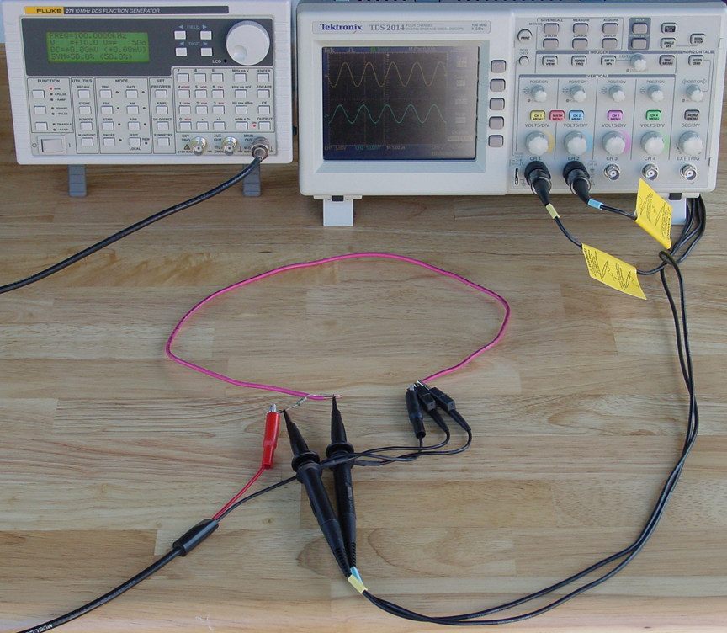
- Set the function generator to apply a 1 kHz, 10 V_{PP} sinewave as measured at TP1. Measure the voltage at TP2. Compare with your calculated value from step 4 of the lab preparation. What happened and why?
________________________________________________________________
________________________________________________________________
- In order to measure small voltages and minimize the background noise, change the acquisition mode of the digital o-scope to sample mode, and select the maximum number of samples. Set the trigger mode to trigger on the input voltage at TP1. You should be able to see voltages down to a few millivolts. Why is it necessary to trigger the scope on TP1?
________________________________________________________________
________________________________________________________________
- Measure the p-p voltage at TP2. Compare the phase of the waveforms at TP1 and TP2 by measuring time delta, ∆, (difference) between the rising zero-crossing points on each waveform. For the low-amplitude voltages at TP2 you may note “in phase,” “leading,” or “lagging” instead of a specific number of degrees of phase shift. When voltages at TP2 are at least 4 divisions vertically, measure the time delta between waveforms and calculate phase with one of the following formulas:
phase=0.360• ∆(µs)•freq(kHz)
Enter your measurements into the provided Excel spreadsheet template, or prepare your own spreadsheet.
- Repeat step (4) at frequencies of 2 kHz, 5 kHz, 10 kHz, 20 kHz, 50 kHz, 100 kHz, 200 kHz, 500 kHz, and 1 MHz. Adjust the output level of the function generator as needed to maintain the 10 V_{PP} at TP1.
- Repeat steps 2 through 5 for each of the other 2-foot test wires.
- After entering the data, examine the two charts in the Excel template. Or, if using your own spreadsheet, create an X-Y scatter plot of the frequencies and voltages. Choose the smoothed curve plot with individual data points. Select logarithmic scales for both axes. How does the log-log scale change the presentation of the data compared with the linear scale?
________________________________________________________________
________________________________________________________________
- How does your lab experiment data compare to your calculated values?
________________________________________________________________
________________________________________________________________
- If one of your test wires was a 28- or 30-gauge wire-wrap wire, what was different about this wire compared with the others, and why?
________________________________________________________________
________________________________________________________________
- What does the phase data tell you about skin effect?
________________________________________________________________________________________________________________________________________________
- Performance – Part 2, Transmission Line Pulse Reflection
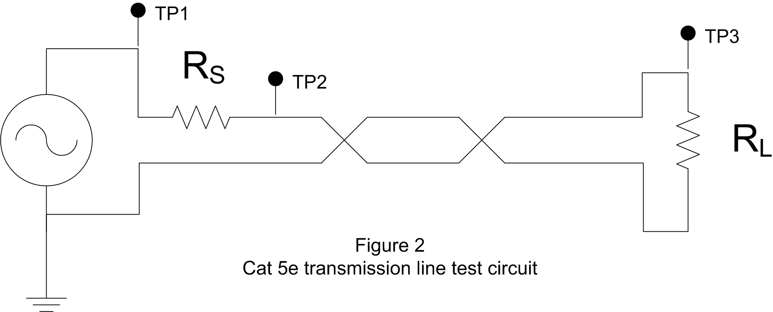
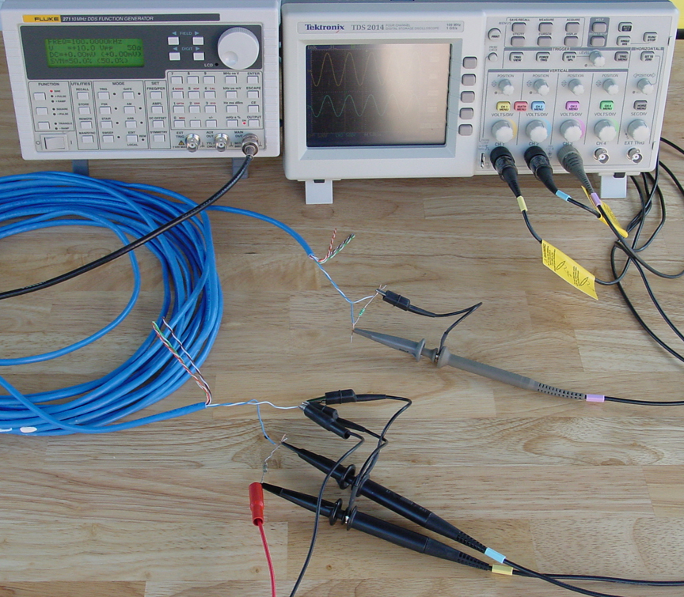
Pulse Reflection
- Connect the circuit in figure 2, shown above. Use any one of the four twisted pairs, such as the blue and blue/white wires. Set the function generator for a 10 Vp-p, 250 kHz square wave output. Verify the generator output impedance is set to 50Ω. With the 100 Ω termination load R_{L} and the 51Ω series source resistor R_{S}, what are the p-p voltages at TP1, TP2, and TP3?
TP1 = ______________
TP2 = ______________
TP3 = ______________
What is the shape of the waveform? Is there any severe distortion at the rising and falling edges?
______________________________________________________________
- Remove the 100Ω termination load and leave an open circuit at the end of the transmission line (but leave the scope probe connected). What are the p-p voltages at TP1, TP2, and TP3?
TP1 = ______________
TP2 = ______________
TP3 = ______________
What is the shape of the waveform? Is there any severe distortion at the rising and falling edges? Sketch the waveform. Can you determine the time needed to “charge the line?” (You will need the charge time value for step 4.)
_______________________________________________________________
- Short the end of the transmission line. Sketch the waveform in the space below.
Did this effect the “charge time?”
________________________________________________________________
- Calculate the time needed for a pulse to travel 100 feet (30.5 m) at the speed of light (c = 3x10⁸ m/s). Calculate v_{p} = (30.5m x 2) / (charge time) Calculate the velocity factor for the CAT5e cable (it should be around 0.75).
v_{p} = ______________
VF = ______________ (v_{p}/c)
- Bonus question: Measure the capacitance of the 100 ft transmission line, then use the formula
v_{p}=(LC)^{-1/2} to find the inductance.
L = ______________
Sinewave Transmission
- Connect the 100Ω termination load. Set the function generator for a 10 Vp-p, 250 kHz sinewave. Measure the voltages at TP2 and TP3 and calculate the attenuation for the 100 ft line.
Att (dB) = 20 log (V_{TP3}/V_{TP2}). Also measure the attenuation at 1 MHz and 10 MHz.
Att (250 kHz)__________________________
Att (1 MHz)___________________________
Att (10 MHz)__________________________
- Set the function generator to 500 kHz. Remove the termination resistor. Slowly increase the frequency and observe the peaks and dips in amplitude at TP2 until you reach 10 MHz. At each peak and dip, record the voltage at TP2, TP3, and the phase angle between TP2 and TP3.
V_{TP2}=___________ V_{TP3}=____________
frequency=__________ phase =__________ peak or dip=__________
V_{TP2}=___________ V_{TP3}=____________
frequency=__________ phase =__________ peak or dip=__________
V_{TP2}=___________ V_{TP3}=____________
frequency=__________ phase =__________ peak or dip=__________
V_{TP2}=___________ V_{TP3}=____________
frequency=__________ phase =__________ peak or dip=__________
V_{TP2}=___________ V_{TP3}=____________
frequency=__________ phase =__________ peak or dip=__________
V_{TP2}=___________ V_{TP3}=____________
frequency=__________ phase =__________ peak or dip=__________
- Now short the end of the transmission line. Repeat the sweep of frequency from 500 kHz to 10 MHz and note the peaks and dips at TP2.
V_{TP2}=___________ frequency=__________ peak or dip=__________
V_{TP2}=___________ frequency=__________ peak or dip=__________
V_{TP2}=___________ frequency=__________ peak or dip=__________
V_{TP2}=___________ frequency=__________ peak or dip=__________
V_{TP2}=___________ frequency=__________ peak or dip=__________
V_{TP2}=___________ frequency=__________ peak or dip=__________
- How do the peaks and dips compare with step 2?
________________________________________________________________
________________________________________________________________
- How do the peaks and dips relate to the frequency (or quarter wavelength)?
________________________________________________________________
________________________________________________________________
- What guidelines can you give for recognizing the effects that wire may have in a circuit? (When does gauge, frequency, cable length become significant?)
________________________________________________________________
________________________________________________________________________________________________________________________________
________________________________________________________________
- Make sure to put everything you used back, in the same condition and location where you found it.

Deliverable(s)
Use the provided Excel template or format and label your own Excel tables and chart so that you are clearly presenting your information (neat layout, titles and labels on tables and charts). Attach your tables and chart to your lab sheet.

Model Deliverable Example(s)
The spreadsheet and this lab sheet show all of the data and conclusions that should be provided to receive maximum credit for this exercise.

Grading
Your instructor will let you know how this lab will be graded.

