R2R Ladder Network

DC/AC

Student Name: ___________________________________________________

Acknowledgements
Subject Matter Expert: Jesus Casas, BSEE, Professor. Austin Community College, Austin, Texas

Purpose
R2R Ladder Networks provide a simple and inexpensive method of converting digital information to an analog signal.

Systems Rationale
The R2R ladder circuit is a very common piece of almost all Digital-to-Analog converters. By understanding how the R2R ladder system works, a better understanding of Digital-to-Analog converters can be had.

System Concepts
This system covers the following system concepts (signified by an X):
__ S1. A system can be defined in terms of its functional blocks i.e., a “structured functional unit.”
X_ S2. A system has a purpose, transforms inputs into outputs to achieve a goal.
X S3. A system is defined by the flow of materials, energy and information, between its functional units.
_ _ S4. A system may be open or closed. In an open system additional inputs are accepted from the environment.
X_ S5. A system is more than the sum of its parts. Individual components can never constitute a system.
__ S6. A system provides feedback to the operator and services to the user. Some system functions may involve operator action.
_ _ S7. Systems have unique problems.

Student Learning Outcomes
For a full course SLOs, click the link and click SLO tab.
http://www.esyst.org/Courses/DC-AC/_delivery/index.php
- Define basic electrical quantities and terms including current, voltage, power, resistance, and efficiency.
- Apply Ohm’s and Kirchhoff’s laws to solve series, parallel, and series-parallel circuit problems as well as loaded and unloaded voltage divider problems.
- Make common circuit measurements such as voltage, current and resistance with a multimeter.

Prerequisite Knowledge and Skills
The student should have an understanding of Ohm’s Law and Thevenin’s resistance and voltage.
Relevant knowledge (K), skill (S), or attitude (A) student learning outcomes include:

K1. Identify and measure a resistor.
K2. To measure current and voltage.
K3. Calculate overall resistance of series, parallel, and series-parallel circuits.
S1. Be able to identify an R2R ladder network.
A1. Be able to systematically approach a circuit to understand its functionality.

Learning Objectives
The objective for this lab is for the student to develop an understanding of R2R Ladder Networks.

Process Overview
The student will first perform a circuit analysis of an R2R ladder circuit, then will assemble the circuit and perform measurements on the circuit.

Performance Overview
This lab may be performed by a single student or by two students working as a team. Upon completion, the lab results should be turned in to the instructor for review.

Length
The time required to complete this lab is approximately one hour.

Equipment and Supplies
- Quantity 1 - breadboard

- Quantity 1 - Variable Power Supply

- Quantity 1 - Multimeter

- Quantity 16 – 1 kOhm Resistor

Lab Preparation
The student should review Thevenin analysis of a circuit.

Introduction
The R/2R ladder network provides an easy method of converting a digital output of “n” bits to an analog voltage. This lab explores how an arrangement of resistors is able to provide this conversion. The R2R ladder has “n” number of inputs directly corresponding to the “n” number of bits of the digital data. Each input of the R2R ladder, however, carries a different weight. In other words, each asserted input of the R2R ladder varies the output voltage by a specific amount. The output voltage of the R2R ladder is the sum of the individual weights (in voltage) of the asserted inputs.
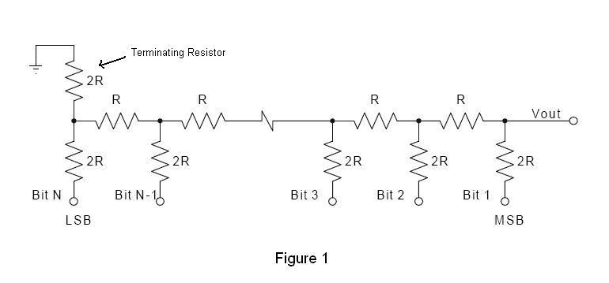

Looking at Figure 1, the terminating resistor, which is grounded, assures that the Thevenin resistance of the network, as measured to ground looking into the circuit from Vout, is always R. This is always the case regardless of the number of bits in the ladder. Figure 2 illustrates the Thevenin resistance of the R2R ladder. Recall that when performing a Thevenin equivalent resistance analysis of a circuit, voltage sources are shorted; therefore the inputs of R2R ladder circuit are shorted to ground.

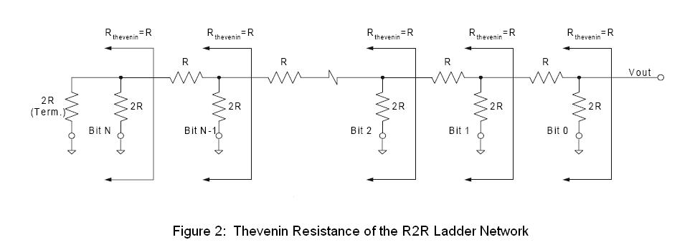

When the R2R Ladder Network is used as a Digital-to-Analog Converter, digital data is inputted to the ladder as individual bits, which are switched between a reference voltage (Vr) and ground.

In this lab, the inputs will be switch between a Vr of +5 Volts and ground. When an input is connected to Vr, it will present a specific voltage worth at Vout; when the input is grounded, it will not contribute any voltage to Vout. Remember, Vout if the sum of the individual voltage worth’s of the inputs connected to Vr.

If all inputs are grounded, 0 Volts is seen at Vout; if all inputs are connected to Vr, Vout approaches Vr. If some of the inputs are connected to Vr and some are grounded, then Vout will be somewhere between 0 Volts and Vr. The following table gives the output voltage worth associated with each input when connected to Vr.

Table 1
Input (Bit) # | Vout
1 (MSB) | Vr/2
2 | Vr/4
3 | Vr/8
4 | Vr/16
5 | Vr/32
6 | Vr/64
7 | Vr/128
N (LSB) | Vr/2^{N}

As seen in the table, Input #1 carries the most weight, with each subsequent input having a weight that is half of the previous one.

Task
The student will interpret schematics and assemble the circuits represented in those schematics. The student will also use a multimeter to measure specific parameters of the circuit.

Process
1. In this Step, the circuit is assembled. Assemble the circuit shown in Figure 3 on a breadboard. R equals a 1 KOhm resistor.

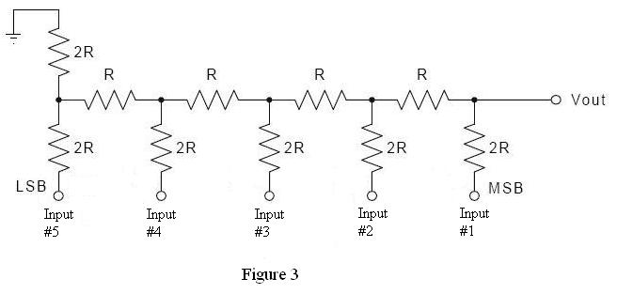

2. In this Step, the Thevenin resistance of the circuit in Figure 3 is measured. Connect all of the inputs to ground. Verify the Thevenin resistance of the circuit by measuring the resistance between Vout and ground. Record the measured value at the end of this Step. As stated in the Introduction of this lab, the overall Thevenin resistance of a R2R Ladder Network is R, which in this case is 1 KOhm. If the measured resistance is not close to 1 KOhm, please consult with your instructor.
The measured resistance value is ______________ KOhm.

3. In this Step, the individual voltage weight of each input at Vout is calculated. Using a Vr of +5 Volts and placing the following groups of voltages at the Inputs, calculate the voltage at Vout for each group of Inputs. Fill in the table with the calculated Vout values. Note that in Group 1, Input #1 is the only input contributing voltage to Vout; in Group 2, Input #2 is the only input contributing voltage to Vout; and so on.

Table 2
Voltages at Inputs
 | Input #5 | Input #4 | Input #3 | Input #2 | Input #1 | Vout (Calculated) | Vout  (Using Table 1)
Group 1 | 0 Volts | 0 Volts | 0 Volts | 0 Volts | +5 Volts |  | Vr/2 =
Group 2 | 0 Volts | 0 Volts | 0 Volts | +5 Volts | 0 Volts |  | Vr/4 =
Group 3 | 0 Volts | 0 Volts | +5 Volts | 0 Volts | 0 Volts |  | Vr/8 =
Group 4 | 0 Volts | +5 Volts | 0 Volts | 0 Volts | 0 Volts |  | Vr/16 =
Group 5 | +5 Volts | 0 Volts | 0 Volts | 0 Volts | 0 Volts |  | Vr/32 =

4. In this Step, Vout is calculated using Table 1. Calculate Vout using the fractional Vr weights from Table 1 and input the values into Table 2. Compare these results against the calculated values from Step 3. The comparisons should reveal similar results. If not, consult with your instructor.

5. In this Step, the circuit is assembled. Assemble the circuit in Figure 3, connecting a voltmeter to Vout of the circuit.

6. In this Step, Vout is measured with a Voltmeter. Place the voltages shown in Table 2 at the inputs of the circuit. Place the Group 1 voltages first and measure Vout, then place the Group 2 voltages and measure Vout, and so on. Record the measured values in the following table.
Table 3
Input Voltages | Vout
Group 1
Group 2
Group 3
Group 4
Group 5

7. In this Step, measured values are compared against calculated ones. Compare the measured Vout values from Table 3 against the calculated Vout values from Table 2. The values should be very close. If not, consult with your instructor.

8. In this Step, several inputs are asserted. Calculate Vout for the following inputted voltages.

Table 4
Input Voltages | Weighted Voltage at Vout
Input #1 = 0 Volts
Input #2 = +5 Volts
Input #3 = +5 Volts
Input #4 = 0 Volts
Input #5 = +5 Volts
(sum of weighted voltages) Vout =

9. In this Step, measured values are compared against calculated ones. Place the voltages found in Table 4 at the inputs to the circuit assembled in Step 5. Using a voltmeter, measure Vout of the circuit and enter it at the end of this Step. Compare the measured value against the calculated one from Step 8. The values should be very close. If not, consult with your instructor.
Measured Vout = ______________ Volts

Conclusion
After completion, please provide your lab results to your instructor for review.

