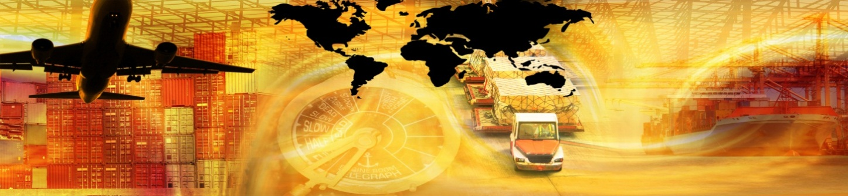

Logistics Case Study: Lenovo

Walter Martin / Tanya Scott
Wake Technical Community College
April 2013

This case study was funded by the National Science Foundation as part of NSF ATE #1003507
Lenovo

Lenovo was first launched in China in 1984 as Legend Holdings and became incorporated shortly thereafter in 1988; it quickly grew into the largest PC company in China, and currently holds 30% of that market share. In 2004, it changed its name to Lenovo and in 2005 it acquired the Personal Computer Division of IBM. Today, Lenovo is a $21 billion company, ranked as the second-largest PC vendor in the world serving more than 160 countries. Headquarters are stationed in Beijing, China and Morrisville, North Carolina, US, with manufacturing occurring around the world in the US, India, China, and Mexico. Lenovo continues to grow and is currently outpacing the worldwide PC market in unit shipments and market share.

Lenovo Worldwide Headquarters


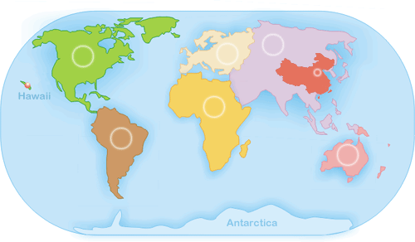

Acquiring the Personal Computer Division of IBM

In 2005, Lenovo purchased the Personal Computer Division of IBM, creating a joint venture that capitalized on Lenovo’s strong client base and sales infrastructure in the Chinese market and IBM’s network in global PC sales. The venture immediately increased Lenovo’s business fourfold, creating an annual sales volume of 11.9 million units. At the point of acquisition, IBM employed approximately 10, 000 employees and Lenovo approximately 9,200. Today, Lenovo employs over 26,000 employees across 60 countries.

Logistics Model: The Lenovo Way

The Lenovo Way: “We Do What We Say. We Own What We Do.”
~Mick Jones, VP Global Logistics at Lenovo (2012)
The challenge of interfacing two very different business cultures following the IBM/Lenovo merger created a business environment supportive of innovative thinking, leading to an integrated business model focusing on new supply chain strategies that factored in risk management, scalability, sustainability, and ultimately, customer satisfaction. This model, Integrated Business Planning, rests on three verticals of procurement, manufacturing, and logistics, while proactively managing the network to drive down costs and drive in value. From the logistics point of view, this involves greater involvement with data, such as forecasting at the plant level.
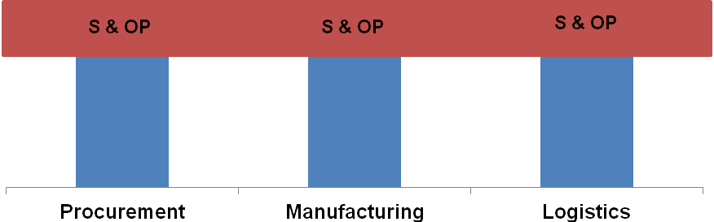

Lenovo globalizes the logistics chain through worldsourcing, maximizing opportunity, talent, and resources from around the globe to create a truly innovative product offered at the best possible price and service to the customer. Lenovo locates hubs of excellence to create and deliver the best possible product in the timeliest fashion. One example of this process in action is the innovation triangle between the three centers of Raleigh, NC; Beijing, China; and Yamato, Japan. Raleigh serves to support software and server management, Beijing supports research and technology, as well as the consumer business unit, and Yamato provides innovative design talent.

Commitment to Sustainability

Lenovo has reaffirmed its commitment to sustainability in its pursuit to expand product volumes. This requires the use of environmentally friendly modes of transportation, such as rail and ocean freight, in an effort to reduce greenhouse emissions.

Manufacturing Centers

All seven Lenovo manufacturing centers are ISO 9001 (Quality), ISO 14001 (Environmental) and OHSAS 18001 (Health and Safety) certified. In addition, Lenovo carefully considers the location of manufacturing centers. For example, Lenovo considered the unique geographical characteristics of the Triad area when it opened its Greensboro, NC center. Its central location to a heavily populated east coast, easy access to an abundance of interstate highways, and access to four container ports within a six-hour truck drive, allows Lenovo to serve 60% of the population of the United States within one day via truck delivery.

Lenovo Manufacturing Centers

Beijing, China  No. 6 Chuang Ye Road  Shangdi Information Industry Base,  Haidian District,  Beijing, P.R. China  100085 | Huiyang, China  Lenovo Science & Technology Park  Sun City, Huiyang  Guangdong, P.R. China  516213 | Shanghai, China  FengJu Road 199  Waigaoqiao Free Trade Zone, Pudong  Shanghai, P.R. China  200131 | Shenzhen, China (two plants)  ISH2 Building, No. 3 Guanglan Road and Shuncang Building, No. 6 Guanglan Road  Futian Free Trade Zone,  Shenzhen, P.R. China  518038
Greensboro, USA  Fulfillment Center  6540 Franz Warner Parkway  Whitsett, NC 27377  USA | Pondicherry, India  Rs No: 19/1A, 2A  Edayar  Palayam Village  Cuddalore Main Road  Thavalakuppam  Pondicherry, India  605 007 | Monterrey, Mexico  Boulevar Escobedo #316,  Apodaca Technology Park,  Apodaca, Nuevo León, México,  CP, 66601

Landed Cost

Landed cost is the total cost involved in shipping from point of origin to arrival at the buyer’s destination. This cost is determined by several factors, including but not limited to:
- origin inland and destination cartage costs;
- origin drayage cost to port of departure;
- origin and destination port fees and surcharges;
- origin and destination documentation and customs charges;
- carrier transportation costs;
- handling fees and surcharges;
- brokerage fees;
- packaging and crating charges;
- customs inspection and duties;
- taxes;
- insurance; and
- Currency conversion.

Determining the best landed cost requires optimizing routes and shipping costs to deliver the product within a needed time frame for the lowest cost with the best service. Transportation costs contribute significantly to landed costs; balancing cost-effective transportation options with high-quality service effects an organization’s ability to meet the Seven R’s of Logistics: product, customer, quantity, condition, place, time, and cost. Furthermore, offshore manufacturing poses unique challenges in transportation. Global supply chains that extend into China and India require additional transportation costs, extended transit times, and are at greater risk for supply chain disruptions.

Modes of Transportation

Typical modes of transportation utilized in a supply chain include truck, rail, air, water, and pipeline; multimodal transportation combines two or more of these modes. Gaining popularity of containerized freight has led to an increase in multimodal transportation. Within the US, the trucking industry dominates transportation, followed by multimodal transportation. Truck, multimodal, and air transportation are typically used to move high-value goods, while rail, water, and pipelines are used to move lower-value items due to their economical price point.

Air versus Ocean Transportation

Air Transportation

Air transportation is commonly viewed as an expensive option; however, demand for air transportation has grown due to an increase in e-commerce, greater reliance on the global supply chain, and efforts to reduce order cycle time and inventory. Air carriers are typically utilized to move small quantities of time sensitive, high-value, low-weight goods, such as computers, electronics, and perishable items. Despite its increasing popularity, the air cargo industry continues to struggle with cost, competition, and security issues.

Ocean Transportation

Water carriers dominate all other global transportation modes, carrying nearly all tonnage and half of global freight. It is a more economical choice in comparison to air transportation and provides greater flexibility in freight carriage due to the availability of a wide range of specialized ships. Major obstacles related to ocean transportation are primarily related to international water transportation, including trade imbalances between export dominant Asian countries and import dominant North America.

Other Factors to Consider in TLC calculation

In addition to the above components, other information may contribute to a better landed cost calculation, namely SKU details by product. For instance, dimensional data such as cube, dimension, and weight information may provide clues on how to build better pallets, optimize space, and consolidate products into fuller shipments. Furthermore, dimension to weight information can provide a more accurate landed cost calculation. Consider the case of laptop bags; these may pose shipment challenges as they take up a considerable amount of container space but do not weigh very much. SKU level data also provides information on additional costs that result from shipping that are not immediately apparent, such as recurring damage of products due to shipping.

Scenario
In 2010, volcanic events in Iceland created massive disruptions to air travel across Western and Northern Europe over a two-month period in April and May. Twenty countries closed their air space and the global supply chain was put at risk. Lenovo was no exception, and it suffered major disruptions to its regional supply chain. Lenovo’s Method of Transportation (MOT) from China was 100% air to air-to-ground customers. Environmental disasters such as the volcanic eruption create added risk to the supply chain, increase costs, and negatively impact serviceability to the customer.
Current Method of Transportation (MOT)
Image reproduced with permission from Lenovo.
Lenovo’s increased focus on predictability and customer delivery date, as well as desire to lower costs, requires innovative approaches to reducing transportation costs by driving 80% of traditional air-to-ground volume through ocean as a method of transportation instead. The proposed model is expected to increase serviceability by 19% from 70% to 89%, and garner a savings of $13 million. The model relies upon a two-phase implementation of kitted options. Phase one of the model requires kit and consolidation in China, with ocean shipment of completed kits to the US. In the kitted model, parts are shipped in bulk packages to the PC assembly plant. Some of the parts are used in PC assembly and some are repackaged, or ‘kitted’ in the plant as sellable option or accessory products. Phase two consolidates bulk packaged parts in China, with ocean shipment to US, where the US then kits options and ships to customers. Shipment assumes 80% container utilization, with 2.5 weeks inventory in the China plant and 6 weeks inventory at the US plant.

Proposed MOT
Image reproduced with permission from Lenovo.
Option A: Kitted |  |  |  |  | Option B: Purchase Complete
Activity or Cost element ($/unit) | Base: LIPC 100% air to American Group customer | Case 1: 100% kit in China & 90% ocean replen to US | Case 2: China 3% ocean to American Group distributors, 7% air to American Group customers & 90% ocean replen to US |  | Base: LIPC 100% air to American Group customers | Case 1: China 3% ocean to American Group distributors & 97% air to other American Group customers | Case 2: China 3% ocean to American Group distributors, 7% air to American Group customers & 90% ocean replen to US
Kitting labor at plant | $2.51 | $1.56 | $7.80
Kitting abor at plant US |  | $2.47
DC handling at plant | $0.53 | $1.06 | $2.32 |  | $1.06 | $1.06 | $2.68
US handling at plant |  | $3.32
China to US transportation | $51.54 | $15.60 | $7.80 |  | $50.25 | $49.95 | $12.49
US to customer transportation |  | $11.02 | $11.02 |  |  |  | $13.66
Inventory (CC, take-down, E&O) | $8.99 | $17.56 | $17.56 |  | $8.99 | $9.26 | $17.56
NRE
Total $/unit | $63.57 | $52.59 | $46.50 |  | $61.43 | $54.49 | $47.90
Delta to base ($/unit) |  | $3.97 | $7.01 |  |  | $0.25 | $3.56
Delta to base ($) |  | $5,551,250.00 | $113,245,500.00 |  |  | $110,025.00 | $2,264,910.00
Annual Planning Reference
Annual volume | 2,300,00 | 2,010,000 | 2,010,000 |  | 1,100,000 | 1,100,00 | 950,000
Inventory reserve | NA | $525,135 | $525,140 |  | NA | NA | $123,500.00
Transportation
Transportation savings |  | $33,307,500.00 | $39,635,925.00 |  |  | $333,075.00 | $11,098,059.00
Total Transportation Savings for US: $50 M
Total Savings: $13.5 M

Case Questions/Scenarios

Scenario One
Should Lenovo move production to other country/countries?
How much would the cost-savings, if any, be?
What modes of transportation should be used and in what percent?
What global risks can be anticipated? What contingency plans can be made?

Scenario Two
Should Lenovo alter transportation mode based on the scenario?
How much would the cost-savings, if any, be?
Considering Lenovo’s commitment to sustainability, how would the proposed route contribute to reducing carbon emissions/carbon footprint?
What global risks can be anticipated? What contingency plans can be made?

References
Bianco, R. (2006). Minimize total landed cost: Strategize, model, act. Inbound Logistics. Retrieved from http://www.inboundlogistics.com/cms/article/minimize-total-landed-cost-strategize-model-act/
Boudreau, J. (2012, July 1). In China, PC giant Lenovo rises to challenge Hewlett-Packard. San Jose Mercury News. Retrieved from http://www.newsobserver.com/2012/06/30/2169323/in-china-pc-giant-lenovo-rises.html#storylink=misearch
Coyle, J.; Langley, C.J.; Novack, R.; & Gibson, B. (2013). Supply chain management: A logistics perspective. Mason, OH: Cengage.
Freightgate. (2012). How to calculate landed cost of shipping. Retrieved from http://logisticsportal.org/community/blogs/-/blogs/how-to-calculate-landed-cost-of-shipping
Heaney, B. (2012). Supply chain visibility excellence. Mastering complexity and landed costs. Aberdeen Group. Retrieved from http://www.feg.unesp.br/dpd/cegp/2012/LOG/Material%20Complementar/Textos%20gerais/supply-chain-visibility%201.pdf
Jearasatit, A. (2012). Using total landed cost model to foster global logistic strategy in electronics industry. Retrieved from http://ctl-test1.mit.edu/sites/default/files/library/public/10_Jearasatit.pdf
Lenovo. (2012). About Lenovo. Retrieved from http://www.lenovo.com/lenovo/us/en/our_company.html
Lofvers, M.; Verkamman, O. & Thompson, S. (2012). Leading the Lenovo way. Supply Chain Movement. Retrieved from http://www.supplychainmovement.com/wp-content/uploads/Supply-Chain-Movement-quarterly-magazine-Q2-2012.pdf
O’Brien, C. (2012). What’s missing in your total landed cost? Retrieved from http://www.chrobinson.com/Blog/post/2012/08/20/Whats-Missing-in-Your-Total-Landed-Cost-.aspx
Spooner, J. G. & Kanellos, M. (2004). IBM sells PC group to Lenovo. CNET. Retrieved from http://news.cnet.com/ibm-sells-pc-group-to-lenovo/2100-1042_3-5482284.html
Thomas Publishing Company. (2012). Supply chain gain. Inbound Logistics. Retrieved from http://www.inboundlogistics.com/cms/article/supply-chain-gain-site-smarts/

Lenovo. (2012).
Spooner, J. G. & Kanellos, M. (2004).
Lenovo. (2012).
Lofvers, M.; Verkamman, O. & Thompson, S. (2012).
http://www.lenovo.com/lenovo/xe/en/our_company.html
Lenovo. (2012).
Lenovo. (2012).
Thomas Publishing Company. (2012).
Freightgate. (2012).
Coyle, Langley, Novack, & Gibson (2013)
Coyle, Langley, Novack, & Gibson (2013)
Coyle, Langley, Novack, & Gibson (2013)
Coyle, Langley, Novack, & Gibson (2013)
Coyle, Langley, Novack, & Gibson (2013)
Coyle, Langley, Novack, & Gibson (2013)
Jearasatit, A. (2012).
Coyle, Langley, Novack, & Gibson (2013)
O’Brien, C. (2012).
Lofvers, M.; Verkamman, O. & Thompson, S. (2012).
Heaney, B. (2012).
CC= cost of capital
take-down = purchase cost reductions that occur while in transit
E&O = excess and obsolete costs such as scrap, write-offs, future reserves, etc.
Includes freight, fuel surcharges, brokerage/custom clearance, duties/taxes, merchandize processing fees, harbor maintenance fees, local drayage & transfer, etc.

