Darigold Reengineering - “The Perfect Order Project”
In a supply chain, a ‘Perfect Order’ is on-time, complete, damage-free, and correctly documented. This ‘perfect order’ metric represents how well a company can anticipate and respond to demand. For a fairly straightforward, pick, pack and ship operation, the metric represents how well the operation is running. For a company that builds-to-order and customizes orders, the perfect order might be harder to achieve, and may require an in-depth look at ‘customer facing strategies’ – those that define how you deal with your customers.
This is exactly the type of radical reengineering Darigold undertook in late 1995 when it sought to improve customer service and drive down unit costs by eliminating cuts, substitutions and damages from all orders, and ensuring that everything was properly documented. A lot of ‘imperfect orders’ , daily fire-fighting, and significant effort spent on error correction was evidence that there was a lot that could be done to improve the ordering and delivery processes for its variety of dairy products.
Darigold is a Seattle, WA based dairy cooperative made up of over 500 regional farmers located in Washington, Oregon, Idaho, Utah, Montana, and Northern California. The 4th largest dairy producer and agricultural cooperative in the nation, it collects 2 million gallons of milk each day, or the equivalents of 8.6 billion pounds of milk annually – enough milk to fill 59,600 Olympic swimming pools. Dairy and related products sales total $2.5 billion annually. Thirteen plants make and distribute 90 million gallons of packaged milk under 30 different labels, 400 million pounds of milk powder, 230 million pounds of butter, 195 million pounds of cheddar cheese, and 45 million pounds of cottage cheese, sour cream, and yogurt.
.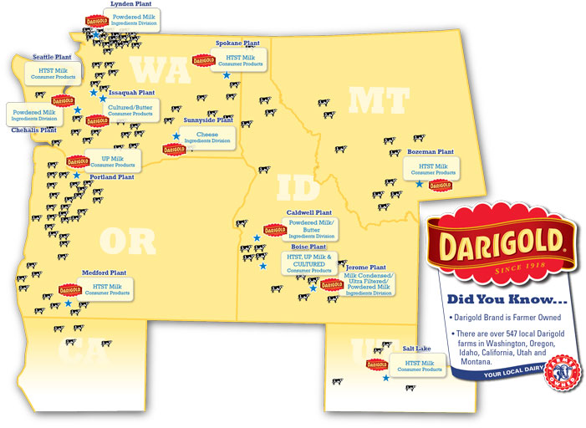
Figure 1

In 1995, in an effort to improve customer service, drive down unit costs, and increase distribution profitability, Darigold initiated ‘The Perfect Order Project’. Working with a data consultant, Hitachi Data Consulting, Darigold planned for 3 phases of the project which ultimately stretched out over 2 and one-half years: a customer gap analysis, problem identification, and problem resolution.
At the initiation of ‘The Perfect Order Project’, the Darigold distribution network consisted of 30 consumer product branch locations. Four of these locations, Seattle, Portland, Spokane, and Medford, were manufacturing facilities/distribution centers which distributed to larger customers such as the various grocery distribution centers as well as to 26 smaller Darigold distribution centers. In turn, the smaller distribution centers distributed Darigold products to a large number of smaller volume customers including independent grocers, restaurants, schools, hospitals and prisons. A large number of the orders to these retailers were for less than $100 each, yielding little, if any profit.
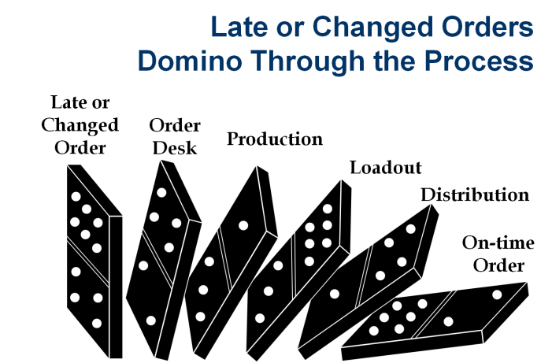
An eclectic collage of ordering systems and processes were used by individual retailers to maintain product on their shelves. In many cases, a standard number of units were delivered to a retailer, however the retailer could make changes to order amounts up the time truck left the distribution center. As many as 45% of all orders were cut after the initial order was made! Depending on production levels, increased order quantities may or may not have been met, especially if the change was last minute. The later the change to an order was processed, the greater the likelihood that the order would not be on-time or incomplete, and the greater the likelihood that it would affect other orders. Three of every ten invoices were for a credit for unfilled items. Weak sales forecasting contributed to production planning problems especially for lower volume products. And because customers did not report on profitability, higher selling volume products were not adjusted for future order or production quantities.

What the customers said – Customer Gap Analysis
The gap analysis phase of the project include a survey which was developed and distributed to 1, 032 retail customers and 300 internal distribution associates. Personal interviews followed up on areas of concern from the survey. As shown in figure 2, customer expectations were not met in 6 key areas.
Figure 2
Of these areas, feedback on condition on delivery, reliability of delivery, availability, value received, and effective response to inquiries corroborated the problems that Darigold knew existed in the ordering process. In short, in trying to provide a high level of service, nobody was receiving optimal service, because so much effort was devoted to operating in a crisis mode.
Problem Identification
In general, late or changed orders were creating havoc throughout operations causing daily fire fighting and a large amount of effort on error-correction. One indicator of the costliness of this policy was the number of credits processed the prior year - 3 of every 10 invoices, or 180,000 credits - were processed for an annual processing cost of greater than $2 million dollars. Lack of a clear and well communicated customer service policy which explicitly instructed customers to always order in a particular way was partly to blame. Customers who have not been “trained” to follow procedures were affecting the entire process. If the cycle could be changed, not only would customer service levels improve, but costly activities that affect profitability could also be removed.
Despite a sales policy that stated that Darigold would not make sales under $100, 734,000 of the invoices for 1995 were for less than $100 while 706,000 were for greater than $100. At 1995 gas prices, a sale of $100 yielded a negative net profit. Furthermore, half of the invoices generated only 7% of the revenue.
Roughly half of the line items ordered were picked to the each (1) level. In other words, 42% of the SKUs yielded 1% of the revenue. For manufacturing, more SKUs mean more production runs. In a lot of cases, these were the items which sell in very small quantities. The implication is that a lot of costly changeover time goes into small runs. Further, you increase the chances that you have products go out of code, or that have a stock out of the ones you need. In terms of distribution, there are implications in terms of managing the inventory, stocking pick lines, the size and complexity of ordering forms, and the amount of special handling that is required.

- How was the customer service policy affecting Darigold’s profitability? What would be a reasonable customer service policy based on the survey criteria?
- How should Darigold deal with the lower volume retail outlets – the 42% of the invoices?
- Should the line items picked to the each level be eliminated from inventory – if so, how would you determine which to eliminate?
- What technology solutions should Darigold consider? How would these help the distribution process?

Instructor Notes – What was Darigold’s Resolution?
One of the first solutions was to deal with the customer profile. There was already a policy in place that specified that all sales were to total at least $100. Nonetheless, on a daily basis Darigold trucks – generally those from the smaller 26 distribution centers - delivered orders totaling less than $100 to a large number of small independent groceries, restaurants, hospitals, and schools. This is where the radical reengineering came into play. Darigold eliminated all but its four largest manufacturing/ distribution facilities in Seattle, Portland, Spokane, and Medford. To replace the 26 smaller distribution facilities, Darigold instead contracted with and then distributed to existing distributors and a variety of smaller independent distributors and outlets. Most of the smaller, less than $100 orders were aggregated to these existing distributors and outlets. A year later, sales for less than $100 accounted for less than 1% of all sales.
Reducing the number of distribution centers also helped to reduce the number of SKUs that were picked to the each level. Some SKU’s continued to be low volume sellers and were deleted – a long, tedious process.
Finally, customer ordering policies were reviewed, communicated, and enforced.
In the year that followed this project, Darigold realized over $1.2 million to the bottom line.
An update: Since this project was completed, Darigold has contracted with a software provider for an ERP solution to manage manufacturing production and distribution. Customer service policies are now a combination of planning and scheduling through the scheduling software as well as defined ordering and order modification policies.

