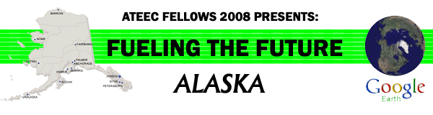
Effects of Climate Change on Glaciers and Permafrost

Virtual Field Trip Teachers Guide

Recommended Usage:

Although climate change is a worldwide phenomenon, nowhere are its effects more evident than in the Arctic. This “virtual field trip” is designed to give high school and introductory college students an understanding of the rapid changes occurring in arctic and subarctic ecosystems, even if they have never visited these areas.

This field trip has been divided into two parts, either of which can be assigned as a stand-alone activity. “Permafrost” lends itself to independent study and research on the part of the student, whereas “Glaciers” contains activities better suited to use in a classroom or laboratory setting. For each topic, it is suggested that students visit the waypoints in order, beginning with #1, and that they complete the activities at each waypoint before proceeding to the next. Many questions and activities are open-ended so that they may be adapted to the specific level of the individual student or class.

It is suggested that the instructor download and use the United Nations Environmental Program publication entitled "Global Outlook for Ice and Snow” (2007) as a reference.
http://www.unep.org/geo/GEO_Ice/

Objectives of this activity:

1. The student will be able to describe the major features and/or types of permafrost/glaciers.
2. The student will be able to explain the importance of permafrost/glaciers, and describe their impact upon humans.
3. The student will be able to cite evidence for the melting of permafrost/glaciers and relate this melting, where appropriate, to global climate change.
4. The student will be able to describe the consequences of glacial/permafrost melting.

Additional Questions to be answered or explored:

Teachers might choose to expand the discussion of glaciers and permafrost to include the Greenland and Antarctic ice sheets, as well as glaciers on other continents. How much melting is likely to occur, and what will be the extent of the consequences? How will arctic and subarctic ecosystems be affected? How do current changes resemble or differ from periods of warming in geologic history?

There are many other aspects of climate change that are beyond the scope of this field trip, notably the link between human activity (release of greenhouse gases) and the rise in global temperature. This topic might be pursued as a follow-up unit.

Minimum System Requirements
• PC/Macintosh with a FREE download of Google Earth. To obtain Google Earth™, go to
http://earth.google.com/
• High-speed Internet connection is highly recommended.
• The videos located inside of the virtual tour are streamed from various sources such as Google Video, Vimeo, Viddler, or YouTube. If you cannot see the videos, check with your school IT department to ensure they are not blocking the Google Video web
site.
• See the system requirements on this page (We encourage the “Recommended Configuration”).

