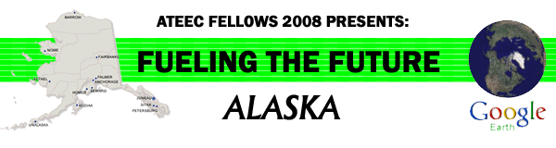

The Exxon Valdez Oil Spill

Virtual Field Trip Teachers Guide

Recommended Usage:
- The Exxon Valdez Oil Spill happened 20 years ago, so students will not have any memory of it and will not understand what happened. Alaska is a great place to visit, but few of us have the opportunity to travel or take a group of students on a field trip there. Utilizing the virtual field trip, teachers and students can begin to explore the area and the impact that the Exxon Valdez oil spill had on Alaska.
- You can start anywhere, begin where you interests lie, or just explore. To begin, download & unzip the Exxon Valdez Oil Spill file. There will be several sections to choose from to begin you trip.
- This virtual field trip is designed as a teacher-directed project, but is primarily student-centered, so students do the work that the teacher directs them towards.
- This virtual fieldtrip is just the tip of the iceberg; there are many types of information, activities and videos to be found online. Just surf.
- There is an entire curriculum and lab activity package developed about the Exxon Valdez oil spill that can be done in the classroom. Go to www.pwsrcac.org/outreach/curriculum/entirecurriculum.pdf to find additional materials to compliment this activity.

Goals or objectives of this activity:
This is an introduction and investigation into the issues and aspects of the oil spill of the Exxon Valdez, which occurred on March 24, 1989. The virtual field trip will investigate the actual path of the tanker, follow the distribution of the oil spill, and identiry of some of the impacts the disaster had upon the environment. Students will have an opportunity to compare the Exxon Valdez accident to other major tanker spills that have occurred in the world.

Additional Questions to be answered or explored:
- Is the Exxon Valdez oil spill impacting the Alaskan environment today- 20 years later?
- Compare and contrast the economic versus environmental issues that occurred at the time of the spill
- Compare and contrast the economic versus environmental issues that are present today.
- After review of other major tanker spills that have occurred, why is the Exxon Valdez considered “the worst environmental disaster in history”?
- Did Alaska recover or can it ever recover from the Exxon Valdez oil spill?

Minimum System Requirements
• PC/Macintosh with a FREE download of Google Earth. To obtain Google Earth™, go to
http://earth.google.com/
• High-speed Internet connection is highly recommended.
• • See the system requirements on this page (We encourage the “Recommended Configuration”).

National Science Standards:
In grades 6-12, all students should develop understanding of
- Personal and community health
- Natural resources
- Environmental quality
- Natural and human-induced hazards
- Science and technology in local, national, and global challenges
In grades 6-12, all students should develop
- Abilities of technological design
- Understandings about science and technology
In grades 6-12, all students should develop understanding of
- Science as a human endeavor
- Nature of scientific knowledge
- Historical perspectives
In grades 6-12, all students should develop--
- Abilities necessary to do scientific inquiry
- Understandings about scientific inquiry

National Language Arts Standards:
Students in grades K-12 will apply a wide range of strategies to comprehend, interpret, evaluate, and appreciate texts. They draw on their prior experience, their interactions with other readers and writers, their knowledge of word meaning and of other texts, their word identification strategies, and their understanding of textual features (e.g., sound-letter correspondence, sentence structure, context, graphics).
Students in grades K-12 will apply a wide range of strategies as they write and use different writing process elements appropriately to communicate with different audiences for a variety of purposes.

Students in grades K-12 will conduct research on issues and interests by generating ideas and questions, and by posing problems. They gather, evaluate, and synthesize data from a variety of sources (e.g., print and nonprint texts, artifacts, people) to communicate their discoveries in ways that suit their purpose and audience.
Students in grades K-12 will use a variety of technological and information resources (e.g., libraries, databases, computer networks, video) to gather and synthesize information and to create and communicate knowledge.

National Mathematics Standards:
In grades 6-12 all students should
- Understand measurable attributes of objects and the units, systems, and processes of measurement
- Apply appropriate techniques, tools, and formulas to determine measurements
In grades 6-8 all students should
- Formulate questions that can be addressed with data and collect, organize, and display relevant data to answer
- Select and use appropriate statistical methods to analyze data
- Develop and evaluate inferences and predictions that are based on data
- Understand and apply basic concepts of probability

This unit uses the Exxon Valdez Oil Spill Virtual Fieldtrip in Google Earth
Click on the plus sign to expand to each section

Section 1: Exxon Valdez’s last trip
Why: To look at the actual route and conditions that the Exxon Valdez took on March 1989 that led to the oil spill disaster.

Get Ready:
- Turn on/ check the section: Path of travel of the Exxon Valdez
- Click on the plus sign to expand, this will mark the path and various points of the Exxon Valdez’s trip on Google Earth
- Each part in this section can be individually checked / unchecked as well; this will allow you to view each part separately.
- By clicking on each section it will:
  - Fly you closer to the map (until you stop it)
  - Open an information box for each.
Things to Do:
- Movement of the tanker
- Zoom in close to fill the entire screen with the tanker points.
- Use the ruler tool to:
  - Measure the distance the Exxon Valdez traveled to each point
  - Record in a chart
Point name | Distance | Time | Speed/velocity

- Calculate the total distance traveled
- Calculate the speed/velocity (see information box for times)
- Infer the speed at which the Exxon Valdez hit Bligh Reef.

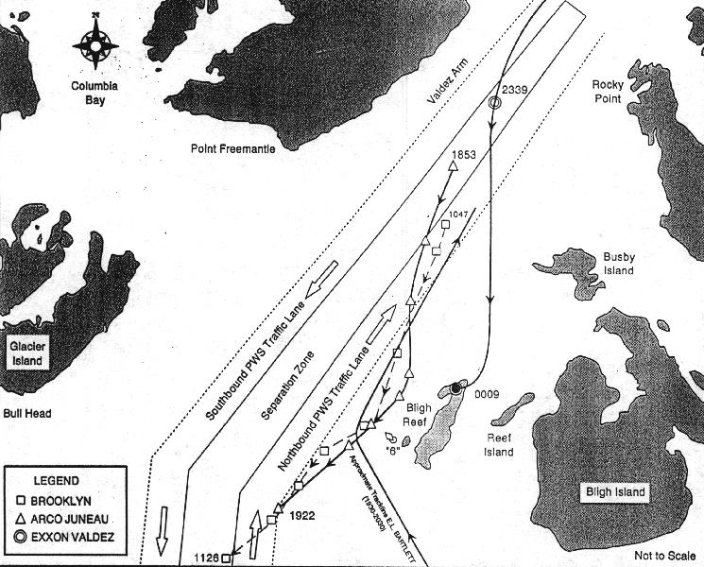
- Shipping route

- Research the shipping lanes or routes that vessels use leaving and entering Prince William Sound. www.tapseis.anl.gov/guides/what.cfm
- What are the pros & cons that need to be addressed for using these routes? Note: The Exxon Valdez left the prescribe route it was supposed to take.
- What issues might be addressed (ie: speed, depth of water, obstacles, communication) when developing routes?

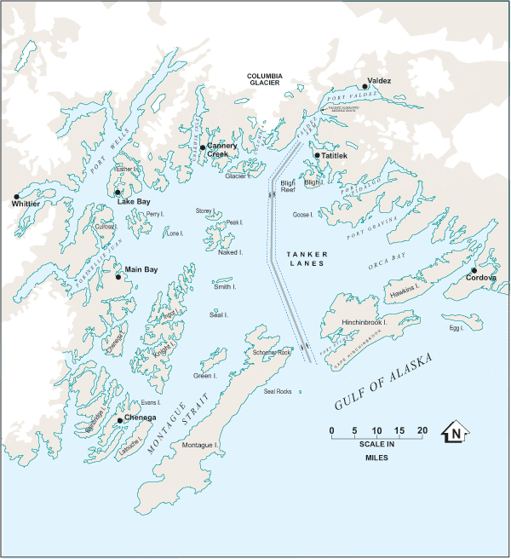
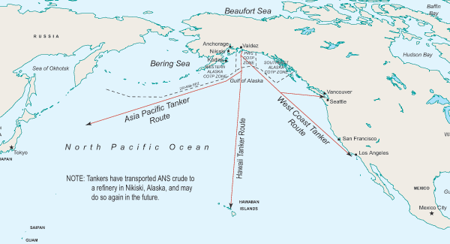

Further Investigations:
- What other ships did Exxon have at the time of the accident? What ships do they have at this time? Where routes do they routinely travel?
- Research information about tankers. (length, width, capacity, weight, hull thickness, how were they made, manufacturing regulations)
- What were the regulation requirements of oil tankers in 1989 and contrast them to the present. Have there been changes since the Exxon Valdez accident?

Section 2: Where did the oil go?
Why: After the Exxon Valdez was breached, the oil spilled forth. How and where did the crude oil move to? What caused the oil to move in the various directions?

Get Ready:

- Turn on/ check the section: Exxon Valdez Oil Spill Distribution
  - Area of spill Information

- Click on the plus sign to expand, this will mark the various areas of the oil spill. on Google Earth
- Each part in this section can be individually checked / unchecked as well; this will allow you to view each part separately.
- By clicking on each section it will:
  - Fly you closer to the map (until you stop it)
  - Open an information box for each.
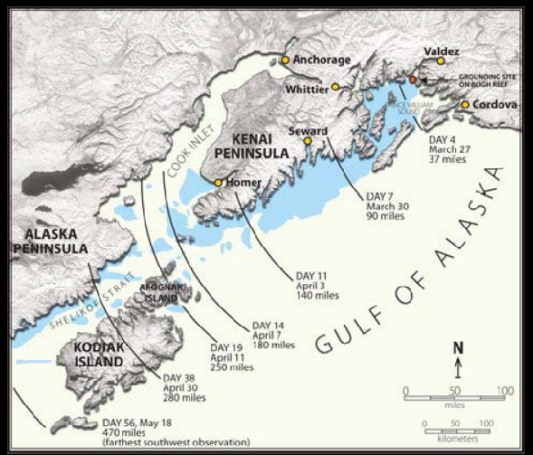

Things to Do:
Note: Each area can be turned on together (to show the whole oil spill distribution) or separately to show the extent for each time period.
- Oil Spill Distribution
- Use the ruler tool to measure the perimeter and area of each time period.
- Record the data.
- Click on the information box for each area to get the rest of the information to fill out the chart.
- Calculate the volume for each area.
Note: Heavy oil surface 6’ deep was found up to 90 miles
Moderate oil surface 4’ deep was found from 60-250 miles
Light oil surface less than 3’ deep was found greater than 250 miles

Date | How many days since accident? | How many days each area? | How many miles from origin? | Perimeter | Surface area | Oil depth | Volume
March 27
March 30
April 3
April 7
April 11
April 30
May 16
totals
- Are there any emerging patterns?
- What are possible affects from each surface area and volume of oil for each time period?
Try it out:
- Does it make a difference with oil types?
- Get a variety of oil types (ie: cooking oil, mineral oil, engine oil, Karo syrup-dark)
- Place a small amount of each type of oil in a clear glass or water.
- Using a flashlight, shine the light from above down through the oil and water.
- Measure how much light penetrates through the surface.
- What do you notice? What are some of the affects that the change in light penetration might cause?

Thinking Further:
Note: The tidal action of Prince William Sound has a range of 10’. In the intertidal zone the range is 16’

Ocean current circulation is counter clockwise, entering in through the Hinchinbrook Island strait, upwards toward Valdez and out through Montague Strait.

Prince William Sound varies in how deep the water is. The overall average depth of Prince William Sound is about 2600’. Lone Island & Eleanor Island has the greatest depth between them. At Hinchinbrook Island Strait the depth is about 1180’. At the Montague Straits has a depth of about 330’ and Herring Bay (the greatest area of oil spill damage) is between 400’-775’ in depth.

Three days after the initial spill, a storm came from the east with winds up to 70 mph (this also increased wind action).

Most of the beaches are high energy beaches (small pebbles) or low energy (large stones). About 75% of the shoreline is exposed bedrock in a variety of sizes.

Try it out:
- Design a model to show the how oil moves with variables such as circulation patterns, wind action, tidal action, and shoreline rock size. What do you find?

Further Investigations:
- Research current circulation, tidal action and wind patterns of your local coastal zone.
- Infer the possible oil spill distribution for that area.
- Section 3: Where are other tanker spill disasters?
Why: Are there other tanker oil spills in the world and where did they happen?

Get Ready:
- Turn on/ check the section: Oil Spills
- Click on the plus sign to expand, this will show the various points of other oil spills on Google Earth
- Each part in this section can be individually checked / unchecked as well; this will allow you to view each part separately.
- By clicking on each section it will:
  - Fly you closer to the map (until you stop it)
  - Open an information box.

Things to Do:
- Other Tanker Spills
- View the information and location of each of the sites of other vessels sites.
- Record the following data. Some research is necessary to complete the data table. You can use the links on each vessel site.
Name of Vessel | Date of Spill | Location | Latitude  Longitude | Amount of Oil Spilled | Type of Oil | Damage | Cost | Cause

- Now look at the completed data table. Do you see any emerging patterns, especially pre-Valdez spill or post-Valdez spill? Are any locations more prone to spills? Do ocean currents play a role? Does the shoreline type make a difference? Are there any contributing factors that can be indentified?

- Lessons Learned
- Research the changes made after the Exxon Valdez disaster. Which countries have made these changes and when did the changes go into effect?
- What are some of the unintentional consequences from any of these spills?

Further Investigations:
- Research methods for clean-up of tanker spills. What are some of the remediations that arise from clean-up?
- Compare and contrast the spills versus their clean-up efforts.
- Identify countries that have not made efforts to prevent tanker accidents by forming more stringent regulations for their waterways. Research the governmental officials who would make those decisions. Compose persuasive letters to those governmental officials to request that they pass laws or regulations to prevent environmental disasters like the ones you have studied.
- Section 4: What happen to the environment?
Why: What was and still is the environmental impact the oil spill has had upon the habitats and local animals?

Get Ready:


- Turn on/ check the section: Environmental Impact of the Exxon Valdez
  - Habitats Wildlife

- Click on the plus sign to expand, this will mark the various parks and animals affected by the spill on Google Earth
- Each part in this section can be individually checked / unchecked as well; this will allow you to view each part separately.
- By clicking on each section it will:
  - Fly you closer to the map (until you stop it)
  - Open an information box.

Things to Do:
Note: The Exxon Valdez oil spill is still considered one of the worst environmental disasters of the modern world.
- Wildlife
- View the various types of animals affected by the oil spill. Click on the information box, this will tell you basic information. Research various sites to gather a greater depth of knowledge about each animal and how the oil spill affected them.
- Birds
  - Chart the various deaths that occurred in the first 6 months at various points in Prince William Sound. Fill in the name of each location at the top of the column.
  - Is there any correlation to number of deaths vs the location?
Bird Specie | Deaths @ | Deaths @ | Deaths @ | Deaths @

- Fish
  - Research information and data on the commercial fisheries and the affect the oil spill had. Compare the immediate effect and the long-term effect.
Note: Salmon, herring and halibut are the primary commercial fish in Prince William Sound.

Further Investigations:
- Research information on these fish. Write a persuasive essay on an aspect of the recovery of these fish in Prince William Sound.
- Imagine you are one of these animals, Research the life and habitats of the animal. Write an essay from the point of view of this animal immediately during the oil spill and one year later. Remember to address the issues of food, water, habitat, family.
References: http://www.adfg.state.ak.us/pubs/notebook/notebook.php Alaska Wildlife Notebook Series
- Habitat
Note: Various national parks and preserves were affected by the oil spill.
- Research one of these areas and how it was affected by the Exxon Valdez oil spill. Write an essay comparing the damage or effects immediately following the spill, after 1 year, 10 years later, and finally 20 years later. Make sure you include any damage that is irreparable or permanent.

Further Information:
Videos:
http://video.google.com/videoplay?docid=8030531194576498661&q=exxon+valdez+oil+spill&ei=KJ1aSKCGCJD6-wGKkMDxDg

http://www.newtonsapple.tv/video.php?id=1043

http://video.aol.com/video-detail/news-report-on-the-exxon-valdez-oil-spill/2824488369?icid=acvsv1

http://video.aol.com/video-detail/exxon-valdez-oil-spill-disaster/4067580473

http://video.aol.com/video-detail/exxon-valdez-oil-spill-case-progressing/1138663653

http://video.aol.com/video-detail/18-years-later--evidence-of-the-exxon-valdez-oil-spill-persists/3484023481

http://video.aol.com/video-search/query/exxon%20valdez%20oil%20spill/familyfilter/1/type/standard video list

News Reels: http://video.google.com/videoplay?docid=7795041943561623691&q=exxon+valdez+oil+spill&ei=GptaSMDiMaOK-QHMzczxDg

http://video.google.com/videoplay?docid=-8733511040632851041&q=exxon+valdez+oil+spill&ei=p51aSPzXOZTU-wG9lL3mDg

http://video.aol.com/video-detail/03241989-exxon-valdez-runs-aground/3267906598?icid=acvsv2

Images:

http://www.evostc.state.ak.us/Gallery/gallery-spill.cfm

http://library.thinkquest.org/10867/intro/gallery/index.shtml
(Kelly, Jeffrey R. Prince William Sound: Paradise Lost? Research Website. [Access Date day month year]. </10867/>.)

http://response.restoration.noaa.gov/gallery_gallery.php?RECORD_KEY%28gallery_index%29=joinphotogal_id,gallery_id,photo_id&joinphotogal_id(gallery_index)=171&gallery_id(gallery_index)=12&photo_id(gallery_index)=106 i

http://response.restoration.noaa.gov/gallery_gallery.php?RECORD_KEY%28gallery_index%29=joinphotogal_id,gallery_id,photo_id&joinphotogal_id(gallery_index)=186&gallery_id(gallery_index)=12&photo_id(gallery_index)=121

Information:

http://www.valdezalaska.org/history/oilSpill.html history

http://explorenorth.com/library/weekly/aa032499.htm history

http://www.epa.gov/history/topics/valdez/index.htm historical information

http://library.thinkquest.org/10867/home.shtml comprehensive information

http://www.fakr.noaa.gov/oil/default.htm research and restoration

http://www.afsc.noaa.gov/ABL/Habitat/ablhab_oil.htm oil containment

http://www.50states.com/maps/print/alaska.htm map of Alaska

