# Variability Activity

Keywords: grid sampling, variability, precision agriculture, zone sampling, soil type, hands-on activity, percentages

## Purpose

This exercise showcases the concept of sampling and variability. Discussion can dive deeper into the importance of this type of sampling and the value it can provide.

The student will demonstrate different soil sampling methods and observe how data can be interpreted differently when looking at different parts of the field versus the whole.

The student will understand the purpose of soil sampling.

The student will be able to define variability and explain some of the data we receive in soil test reports.

Sampling=the act of taking observations

## Materials Needed:

Grid Dimensions 7 feet by 7 feet

* 49 cups
* Cards labeled 1-49 for the cups
* 49 Crayola markers representing four to five different colors. Example:
  + 7-10 red markers
  + 7-10 orange markers
  + 7-10 yellow markers
  + 7-10 green markers
  + 7-10 blue markers

Alternative Options:

* Use marbles, beans, or buttons and place them in containers with lids inside each square.
* Use a different-sized grid than 7x7 to allow for more samples collected or to cut down time on collecting samples.

NOTE: There are a variety of ways that you can create this grid and sample sheet. Be creative and use the resources you have! You can make smaller table-top grids, or larger ones for more room for movement. Always reach out if you have any questions.

## Activity Class Time

Set up takes about 15 minutes.

The lesson takes about 45 minutes utilizing introduction, activity, and take-home messages. This can be done as a stand-alone or as a supplement to Lesson 1 of the Precision Agriculture PowerPoints.

## Set-up Before Class (15-20 minutes)

1. Set out labeled cups
   1. 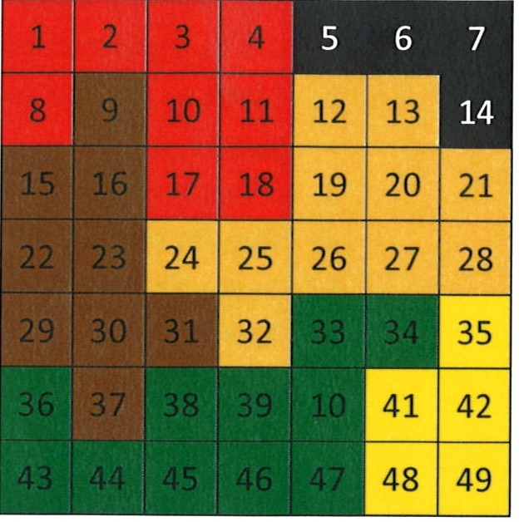Ensure that you have labeled each cup with its appropriate ID. For this activity, our identification numbers will be 1-49.

Figure 1. Sample Grid

* 1. Place numbered cups in a grid. Space cups evenly about one foot apart-enough space for students to be able to move throughout the grid. Use Figure 1 to help you set the cups up to match the sample sheet.

1. Put data in each cup
   1. Take your variety of markers and distribute them amongst the cups. I put two of the same color in each cup just so two people can be at a location as the same time, but one in each cup will suffice.
   2. A picture containing floor, ground, laying, lying

      Description automatically generatedPut them in the cups lid down so they can’t see the color as easily. Figure 2 showcases this. If you are feeling fancy, you can make an intentional pattern. I place the markers in the cups randomly. You can use Figure 1 help you get started, but it does not have to match this pattern every time.
2. Get Sample ID data sheets printed.
   1. These are available towards the end of this activity. Be sure not to print the answer key.

Figure 2. Example of markers cap down in the cups

1. Set-up is complete when each cup has at least one marker in it, and you have the students’ data sheets printed.

## Classroom Instructions

Materials Students Might Need:

* Clipboards, or something that they can write on when they are moving through this activity collecting samples.

### Introduction Talking Points (Spend about 10 minutes discussing these topics)

Introduce the topic by explaining the concept of sampling.

* Ask the students if they know what sampling is, and what different kinds of sampling exists.
  + Sampling=taking observations about something
  + Soil sampling, tissue sampling, random sampling, grid, zone, to name a few. Feel free to discuss the definition of each of these as applicable.
  + Today we are going to demonstrate variability through a variety of sampling methods.
* Ask if they can define different sampling types.
  + Grid Sampling=soil sampling method in which a field is divided into square sections (grids) of equal size. Size of each grid is dependent on the grower and what their goals are. Samples are then taken from each grid.
  + Zone Sampling=areas of fields that have been recognized to have similarities, so they are put together into management zones.
* Share with them:
  + UNL recommends a grid size of 1 acre. A general recommendation is grid size of no bigger than 2.5 acres. [g1740.indd (unl.edu)](https://extensionpublications.unl.edu/assets/pdf/g1740.pdf)
  + Full soil sampling should happen every 4-5 years (this is general practice our agronomy instructors use. It is not an exact science). If you are working more intensely on improving soil health, it would be a good idea to have your soils tested more frequently than that.
  + In a real-world scenario, we would collect 10-15 soil samples, called cores, from each location on the grid. Today, we will be collecting one marker from each spot. We can assume this one marker is the average of our 10-15 samples from that location.
  + The grid you have in front of the students represents a field. You can decide what each sample grid represents-I normally say 1-acre represents one square in our grid.
  + When you collect samples, you keep them organized by using Sample IDs. Today, our sample IDs are simply the numbers of 1-49. Growers can use any ID organizational method they want, as long as it makes sense to them.

### Activity (20 minutes)

Your students are going to be soil samplers today.

* Let’s break the students into groups, and they will each have one of three soil sampling methods. I find that pairs seem to be the sweet spot for this activity.
  + Option 1: Full grid sampling. Send kids who will work through this quickly to collect all 49 samples. In theory, this would take the longest (and the most amount of money). You only need two pairs to do this one, because all their data should be the same if they do it correctly. It is nice to have the two sets to show students that the data is the same.
  + Option 2: Partial grid sampling: Allow these groups to collect 18 random samples from throughout the field. Let them pick which 18 to do.
  + Option 3: Zone sampling: Split the field into three uneven pieces. Discuss how these zones are called management zones. Over time, these areas have shown similar soil characteristics, so people who work in precision agriculture might use these zones to treat different parts of the field differently. Have these groups collect four samples in each zone (so 12 total soil samples).
* To sample, they will go to each place in the field, grab the marker out of the cup, and color the corresponding location on their data sheet. Color spot 1 on the sheet with the marker in cup 1 and so on and so forth.
* Have them grab clipboards and the soil sample sheet, and begin.
* Once they collect all the sample points needed for their assigned group, have them report what percent of their samples were each color.
  + Each group will divide by the number of samples they collected.
  + Have them round to two decimal points and have them confirm their math is right by checking it all adds up to 100% at the end.
  + They can write their percentages in the margins of their worksheet.
* Have them share their results by writing their percentages up on the board. Allow them to make observations. The groups that did full grid sampling should have the same percentages, while everyone else has different percentages. Some groups might even have 0% for a certain color.
* Explore the logic and rationale behind Option 2 and 3 group’s samples. I have had groups use random number generators, and I have had groups just do 1-18 out of simplicity. Discuss some of the ways that would make good random samples, and some that would be poor.
  + When groups just do one side of the field (example 1-18 because it was closest to them), they are missing out on an entire side of the field. That other side might be the bottom of a hill or somehow different than the side they sampled, so these are some of the things that we need to think through as we go out to do samples.
* Data can be skewed based on how we sample and perceive the field. This is a really good statistics and perspective lesson as well. The takeaway is not that full grid sampling is the best way to do it, or that one of the other methods is wrong. It is to introduce some of the different options and challenge students to think through what picture they really want to receive and what would be the best way for them to get that information.

### Post-Activity (15 minutes)

There are several different avenues you can take based on your age group and what you have already discussed in class. Feel free to wrap up the conversation however you see fit. Here are some ideas I have for you:

* When the students wrap up, ask them what they noticed about this activity. Ask them what these represent in the real world.
  + These points that we collected could be a variety of things. One possibility is soil types. Regardless of what it represents, it reveals the variability in a field. The take-home message is that with precision agriculture, we are looking for this type of variability and then we make more informed decisions based off the variability we see in our data.
  + You can discuss deeper the different soil types, and how they can be treated differently. One example is with variable-rate irrigation. This would allow us to irrigate the sandier parts of the field more frequently than the clay areas.
  + Doing forms of variable-rate application, whether it be irrigation, fertilizer, or planting, can allow us to save money in the long-run by not overusing products.
  + Have the kids go to Web Soil Survey and look up a field on their own farms or near your school. Have them find the sand, silt, and clay make-ups of each area of that field.
  + Discuss the differences between grid sampling and zone sampling.
    - Zone Sampling=areas of fields that have been recognized to have similarities, so they are put together into management zones.
      * Less samples can be taken in a field when compared to a grid sample as there might only be 4-8 management zones in a field. The exact number will vary, but they will generally be significantly less than the amount of grid samples that would be taken. It is still a good idea to periodically do the full grid sample as management zones may change over time. There are pros and cons of using each of these styles, and these few reasons are some of them.
    - You can watch this video to explain zone sampling versus grid sampling: [Zone Sampling vs Grid Sampling - YouTube](https://www.youtube.com/watch?v=wlXYIfx8C00&list=PLHCAIed9eN7xkAEm7426em3zclx5yU4eg&index=31)
* Careers: Who would do these sorts of jobs?
  + Farmers/ranches can soil sample fields and pastures and send in their own.
  + Agronomists can be hired and this can be one of the roles that they do.
  + Natural resources companies
  + There are companies who specialize in this work and that is all they do.
  + Consistency in soil sampling is really important, so this is a serious task to help understand what is going on in our fields and pastures!
* Video about Soil Sampling:
  + [The Importance of Soil Sampling - YouTube](https://www.youtube.com/watch?v=uNLM4dBCBek&t=134s)
  + 2-minute video. The video says to soil sample every 3-4 years, depending on needs. This video showcases using the mechanical soil sampler, rather than the hand probe. You can discuss both methods with your students.

### Conclusion

The key takeaway is soil sampling is a critical component of our farming and ranching process. Soil sampling helps reveal variability and allows us to make more informed decisions on that field to better control inputs (what we put into that field such as seed, grazing, irrigation, nutrients, etc.). Precision agriculture exists because of this variability and our effort to make sense of those differences that we see.

**Sample Sheet**

|  |  |  |  |  |  |  |
| --- | --- | --- | --- | --- | --- | --- |
| **1** | **2** | **3** | **4** | **5** | **6** | **7** |
| **8** | **9** | **10** | **11** | **12** | **13** | **14** |
| **15** | **16** | **17** | **18** | **19** | **20** | **21** |
| **22** | **23** | **24** | **25** | **26** | **27** | **28** |
| **29** | **30** | **31** | **32** | **33** | **34** | **35** |
| **36** | **37** | **38** | **39** | **40** | **41** | **42** |
| **43** | **44** | **45** | **46** | **47** | **48** | **49** |

What could the different colors in this map above represent? ______

__________________________________________________________

Why is variability important for people to understand? _____________

What are some examples of decisions you can make from this data?

How often should you fully grid sample? _________________________

|  |  |  |  |  |  |  |
| --- | --- | --- | --- | --- | --- | --- |
| **1** | **2** | **3** | **4** | **5** | **6** | **7** |
| **8** | **9** | **10** | **11** | **12** | **13** | **14** |
| **15** | **16** | **17** | **18** | **19** | **20** | **21** |
| **22** | **23** | **24** | **25** | **26** | **27** | **28** |
| **29** | **30** | **31** | **32** | **33** | **34** | **35** |
| **36** | **37** | **38** | **39** | **40** | **41** | **42** |
| **43** | **44** | **45** | **46** | **47** | **48** | **49** |

**Sample Sheet ANSWERS**

What could the different colors in this map above represent? Anything on a soil test report: soil type, electrical conductivity, nutrient levels…

Why is variability important for people to understand? It allows us to make more informed, intentional decisions. In the long run, it has the capability to save growers money and help protect the environment.

What are some examples of decisions you can make from this data? The data we collected today can help us make irrigation application decisions (how much water, when?), variable-rate fertilizer recommendations, adjust our planting population, etc.

How often should you fully grid sample? Every 4-5 years, depending on the grower’s goals and needs.