Vacuum Equipment Simulation Lab

EquipSim - Vacuum Equipment Simulation

Vacuum Technology Module

Gas Flow Module

Heat Transfer Module

Background:

The EquipSim Vacuum Simulator is used to educate students in the safe and efficient operation of vacuum systems representative of those used in nanofabrication. Since this is a computer simulation, it allows the students to make and learn from mistakes prior to using the vacuum processing equipment in the lab. This will prevent costly repairs and downtime to equipment.

As you have learned from classroom lecture, vacuum systems are used for many processes including, but not limited to, the following: metal deposition, etching, implanting, as well as different surface characterization techniques. (e.g. FESEM)

The vacuum simulator utilizes a block diagram schematic of a vacuum system that closely resembles actual systems used on process equipment. This enables the students to visualize components of a vacuum system to ensure efficient and safe operation of the systems they may encounter later in research or industry.

EquipSim Vacuum Simulator Activity #1

Vacuum Technology Module

1. Locate and open the ‘EquipSim3’ software.
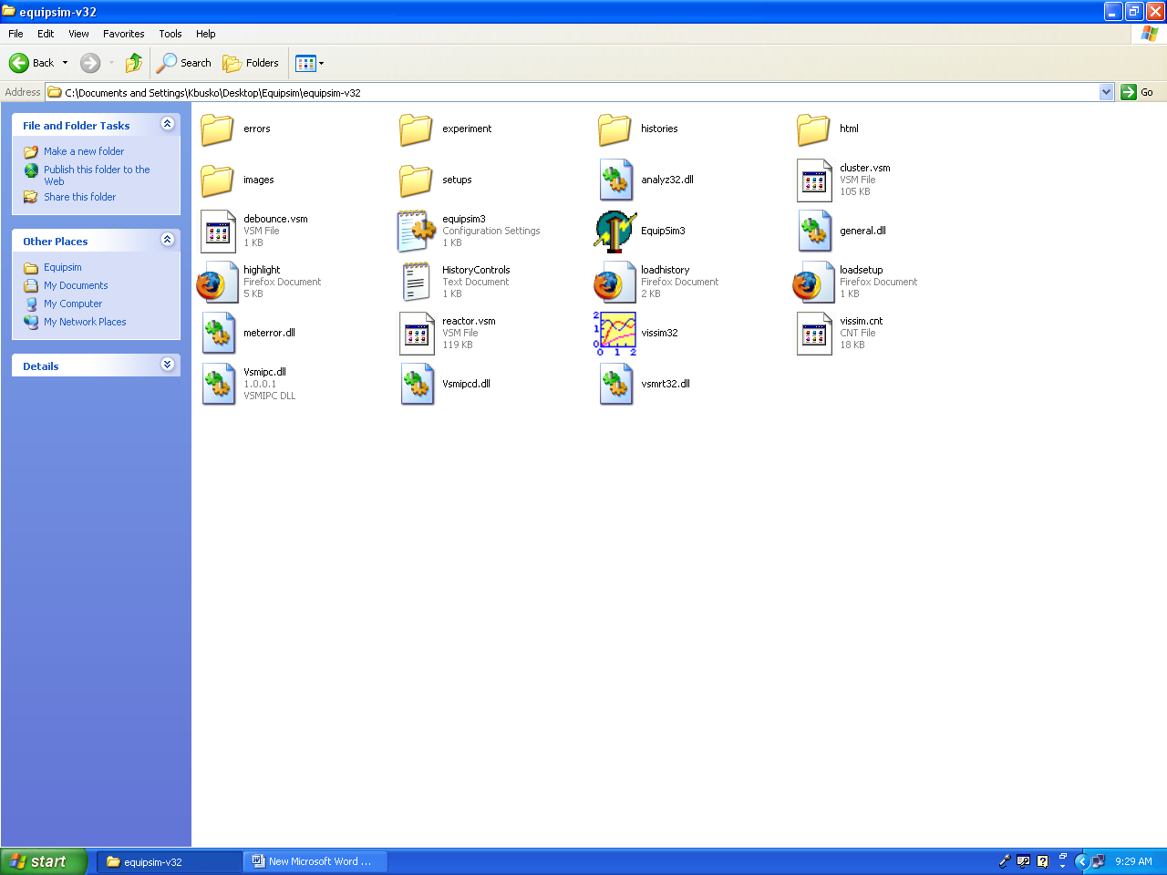 Figure I. Equipsim-v32 folder.
Select this

2. After selecting the ‘EquipSim3’ icon, the window on the next page should open.
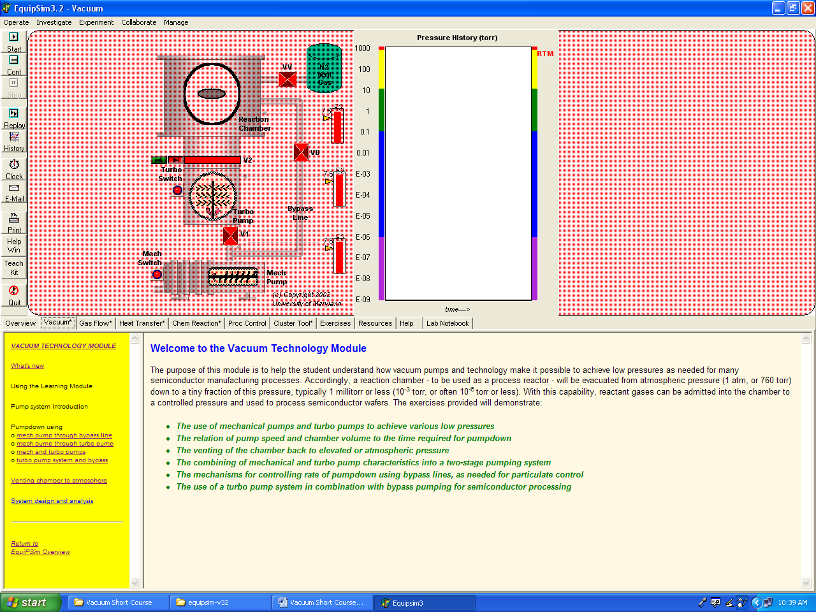
Items to Select and Read
Figure II. Main screen of the vacuum simulator.

Read “Welcome to the Vacuum Technology Module.”

3. Next, from the yellow block on the left sidebar, click on Mech pump through bypass line.

Read the description and complete exercises #1 and #2. Try to answer the questions before looking up the Answers. There are spaces on the handout to write your answers before you read the correct answers. Remember, information from lab activities will appear on quizzes or exams.

1-1. What base pressure is reached in the mechanical pump? ________
1-2. Does the pump achieve this pressure slowly or quickly? _________
1-3. What base pressure does the chamber reach? _________
1-4. Why does the chamber take longer to achieve base pressure than the mech pump?
__________________________________________________________

1-5. Why is it advantageous for a vacuum system to pump down quickly?
__________________________________________________________

1-6. Why is it advantageous for a vacuum system to pump down slowly?

__________________________________________________________
4. Select Mech pump through turbo pump and read the description, complete exercise #1 and answer the questions below. (Note: be sure VB-cutoff valve is closed before starting this exercise)

1-1. What base pressure does the chamber reach? _________________

1-2. What influences pump down speed? ______________________

5. Select Mech and turbo pumps and read the description, complete exercises #1 and #2 and answer the questions below.

Exercise #1.
1-1. After opening V1 and V2, what base pressure was achieved in the Reaction Chamber? _________________

1-2. When the turbo pump was turned on what was the reaction of the pressure in the:

Mech pump? _________________
Turbo pump and Reaction chamber? _________________
Exercise #2.

2-1. Below what chamber pressure will the influence of the turbo pump be observed? ___________________________

2-2. What happened to the Mech pump pressure at the pressure indicated in question 2-1? _________________

6. Select Turbo pump system and bypass and read the description, complete exercise #1 and answer the question below.

1-1.____________________________

7. Select Venting chamber to atmospheric pressure and read the description, complete exercise #1 and answer the questions below.

1-1. What four factors does chamber vent rate depend on? ____________________________________________________________

1-2. Explain why a fast vent is advantageous ____________________________________________________________

1-3. Explain why a slow vent is advantageous

____________________________________________________________
EquipSim Vacuum Simulator Activity #2

Gas Flow Module

1. Click on the ‘Gas Flow’ tab. The window below should appear.

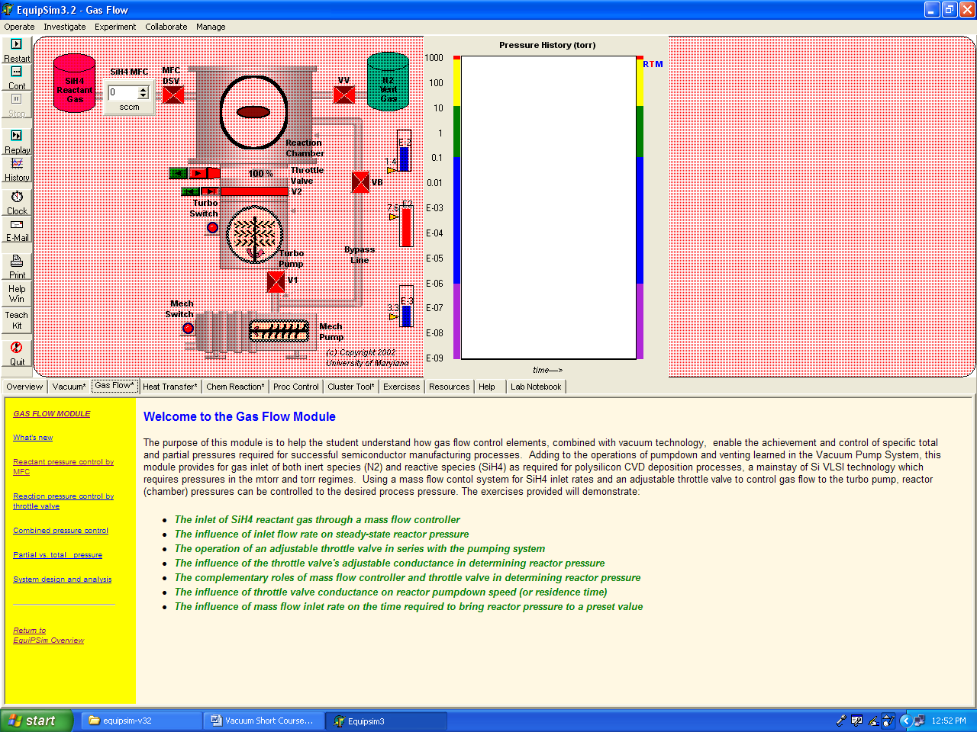
Gas Flow Tab
Figure III. Main screen of the Gas Flow exercise screen.

Read “Welcome to the Gas Flow Module.”

NOTE: the observations in the exercise in the simulation are incorrect, use the information for MFC and throttle valve settings in this handout and record the resulting reaction chamber pressures.

2. Next, from the yellow block on the left sidebar, click on Reactant Pressure Control by MFC.

Read the description and complete the exercise. (Note: the first step of the exercise should read “valves V1 and V2 are open.”)

What reaction chamber pressure was achieved w/10 sccm of SiH₄ flow? ___________________

What reaction chamber pressure was achieved w/100 sccm of SiH₄ flow? __________________

How much SiH₄ flow results in a 3.7 X 10⁻³ Torr reaction chamber pressure? ______________
3. Next, from the yellow block on the left sidebar, click on Reactant Pressure Control by Throttle Valve.

Read the description and complete the exercise. (Note: the first step of the exercise should read “valves V1 and V2 are open.”)

What pressure resulted from 100 sccm of SiH₄ and a 100% throttle opening? ________________

What pressure resulted from 100 sccm of SiH₄ and a 50% throttle opening? ________________

What pressure resulted from 100 sccm of SiH₄ and a 20% throttle opening? ________________

What pressure resulted from 100 sccm of SiH₄ and a 10% throttle opening? ________________

What throttle opening would result in 8.7 mTorr pressure with 100 sccm of SiH₄ ? ________________

4. Next, from the yellow block on the left sidebar, click on Combined Pressure Control.

Read the description and complete the exercise. (Note: the first step of the exercise should read “valves V1 and V2 are open.”)

100 sccm SiH₄ and 100% throttle opening. ________________________

100 sccm SiH₄ and 50% throttle opening. _________________________

50 sccm SiH₄ and 100% throttle opening. _________________________

50 sccm SiH₄ and 50% throttle opening. __________________________

Give two different MFC/Throttle opening combinations that yield 84 mTorr reaction chamber pressure.
__________________________ __________________________

5. Next, from the yellow block on the left sidebar, click on Partial vs. Total Pressure.

Read the description. There are no exercises or questions for this section.

EquipSim Vacuum Simulator Activity #3.

Heat Transfer Module

1. Click on the Heat Transfer tab to get this window.

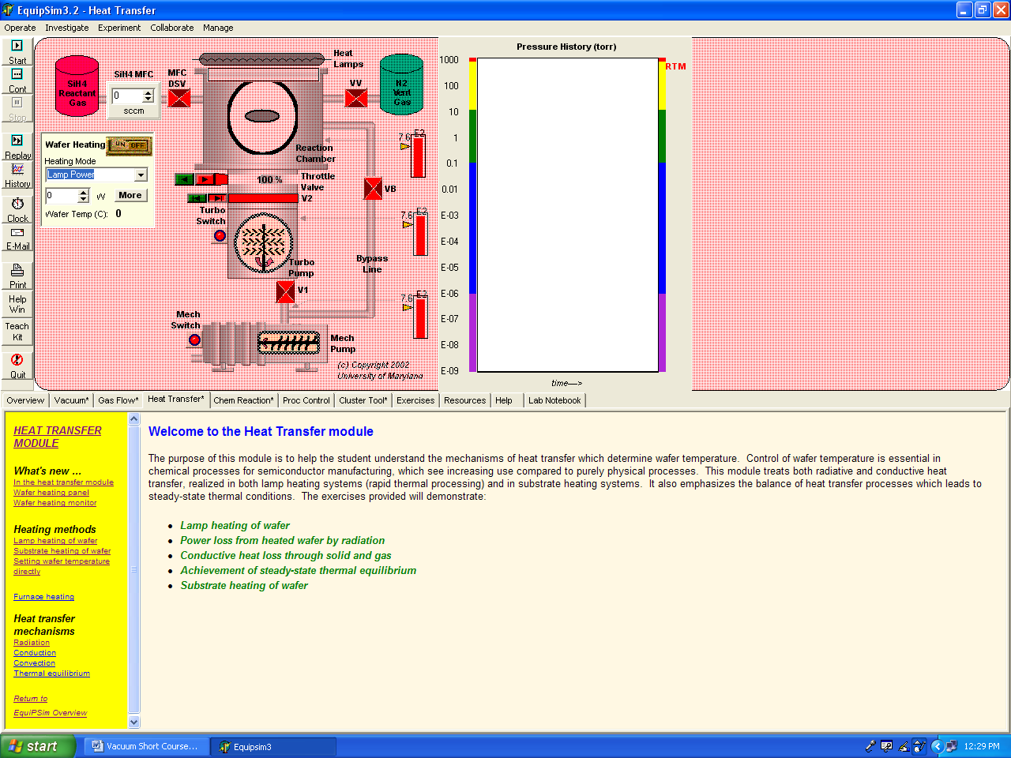
Heat Transfer Tab
Figure IV. Main screen of the Heat Transfer exercise.

Read “Welcome to the Heat transfer Module”.

2. Next, from the yellow block on the left sidebar, click on Lamp Heating of Wafer.

Read the description and complete the exercise. Note: Be sure to click on ‘MORE’ to bring up the “Wafer Heating Details” window.

What was the starting net power to the wafer? __________________

What happened to the net power to the wafer after the lamp was turned on? ________________________________________________________

At what temperature does the wafer stabilize using …

2,500 Watts? _____________ 5,000 Watts? _____________

3. Next, from the yellow block on the left sidebar, click on Substrate Heating of Wafer.

Read the description and complete the exercise.

With a 600 °C set point what actual wafer temperature was realized? _____________

Left click the ‘MORE’ button to get information regarding power absorbed and lost by the wafer.

How much power was absorbed by the wafer from the substrate heater by:

Radiative? _____________

Conductive/solid? _____________

How much power was lost by the wafer and by what means? _____________ / _____________

4. Next, from the yellow block on the left sidebar, click on Furnace Heating.

Read the ‘Furnace Heating’, ‘Radiation’, and ‘Conduction’ sections.

With Furnace Heating where does deposition occur? ____________________________________________________________

What law demonstrates that bodies at high temperature radiate large amounts of power? ____________________________________________________________

Why is the thermal conductivity of gases less than that of solids or liquids? ____________________________________________________________

EquipSim Pump Down Procedures

- All valves closed
- Turn on the Mech Pump (rough pump)
- Open VB (bypass valve or roughing valve)
- Wait for the chamber to pump down to a pressure of 2.3 X 10⁻³ Torr (crossover pressure)
- Close VB
- Open V1 (foreline valve or turbo backing valve)
- Wait for the foreline to pump down to a pressure of 2.3 X 10⁻³ Torr (crossover pressure)
- Turn on the Turbo Pump
- Open V2 (hi-vac valve)
- Wait for the chamber to pump down to a high vacuum pressure of 4.9 X10⁻⁶ Torr

Generic Pump Down Procedure (to be used in later labs)

- All valves closed
- Turn on the Rough Pump
- Open the isolation valve, if equipped
- Open the roughing valve
- Wait for the chamber to reach base roughing pressure
- Close the roughing valve
- Open the foreline valve
- Wait for the foreline to reach base roughing pressure
- Turn on the Turbo Pump
- Wait for the Turbo Pump to reach its operating speed
- Open the High-Vac valve
- After about 1 minute, turn on the High-Vac gauge

