Physical Vapor Deposition (PVD): Evaporator Practice

Objective: The purpose of this lab is to gain a better understanding of the evaporation process and practice operating the Cooke thermal evaporator. This will be the first time you apply your knowledge of vacuum systems to a real tool in the lab.

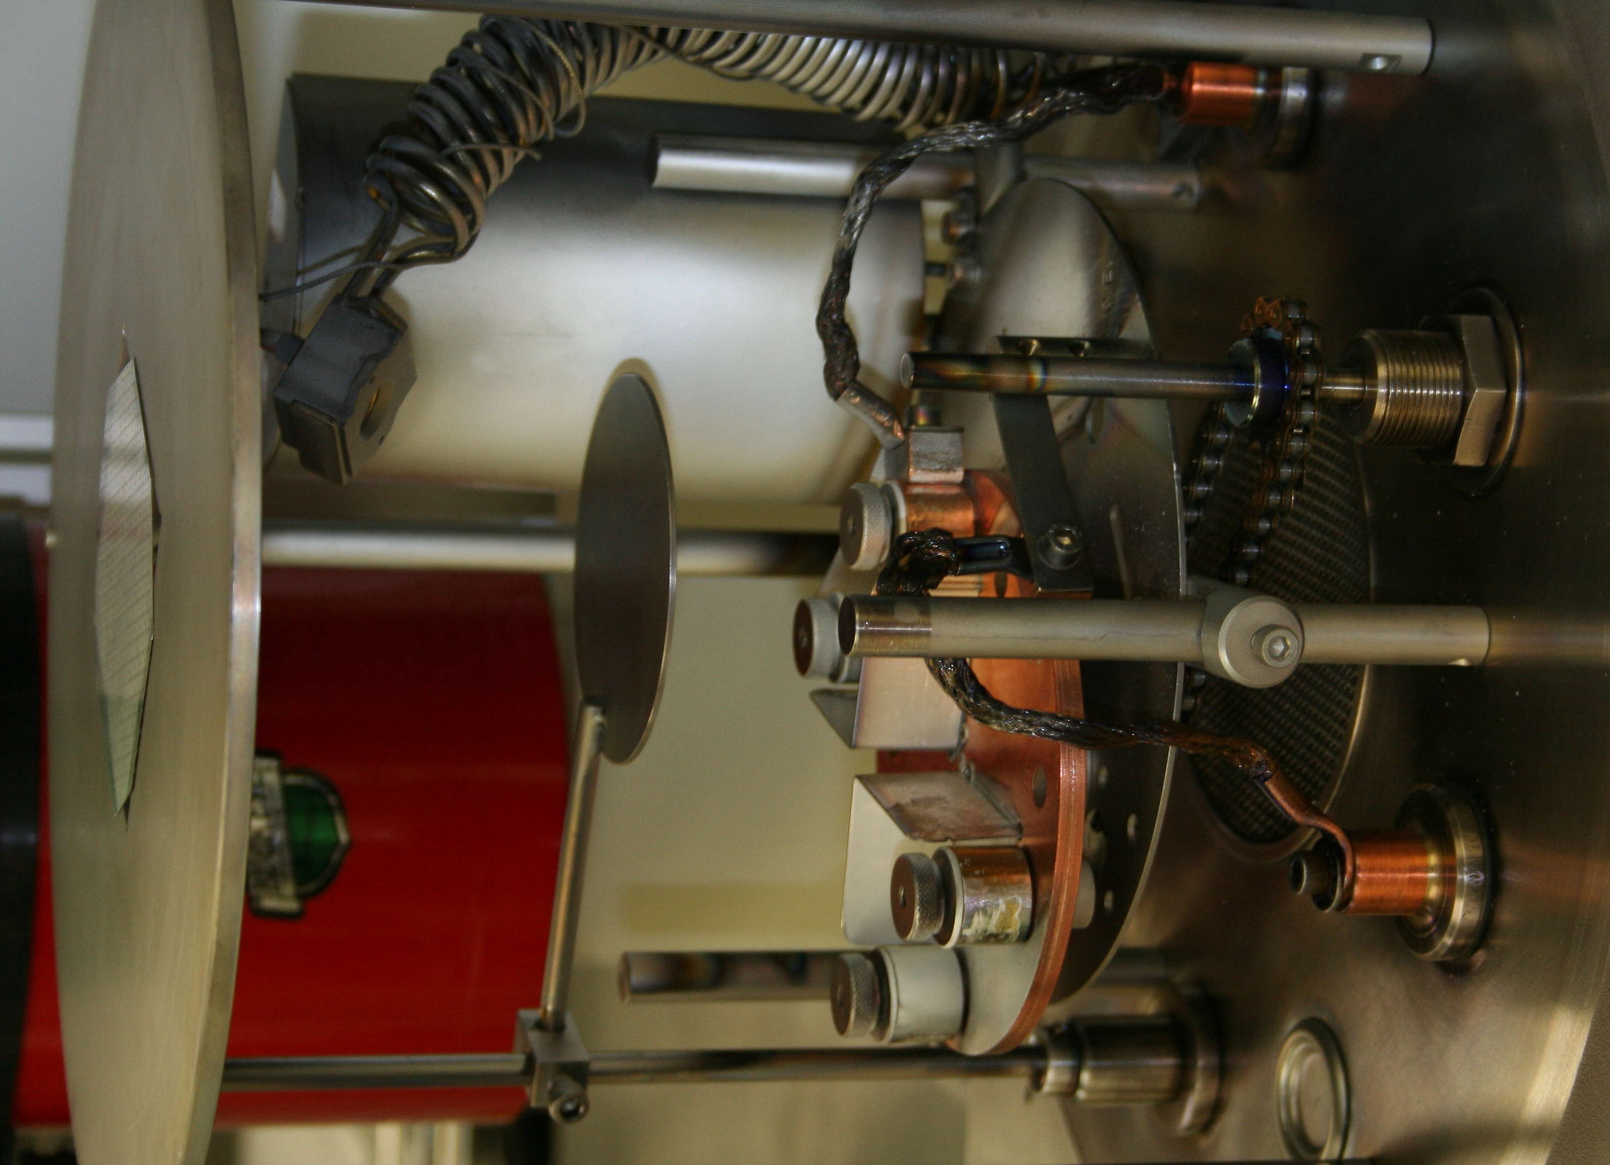

Figure I: Cooke Thermal Evaporator

Background: Training on the Cooke thermal evaporator (Figure I) and a general introduction to the evaporation process were provided in the microarray demonstration. However, several important details were glossed over. The first of which is the operation and calibration of the crystal thickness monitor (CTM). The CTM is essentially a transducer comprised of a piezoelectric crystal that generates a potential difference in response to mechanical stress. It can be modeled as a resistor (R) inductor (L) capacitor (C) (RLC) circuit with its own natural frequency response. When metal vapors strike and condense on the crystal they exert a force on its surface which alters its frequency response. The frequency response of the crystal is monitored by the CTM controller which determines the deposition rate and thickness according to two material parameters: z-factor and mass density. The z factor is the acoustic impedance of the deposited material. Before performing a deposition, the user must program the CTM with the appropriate material parameters. The density and z factor for some common metals are shown in the table below.

Metal | Density g/cm³ | Z-factor | Melting Point °C
Al | 2.73 | 1.08 | 660
Au | 19.3 | 0.381 | 1062
Cr | 7.20 | 0.305 | 1890
Cu | 8.93 | 0.437 | 1083
Ni | 8.91 | 0.331 | 1453
Ti | 4.5 | 0.628 | 1675

The crystal in the CTM has a finite lifetime. The life of the crystal needs to be checked before each evaporator run. If the life is below 50%, it should be replaced.

Another important component of the evaporator system is the shutter. The shutter allows the user to abruptly start and stop the deposition and shields the substrate from contamination during source metal heating. Some metals, including aluminum, form a native oxide. The eutectic temperature of aluminum oxide is less than the melting point of pure aluminum so it evaporates first. The shutter catches the oxide before they deposit on the substrate. The tungsten boat is another source of contamination; small amounts of particles are outgased during filament heating. The shutter must remain closed until the source metal begins to evaporate, otherwise the quality of the deposited film will be significantly reduced. In some evaporator systems control of the shutter is automated. This greatly simplifies the evaporation process and provides better control of film thickness.

Post deposition cool down is a critical step in the evaporation process. After the deposition the substrate remains under high vacuum for a minimum of twenty minutes. This allows the substrate and the tungsten filament to adequately cool before venting the chamber. Venting the chamber to atmosphere without cooling exposes the substrate to unnecessary thermal stress and encourages oxidation. The post deposition cool down also eliminates the possibility of the user being burned when removing the used boat.

Experiment: The task is to perform two successful Al depositions with the Cooke thermal evaporator. The lab group will be divided into a pump down team and a deposition team. After the first run, the teams will switch roles. Be sure to modify the Cooke thermal evaporator procedure in your lab notebook with the additional details discussed in this lab.

Questions:

- Describe in your own words how the CTM works? (4)

- Why couldn’t an alloy be evaporated onto a wafer using a single filament? (3)

- List two reasons why a shutter is used in the evaporator? (2)

- Why must the evaporation take place in a vacuum? (3)

- Name two concerns when using a shadow mask. (2)

- Which of the metals listed in the table on the previous page can be deposited using the Cooke Thermal Evaporator? (3)

- Describe the importance of the post deposition cool down. (2)

- What was the filament current prior to opening the shutter? How did this value compare to the filament current during the gold deposition in the microarray lab? Why the large difference? What other parameter might this value depend on? (4)

- Suppose you were given the task to deposit 500 Å of Au on top of 500 Å Al on a Si substrate. Excellent film quality and high purity are essential. Would it be better to perform the Al and Au depositions under the same pump down or two successive pump downs? Why? (4)

- List the types and ranges of the vacuum gauges on the Cooke Thermal Evaporator. (3)

No work will be accepted late! Lab questions are due by 11:45 AM the Monday following lab completion.

