Introduction to Top-down Lithography Contact and Proximity Lithography

Objective: The objective of this lab is to demonstrate and overview the procedures necessary to perform contact lithography.

Background: Lithography is essential for defining patterns on materials in nanofabrication. An energy-sensitive chemical is applied to the surface of a sample and is then exposed to a particular energy source, to produce a pattern. When the process involves light as an energy source, it is called photolithography. This ubiquitous process is an essential aspect of nanofabrication and is relatively versatile and inexpensive. Lithography can be used as a deposition mask (liftoff), an etch mask, an ion implant mask, and for microfluidic mold creation. The Karl Suss MJB3 shown in Figure I and the Karl Suss MA6 shown in Figure II are both popular contact lithography tools. Both systems are termed contact aligners, because these systems clamp the mask and sample together in a tight seal before exposing the sample to ultraviolet light energy. Both systems are theoretically capable of printing features as small as ~0.5µm. Importantly, the key concept used for contact lithography can be related to e-beam lithography technology and stepper lithography technology.

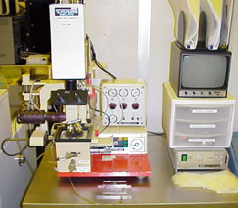
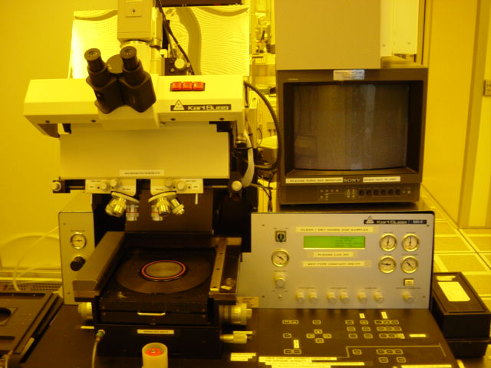
Figure I. Karl Suss MJB3 Contact Aligner Figure II. Karl Suss MA6 Contact Aligner

While conceptually simple, the lithography process requires some practice, and the minimum feature resolution is often a function of skill. Small deviations in the photoresist, developer, mask contact pressure, substrate material, process temperatures, room temperature and humidity can cause variations in the results. Understanding these dependencies and practice, will allow one to define the smallest feature sizes. Figure III shows a side view of a sample coated with photoresist in contact with a photomask. Table I lists the typical process parameters for Shipley 1813 photoresist application. Modification of any of the parameters often impacts the final product. A consistent repeatable process is necessary to maintain a desired resolution.
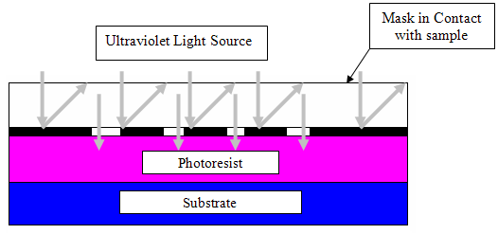
Figure III. A sample coated with photoresist, in contact with a photomask.

Photolithography Steps for Shipley 1813 Positive Photoresist
Processing Step | Temp. | Time | Description
1. Clean Sample |  |  | Acetone/Isopropanol/Deionized (DI) water is used to remove particles and residual materials from a past step.
2. Dehydration Bake | 105ºC | 3-5 min | Removes moisture and volatizes other liquids from the surface, in order to promote adhesion of the photoresist (PR) to the substrate.
3. HMDS Application |  |  | Use HMDS recipe application (hexamethyldisilazane).  Increases the hydrophilicity of the sample surface, which increases the wettability of the PR material, so as to increase adhesion.
4. HMDS Bake | 110ºC | 15 sec | Removes any remaining solvents from the HMDS.
5. Spin Photoresist |  | 45 sec | Use D09.40/45 recipe. Photoresist is applied dynamically during step one and spun to provide a uniform coating.  Final thickness is a function of spin RPM.  Uniformity is a function of ramp rate.
6. Soft Bake | 105ºC | 90 sec | Removes solvents and hardens the PR, to prevent material from sticking to the mask in the contact aligner.
7. Exposure |  | 6.3 sec | Expose PR on sample to 365nm wavelength UV light to break polymer bonds in positive-type PR.
8. Develop |  | 55 sec | Use CD26 or MF312/DI water (tetramethylamoniumhydroxide) to remove the PR in areas exposed to UV light.
9. Rinse/Dry |  | 30 sec | Remove the sample from the developer and place in an overflow DI water bath for approximately 30 sec.  Dry with nitrogen, which displaces moisture.
10. Inspection |  |  | Check pattern for defects such as over/under exposure, over/under development, contamination, etc.
11. Hard Bake (optional) | 120ºC | 3-5 min | Hardens PR for further processing when desired
12. Clean Spinner |  |  | Use EBR and CLEAN recipe

HMDS application recipe:

Step | Time | RPM | Ramp (RPM/Sec.)
1 | 15 sec | 500 | 1000
2 | 10 sec | 2500 | 1000

D09.40/45 photoresist spin recipe:

Step | Time | RPM | Ramp (RPM/Sec.)
1 | 15 SEC. | 900 | 1000
2 | 1.5 SEC. | 2000 | 10,000
3 | 45 SEC. | 4000 | 10,000
4 | 1 SEC. | 100 | 5000

EBR CLEAN recipe:

Step | Time | RPM | Ramp (RPM/Sec.)
1 | 1 SEC. | 400 | 1000
2 | 20 SEC. | 2000 | 300
3 | 1 SEC. | 2100 | 1000

Experiment: This exercise enables you to become familiar with the lithography process. Please take good notes and ask questions.

Take Detailed Notes! Remember to bring a thumb drive and a 3½″ floppy disk.

Questions:

- Name two major differences between the MJB3 and the MA6. (2)

- Generally, what process tool creates the mask? (2)

- What side of the mask is in contact with the PR? (2)

- Research the MSDS for MicroChem EBR PG. What are ingredients in this material and what are the handling precautions for this material? (2)

- Research the MSDS for Microposit CD-26. What are the ingredients and in what percentages are they found in this material? What are the environmental precautions for disposal? (2)

- Name and briefly describe three things that can impact the final pattern resolution (think about this in great detail and give a well educated answer). (3)

- What happens when the mask is not in good contact with the PR? (2)

- What dictates resist thickness? (2)

- List and describe the chemical makeup of resists. (3)

- Describe the resolution limits of contact lithography and explain why it exists. (3)

- Describe the mechanism on which positive photolithography works. (4)

- Create a table for nanospec readings using the standard five point measurement method. (3)

Lab questions are due 11:45 AM the Monday following the lab completion date. NO WORK WILL BE ACCEPTED LATE!

