Liftoff and Surface Modification Lab

Objective: The objective of this lab is to determine the relative adhesion of different metals on various substrates. Hard baking photoresist and plasma surface treatment will be employed to determine which combination yields the best results.

Background: The liftoff process is used to selectively deposit metals without the need for etching. This is a valuable technique because pre-existing layers may exclude some etch techniques. The process is also valuable because it is simple, low temperature, and cost effective.

One major concern using this technique is adhesion of the metal to the exposed substrate. Another concern is the sidewall profile of the photoresist. This experiment will look at both issues. The hard bake affects the slope of the photoresist sidewalls, which in turn affects the quality of the metal deposition and liftoff. Figure I shows some examples of this.

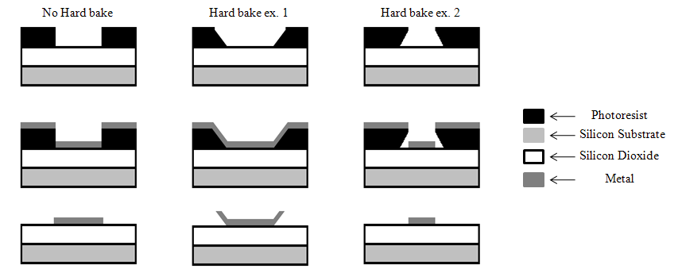
Figure I. Examples of sidewall profiles and the effect hard baking has on metal deposition after the liftoff process.

The last example in Figure I produces the best liftoff quality. During photoresist removal, any material that is in contact with the metal can interfere with the success of the liftoff.

The liftoff technique is valuable, but is not effective at times due to poor adhesion of the metal to the surface it is deposited on. Two basic adhesion problems are surface contamination and surface condition. Surface contamination often occurs from the residual organics of photolithography. Surface condition is often "given by nature," or a function of the last process. While there are a wide range of contaminants and surface conditions, plasma pre-treatments can often clean and modify the surface for increased adhesion of deposited metals.

Training necessary: Thermal evaporator, Technics Micro 80 RIE and metrology tools.

Experiment: Photoresist hard baking and plasma surface treatment will be performed to investigate the affect of metal adhesion for aluminum and gold on silicon and silicon dioxide. This experiment will take two full lab sessions. Good note taking and organization are essential for timely lab completion. Be sure to have a defined plan of action before starting this experiment.

Day 1

Start the first lab session by performing a 6:1 buffered oxide etch (BOE) on the silicon substrate to remove native oxide. Next, photolithography with Shipley 1813 positive photoresist will be performed on both the silicon and the silicon dioxide samples. Cleave and label both samples according to the process flow sheet on the last page of this handout.

The profilometer will be used to find the height of the photoresist and width of a specific feature to be metalized. Some samples will be hard baked others will only be soft baked. Try to measure a feature that can be found on each sample and be sure to measure the exact same feature each time the profilometer is used on any specific sample.

To see if hard baking has an impact on the conformability of the metal, hard bake the appropriate samples for 4 minutes at 120°C. Plasma treat the appropriate samples using the recipe found in Table I, and then thermally evaporate 250Å of aluminum on the indicated set of samples.

Day 2

This lab session will start with the plasma treatment of the samples for gold deposition using the recipe found in Table I. Thermally evaporate 250Å of gold onto the appropriate samples. Next, perform liftoff on all samples in acetone using the ultrasonic cleaners. Each sample should be sonicated for 3min. After sonication rinse each sample with isopropanol and DI water. Measure the metal feature’s width on each sample for comparison with the width data from the photoresist profilometer scans.

Use the microscope to obtain both bright and dark field images of each metalized feature. Record observations made of the samples while using the microscope.

Use your processing skills and resources to complete the objectives. Like many processing projects, you should plot out your course of action. Some details can be lost if you do not draw up a well-detailed plan.

Hints: Delegate work to each group member. Keep details of the process for ease in writing your report.

Technics Micro 80 Plasma Treatment Recipe
Base Pressure | 10 mT
Processing Pressure | 410mT
Processing gas ratio | 4:1 Ar:O₂
Power | 200 W
Time | 45 sec
Table I: Recipe for Plasma Treatment

Questions:

- List and describe the role of the chemistry used for BOE. (3)

- List and describe the role of the gas chemistry used for plasma treatment. (4)

- Research and summarize one alternative photoresist for Shipley 1813 for the liftoff process. (3)

- Research and summarize one peer - reviewed reference on the liftoff process. (5)

Lab reports are due 11:45 AM the Monday following the lab completion date. NO WORK WILL BE ACCEPTED LATE!

