Introduction to Plasma-based Processing
Objective: The purpose of this lab is to introduce plasma processing for both deposition and etch while improving your note taking abilities. This lab will also serve as a training session for the operation of the sputtering and reactive ion etch (RIE) tools in the CNEU lab. These tools will be used throughout the semester and will help with your understanding of more complex systems.
Introduction: Plasma is one of four states of matter and simply put, is energized gas consisting of neutral species, positive ions, and free electrons. Plasma is created when a gas is introduced into a vacuum chamber typically at pressures from a few Torr to 100s of mTorr, in the presence of DC or RF fields. Pressure plays an important part in how the plasma can be used by controlling the plasma density. Processing with plasma is useful because high energy reactions occur near a surface at relatively low temperatures. This technique can be applied to either deposit or remove (etch) materials.
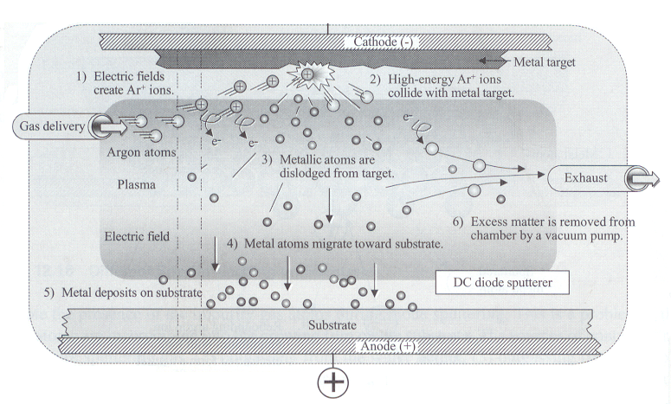
Sputtering is a physical vapor deposition (PVD) technique. Although there are many forms of sputtering, the basic idea is that a plasma [typically created from Argon (Ar)] is generated between the cathode (the target) and the anode (the substrate), the Ar⁺ ions from the plasma are directed towards the target. As Ar⁺ bombards the target, material is removed from the target and subsequently deposits on the substrate. Ar is often the gas of choice for sputtering, due to its large mass. Figure I overviews the sputtering process.

Figure I: Sputtering overview diagram. (Quirk 2001)
Reactive ion etching (RIE), is a plasma-based technique used to remove materials from a sample. In RIE, a plasma is generated between two electrodes, the substrate (cathode) and the anode. Gas selection in RIE is specific to the materials being etched. Organic materials are typically etched with oxygen in a process called ashing. Silicon based materials such as SiO₂ and Si₃N₄ are typically etched in a mixture of a fluorine containing gas such as CF₄ and oxygen. An overview of the etching process is shown in Figure II.
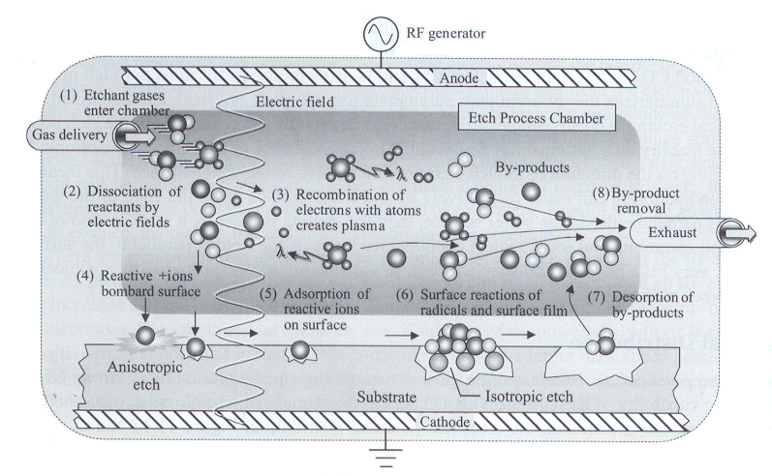

Figure II: RIE overview diagram. (Quirk 2001)
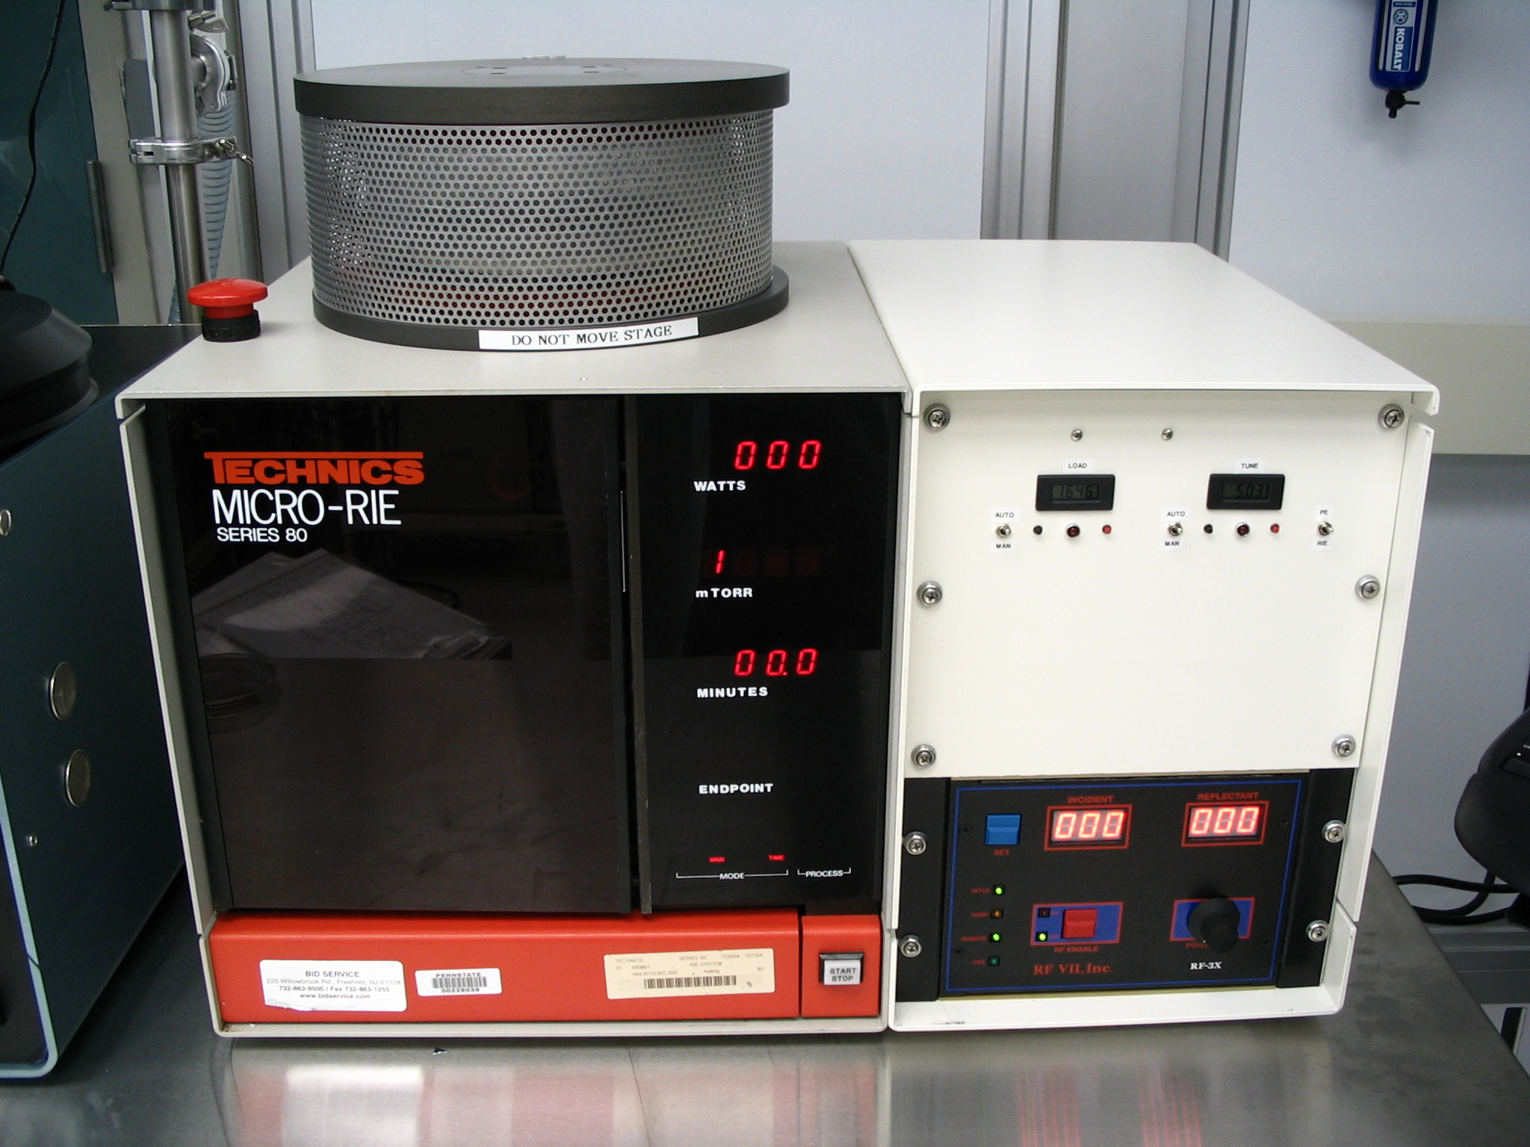
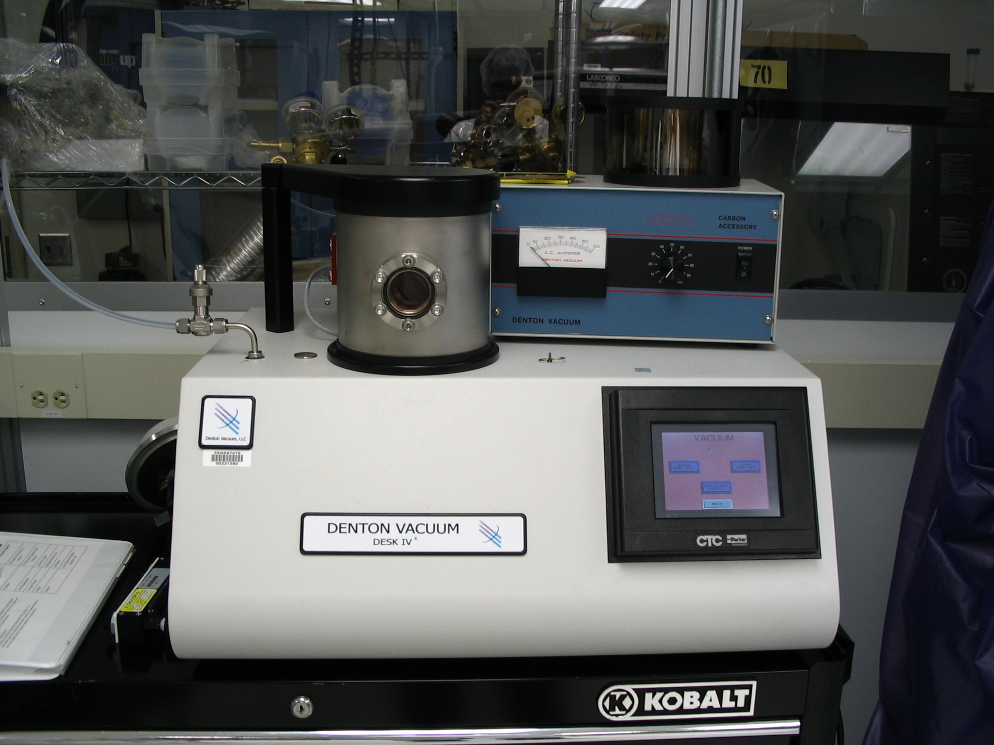
Plasmas can also be used in chemical vapor deposition (CVD). This technique will be overviewed in other laboratory sessions.

Figure III: Denton Desk IV Sputtering Tool Figure IV: Technics Micro-RIE 80

Experiment: Students will undergo training on the Denton Vacuum Desk IV Sputtering Tool (Figure III) and the Technics Micro-RIE 80 (Figure IV). Both of these tools will be used throughout the semester and will be used in more detail in later labs. Take good notes and answer the following questions. There will not be a formal lab report for this activity.
Questions:
1. What is the typical base pressure of the sputtering tool? (3)
2. What is the typical operating pressure of the sputtering tool? (3)
3. What is the typical gas source for sputtering and why is it used? (3)
4. What typical materials are sputtered with the Denton Desk IV? What materials cannot be sputtered with the Denton Desk IV? (3)
5. What type of power supply does the Denton Desk IV have? (3)
6. What is the typical base pressure of the Technics Micro-RIE 80? (3)
7. What gas sources are used for the Technics Micro-RIE 80? (3)
8. What are typical materials that can be etched with the gas sources on the Technics Micro-RIE 80? (3)
9. What type of power supply is on the Technics Micro-RIE 80? (3)
10. What is the difference between PE and RIE? (3)
References:
Quirk, M. and Serda, J. Semiconductor Manufacturing Technology. Prentice Hall. New Jersey. 2001

