Dry Etch Rate Lab for Photoresist, SiO₂ and Si₃N₄

Objective: The processing objective is to show insight into the dry etch process; this experiment will also give the students experience with the Technics Mirco-80 and the Plasma Therm 720 Reactive Ion Etch (RIE) systems. The goal of this experiment is to determine the etch rates for photoresist, silicon nitride, and silicon dioxide based on varying the process conditions to build an understanding of how these changes affect etch rates.

Background: The dry etch process can be used to produce an isotropic or anisotropic etch profile. Dry etching holds several advantages over its wet chemical predecessors. Figure I below, shows the differences between anisotropic and isotropic etch profiles. Figure II at the top of the next page, illustrates the affect wet etch has on sidewall profiles.

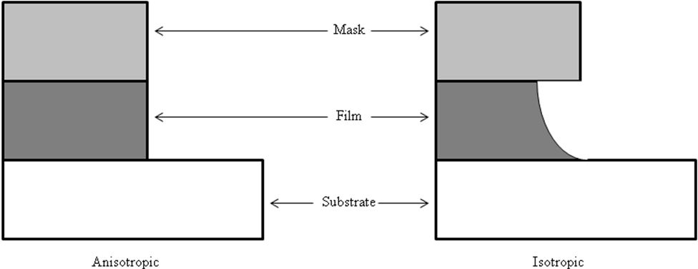
Figure I. Dry etch profile versus wet etch profile.

Only dry etching is capable of high resolution (micron, submicron, and nanometer) features from lithographic resist layers. This is due to the inherent directionality of reactive ion etching, which utilizes ion bombardment (with energies ranging from tens to hundreds of eV) of the material surface to aid the chemical etch processes. For many dry etch chemistries, there are specific film formers added to the chemistry to protect the sidewalls. Dry etch processes are also generally more reproducible than wet etching. For example, the etch rates of many wet chemical etchants are highly dependent on the film stress, state of the material, and even on very small changes in chemical bath temperature (a few degrees Celsius).
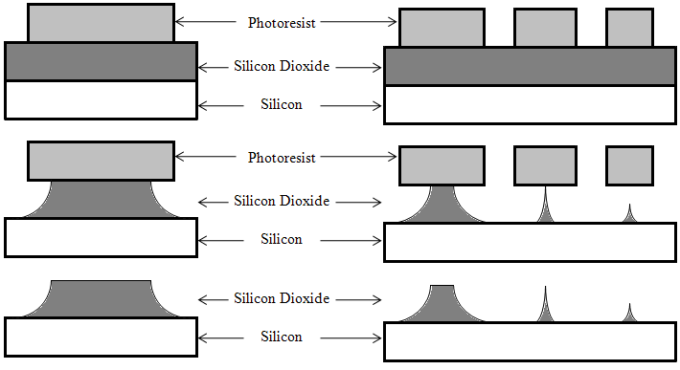
Figure II. Wet etch profiles. Notice the loss of definition with this method.

Wet etch processes also generally have environmental drawbacks. Waste from wet etch processing is usually voluminous (~gallons) and waste treatment and disposal is a bigger problem when compared to dry etch processing.

Dry etching does, however, have some disadvantages compared to wet chemistry. For example, the energetic ions that are the essence of dry etch processing can damage materials and adversely affect properties of the etched layers. This damage includes point/extended crystal defects, implanted impurities, surface residue, damage due to ultraviolet (UV) light generated in the plasma, and defects due to electrical charging of the sample. Loading effects, or the dependence of etch rate on feature size and local geometry, is also a problem in dry etching. Furthermore, low etch selectivity (eg. erosion of photoresist layer) is also a problem in dry etching. Resists that can withstand dry etch processes by design or by treatment are often difficult to remove after the dry etch process step. Dry etching requires a large capital equipment investment in the form of vacuum equipment, corrosive gas handling, radio frequency (RF) electrical power generation/transmission, and sample handling. This capital investment is generally always more expensive than the most complex wet etching equipment. However, all of these disadvantages are tolerated in modern micro-and nanofabrication since there is generally no alternatives to dry etch processes in the fabrication of submicron feature sizes.

The parallel plate reactive ion etch (RIE) tool is popular in the fabrication of etched features in the submicron range. The Plasma Therm 720 is a good example of this design. The energy is commonly coupled via a capacitor from a 13.56 MHz generator. The pressure on the system is varied from the mTorr range up to a few Torr to generate a plasma with properties needed to produce a certain etch profile, dictated by the end application.

Training necessary: Technics Miro-80 RIE system, Plasma Therm 720 etch system, Ellipsometer, and Profilometer.

Experiment:
RIE I – Day I

The first part of the experiment will investigate selectivity of an etch using the Technics Micro-80 RIE. The etch rates of Shipley 1813 photoresist (PR) under two different power settings will be determined. Cleave the sample in half and measure three areas with the profilometer on each half as shown in Figure III. Scribe a mark near each point of measurement, so the same location can be measured post etch. Perform an oxygen plasma ash on the first piece using the following recipe:

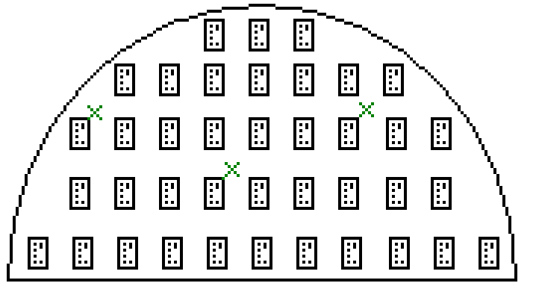
Figure III: Sample map for RIE-I PR & RIE-II etch rate study

Pressure and gas = 200 mTorr O₂, Power = 150 Watts, 1 minute ashing time.

For the second sample, change the power to 250 Watts. Measure the post etch thickness of the photoresist with the profilometer. Fill out Table I completely and include it in your lab report.
 | Soft Baked Shipley 1813 Photoresist
 | Pre-etch Thickness |  |  | Post-etch  Thickness |  |  | Average Etch Rate  (Å /sec)
Sample | Position |  |  | Position
Sample | 1 | 2 | 3 | 1 | 2 | 3
150W
300W
Table I. Soft baked Shipley 1813 PR pre and post etch thicknesses, calculated etch rates.

The second part of this experiment will investigate uniformity of an etch using the Technics Micro-80 RIE on both a SiO₂ and a Si₃N₄ sample. This section of the lab will utilize both the Plasma Etch (PE) and the RIE setting on this tool. A total of four etches will be preformed in this section. Quarter samples will be used. Measure each sample pre and post etch using the standard five point measurement system shown below in Figure IV.

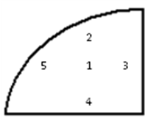
Figure IV: Sample map for measurements.

Setup the following recipes in Table II to use a 5:1 CF₄:O₂ ratio. Use each recipe once per sample.

Tool Setting | Material | Base Pressure | O₂ Pressure | CF₄ Pressure | Total Pressure | Power | Time
PE | SiO₂ | 10mT |  |  | 310 mT | 250 W | 60 sec
PE | Si₃N₄ | 10mT |  |  | 310 mT | 250 W | 60 sec
RIE | SiO₂ | 10mT |  |  | 310 mT | 250 W | 60 sec
RIE | Si₃N₄ | 10mT |  |  | 310 mT | 250 W | 60 sec
Table II: Recipes for Day 1 SiO₂ and Si₃N₄ samples

Create a table to organize your etch data for this section of the lab.

RIE II – Day II

The second part of the experiment will use the Plasma Therm 720 to determine the etch rates of patterned SiO₂ and Si₃N₄ samples. Fluorine (F) is know to etch silicon and silicon containing materials, but has no selectivity for silicon or silicon containing material and is therefore, not used when silicon containing materials are found in the presence of silicon (e.g. SiO₂ on top of Si). Fluorocarbons are a preferred source gas for plasma etching of silicon containing materials in the presence of silicon, because CF_{x} radicals do not spontaneously etch the silicon containing materials. The etch is a result of large CF_{x} ion bombardment (eg. RIE). The addition of O₂ (up to 30%) during fluorocarbon etching of silicon containing materials, increases free F while decreasing CF_{x} and effectively increasing the etch rate of a silicon containing material. When etching silicon containing materials patterned with a photoresist, using CF_{x}/O₂ chemistry, the photoresist is ashed as the underlying material is etched. Consequently, there are two etches rates to calculate for these samples, which will be discussed during the lab.

Measure three areas with the profilometer on each sample as shown in Figure III. Scribe a mark near each point of measurement, so the same location can be measured post etch. Be sure to measure the PR height and feature width of each feature, then remove the PR and measure the same feature a third time. Create a table for this data.

Four etches will be performed during this section of the lab. Details of the recipes for these etches are listed below in Table III. Record the DC bias for each trial.

Material | Pressure | O₂ | CF₄ | Power | Time | DC bias
PR Patterned SiO₂ | 300mT | 5sccm | 45sccm | 300 W | 60 sec
PR Patterned Si₃N₄ | 300mT | 5sccm | 45sccm | 300 W | 60 sec
PR Patterned SiO₂ | 30mT | 5sccm | 45sccm | 300 W | 60 sec
PR Patterned Si₃N₄ | 30mT | 5sccm | 45sccm | 300 W | 60 sec
Table III: Recipes for day 2 PR patterned SiO₂ and Si₃N₄ samples.

Hints:
Keep details of the process. Often changes in the intended experiment can lead to good results! Mistakes happen in all experiments. Take advantage of mistakes, comment and learn from them.

Questions:

- Given the etch rate found for Shipley 1813, from your results in Table I, at 300W, what would you expect the etch rate to be of a precise Shipley 1827 layer? (2)

2. Given the etch rate found for Shipley 1813, from your results in Table I, at 300W, approximately how long would you expect it to take to remove all the PR from a silicon sample precisely coated with : (3)
- Shipley 1813?
- Shipley 1827?
- Shipley 1805?

- If the same processing recipes are used, why would it be inadvisable to etch many varying materials concurrently in a dry etch system? (2)

- Why is the etch rate different between the SiO₂ and the SiN_{x}? (3)

- Research and summarize one peer reviewed source of plasma etching silicon based materials. (5)

Additional references:

Lieberman, Michael. Principles of Plasma Discharges and Materials Processing.
ISBN 0-471-00577-0

Lab reports are due 11:45 AM the Monday following the lab completion date.
NO WORK WILL BE ACCEPTED LATE!

