Introduction to Physical Vapor Deposition (PVD): Thermal Evaporation of a Microarray

Objective: The objective of this lab is to observe the steps necessary to fabricate a microarray while practicing lab protocol and safety procedures. The operation of the Cooke Thermal Evaporator (Figure I) will be demonstrated by the instructor. Take good notes. This tool will be used repeatedly throughout the semester and will be part of your practical examinations. This lab will also serve as your formal training of the operation of this tool.

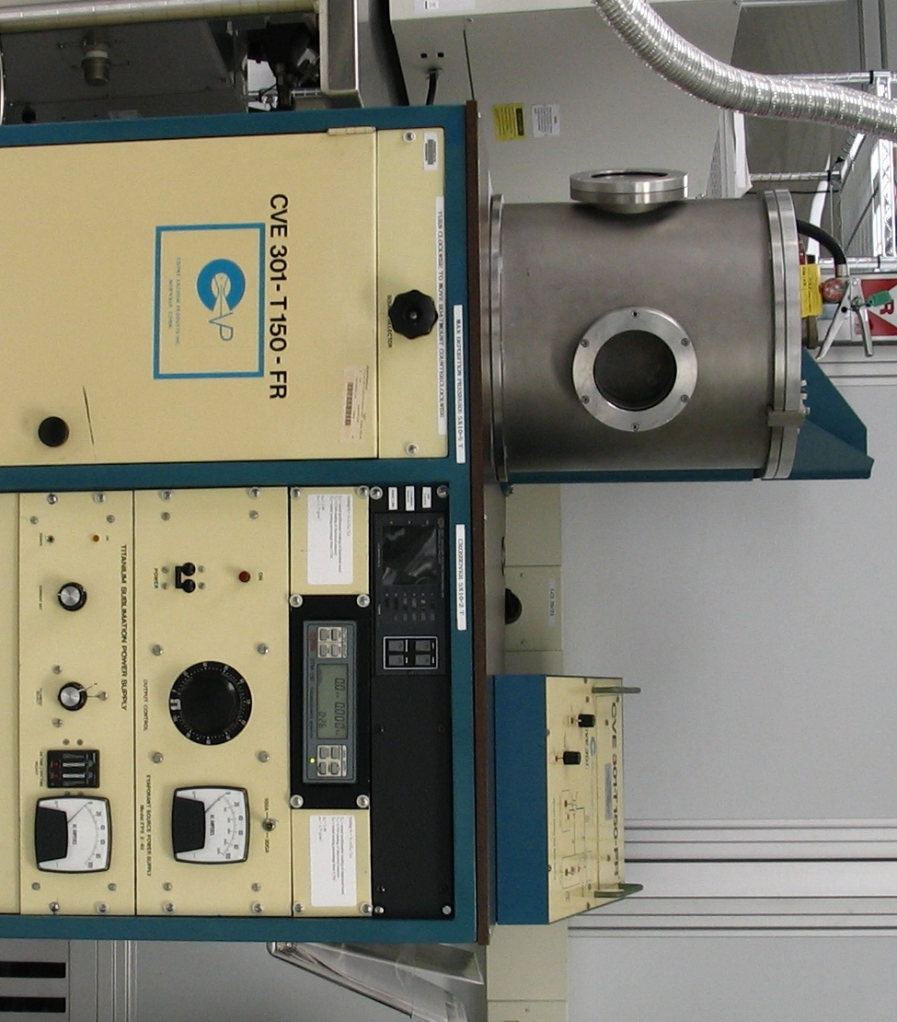
Figure I: Cooke Thermal Evaporator

Introduction: An evaporator is a tool used for depositing metals in many nano-scale products. In evaporation the source metal is heated under vacuum until it vaporizes. The vapor travels in a straight line until it reaches the substrate and condenses on its surface. This technique of metal deposition is widely used because it is a relatively inexpensive and simple process. In an evaporator, the metal heating source can be filament or electron gun based. Both systems utilize high vacuum chambers to maintain the appropriate mean free path (MFP). In order to achieve a successful deposition, the MFP must exceed the distance between the source and the substrate. One drawback of evaporation versus other PVD techniques is that alloys cannot be deposited efficiently because of thermal segregation. Other shortcomings are the inability to fill high aspect ratio holes and produce conformal step coverage.

A filament is a simple heat source. The source material is placed in a metal coil, or boat usually made of tungsten because of its high melting point. A high current is passed through the coil heating the metal until it becomes liquid and eventually vaporizes. Despite the ease of thermal evaporation, filament heating can be difficult to control, and refractory metals such as titanium cannot be deposited due to their high melting point. In addition, the evaporation process is susceptible to contamination from unwanted vapors emitted by the heated filament.

The second kind of heat source, electron gun, or e-gun, is more complicated and more expensive. In e-gun evaporation, a beam of electrons is focused by magnets, and strikes a water-cooled crucible containing the source metal. Electron beam evaporators are capable of depositing refractory metals and offer better control of the evaporation rate.

Background: A microarray (Figure II) is a collection of micron sized features that are spatially arranged in a two dimensional grid. Micro arrays form the basis of many biological assays including: DNA detection, gene expression profiling, and protein or antibody detection. Microarrays offer an inexpensive, high-throughput alternative to traditional testing methods in microbiology and medicine. In this experiment we will fabricate a gold microarray, which will be used as a self assembly platform for thiolated quantum dots later in the course. Fluorescent quantum dots are commonly used as biomarkers in DNA/oligonucleotide microarrays. Many organic molecules including alkanethiols and DNA nucleotides have a high affinity for gold, making it an excellent choice for self assembly platforms and lab-on-chip applications. In addition, gold is corrosion resistant and relatively easy to deposit. The metal features will be deposited onto a thin oxide layer to prevent fold diffusion into the silicon substrate.

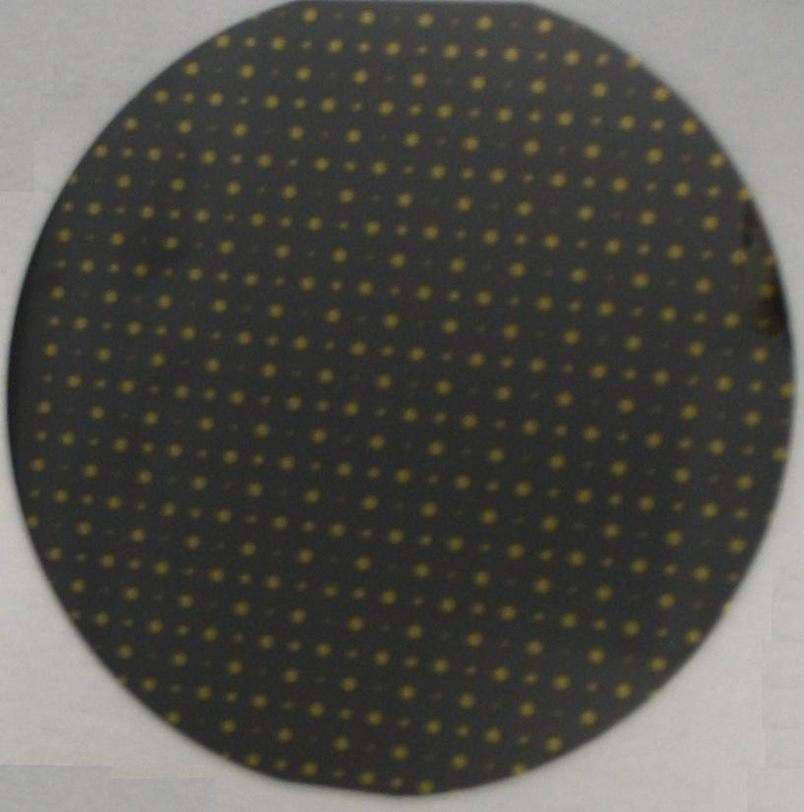
Figure II: Evaporated Au Microarray

It should be noted that the structure fabricated in this lab is synonymous with the metal oxide semiconductor (MOS) capacitor which is the basis of CMOS technology found in most electronics produced today, and can serve as a powerful characterization tool.

Training Necessary: Safety training, lecture review of vacuum technology, Dektak 32 Profilometer, Leitz Ergolux Optical Microscope.

Experiment: To save time, 200Å of oxide has been grown onto a 3 inch P type wafer prior to entering the lab. Start by verifying the oxide thickness with the ellipsometer. The instructor will demonstrate the operation of the evaporator by depositing 500 Ǻ of Au onto the prepared substrate. A shadow mask will be used to define the metal features on the substrate. Be sure to take good notes on the operating procedure and record all observations and results. After the deposition, image the sample with the optical microscope. Take at least one bright field and one dark field image with measurements. Next, perform 5 profilometer scans with height and width measurements. Pay strict attention to the operation of the system. This lab will serve as your formal training of the evaporator.

Be safe, ask safety questions, and become familiar with the clean room. Use your observation skills, and please ask the instructor questions.

Questions:

- Explain the principle of operation of the evaporator. (2)

- What is the melting temperature of gold (ºC)? (1)

- According to your text book, what is the biggest drawback to the evaporation process? (3)

- What is one testing method for measuring oxide thickness and is it destructive or non-destructive? (1)

- What is a testing method for measuring metal thickness and is it destructive or non-destructive? (1)

- Which PVD technique would you select to deposit the following materials? (3)
- Al
- Ti
- SiO2

- Research and summarize a peer reviewed source for application of gold microarrays. (4)

References:
E.H. Nicollian, J.R. Brews
MOS (Metal Oxide Semiconductor) Physics and Technology

Pierret, Robert
Field Effect Devices, 2nd edition
ISBN 0-201-12298-7

Smith, Donald L.
Thin Film Deposition, Principles and Practices
ISBN 0-07-113913-3
No work will be accepted late! Lab reports are due by 11:45 AM the Monday following lab completion.

