Student # __________ Group # __________ TA _______________

Vacuum Equipment: Components and Systems Part 1

Objective: The objective of this lab is to reinforce the classroom theory of vacuum systems with the hands-on creation of two types of vacuum systems. The first task is the assembly of a low vacuum system followed by the performance of an up-leak test to verify that the system was assembled properly and is operating within appropriate leak tolerances. The second task is to change the low vacuum system into a high vacuum system, achieve a high vacuum state and manipulate the pressure of the system with a mass flow controller.

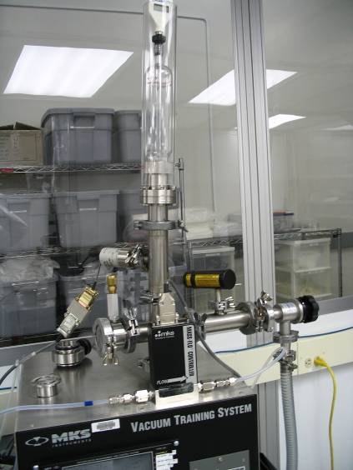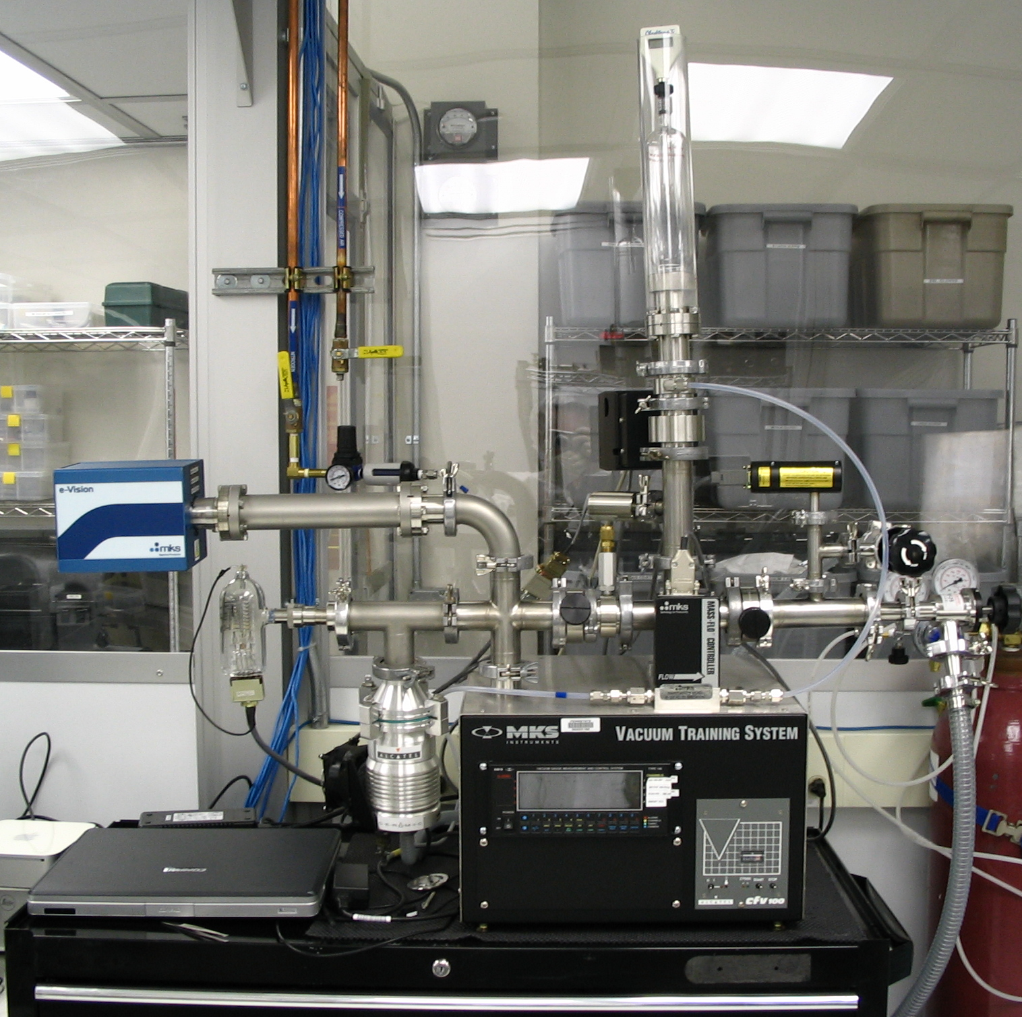

Background: Vacuum systems are used in many nanofabrication processes such as physical vapor deposition (PVD), reactive ion etching (RIE), chemical vapor deposition (CVD) and others. It is important to understand the various types of systems and the purpose each variant serves. The MKS Vacuum Trainer is a versatile tool used to instruct students in the proper use of vacuum systems representative of those used in nanofabrication. By understanding the basic concepts and components of a vacuum system, the student will be able to operate the equipment they learn on and use throughout the semester with confidence. By learning to troubleshoot vacuum systems, the student will develop the skills needed to identify and correct problems encountered in a nanofabrication production environment.

Lab Procedure: The lab will begin with a discussion of the vacuum components (fittings, plumbing, pumps, and gauges) encountered in the exercise, their assembly, and operation. Following the discussion, the remainder of the lab will be hands-on. You are expected to get your hands dirty! Identify and assemble the components of the vacuum system as per the assembly information and instructor’s directions. Pay attention to the procedure. In the remaining vacuum labs the students perform all the testing and operation procedures.

Steps – Part 1, Low Vacuum System Construction:

- Connect the components of the vacuum system per the assembly instructions on the following two pages and instructor directions.
- Close all valves.
- Turn rough pump on.
- Open isolation valve.
- Use pirani gauge to monitor the system pressure.
- At base pressure (around 5X10⁻² torr) perform an up leak test.
- Record base pressure.
- Close isolation valve.
- Record a pressure reading every 10 seconds for 2 minutes.
Time (s) | Pressure (mTorr) | Time (s) | Pressure (mTorr)
0 | (Base Pressure) | 70
10 |  | 80
20 |  | 90
30 |  | 100
40 |  | 110
50 |  | 120 | (End Pressure)
60

- Using the base and end pressures, calculate an up leak rate in torr/second. An acceptable rate is in the range of 1 millitorr/second.
  - The numbers from step 3 can be graphed to show a greater initial up leak rate due to virtual leaks. The slope should level out over a period of time. A plot that does not level out and/or rapidly goes to atmospheric pressure most likely has a real leak.

- Shut Down.
      - Close isolation valve.
      - Turn rough pump off.
      - Open vent valve.
      - Open Isolation valve.
      - Close vent valve.

- System Base.

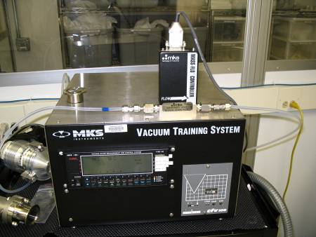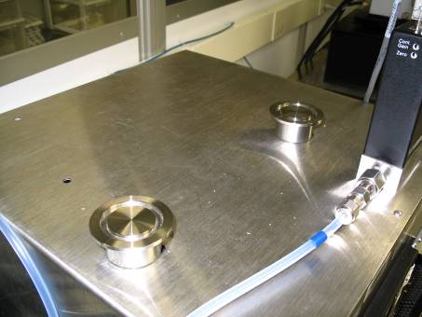
2. Connect QF40 cross to  QF40 - ¼” NPT adapter tee w/ vent.  Connect assembly to right side base mount.  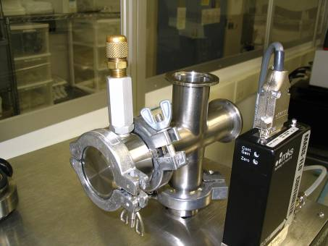 | 3. Connect QF40 - ¼” NPT adapter tee w/ vent to QF40 blank.
4. Connect QF40-QF16 reducing tee to QF40 cross. Connect pirani gauge to QF40-QF16 reducing tee. Note, that the horizontal line on the pirani gauge must be installed horizontally and level for accurate operation.

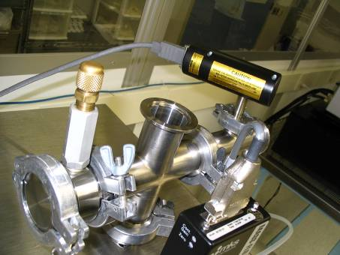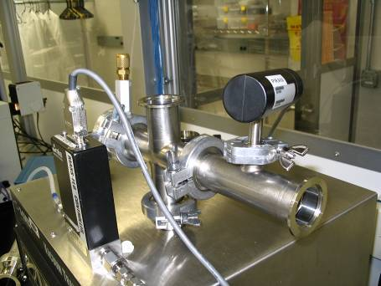

5. Connect QF40-QF25 reducing nipple and QF40-QF16 reducing nipple to QF25 right angle valve. Connect assembly to QF40-QF16 reducing tee.  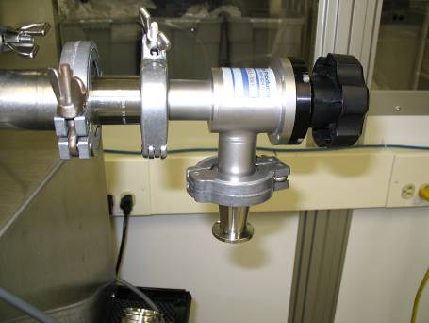 | 6. Connect mechanical pump tubing to QF40-QF16 reducing nipple.  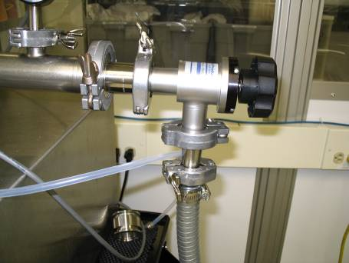
7. Connect QF40-QF16 reducing tee to QF40 cross.  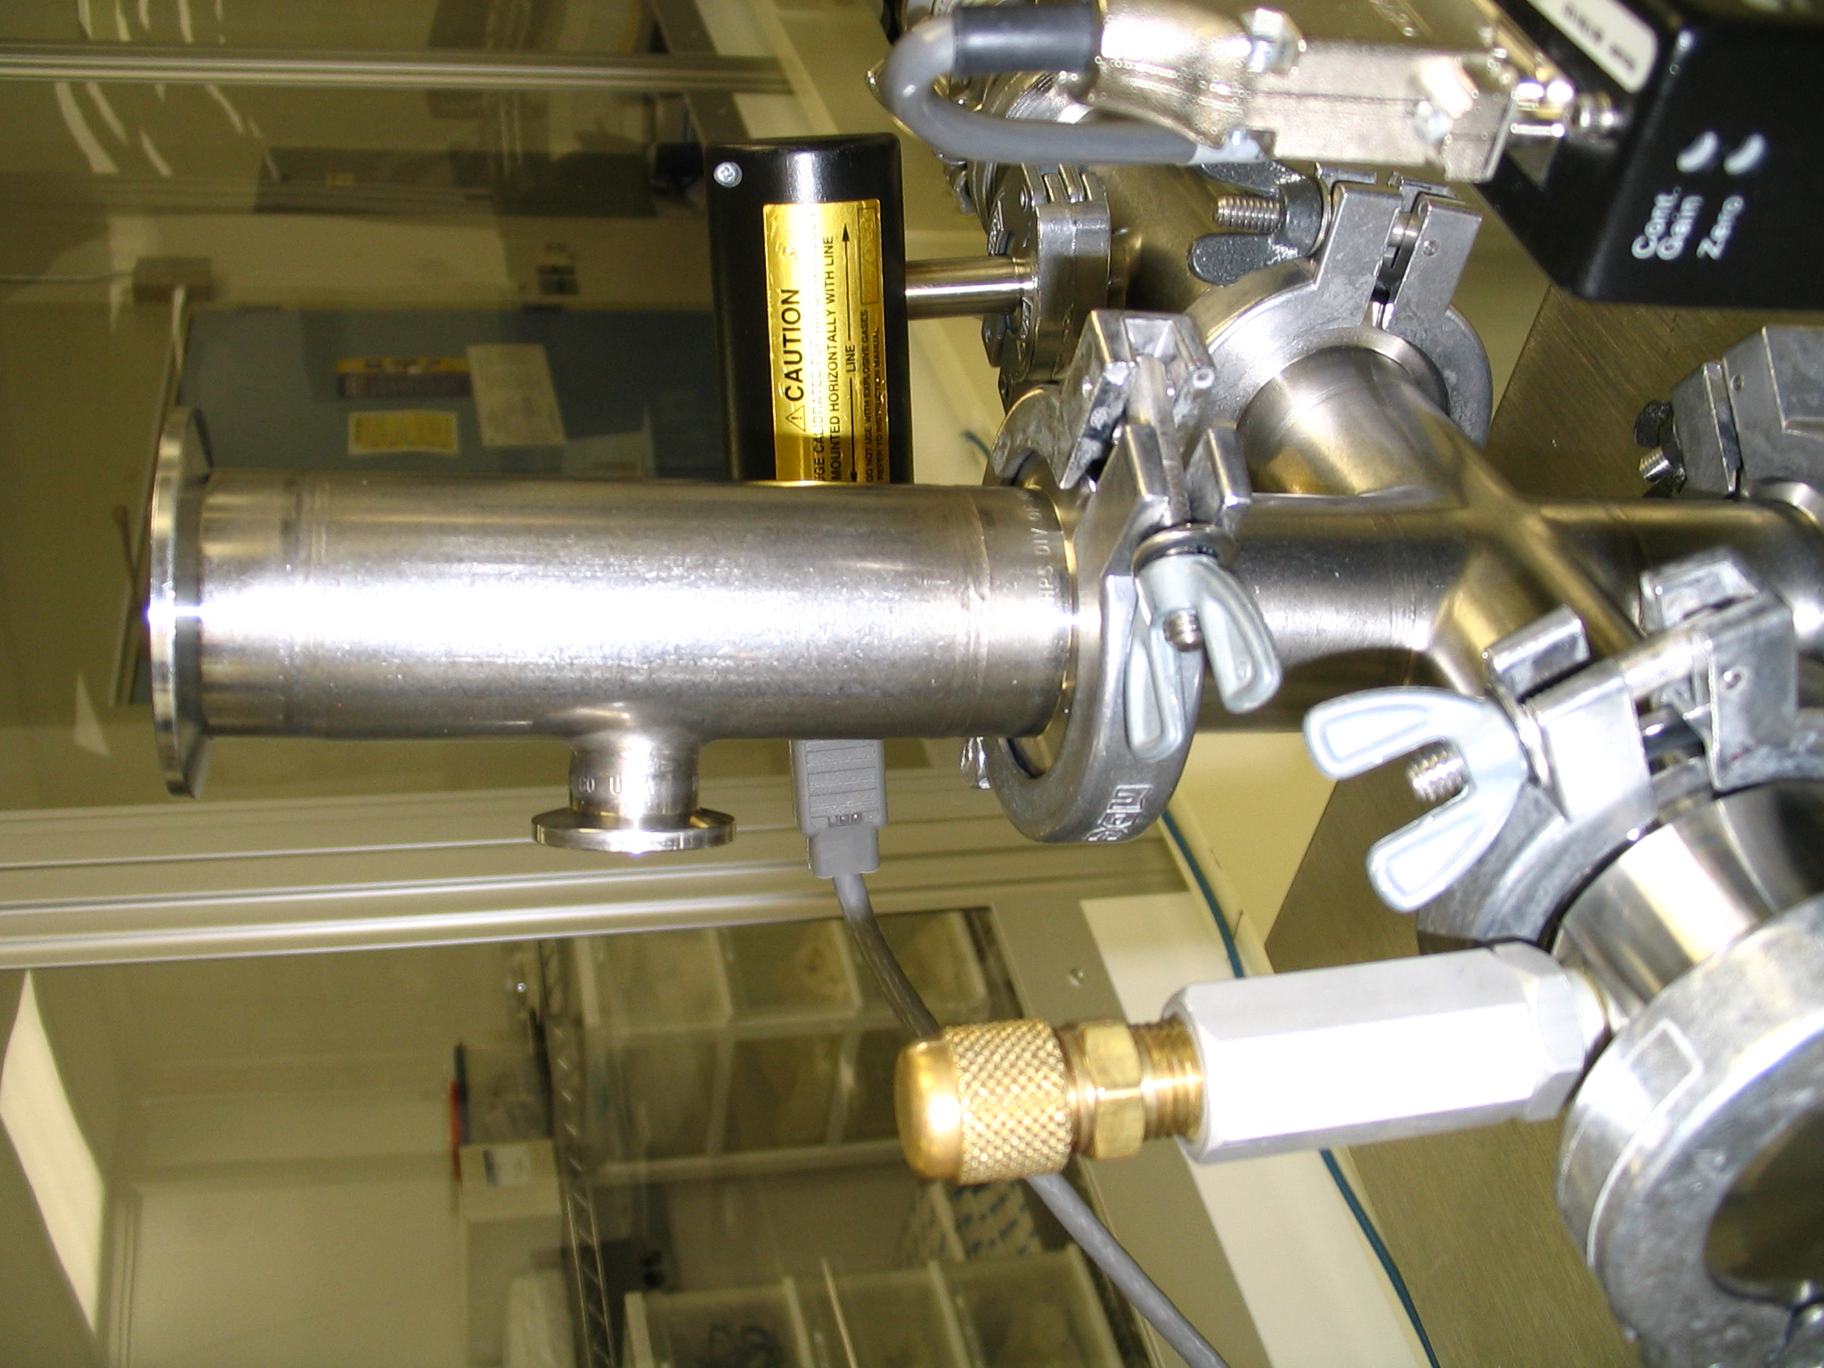 | 8. Connect baratron gauge to QF40-QF16 reducing tee.  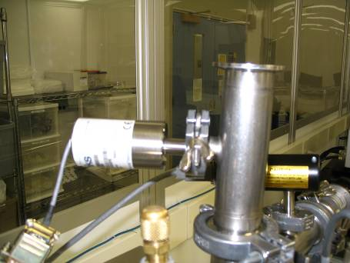
9. Place QF40 gasket on screened centering ring on top of QF40-QF16 reducing tee.  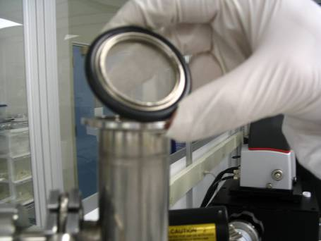 | 10. Attach Process Chamber Assembly to QF40-QF16 reducing tee.  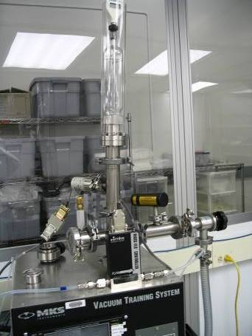

Questions for Part 1 are located at the end of this lab handout.

Steps – Part 2, High Vacuum System Construction:

- Connect the components of the vacuum system as per the assembly instructions following these steps and the instructor directions.
- Close all valves.
- Turn rough pump on.
- Open isolation valve.
- Open roughing valve.
- Open throttle valve (if throttle is used).
- When base pressure (5X10⁻² Torr) is reached close the roughing valve and open the backing valve.
- When base pressure is again reached, turn on the turbomolecular pump.
- When the turbo pump is up to speed (27,000 RPM) open the hi-vac valve.
- Wait 30 - 60 seconds then turn on the ion gauge.
- To turn the ion gauge on – press 3 – ON – 3 on the 146 controller.
- A Pressure in the range of at least 10⁻⁴ Torr should be reading on the gauge.
- Discuss with the TA how to vent the chamber with the turbo pump running, and under what circumstances it would be necessary to perform such an operation. The group should then perform this procedure.
- Bring chamber back to high vac. Discuss and have your TA approve your procedure before performing this operation.
- The pressure in the chamber will be affected by any gas introduced into the system. Only a low flow of gas through the MFC is required to affect the pressure. A flow of 2 to 10 sccm is appropriate for this experiment.
- To change the gas flow through the MFC:
- Repeatedly press the [DISPLAY MODE] key until the 146 is in SETUP MODE.
- Use the arrow key to scroll to the CODE legend.
- Enter the number 174 (assuming the MFC is on channel 4) and press [ENTER].
- Enter the flow rate (in the range of 2 to 10 sccm) and press [ENTER].
- Return the 146 unit to NORMAL MODE by pressing the DISPLAY MODE.
- Turn on the MFC. Try several settings observe the pressure changes.
- Vent and Shutdown.

Follow this procedure to shut down the system from high vacuum and vent the system.

Turn off the ion gauge.

Close the high vacuum valve.

Close the backing valve.
- Turn off the turbo pump.
- Close the isolation valve.
- Turn off the rough pump.
- Open the chamber vent.
- Open the roughing valve.
- Wait for the turbo pump to stop spinning.
- Open the backing and hi-vac valves.
- Open the isolation valve.
- Entire system is now vented to atmosphere.
- Disassemble the entire system and put parts back into toolbox drawers.
- Connect QF40 butterfly valve to QF40/ ¼” NPT adapter tee w/ vent.  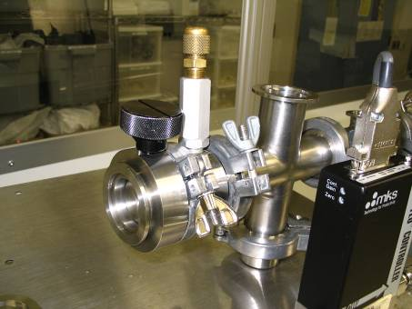 | - Connect QF40 butterfly valve to QF40 cross.  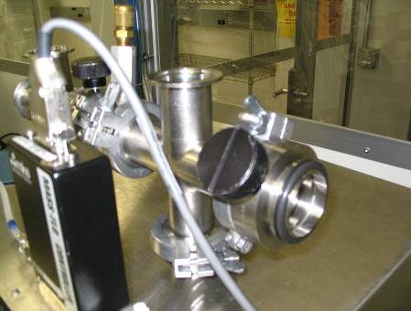
- Connect QF40-QF16 reducing tee to QF 40 butterfly valve. Connect rough pump valve assembly to QF40-QF16 reducing tee.  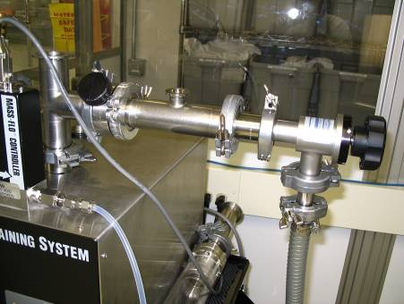 | - Connect QF40 cross to QF40 cross.  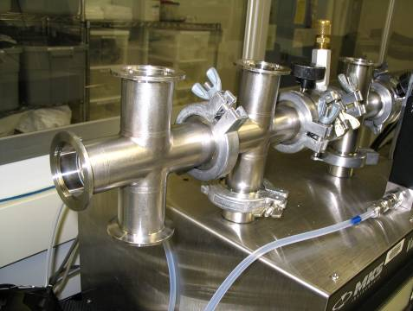
- Connect turbo pump to QF40 cross.  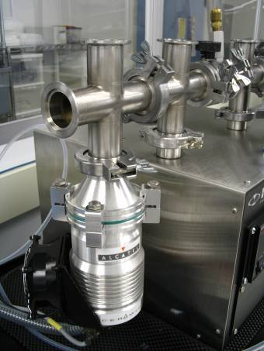 | - Connect ion gauge to QF40 cross.  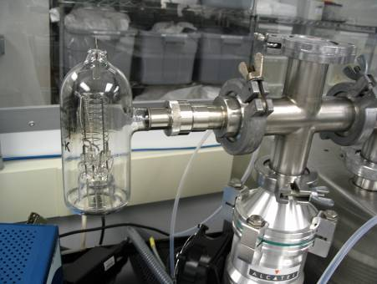

- Connect QF40 blank to QF40 cross.  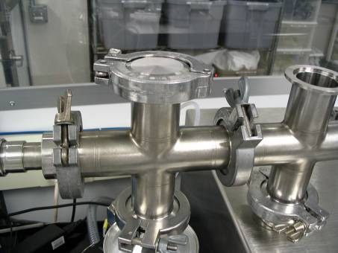 | - Connect residual gas analyzer to QF40 cross.  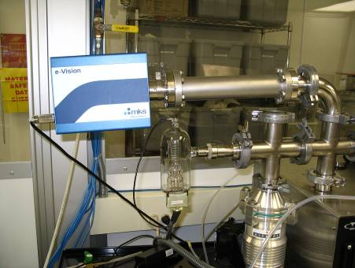
- Connect QF16 tee to QF40-QF16 reducing tee.  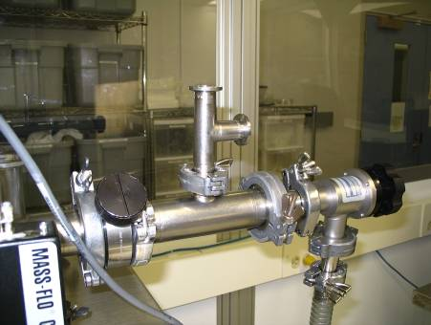 | - Connect QF16 backing valve to QF16 tee.  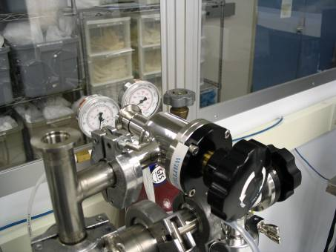

- Connect QF16 backing line to QF16 backing valve.  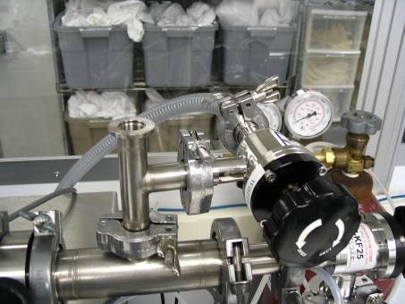 | - Connect QF16 pirani gauge to QF16 tee.  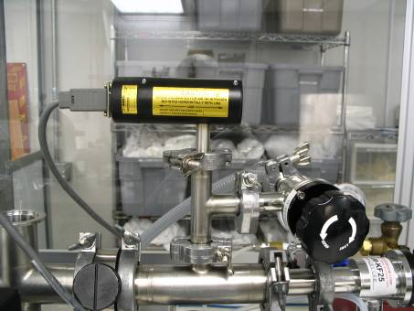
- Connect QF40-QF16 reducing tee to QF40 cross.  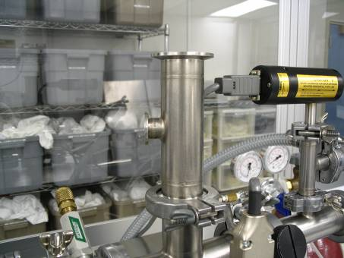 | - Connect capacitance manometer to QF40-QF16 reducing tee.  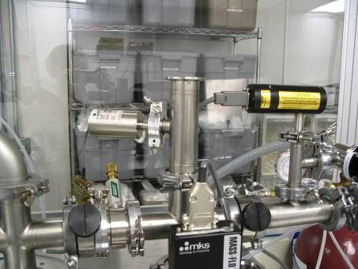
- Connect throttle valve to QF40-QF16 reducing tee. Note which side of valve faces down.

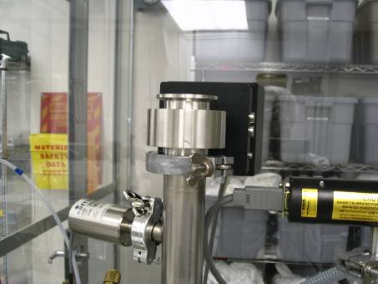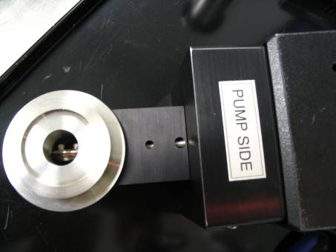

- Connect QF40 to ¼” NPT adapter tee to QF40-QF16 reducing tee.  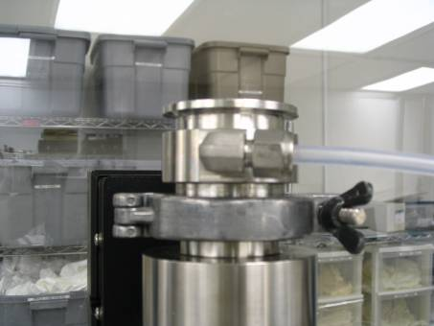 | - Using a centering ring with a screen connect the chamber to the QF40-¼” NPT adapter tee.  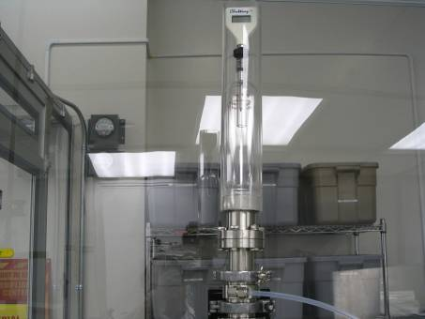

Part 1 Questions:

- The rough pump used in this system is an oiled sealed rotary vane type pump. List two disadvantages that might be encountered when using this type pump.

- What could be done to eliminate or reduce these problems?

- What would happen if the pump was suddenly turned off while the system was pumping under vacuum (name it and explain)?

- How could the pump be turned off while the system is under vacuum without having the problem from question #3 occur?

- What is the vacuum range for each of the following?

  - Pirani gauge - ___________________

  - Capacitance manometer - _____________

  - Ion gauge - _______________

- Identify each of the nine items displayed by the instructor and list below.

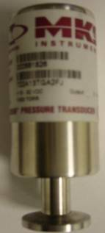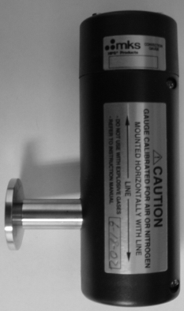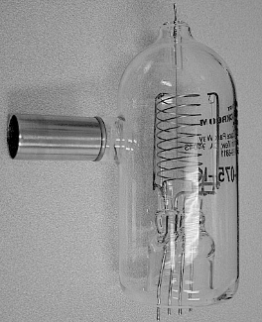
1: 2: 3:

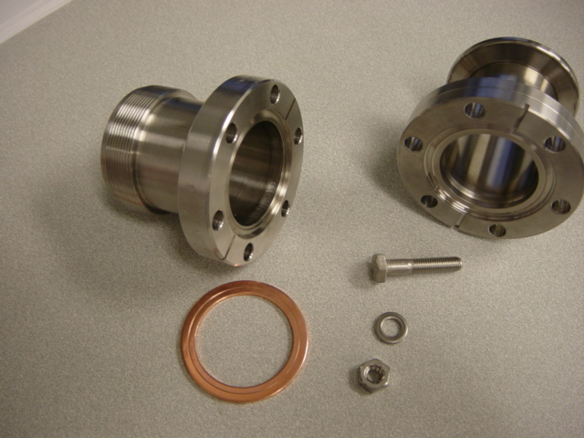
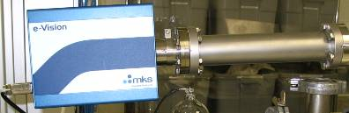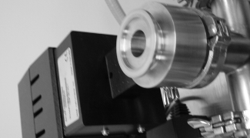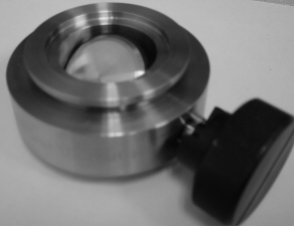
4: 5: 6:

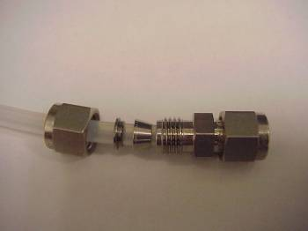
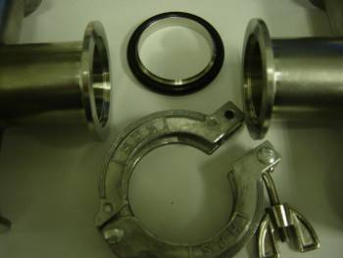
7: 8: 9:

- With the data collected from the up-leak test of the system use Microsoft Excel to plot a graph of the pressure rise. Make sure to properly label the graph and include the calculated average leak rate. Print this plot and attach it to the back of this lab handout before submitting.

- List three reasons a vacuum system may not be able to reach the rated base pressure of the pump being used.

- List three enemies of a vacuum system.

- What is a real leak and list three factors that could create this type of leak?

- What is a virtual leak and list three factors that could create this type of leak?

- Why are vacuum systems kept under vacuum even when not in use?

Part 2 Questions:

1. What is the range of an ion gauge, and how does it work?

2. There are two primary situations to avoid when shutting down a Turbo pump while it is running at full speed. What are they? Describe in detail.

3. You are assigned the task of improving the throughput of the Cooke thermal evaporator system in the PSU lab. What would you do?

4. Why do you close the roughing valve before opening the foreline/backing valve?

5. What was the effect to the vacuum system when gas was introduced into the chamber through the MFC?

6. What does MFC stand for? What function does an MFC perform on a system? What is the working principle of the MFC on the MKS training system?

7. The MFC on our system is not working and must be replaced. The malfunctioning MFC is calibrated for Argon. The only MFC available is calibrated (at the factory) for CF₄. Will it work? Give details!

