Statistical Process Control

Objective: This lab will demonstrate Statistical Process Control (SPC). It will show how to create a basic SPC graph for maintaining gold nanoparticle manufacturing controls. Particularly, a process average and range graph will be created. It will demonstrate how to read and interpret control charts and how to determine when a manufacturing process may need to be investigated for errors. It will illustrate the statistical variation that exists in a manufacturing process.

This handout contains several parts:
- Background and Introduction to SPC
- Introduction to Transmission Electron Microscopy (TEM images will be provided to generate data for SPC calculations)
- Procedure for using ImageJ software to analyze TEM images of nanoparticles
- Instructions for SPC analysis of gold nanoparticles

Background: Statistical Process Control (SPC) is a method that allows quality control engineers to objectively monitor a process or product. When working in a production setting, it is commonplace to do quality checks on products that are being produced. For example, a few randomly selected products may be selected each hour and sent to a quality control lab for measurement or testing. The data collected is usually logged so that the performance of the production line can be monitored over time. However, processes always have some inherent variability and quality checks quickly generate a large volume of data. So engineers often wonder whether differences in product characteristics are the result of common causes (natural variation in the process) or special causes (something is not going according to plan and needs to be investigated further). By comparing new data to historical data, SPC helps engineers determine when to take corrective actions.

Statistical Quality Control is the process of inspecting enough items from different lots (batches or production runs) of product to probabilistically ensure a desired quality level. For example, in order to maximize material usage and machine time, a quality engineer may want 99.5% of all product to meet specifications. Due to time constraints, all products usually cannot be inspected, but a set of samples from each lot often suffices. Comparing the selected products to historical data helps to determine whether the process is running within expected limits.

How do engineers keep track of large amounts of quality control data? Control charts are useful tools for visualizing large amounts of process data. They help to determine whether a process is in a state of statistical control. There are many different types of control charts and each has its own benefits. Some common charts are: Shewhart control charts, Cumulative Sum (CUSUM), and Exponentially Weighted Moving Average (EWMA). Shewhart charts help to determine if a process is deviating from its mean operating value (i.e., something is going wrong and the product may be drifting out of specifications). CUSUM and EWMA are used for similar purposes but are generally used to pick up on small deviations in a process or product.

In this lab, Shewhart charts known as X-bar and R-charts will be utilized. X-bar (X with a line over the top of it) is a common symbol that represents the sample mean, while R refers to the range of a set of data (difference between the maximum and minimum data points). Shewhart control charts set up a model based around the mean, standard deviation, and range of a set of data points (formulas for these terms are provided below). In this context, the mean is another word for average or expected value. The standard deviation measures how narrowly or broadly distributed a data set is. A small standard deviation indicates that all of the data points lie close to the mean value. After a large amount of data has been collected, the distribution of the data can be determined: the mean, standard deviation, and range can be calculated. Then, this information can be used to make predictions about future measurements. For example, what is the expected value for future measurements? What is the chance (probability) that the next measurement will be within a certain range of values? How many of the next 100 products are expected to fall outside of a specified range? As data points are collected, they are compared to the historical population. If they continue to follow the same distribution (no drift over time), then the process is said to be “in control." Importantly, the term "in control" only means that the process is predictable in a statistical sense. It does not necessarily mean that all products meet pre-determined manufacturing specifications.

The first step to applying SPC is to find a process which is “in control.” If it is not “in control,” then the procedure needs to be changed in order to be “in control.” In other words, the product attributes being measured have a well-defined distribution that is not varying with time – the process is stable. One can go a step farther and classify the process as “capable” or not. A capable process is one where almost all the measurements fall inside the specification limits. This is discussed in more detail below.

The Shewhart model is based around the mean and standard deviation of the process and it continually plots new data onto the model. Shewhart charts are easy to create and interpret. X-bar charts show the center of process measurements (accuracy) while Range charts (R-charts) show the spread of the data (precision). One could also use X-bar and S-charts (standard deviation charts). However, in smaller sets of data, range is easier to establish than standard deviation. One would use an S-chart if the samples per sub-group are greater than 10. This would create a more accurate model than the R-chart.

For the Shewhart model, one pre-determines the confidence interval, by choosing how many standard deviations (sigma, σ) away from the mean for which control limits are established. Manufacturing standards in industry are typically three or six sigma. In this lab, 3-sigma control will be used for our model. Therefore, the control limits will be ±3 standard deviations from the mean. Note that for a normal distribution, 99.7% of the data falls within this range (i.e., 99.7 out of 100 measurements lie within the range defined by the mean ± 3σ). This sets up the confidence interval for 3-sigma control. Note also that this predicts a small percentage of product (0.27%) will unavoidably fall outside of the confidence interval during normal operation. If 4-sigma control is used, then the confidence interval would contain >99.9% of the data. The larger the sigma, the more control one has over a process. However, it is more difficult to achieve a process that is “in control” and capable for higher sigmas.

Once control limits are set and a graph is created, we can continually plot data onto this model to check for trends and indicators that may point to faulty products. If any indicators are detected, then one should investigate the process to determine why is it not operating within specifications. There are chance causes (common causes), which are simply small random changes in the process that cannot be avoided, such as the 0.27% chance of falling outside the limits. Then, there are assignable causes (special causes) that are not part of the process on a regular basis. Assignable causes are the things a quality-assurance analyst seeks to find and troubleshoot. If an assignable cause is suspected, then one would check for such problems as machine calibration, changes in materials, tool wear, operator misuse, or anything else that might affect the manufacturing process. For 3-sigma control, even when everything is operating smoothly, the probability of a measurement creating an alarm is 1 out of 370.

Typical indicators and trends are listed below. These are items to watch out for that may signal an out-of-control process. Appendix A (attached at the end) shows some examples of how these errors appear on the control charts.

Typical indicators and trends include:
- Any point more than three standard deviations away.
- Two out of three successive points are on the same side of the centerline in
zone A.
- Four out of five successive points are on the same side of the centerline in zone B.
- Runs: eight or more points in a row on one side of the centerline.
- Trends: six or more points in a row decreasing or increasing.
- Cyclical Patterns: a repeating pattern.
- Alternating Values: 14 or more points in a row that alternate direction (e.g., up/down/up/down/up/down etc.)
- Excessive Variability: eight or more consecutive points outside the center third.
- Lack of Variability: 14 or more points in the center third (near the centerline).
- Multiple points either above or below the mean.

Sample Number
LCL
Measurement Averages
Mean
Zone a http://www.itl.nist.gov/div898/handbook/pmc/section3/pmc32.htm#WECO%20rules
L
Zone b
Zone c
Zone b
LSL
Zone a
UCL
USL
Zone c
3σ http://www.itl.nist.gov/div898/handbook/pmc/section3/pmc32.htm#WECO%20rules
L
Figure I. Sample X-bar chart

The X-bar chart is used to monitor the variation of the subgroup averages that are calculated from the individual sampled data. It shows the change in quality from one subgroup to the next. Looking at the X-bar chart in Figure I, one should notice that the graph represents a measurement vs. time/sample number. The mean and standard deviation is either calculated from previous data, or it is given for the process. In this lab, we will use our data to calculate the mean and standard deviation. The process average (mean) will be the center line. One will then calculate the upper and lower control limits (UCL and LCL) which should fall within the given upper and lower specification limits (USL and LSL). It is also helpful to divide the graph into 6 zones between the upper and lower control limits. Each zone will be approximately ±1σ from the last. These zones make it easier for a user to observe the graph for the indicators listed above.

Figure II shows an example of an R- chart. The R chart is similar to the X-bar chart. However, it is Range vs. time/sample number, where the center line is the average range. The R-chart shows the spread of the individual samples within the subgroups. The R-chart can tell how much overall variation there is in a process. Therefore, as steps are taken to improve a process, it becomes more and more in control and the variation on the R-chart decreases. Typically, the LCL for the R-chart will be zero. It is also useful to divide this chart into six zones in order to inspect for indicators. Use the formula given for UCL_{R}. This number should be close to$\bar{R}+3\hat{σ}$. The R-chart is usually tabulated after the X-bar chart.
Ranges
R-bar
UCL
LCL
Sample Number
Figure II. Sample R-chart
Capability is another parameter that determines if a process, given its natural variation, is capable of meeting the established specification limits. Capability indices help you place the distribution of your process in relation to the specification limits. If C_{P} > 1; then the process is capable. Also, there are C_{PL}, C_{PU}, and C_{PK} values. These help show if the distribution is centered on the mean or target value. If C_{PU} = C_{PL}; then the distribution is centered. If it is not centered, use the C_{PK} value instead of the C_{P}. Therefore, if C_{PK} < 1, the process is not capable. Notice in Figure III below, when the capability indices increase, the process will be less likely to produce an alarm. This is because the tails of the data are well within the range defined by LSL and USL.
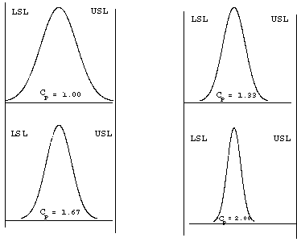
Figure III. Capability indices

Important Formulas

Mean | $$\overline{Χ}=\frac{\sum_{i=1}^{n}{X_{i}}}{n}$$ | n = # of Samples (this lab n = 4)
Standard Deviation | $$σ={\left[\frac{\sum_{i=1}^{n}{{\left(X_{i}−\overline{Χ}\right)}^{2}}}{n−1}\right]}^{\frac{1}{2}}$$
Range | X_{max} – X_{min}
Average Range | $$\overline{R}=\frac{\sum_{i=1}^{k}{R_{i}}}{k}$$ | k = # of Subgroups (this lab k = 10)
Process Average | $$\overline{\overline{Χ}}=\frac{\sum_{i=1}^{k}{\overline{Χ_{i}}}}{k}$$
Process Standard Deviation | $$\hat{σ}=\frac{\bar{R}}{3\text{.}\text{078}}$$
Control Limits | $$\begin{aligned}{\text{UCL}}_{\overline{Χ}}=\overline{\overline{Χ}}+3σ \\ {\text{LCL}}_{\overline{Χ}}=\overline{\overline{Χ}}−3σ\end{aligned}$$ | $$\begin{aligned}{\text{UCL}}_{R}=1\text{.}\text{78}(\overline{R}) \\ ({\text{UCL}}_{R}≈\text{ \{}\bar{R}\end{aligned}+3\hat{σ}){\text{LCL}}_{R}=0$$
Statistical Limits | $$\begin{aligned}\text{USL}=\overline{\overline{Χ}}+4σ \\ \text{LSL}=\overline{\overline{Χ}}−4σ\end{aligned}$$
Process Capability Indices | $$\begin{aligned}C_{P}=\frac{\text{USL}−\text{LSL}}{6σ} \\ C_{\text{PK}}=\text{min}\left\{C_{\text{PL}},C_{\text{PU}}\right\}\end{aligned}$$ | $$\begin{aligned}C_{\text{PU}}=\frac{\text{USL}−\overline{\overline{Χ}}}{3σ} \\ C_{\text{PL}}=\frac{\overline{\overline{Χ}}−\text{LSL}}{3σ}\end{aligned}$$

Transmission Electron Microscopy
Background: Transmission electron microscopy (TEM) is an imaging technique whereby a beam of electrons is transmitted through a specimen. An image is formed, magnified and directed to appear either on a fluorescent screen or layer of photographic film. It can also be detected by a sensor, such as a CCD camera. The first practical transmission electron microscope was built by Albert Prebus and James Hillier at the University of Toronto in 1938, using concepts developed earlier by Max Knoll and Ernst Ruska.
Like all matter, electrons have both wave and particle properties (as theorized by Louis-Victor de Broglie), and their wave-like properties mean that a beam of electrons can in some circumstances, be made to behave like a beam of radiation. Their wavelength is dependent on their energy and can be tuned by adjustment of accelerating fields, and can be much smaller than that of light. Yet, they can still interact with the sample due to their electrical charge. Electrons are generated by a process known as thermionic discharge, in the same manner as the cathode in a cathode ray tube, or by field emission. They are then accelerated by an electric field (measured in V/m, or volts per meter) and focused by electrical and magnetic fields (measured in A/m, or amperes per meter) onto the sample. The electrons can be focused onto the sample providing a resolution far better than is possible with light microscopes and with improved depth of vision. Details of a sample can be enhanced in light microscopy by the use of stains. Similarly with electron microscopy, compounds of heavy metals such as osmium, lead, or uranium can be used to selectively deposit heavy atoms in the sample and enhance structural detail. The dense nuclei of the heavy atoms scatter the electrons out of the optical path. The electrons that remain in the beam can be detected using a photographic film, or fluorescent screen among other technologies. Therefore, areas where electrons are scattered appear dark on the screen, or on a positive image.
In analytical TEMs, the elemental composition of the specimen can be determined by analyzing its X-ray spectrum, or the energy-loss spectrum of the transmitted electrons. The TEM is used heavily in both material science and metallurgy, as well as in the biological sciences. In both cases, the specimens must be very thin and able to withstand the high vacuum present inside the instrument.
There are a number of drawbacks to TEM techniques. Many materials require extensive sample preparation to produce a sample thin enough to be electron transparent. This makes TEM analysis a relatively time consuming process with a low throughput of samples. The structure of the sample may also be changed during the preparation process. Also, the field of view is relatively small, raising the possibility that the region analyzed may not be characteristic of the whole sample. There is potential that the sample may be damaged by the electron beam, particularly in the case of biological materials.

ImageJ Instructions

The ImageJ software was developed by the National Institute of Health and is available free of charge from their website at http://rsb.info.nih.gov/ij/download.html. This software is instrumental in evaluating nanoparticles, since they can be quite small and numerous. The software has functions for counting particles and rendering their sizes on an individual basis¹. Transmission electron microscopy (TEM) was used to yield the high-resolution images² for use with the ImageJ program.

Getting Started:

- Download the appropriate Image J software package from: http://rsb.info.nih.gov/ij/download.html.
- Save images to be analyzed to your computer.
- Open up the Image J software
  - A toolbar should appear (See Figure I) on your screen, but a full window will not open. Some of the basic functions to be used are listed in Figure I.
- A Grid function will be used in the analysis that may need to be downloaded as a plugin:
  - Check if it is included by clicking PLUGINS→GRID on the toolbar.
  - If this is not included it can be downloaded at the following web address; http://rsb.info.nih.gov/ij/plugins/grid.html.
  - Select the Grid .class next to Installation
  - You will be prompted to save or open the file.
    - Save the file in the plugins folder of the Image J Program File.
    - C:\→Program Files→ImageJ→Plugins.
- To analyze a sample select:
  - FILE→OPEN→Navigate to and choose the first image from Step 2.
    - The image will open in a different window.
Pencil Icon
Magnifying Glass Icon
Rectangle Icon
Eye Dropper Icon
Paint Brush Icon
Line Icon

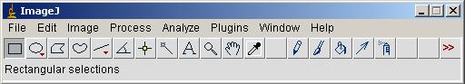
Figure I. The ImageJ main toolbar.

Preparing the Images for Analysis:

The image currently is not suitable for the software to process (Figure I). To get the most reliable results, you must change the appearance to yield a black and white image with high clarity (Figure II).
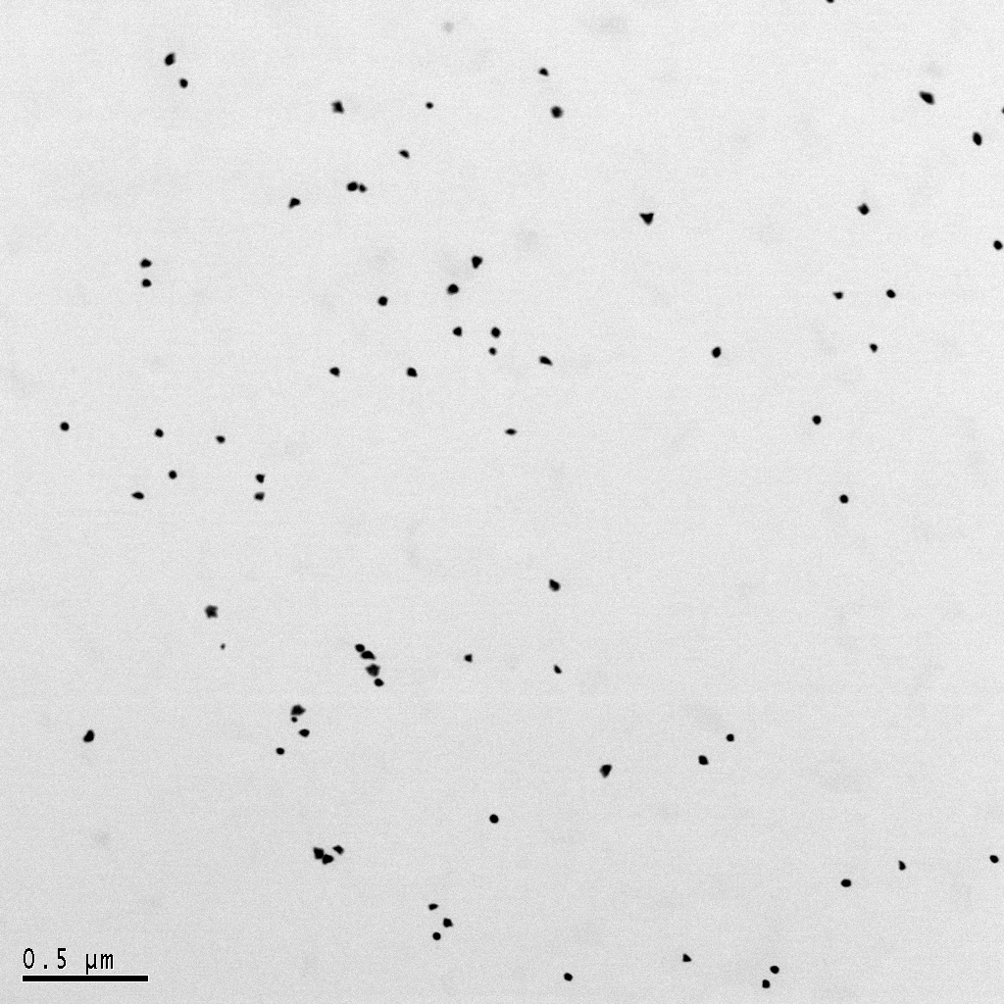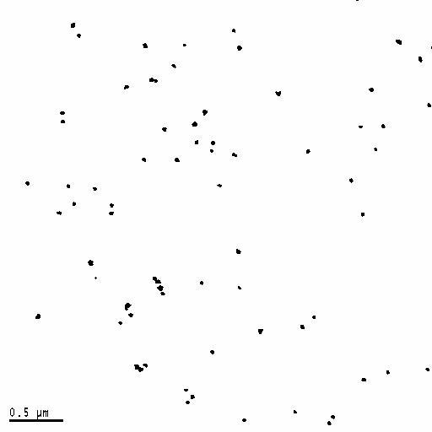
Figure II. Figure III.
Original Image Altered Image

- On the Toolbar choose PROCESS→BINARY→MAKE BINARY.
  - If this gives you highly defined black particles with a white background go on to #2, otherwise adjust the image manually:
    - From Toolbar IMAGE→ADJUST→BRIGHTNESS/CONTRAST.
    - Adjust the contrast all the way to the right to get a black and white image. Be careful not to lose the resolution of the particles. You may first adjust brightness if the contrast alone doesn’t resolve a clear image.
    - After your image looks good, redo step 1. The software requires this step in order to analyze particles.

SETTING THE SCALE
- Select the Magnifying Glass Icon (Figure I) and zoom in on the scale bar on the image by left-clicking to zoom in and right-clicking to zoom out after measurement is made.
- Select the Line Icon (See Fig. I)
  - Select one end of the scale bar and drag to the other making sure to keep your measurement line horizontal and as close to the ends as possible (See Figure IV.)
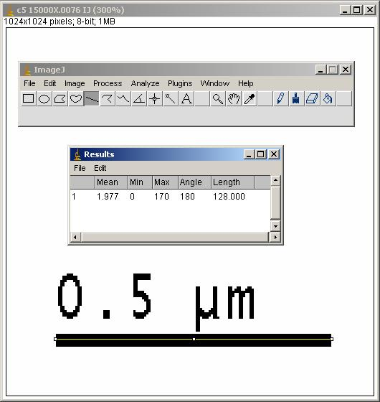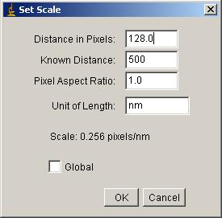
Figure IV. Measurement View and Set Scale Dialog Box

- On the Toolbar select ANALYZE→MEASURE.
  - A result will pop up, do not worry about this window.
- Select ANALYZE→SET SCALE (Figure IV)
  - The Distance in Pixels should be displayed in the first box already, if not then the length is listed in the result window from the line measurement.
  - In the Known Distance box enter the measurement above the scale bar in nanometers (i.e., 0.5 μm = 500 nm).
  - Leave Aspect Ratio at 1.
  - Change Unit of Length to “nm.”
  - Leave Global unselected.
  - The image window should now display the area above as “nm x nm” instead of “pixels x pixels.”
- To remove the scale bar so it is not counted as a particle, choose the Rectangle Icon (see Figure I) and form a box around the scale bar (number with it) and press Backspace.
  - If there are particles that will be affected by this method use the Paint Brush Icon (Figure I) for a more selective deletion (use Eye Dropper and click in white area for brush color, use Magnifying Glass if necessary).
- To remove any unwanted “noise” in the form of tiny specks select PROCESS→NOISE→DESPECKLE.
  - Be careful not to remove any nanoparticles with this function.
- If particles are very close together and will be counted as one large particle use the Eye Dropper Icon (Figure I) to choose white as the color, then zoom in on the particles and select the Pencil Icon (Figure I) and separate the particles with a thin line. Use discretion as not to alter data more than necessary.
- Next select PLUGINS→GRID.
  - Grid Type should be “lines.”
  - Area per point should be the total area of the image (top left corner of the image), multiply the dimension to get area in sq nm and enter this value.
  - Leave line width at 2 pixels and random offset unselected.
  - If no grid appears, be sure your Eye Dropper Icon is black or your grid lines will blend in with the background.

Particle Analysis:

- Choose the Rectangle Icon and choose the first quadrant to the top right square (as is with the Cartesian Coordinate System).
  - Choose ANALYZE→ANALYZE PARTICLES.
  - The Size (nm^2) should be set to ignore very small and large particles which are indicative of background noise and clumped particles or readings from the grid lines (this is done by trial and error).
  - The Circularity should be left at 0.00-1.00.
  - For Show, select Outlines (See Figure V).
  - This allows you to see which particles were analyzed and you may adjust your size range to include more or less if necessary.
  - In the boxes at the bottom you only need the Summarize one checked, but clearing previous results will avoid any confusion from previous analysis steps. (See Figures V and VI).
  - The Count in the Summary is your total number of particles.
- Repeat Step 1 under Particle Analysis for Quadrants II-IV following a counter-clockwise pattern.

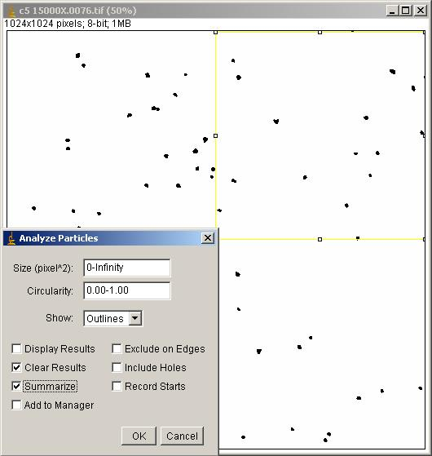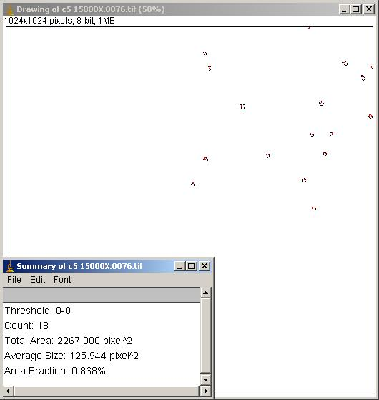
Figure V. Figure VI.
Analysis Using Grid Function Particle Outlines and Summary Screen

References:
- Xiong Liu et al., Extinction coefficient of gold nanoparticles with different sizes and different capping ligands, Colloids and Surfaces B: Biointerfaces (2006).
- TEM images provided by Xiong Liu and Qun Huo, Nanoscience Technology.
SPC Analysis of Gold Nanoparticles

Procedure: Ten TEM scans (images) of gold nanoparticles will be supplied. Each member of the group will utilize ImageJ, a particle counter software program, to perform particle counts on the ten scans. Specifically, measure each scan at four locations, one in each quadrant. Therefore, each student will obtain 40 measurements.

It is useful to explain repeatability and reliability. Repeatability exists if different users can perform a particle count on the same scan and get the same results every time. Reliability exists if the software shows the same results every time for the same scan. If different users or the software itself cannot be precise and accurate, then it is impossible to measure for control.

Assume that the TEM images were being produced consecutively and each subgroup will represent a certain time when measurements were taken. For this lab, each image should be its own subgroup. Therefore, all together 40 measurements will be performed four measurements per subgroup, for a total of 10 subgroups. Once the dataset is complete, plot it in a spreadsheet program such as Excel. Keep the sample measurements for each subgroup in the same row and list the subgroups down the columns. After each subgroup, calculate the mean and range. From this data, determine the process average and average range. Next, complete the rest of the calculations: capability indices and control limits. Now, with all this information you can create your model. Set up graphs like the examples above by plotting the data onto a line graph. Draw in your control limits, along with the zones in order to ease interpretation for errors. Referring to the list of errors and the appendix for examples, determine if your process shows any alarms. If so, determine if the indicators are an actual process malfunction, or if it was just a faulty alarm.

Results:
- Display clearly labeled data. Include the subgroup means and ranges. Include an X-bar chart and a Range chart showing UCL and LSL.
- Report your descriptive statistics in a table in your lab writeup and submit an Excel sheet to show all calculations.
- Calculate capability indices in intervals of n = 10.
- Display clearly labeled models. Highlight and explain any alarms found.

Conclusions:
- Describe if your model is in statistical control or not.
- Describe what the errors were that you found and your reasons for why this type of error may have occurred.
- If you think the error occurred does not show a process error, but just the probability of being faulty, explain.
- Discuss what the capability indices say about your process.

Questions:
- Describe the difference between chance and assignable causes. (3pts)

- Describe if your data is not only in statistical control, but also in process control and what the differences are between the two? (3pts)

- Why is it important to determine if your process is centered? (3pts)

- Why is it important to establish an R-chart along with the X-bar chart? Explain what each chart illustrates? (3pts)

- What are Repeatability and Reliability and why are they significant in process control? (3pts)

Lab reports are due 11:45 AM the Monday following the lab completion date.
NO WORK WILL BE ACCEPTED LATE!

References:
- NIST/SEMATECH e-Handbook of Statistical Methods, http://www.itl.nist.gov/div898/handbook/pmc/pmc_d.htm
- Summers, Donna. Quality. 3rd ed. Pearson Education Inc. New Jersey: 2003.
- Heckard, Robert F. and Utts, Jessica M. Mind on Statistics. Thomson Learning Inc., Pacific Grove, CA 2002.

Appendix A: Example of how indicators appear on a model.

Any point outside control limit | 2 out of 3 points in zone a or beyond
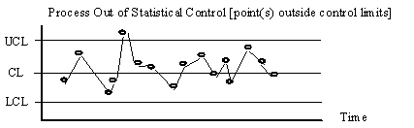 | 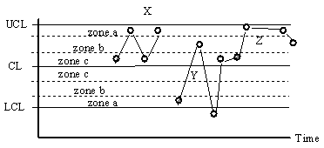
For all charts | For X-bar chart
4 out of 5 points in zone b or beyond | 8 consecutive points above or below centerline
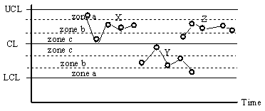 | 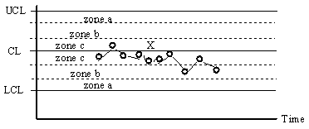
For X-bar chart | For all charts
6 or more points increasing or decreasing | 14 or more points oscillating
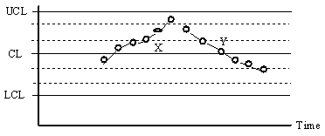 | 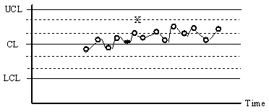
For all charts | For all charts

