Microcontact Printing

Objective: This lab demonstrates pattern replication and transfer via microcontact printing. Students use photolithography to create a master mold. PDMS is used to create a replica of the master. The resulting PDMS stamp is used to print a thiol-based self-assembled monolayer onto selected areas of a gold film. Etching of the gold film transfers the original master pattern by removing gold in areas not protected by the thiol.

Background: Microcontact printing is a relatively inexpensive and easy-to-perform lithography process that offers submicron patterning capability. The basic concept is that an elastomeric polymer stamp, typically polydimethylsiloxane (PDMS), is “inked” with an alkanethiol (a hydrocarbon with a sulfur end). The stamp is then applied to a gold-coated substrate for a short time and removed. The alkanethiol transfers from the stamp to the gold surface, where it forms a self-assembled monolayer (SAM). This step transfers the original pattern to the gold surface. Octadecanethiol (ODT) will be used as the “ink” because it is resistant to the gold etch chemistry. Therefore, only areas of the gold film that are not covered by the SAM will be removed during the gold etching step. After the etch process, an ethyl alcohol rinse can remove the alkanethiol, so further processing can be performed (e.g., pattern transfer into the substrate below). The process flow is outlined in the figure below.

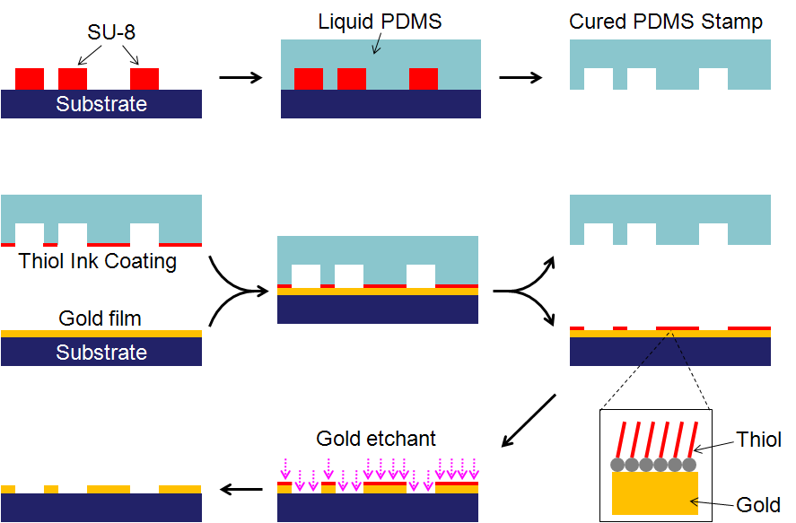
Figure I. Schematic of the microcontact printing process.

Training Necessary: Sputtering Tool, Wet Bench Safety, Optical Microscope.

Experiment: Students fabricate a mold using negative photolithography and SU-8 photoresist. Next, a PDMS stamp is made using the mold as a template. This produces a mirror image of mask features. The stamps are “inked” with an ODT solution and then applied to the gold substrate. This delivers a self-assembled monolayer (SAM) of the alkanethiol material to the substrate. The SAM acts as an etch mask when the substrate is immersed in a gold etchant. The results will be viewed with the optical microscope and the resultant patterns will be observed. Refer to the following pages for the specific processing details.

Use your processing skills and resources to complete the objectives. It is important to plan this experiment with the given details. You should draw a process flow diagram and review the plan with your group members. It would be advantageous to design tables to record the data before doing the experiment. All results must be included in your report.

Hints: Keep detailed notes of the process. Often, changes in the intended experiment can lead to good results! Mistakes happen in all experiments. Take advantage of mistakes, comment and learn from them.

Procedure for Microcontact Printing/Gold Etch lab:

Day 1

1. Negative Lithography Procedure: Creation of Master Template
- Clean a 2 inch silicon wafer with acetone, IPA, and DI water.
- Dehydration bake for 3 min at 105 °C.
- HMDS application.
- Dehydration bake for 15 sec at 110 °C.
- Spin on SU8-25 photoresist for a thickness of 25 µm.
  - Use the two step recipe SU25.20/30 on the spinner:
    - The first step is 500 RPM at a ramp rate of 100 RPM/sec for 5 sec.
    - The second step is 2000 RPM at a ramp rate of 300RPM/sec for 30sec.
  - Note: Use a 3 mL pipette and cut the tip down to facilitate application of photoresist.
- Note: Do not use the cooling chuck between bakes. This will minimize the thermal stress on the photoresist.
- Soft bake # 1 for 3 min @ 65 °C.
- Soft bake # 2 for 7 min @ 95 °C.
- Expose in the MJB3 for 20 sec.
- Post exposure bake #1 for 1 min @ 65 °C.
- Post exposure bake #2 for 3 min @ 95 °C.
- Develop in SU-8 developer.
  - Bath 1 for 2 min.
  - Bath 2 for 2 min.
  - Bath 3 for 1 min.
  - Note: Additional development may be needed in the 3rd bath.
- Rinse and dry the wafer.
- Inspect with optical microscope using bright and dark field techniques.

2. Profilometer
- Measure a specific feature on the sample after photolithography.
- Measure the same feature on the mask for comparison.

3 . Application of Sylgard 184 PDMS Over Mold (this will be done before the lab)
- Place wafer in Petri dish.
- Mix Sylgard 184 to a 10:1 ratio of elastomer to curing agent.
- Pour over wafer to depth of approximately 5 cm.
- Cure for 3 hrs at 65 °C in the environmental shaker.

Day 2

1. Gold Substrate Preparation
- Start with a clean 2 inch silicon wafer or glass slide substrate.
- Sputter approximately 75 angstroms of chromium (Cr) onto the wafer using the RF sputtering head.
  - 10 mTorr pressure
  - 200 W
  - 25% rotation
  - 30 seconds

- Sputter approximately 500 Angstroms of gold (Au) on top of the Cr using the DC sputtering head.
  - 10 mTorr pressure
  - 50 mAmps
  - 25% rotation
  - 120 seconds

2. Octadecanethiol Preparation (This will be done ahead of time)
- Create a 2 mM solution of the octadecanethiol (ODT) in ethanol.
- Molecular weight of ODT is 286.56 grams per mole, therefore, 1 M = 286.56 g ODT per Liter of final solution.
  - 2 mM = 0.573 g/L of solution

3. Stamping Procedure
- Note: Use the wet bench for this procedure.
- Pipette a small amount of thiol solution to PDMS surface.
  - Allow it to air dry.
  - Finish drying with N₂ stream.
- Apply PDMS stamp to substrate for 10 seconds, then remove.
- Etch substrate for 20 seconds using a 2:1 DI water to gold etchant solution (Transene Gold Etchant Type TFA). Note: The undiluted gold etchant has an estimated etch rate of 28 Angstroms/second.

4. Profilometry
- Measure the same feature from the mask on both samples to assess the effectiveness of the pattern transfer.

5. Microscope Analysis
- Use the optical microscope to examine the resulting gold features. Take both bright and dark field images of the patterns.

Questions:

- Give an overview of what microcontact printing is and how it is performed. (2)

- Discuss any changes in the feature dimensions from the photoresist through metallization. (3)

- Why is Cr sputtered onto the substrate before the Au? (3)

- What chemicals are in the gold etchant and what are some of the health/safety concerns associated with using this material? (3)

- What is the molecular formula for octadecanethiol? (2)

- Discuss the success of the final etch results and discuss ways the results could be improved through changing processing parameters. (4)

- From the MSDS, what materials are not compatible with octadecanethiol? (3)

- Read the research paper in the Microcontact Printing drop box on ANGEL. State what other alkanethiols were used in that paper and discuss why octadecanethiol was chosen over them. (5)

- Research and summarize one peer reviewed source on microcontact printing. (5)

References:
[1] Cao. G. Nanostructures & Nanomaterials: Synthesis, Properties & Applications. Imperial College Press. London. 2004.

Lab questions are due 11:45 AM the Monday following the lab completion date.
NO WORK WILL BE ACCEPTED LATE!

