Electron Beam Lithography

Objective: The objective of this lab is to learn electron beam (e-beam) lithography. Students will learn about the basics of e-beam lithography, differences and advantages of this technique over conventional photolithography techniques. Students will then use the FESEM to image patterns on a substrate which were defined using e-beam lithography

Background: E-beam lithography is a lithography technique for patterning extremely small features (down to ~10nm) in ‘e-beam resists’. In conventional photolithography processes, a light source (typically emitting UV light) is used to expose a photoresist through a mask to produce the desired pattern. However, the minimum feature size that can be patterned using this technique is ultimately limited by the wavelength (λ) of light waves being used – the minimum feature size is typically slightly larger than the wavelength used. As a result, the minimum feature size that can be patterned using photolithography is limited to ~200nm (achieved in deep-UV lithography).

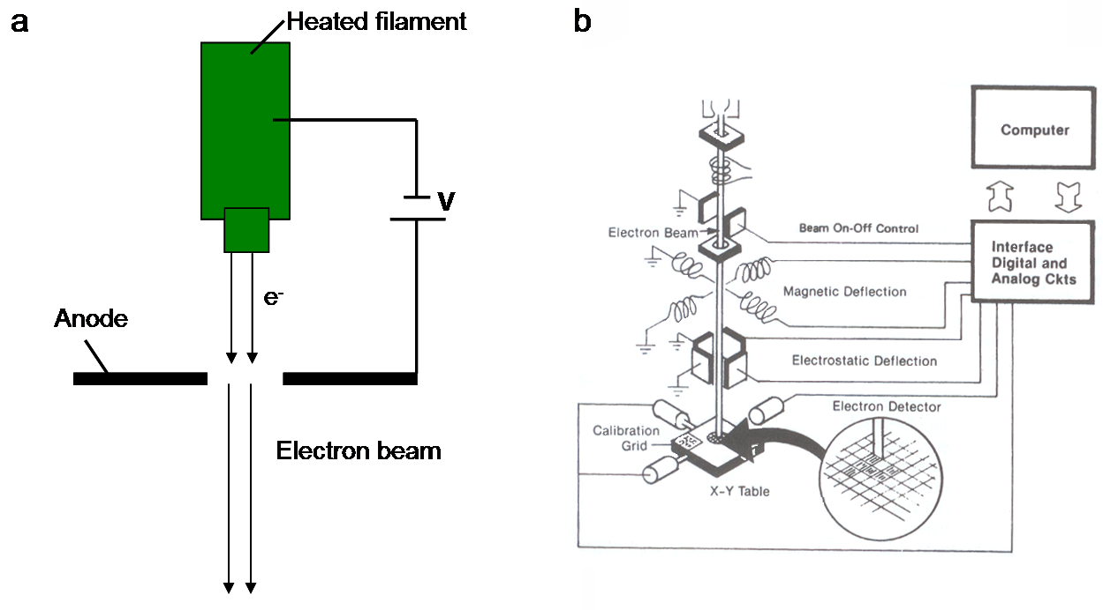
Figure I: Schematic of a) a thermionic emission electron gun, and b) electron beam lithography column [1].

In e-beam lithography, an electron beam is used instead of light waves to define patterns in an e-beam resist. An electron beam is created using an e-gun, shown schematically in Figure Ia. Typically, a tungsten filament acts as a source of electron. Upon heating, the filament emits electrons by process of thermionic emission. The emitted electrons are accelerated towards the hole in the anode plate by applying a high positive potential to the anode. This results in the formation of an electron beam. The wavelength (λ) of the electron beam is related to the acceleration potential (V) applied on the anode by the equation, λ = hc/eV, where h is the plank’s constant, c is the speed of light and e is the electron charge. Thus, by applying a high enough acceleration potential, we can create electron beams with very small wavelengths, thus much finer patterns can be defined using this technique. Typical acceleration voltages used are in the range of 50 to 100 kV.

Figure Ib shows the schematic diagram of an electron beam column. The electron beam emitted from the gun is focused and manipulated using a series of electromagnetic ‘lenses’, and focused on the resist coated substrate, placed on the stage at the bottom of the column. Unlike conventional photolithography, no masks are used in this technique - the electron beam exposes the resist directly. The desired pattern is ‘written’ in the resist by moving the beam over the substrate and/or by moving of the stage underneath the beam.

Training Necessary: Safety training, Introduction to Photolithography, SEM training

Experiments: For this lab, student will image samples patterned by e-beam lithography with the FESEM. Two samples will be provided. The first sample has patterned e-beam resist. The second sample has metal feature created by e-beam patterning, metal deposition, and liftoff process. Submit answers to the questions along with images taken from the sample. No formal lab report is required for this activity.

Questions:

- What is thermionic emission of electrons? (1)
- Referring to Figure Ia, assume electrons emitted from the filament have zero initial energy (E = 0). What is the energy of an electron as it passed through the hole in the anode plate? Remember, electrons are being accelerated by the potential V. (1)
- What is the expression for energy of an electron in terms of its wavelength (or frequency)? (1)
- Use the answers from 2 and 3, derive the expression for wavelength of an electron beam in terms of acceleration potential V. (1)
- List one major difference in sample preparation for photolithography and e-beam lithography. Why is it important ? (1)
- List three major differences between conventional lithography and e-beam lithography process. (3)
- Comment on the edges of the features you saw with the FESEM. What was the reason for edges to look that way? (1)
- Research and summarize one peer reviewed source on e-beam lithography used in nanotechnology (6)

References:
1)Van Zant, P. Microchip Fabrication 4th Edition. McGraw Hill. New York. 2000.

