Furnace Oxidation

Objective: The objective of this lab is to learn about oxidation and the furnace used to grow oxides. Experience on the ellipsometer will also be gained.

Background: Furnace oxidation can be used to grow two types of oxides, dry and wet. Dry oxidation is a slow reaction between oxygen and silicon that creates a dense, high quality oxide layer that can be used as a dielectric gate material. Temperatures for dry oxidation are usually in the 800°C to 1100°C range. Typical thickness of a dry oxide is in the 20 Å to 2,500 Å range. The reaction sequence below is associated with dry oxidation.
Si (solid) + O₂ (gas) ↔ SiO₂ (solid)

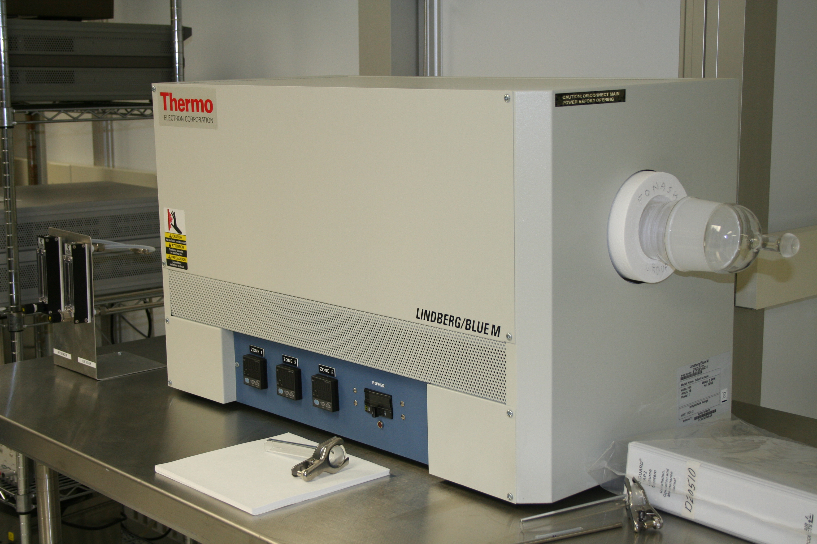
Figure I. Tthe Lindberg Blue M Furnace.

Wet oxidation is a relatively fast reaction between oxygen, water vapor, and silicon that creates a less dense, fast growing oxide layer that can be used as a field oxide. Temperatures for wet oxidation are in the range of 800°C to 1100°C. Typical thickness of a wet oxide is around 2,500 Å to 25,000 Å. The reaction sequence below is associated wet oxidation.

Si (solid) + 2H₂O (vapor) ↔ SiO₂ (solid) + 2H₂ (gas)

Every recipe has a few things in common:

- Ramp Up: The gradual increase in temperature, ~5°C per minute, once the wafers are inside the furnace tube.
- Flow Rates: The amount of gas that is flown into the furnace tube once the oxidation temperature has been reached.
- Cool Down: The gradual decrease in temperature, ~ 3°C per minute, occurs after the process has finished in the furnace tube.

Drastic temperature changes can cause a great deal of damage and all of these steps are very important for minimizing the thermal stress on the sample..

Training Necessary: Ellipsometer and Safety Training.

Experiment: One half of the lab session will be spent listening to a lecture, learning about oxidation and the oxidation furnace that is used in the lab. Take good notes. (You could be tested on any of the material in this lab.) Next, the group will be trained on the operation of the furnace. They will set the system up for an oxidation using the following parameters:

- 5ºC/min ramp up to 1000ºC (~3hr)
  - 1000ºC oxidation temperature
  - 60 units of oxygen
- 10ºC/min ramp down to 400ºC (~1hr)
- 1ºC/min cool down to 23ºC (~4hrs)

While the samples are going through the oxidation process, the group will attempt to visually determine the oxide thickness of oxidized samples from a previous group. This will be accomplished by cross-referencing a color oxidation chart found on the last page of this document. Be careful while estimating the oxide thickness. Due to the reflective properties of the sample, the color of the sample will change from different angles. You must observe the sample from directly above to observe the color used for thickness determination.

The group will then measure each sample using the ellipsometer noting the index of refraction for each measurement. The measurements will be using the five point measurement system shown in Figure II. Complete as many samples as possible in the time allowed. Each group member should practice using the ellipsometer. Record estimated and measured thickness as well as the index of refraction in a Table I.

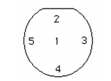
Figure II. Wafer map for five point measurement.

No formal lab report will be written for this activity, only the questions below will be due.

Questions:

- What is a gate oxide? What is a field oxide? (2)

- Name the six other types of silicon oxides listed in your Q&S book. (6)

- What is the ramp rate of the furnace temperature and why is it important? (2)

- Why is cool down a necessary step in oxidation? (2)

- From your Q&S test book, why is HCl used in dry oxidation? (2)

- What gas(es) are used for dry oxidation? What gas(es) are used for wet oxidation? (2)

- Organize your data from the lab below in Table I. (6)

Sample | Estimate thickness | 1 | 2 | 3 | 4 | 5 | Average thickness | Average index of refraction
1
Measured index of refraction
2
Measured index of refraction
3
Measured index of refraction

8. Oxidation growth rates are governed by mathematical relationships, which describe the movement of diffusing material based on temperature, concentration and energy. This is referred to as Fick’s Law. Using the Fick’s Law chart in Figure III estimate the time to grow each of the sample oxides below: (3)

Color of Wafer | Thickness | Temperature | Oxidation Method
Royal Blue | 1150Å | 1000ºC | Dry
Gold | 2100Å | 1100ºC | Wet
Carnation Pink | 4400Å | 1100ºC | Wet
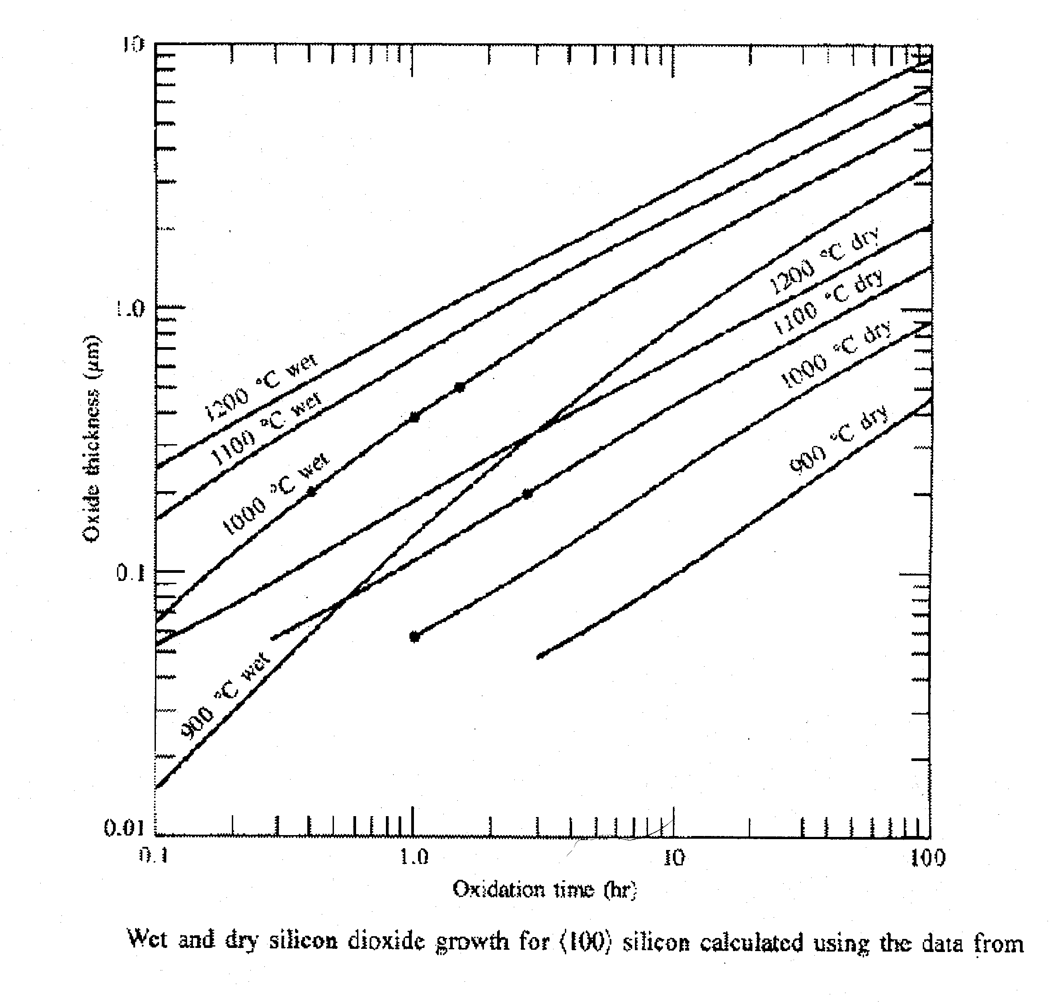
Figure III. Fick’s Law chart for determining oxidation times and thicknesses.

Color Chart for Thermally Grown SiO₂

