ID # _______________ Group # _______________
Ion Implantation Simulation
Objective: In this lab, a further understanding of the affects of ion implantation will be gained. It will be seen how the electrical properties of wafer are changed, how damage is caused to the crystal lattice, and how the amount of energy applied to the ions affects the impanation.
Background: Ion Implantation is the most common method of doping wafers. A gas is selected based on the desired dopant type. Boron is the most common p-type dopant while phosphorus and arsenic are common n-type dopants. Implantation is a physical process in which the dopant gas is ionized and the desired dopant ions are extracted and accelerated into the target material. Figure I shows a generic block diagram on an ion implant system. The primary application of ion implantation is to change the electrical properties of the material.. Implantation can also be used to change the optical, mechanical, and etch properties of a material.
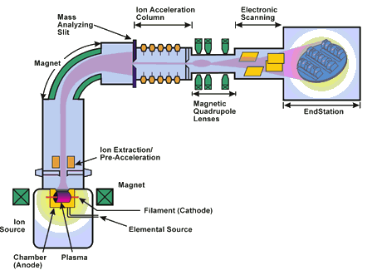
Figure I: Block Diagram of an Ion Implanter
Figure II & III depict the location and concentration of dopants delivered by diffusion and implantation. Some advantages of ion implantation are: control of dopant concentration, dopant uniformity, depth control, and repeatability. Some disadvantages are: damage to the crystal structure and the expense of the equipment.

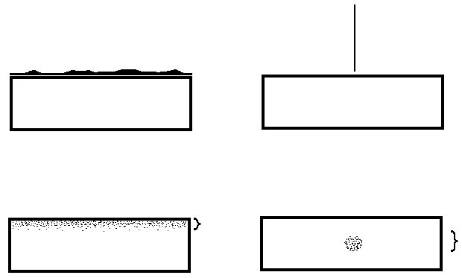
Figure II: Solid Source Dopant Figure III: Ion Implantation
Diffusion Distribution Distribution
Training Necessary: Understanding of ion implantation an wafer doping
Experiment: Below are the instructions to perform the lab using the SRIM/TRIM Ion Implantation Simulation Software. Follow the instructions step by step. Do not try to skip ahead as the experiment is highly dependent on each recipe parameter listed in this lab. Take note of the questions placed through the lab. Answer these questions as you come to them.
- Open the SRIM program
- Click “Stopping Range Tables”
- Select the Ion to implant. Click the “PT” button next to “Ion” to view the periodic table. Click the atomic symbol of an atom to select that atom. Select phosphorous.
- In the field in the middle of the SRIM window is a second “PT” button. Click this button to view the periodic table. Clicking an element here will select your target material. Select silicon
- Click the “Calculate Table” button. When the prompt comes up, select “OK”. The n-well will be 200nm deep. This is listed as “Projected Range” on the table. **NOTE THE UNITS**
1. How much ion energy is needed to achieve the desired range? _______________
- Click the “Main Menu” button.
- Click the “TRIM Calculation” button. This screen will allow various test to be run, based on the information gathered from the table generate before.
- Click the “PT” button next to the “ION DATA” button. Select phosphorous.
- On the “ION DATA” line, in the box titled “Energy (keV)” enter the energy you found on the table.
- Click the “PT” button in the field titled “TARGET DATA”. Again select silicon.
- On the same line, in the box titled “width” enter a value larger than the depth you want your n-well to be. As the desired n-well depth is 200nm, enter a value equivalent to 400nm (to ensure all points show up on the plot). **NOTE THE UNITS** Then type in “silicon” in the box titled “Layer Name”.
- In the box titled “DAMAGE” at the top of the window, select “Detailed Calculation with full Damage Cascades”.
- At the bottom left of the window there is a box title “Total Number of Ions”. Type in “50”. Such a small number is used strictly to save time on the calculations.
- Click the button titled “Save Input & Run TRIM”. Watch the first few ions to see the path the ions will take. After the first five ions or so, minimize this window. Back on the TRIM Input window, at the far right of the middle of the window is a gray box with a “?” in it. This box is directly to the right of the “Compound Dictionary” button. Click this “?” button and a window will pop up, listing the three different types of energy that TRIM calculates when calculating the ion collisions.
2. Give a brief definition of these three energy types:
A) Displacemnet Energy - __________________________________________________
________________________________________________________________________
B) Surface Binding Energy - ________________________________________________
________________________________________________________________________
C) Lattice Binding Energy - _________________________________________________
________________________________________________________________________
- By now the ion implant simulation should have competed its 50 runs. A window will pop up saying that the calculation has completed and ask you if you want to save the data or continue the calculation by adding more ions. Click “No”. A new window will come up asking you to “Enter new Total Number of ions?” Click “Cancel”. A third window will come up stating that the data can be saved. Click “Continue without Saving TRIM”.
- Note the distribution of ion depth, as shown on the graph. Also note how there are more green dots than red dots. The red dots represent a silicon atom that was “knocked” out of place by a phosphorous ion. The green dots represent a silicon atom that was “knocked” out of place by a recoiling silicon atom.
3) Why are there more green dots than red dots? ___________________________________
___________________________________________________________________________
___________________________________________________________________________
4) Why are there fewer ions in the shallow and deep regions of the wafer, as compared to the middle area? _______________________________________________________________
___________________________________________________________________________
___________________________________________________________________________
- Now click the plot titled “Ion/Recoil Distribution”. When the window pops up asking “Plot which Distributions?” Click plots 1 and 2. The distribution window will automatically pop up. Notice how the plot for “Si Recoil Distribution” is more shallow in the wafer than that of the “ions”.
5) Why do the silicon recoil atoms not run as deep as the phosphorous ions?
___________________________________________________________________________
___________________________________________________________________________
___________________________________________________________________________
- Close the SRIM window. A prompt will ask if the data is to be saved. Click “No”. Return to the TRIM input window. Change the ion energy to 20keV. Click “Save Input & Run TRIM”.
- When the calculation completes, check the depth of the ion implantation as well as the two additional plots listed above (“Ion Distribution” and “Ion/Recoil Distribution”)
6) Did the depth of the ion range and the ion/silicon recoil change? If so, how and why? If not, then why not? ___________________________________________________________
___________________________________________________________________________
___________________________________________________________________________
___________________________________________________________________________

