Stiction Overview and Demonstration

Objective: The objective of this lab is to demonstrate and overview the procedures necessary to overcome stiction between two micron surfaces.

Background: Stiction is an informal portmanteau of the term "static friction" (μ_{s}), perhaps also influenced by the verb "stick". Two solid objects pressing against each other (but not sliding) will require some threshold of force parallel to the surface of contact in order to overcome static cohesion. Stiction is a threshold, not a continuous force. In situations where two surfaces with areas below the micrometer range come into close proximity (as in an accelerometer), they may adhere together. At this scale, electrostatic and/or Van der Waals and hydrogen bonding forces become significant. The phenomena of two such surfaces being adhered together in this manner is called stiction. Stiction may be related to hydrogen bonding or residual contamination.

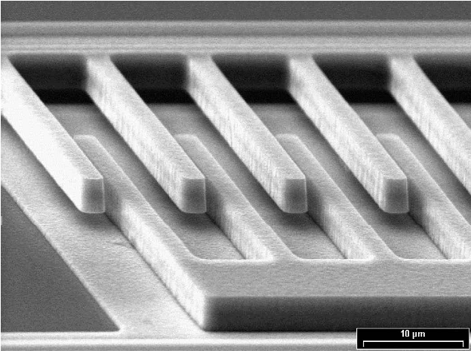
Figure I: Scanning electron microscope picture of stiction failure in a comb drive

Many micromachines depend for their functionality on the contact and separation of surfaces, such as switches. In many other applications, large surface areas close to each other are common in surface micromachining, and although they are not intended to contact each other, they may come together accidentally. When the surface forces are too large, the surfaces cannot be separated again, and the micromachined device ceases its intended operation by a failure mode called stiction (Fig. I). Stiction (short for: static friction) is one of the main failure modes in micro-electromechanical systems (MEMS), and as such, considerable research has gone into the description of the phenomenon.

Stiction will only occur when two requirements are fulfilled. The surfaces have to be in contact, at least for a little while, and the adhesion energy of the surfaces has to be larger than other forces acting on the surfaces (i.e. spring force of the device or an electrostatic actuation with a counter electrode). Most activities related to stiction reduction are primarily concerned with the amount of water between the surfaces of a MEMS device.

Capillary stiction depends on the ability of water to wet surfaces, the amount of roughness, and the proximity of the surface to each other which, in turn, depends on the relative humidity and temperature of the surrounding environment. Thus the main approaches one can take to counteract humidity related forces are: the use of rough surfaces (not much surface area in intimate contact), the use of hydrophobic surfaces (no capillary condensation), and to reduce or eliminate the humidity (water) in the environment.

In the 1990s the use of anti-stiction coatings emerged attempting to alleviate this problem. These coatings cover the surfaces of a MEMS device with molecules having long hydrophobic chains. Unfortunately, a commonly used procedure for anti-stiction coating on an industrial scale has not yet been established. In this lab a method of obtaining hydrophobic surface layers are discussed.

Because of the problems with respect to the conformity of plasma-deposited coatings, notably on the bottom side of surface machined microstructures, and also to facilitate the release of microstructures, self-assembled monolayer (SAM) coatings were proposed. If the process conditions are well controlled, it is possible to grow well adhering monolayers of covalently bonded silanes with a long hydrophobic chain on the surface (Fig. II).

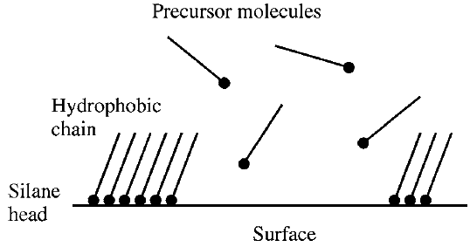
Figure II: SAM-formation

These coatings are created by reacting an alkyltrichlorosilane with a OH-terminated silicon surface in the presence of a trace amount of water on the surface. A covalently bonded Si-O-R group is formed, cross-linked to other Si-O-R groups, forming a thin, highly hydrophobic film on the surface (Fig. III).

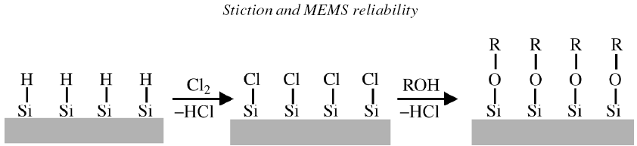
Figure III: Formation of a hydrophobic monolayer

Apart from plasma polymerization and SAM-coating from a liquid, it is also possible to obtain hydrophobic layers using vaporized precursor molecules. Although the process is very attractive because it is easier to implement, the results are not as good as for liquid phase SAM-coatings.

Film applications to Overcome Stiction (Anti-stiction film)

Vacuum processing and the vapor-phase deposition of these anti-stiction films, implemented by the Molecular Vapor Deposition (MVD) method, have proven capable of producing higher quality films, due to tight control of the process environment (moisture), and appear to be an attractive alternative in MEMS manufacturing. Ultra-thin hydrophobic coatings repel moisture, which is the main cause of the capillary stiction in MEMS devices.
MVD systems have been used in other microfluidic devices (lab-on-a-chip, biosensors, etc.) for surface modification of microchannels. Passivation of long (up to 6m) buried microchannels with controllable wetting coatings has been recently demonstrated using MVD process technology. The capability to coat microchannels in a fully assembled device (buried channels) simplifies the manufacturing process and reduces device cost.
Another emerging MVD application-release layers for nanoimprint lithography (NIL)-has already shown yield improvement and cost reduction advantages and has been used in many development labs worldwide. NIL, as a printing technology, requires mechanical contact between the mold and resist (polymer material), thus resist adhesion to the mold is one of its primary challenges.
When intimately contacted, the resist tends to be pulled from the substrate and remain on the mold, creating a defect that affects not only that specific substrate, but all other subsequently printed substrates because of the air gap formed between the mold and substrate. The main approach to overcoming this problem is to apply a low surface energy coating to the mold surface that can drastically reduce adhesive forces between the mold and resist materials. Imprint molds coated with a thin and conformal nanolayer perform hundreds of replication cycles without recoating and provide high fidelity of sub-50nm features (Fig. IV).
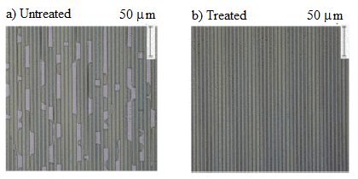
Figure IV: Line imprints for a) untreated imprint molds, and b) molds treated with a low energy surface coating

Stiction Lab: PDMS mold-coated with anti-stiction molecular layer for nanoimprint lithography
Processing Step | Temp | Time | Description
1. TFOS Application |  | 20 min | The PDMS mold is exposed to TFOS vapor under vacuum (~50 torr) for 12 min.
2. Clean Sample |  |  | Acetone/IPA/DI water is used to remove particles and residual materials from a past step.
3. Dehydration Bake | 105ºC | 3 min | Removes moisture and volatizes other liquids from the surface in order to promote adhesion of the resist to the substrate.
4. Plasma Treatment |  | 3 min | The Si sample is treated with O₂ plasma (50 W, 3 min, 200mT).
5. HMDS Application |  | 15 sec | Spin at 3000RPM using a ramp rate of 1000RPM/sec. Displaces moisture and acts as an adhesion promoter for resist solution.
6. HMDS Bake | 110ºC | 15 sec | Removes any remaining solvents from HMDS.
7. Spin Photoresist |  |  | Perform a standard Shipley 1813 photoresist application on a silicon substrate.
8. Imprint Process |  | 30 min | The PDMS mold is placed on top of the Si sample for 3 min at room temperature.
9. Post Bake | 95ºC | 10 min | To obtain robust structures..
10. Inspection |  |  | Check pattern for defects..
11. Repeat all steps expect for step 1. | 120ºC | 3-5 min | Repeat procedure with untreated PDMS mold.
Experiment: This exercise enables you to become familiar with the stiction concept in nanomanufacturing. Please take good notes and ask questions.

Questions:

- What is stiction? (2)

- Discuss the concept of hydrophobic and hydrophilic surfaces. (3)

- Describe how the PDMS surface treatment affects the quality of the imprinting (4)

- Explain the relationship between capillary stiction and surface contact angle (4)

- Using your results, support your answers regarding the effectiveness of an anti-stiction film for nano-micro fabrication. (4)

- Include bright field and dark field images of both samples. (4)

- Explain a fabrication technique that we can overcome capillary stiction in MEMS devices (4)

- Research and summarize one peer reviewed source on film applications to overcome stiction (5)

Additional References:
www.gelest.com
www.dowcorning.com
Lee, Nae Yoon and Kim, Youn Sang 2007 Nanotechnology, 18(41), 415303

Lab reports are due 12:00 NOON the Monday following the lab completion date. NO WORK WILL BE ACCEPTED LATE!

