Spin on Doping and Four Point Probe

Objective: The objective of this lab is to observe material modification through dopant diffusion and to demonstrate the operation of a four point probe for the measurement of sheet resistance.

Background: Sheet resistance is the parameter used to characterize the electrical resistance of thin films that have a uniform thickness and is given in ohms/square. Dimensionally this is the same as ohms. The square serves as a reminder of the parameter’s geometrical significance. Sheet resistance is independent of any lateral dimension and is therefore a function of the material and film thickness. It is commonly used to characterize materials made by semiconductor doping, metal deposition, resistive paste printing, and glass coating. Examples of these processes are: doped semiconductor regions (e.g. silicon or polysilicon), and the resistors which are screen printed onto the substrates of thick film hybrid microcircuits.
Sheet resistance is applicable to two-dimensional systems where the thin film is considered to be a two-dimensional entity. It is analogous to resistivity as used in three-dimensional systems. When the term sheet resistance is used, the current must be flowing along the plane of the sheet, not perpendicular to it.
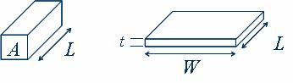
Figure I. Geometry for defining resistivity (left) and sheet resistance (right). In both cases, the current is flowing parallel to the direction of length (L).
In a regular three-dimensional conductor, the resistance can be written as
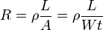
where ρ is the resistivity, A is the cross-sectional area and L is the length. The cross-sectional area can be split into the width W and the sheet thickness t.
By grouping the resistivity with the thickness, the resistance can then be written as:
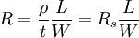 or 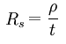
R_{s} is then the sheet resistance.

The primary tool used for this procedure is a four point probe. The tool uses the configuration shown in Figure II.
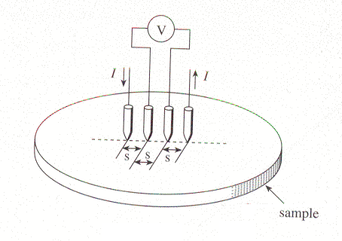
Figure II. Configuration of a four point probe measurement system
Pierret, R. Semiconductor Device Fundamentals, Addison-Wesley. 1996

A known current (I), is driven through the outside probes, while the potential developed in the film is measured between the inside probes. s indicates the distance between tips and is important for determining the proper correction factor that appears in the sheet resistance equation. The four point probe is preferred over the traditional two point probe method because the contact resistance and the resistance in the probe leads are eliminated. Contact resistance can be especially problematic for semiconductor samples because of the schottky barrier.

The value for the sheet resistance is obtained through the following equation:

R_{s}=4.532 (V/I)

The geometrical correction factor: 4.532 is given for samples that are a thin circular slice. It is only valid when the film thickness is less than half the spacing between the probe tips and the measurement is made in the center of the sample.

Experiment: A P-type <1-0-0> silicon wafer will be measures with a four point probe, using the standard four point measurement system shown in figure II, to find the initial sheet resistance. The sample will then undergo modification through the application of a spin on dopant and furnace diffusion. After the diffusion has been performed, the four point probe will be used to measure the change in sheet resistance of the sample.

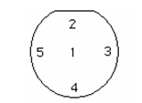
Figure II: Standard five point measurement map.

Day 1

1. Remove the native oxide from the sample using buffered oxide etchant (BOE).
2. Measure the initial voltage of the sample and record the values in a table.
3. Dopant application
- Secure the sample on a vacuum chuck
- Apply 2mL of B216 spin on dopant
- Spin at 3000 rpm with 1000 rmp/sec ramp rate for 20 sec
- Bake the sample for 20 min at 200ºC
4. Load sample into the furnace and use the following parameters for diffusion
- 1000ºC
- Under constant N₂ flow
- 10 min
5. Calculate the sheet resistance of the sample before diffusion

Day 2

1. Remove the samples from the diffusion furnace
2. Remove the oxide formed from diffusion with BOE
3. Perform a standard four point measurement of the sample with the four point probe
4. Record your values in a table.
5. Calculate the sheet resistance of the sample after diffusion.

Questions:
1. Calculate sheet resistance before and after doping for all measurement points. (5)
2. Graph the resulting sheet resistance before and after doping. (3)
3. Calculate the corresponding thickness before doping for all measurement points. (5)
4. Calculate the corresponding resistivity after doping for all measurement points. (5)
5. Graph the resulting resistivity before and after doping. (3)
6. Explain how four point probe measurement can eliminate the contact and probe lead resistance. (4)
7. Research and summarize a peer review article on sheet resistance. (5)

