Scanning Electron Microscopy (FESEM) & Atomic Force Microscope (AFM) Practice Lab

Objective: The objective of this lab is to gain experience through hands-on practice of AFM & FESEM imaging techniques.

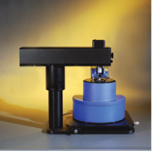
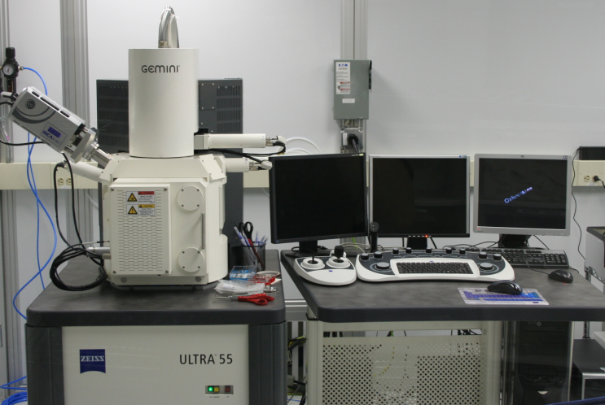

Figure I: Veeco diCP-II SPM Figure II: The Zeiss Ultra 55 FESEM

Introduction:

The AFM and FESEM are important tools for characterizing nanoscale features. Good quality images require many hours to be logged on these microscopes. Review the operation procedures for these tools before attending this lab session. Create a list of techniques/functions that may be unfamiliar to you. Practice these functions. By the end of the session create a list of techniques/functions to attempt next time you use these tools. Below is a list of suggested areas to practice.

For the AFM practice the following:

- Tip installation
- Laser alignment
- Sample approach
- Image capture
- Image analysis

For the FESEM practice the flowing:

- Focus
- Working Distance
- Stigmation
- Wobble
- Familiarity with types and functions of the detectors
- Loading/exchanging samples
- Software operation
- EDS characterization

Training Necessary: Safety training, lecture review of SEM technology, SEM training, FESEM training, AFM training, contact mode AFM

