Introduction to Field Emission Scanning Electron Microscopy (FESEM)

Objective: The objective of this lab is to observe the steps necessary to operate the Zeiss Ultra 55 FESEM.. The tool will be demonstrated by the instructor. Take good notes. This tool will be used repeatedly throughout the semester. This lab will also serve as the formal training of the operation of this tool.

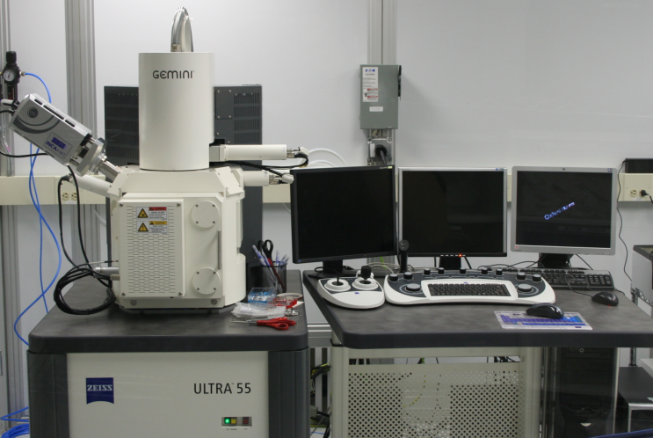
Figure I: The Zeiss Ultra 55 FESEM

Introduction:

The Zeiss Ultra 55 FESEM provides imaging capabilities beyond that of a conventional SEM. This piece of equipment is capable of magnifications up to 900,000X and is outfitted with 5 detectors (4 electron detctors and 1 x-ray detector). Two of the electron detectors are inside the lens system and detect electrons that travel back up the column from samples imaged at low working distances (1-4 mm). Acceleration voltages of 0.02-30 kV can be used and the 5 axis stage allows for easy manipulation of the samples in the system for the best view. In addition to the basic functions for obtaining an image, the software allows imaging from two detectors at the same time, balance signals from two detectors into one image, and adjust grid voltages at the detectors to attract and filter electrons based on their energy. X-rays are detected with an Oxford Inca EDS. This is a Peltier cooled EDS with the capability of analyzing individual spots, selected regions, or entire scans for either specific elements or the entire range of elements in its detection capability (from atomic number 3 and larger).

Training Necessary: Safety training, lecture review of SEM technology, optical microscope, scanning electron microscope

Questions:

- Give a detailed overview of how the electron beam is created for the FESEM. (4)

- What working distance must be used for the proper operation of the EDS.(2)

- What resolution is the FESEM capable of achieving? (3)

- Explain what sample charging is and how this can be eliminated. (2)

- State the type of chemical detection the FESEM is capable of and explain the principle of operation behind this technique. (4)

- Include an image from the FESEM at 50,000X magnification. (5)

