Transmission Electron Microscopy (TEM) Demonstration

Objective: The objective of this lab is to oversee the use of a TEM and to reinforce how electron microscopes generate images.
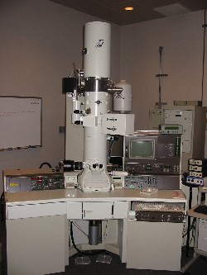

Figure I: JOEL 2010 G 200 kV, field emission TEM
Introduction:

An electron beam is generated from a Schottky emitter using an extraction voltage between 120-200 keV. The electron beam is focused through a series of electromagnetic lenses. The lenses before the sample change the size and shape of the beam which allow you to increase or decrease the illumination intensity on the sample and the spot size on the sample. The electron beam will interact with the sample in many ways including back scattering off the surface of the sample and passing through the sample. These interactions provide different kinds of information about the sample. After the beam has interacted with the sample, the electrons are imaged onto a fluorescent screen. This image is transferred to a computer monitor via a CCD camera. The resolutions of a TEM is ~2 nm. In order for an electron beam to be passed through a sample, the sample must be thinned to ~200 nm.

By the end of this demonstration you should understand how the following generated species are used in TEM imaging and chemical analysis:

- Backscattered electrons
- Secondary electrons
- Auger electrons
- X-rays
- Unscattered electrons
- Elastically scattered electrons
- Inelastically scattered electrons.

Training Necessary: Safety training, lecture review of SEM technology, SEM training, FESEM training

