Process Control: Intermittent Contact Mode and
Non-Contact Mode Atomic Force Microscopy

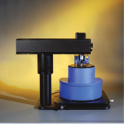

Figure I. Veeco diCP-II SPM. Figure II. Veeco diInnova SPM

Non-contact AFM (NC-AFM) uses a vibrating cantilever technique to image a sample surface. The probe tip does not come into contact with the sample surface, leaving spacing between the tip and sample on the order of tens to hundreds of angstroms. This minimizes the lateral frictional forces found in contact AFM. The total force between the tip and sample is very low, generally about 10-12 N. Non-contact mode uses a stiffer cantilever compared to contact mode, because the soft cantilevers used in contact mode can be pulled into contact with the sample surface. The combination of small forces and stiffer cantilevers makes NC-AFM signals small and therefore difficult to measure. A sensitive AC detection scheme is necessary for NC-AFM operation.

A more preferable alternative to NC-AFM is intermittent-contact AFM (IC-AFM). In this method the vibrating cantilever is brought closer to the sample, so that it just barely hits or “taps” the sample surface. Intermittent-contact mode is also referred to as “tapping mode.” IC-AFM covers the interaction ranges of both contact and non-contact AFM, as depicted below in Figure III.

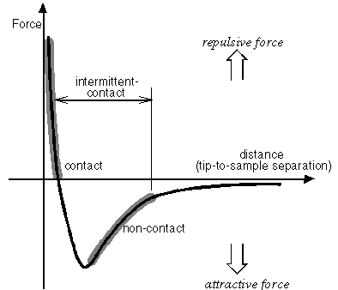

Figure III. Interatomic Force versus Distance curve.

The vibrating cantilever vibrates near its resonance frequency (typically from 100 to 400kHz) with an amplitude of a few tens to hundreds of angstroms. The resonance frequency depends on the cantilever dimensions and material used to fabricate it. Imaging occurs with detection of changes in resonance frequency or vibration amplitude as the tip comes near the sample surface. The sensitivity of this detection scheme provides sub-angstrom vertical resolution in the image, similar to contact AFM.

The relationship between the resonant frequency of the cantilever and variations in sample topography can be explained as follows. The resonant frequency of a cantilever is the square root of its spring constant (k) divided by its mass (m);

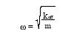 (1.1)

Here, the spring constant is written as k_{eff}, the effective spring constant, because the spring constant of the cantilever changes as the cantilever moves into close proximity (within a few hundred angstroms) of the sample surface. When this occurs, interatomic forces affect its behavior.

Specifically, the spring constant changes when the force between the tip and the sample has a spatial gradient, as it does in the non-contact regime. For a force gradient (f'), the effective spring constant is given by the following expression;

k_{eff} = k – f' (1.2)

In Equation 1.2, k is the value of the cantilever’s spring constant in free space, i.e., it is the value when the cantilever is far from the sample surface. The value of the cantilever’s resonant frequency far from the sample surface is referred to as its “free-space resonant frequency.” Equations 1.1 and 1.2 show that if the cantilever moves into a tip-to-sample spacing regime, where the force gradient is positive and increasing, then the effective spring constant of the cantilever and therefore, its resonant frequency, decrease.

The system monitors the resonant frequency or vibrational amplitude of the cantilever and keeps it constant with the aid of a feedback system that moves the scanner up and down. By keeping the resonant frequency or amplitude constant, the system also keeps the average tip-to-sample distance constant. As with contact AFM (in constant-force mode), the motion of the scanner is used to generate the dataset.

Training necessary: Safety training and lab review.

Objective: The objective of this lab is to understand and learn how to use the Veeco Digital Instruments CP-II and Innova SPM hardware and software in intermittent and non-contact AFM mode.

Experiment: Each student will prepare the AFM for intermittent contact mode imaging, image a given sample, and perform a proper shutdown of the AFM.

Attachments:
The following must be included in the report in order to receive credit. These scans should be included in the results section.
- Scan of nanoparticles in IC and C (contact) modes.

Questions:

- Describe the fundamentals of IC-AFM. (4)

- What is the relationship between the resonant frequency of the cantilever and variations in sample topography? (3)

- What properties of the cantilever does its resonance frequency depend on? (3)

- What are the advantages and disadvantages of IC-AFM over NC-AFM and C-AFM? (5)

Reference: http://www.veeco.com

