Transmission Line Measurements

Electronics Communications

Student Name: ___________________________________________________

Acknowledgements
Subject Matter Expert: Louis E. Frenzel Jr.

Purpose
Familiarize students with common measurements on coaxial transmission lines.

Systems Rationale
Communications equipment, systems and test instruments are generally connected to one another by coaxial cable. For that reason, it is essential that students know the characteristics of transmission lines using coax cable and how to make basic measurements on them.

System Concepts
This system covers the following system concepts (signified by an X):
_ _ S1. A system can be defined in terms of its functional blocks i.e., a “structured functional unit.”
_ _ S2. A system has a purpose, transforms inputs into outputs to achieve a goal.
_X_ S3. A system is defined by the flow of materials, energy and information, between its functional units.
_ _ S4. A system may be open or closed. In an open system additional inputs are accepted from the environment.
_ _ S5. A system is more than the sum of its parts. Individual components can never constitute a system.
_ _ S6. A system provides feedback to the operator and services to the user. Some system functions may involve operator action.
__ S7. Systems have unique problems.

Student Learning Outcomes
Appropriate SLOs for the lab activity are below. For a complete list of course SLOs visit: http://www.esyst.org/Courses/Communications/_delivery/index.php

- Explain the theory of transmission lines, name the most common types and their specifications and make basic calculations with them.
- Define reflection coefficient, standing wave ratio (SWR), and make basic calculations with them.

Prerequisite Knowledge & Skills
The student should have completed a lecture on transmission line fundamentals and read appropriate textbook assignments related to transmission line characteristics and measurements.

Learning Objectives
Relevant knowledge (K), skill (S), or attitude (A) student learning outcomes include:
K1. State the two most common specifications of a coaxial transmission line.
K2. State the condition for a transmission line that ensures maximum power transfer to the load.
K3. Define standing wave ratio (SWR).
S1. Measure SWR.
S2. Measure the attenuation in dB of a coax cable.
S3. Measure the complex impedance of a load on a coaxial line.

Process Overview
In this lab experiment you will become familiar with the test instruments used to measure transmission line characteristics like characteristic impedance, SWR, attenuation and complex load impedance and actually make such measurements.

Time Needed
Lab Performance:
It should take students approximately two hours to work through the entire lab.

Lab Deliverables:
It should take students approximately one hour of homework time to create the assignment

Equipment & Supplies
Item | Quantity
Coaxial cable (RG-8x) *See note. | 50 to 100 feet
SO-239 coax connector | 1
PL-259 coax connector (on coax) | As needed
MFJ Enterprises MFJ-269 SWR Analyzer | 1
Coax adapter (N to UHF) | As needed
Resistors – ¼-watt (51, 27, 120) | 1 each
Capacitors – 68 pF ceramic | 1 each
Solder lug | 1
#4 – ½” screw and nut | 1
Instruction Manual for the MFJ-269 (Available online) | 1

Note: It is strongly recommended that the coax cable be purchased with connectors already attached. Coax cable is typically sold in 50 or 100 foot lengths with connectors. RG-8x cable usually comes with PL-259 male UHF connectors. This will greatly facilitate and speed up the lab process eliminating the time consuming and error prone process of putting connectors on the cables. Depending on the cables you select, you will need to purchase coax adapters that convert N to UHF. The MFJ-269 uses an N connector for its input/output.
It is also possible to use other cable such as RG-58/U or variations thereof. It has a 50 impedance but typically uses BNC connectors instead of UHF connectors. An adapter from N to BNC or UHF to BNC will be needed if an alternate cable is used.

Special Safety Requirements
None

Lab Preparation
Become familiar with the operation of the MFJ-269 Analyzer (Figure 1) by reading the manual.

Introduction
Virtually all connections between equipment and circuits in communications equipment are made with coax cable. Some typical cases are:
1. Test instrument to circuit or equipment.
2. Between printed circuit boards.
3. Between different types of equipment.
4. From antenna to radio.
5. In some types of computer networks.

The important specifications of a coax cable are its characteristic impedance (Zo) and its attenuation. Characteristic impedance (Zo) refers to the value of the load required to match the cable to the equipment. A common Zo for most communications coax cables is 50 ohms or some value close to it (52, 53.5 etc). Other common specifications are capacitance per foot, velocity factor, and DC voltage rating.

Attenuation refers to the loss of signal in the cable. Losses are made up of a combination of resistance, capacitance and inductance, and are a function of frequency, with attenuation increasing with frequency. Attenuation is expressed in dB loss per foot. The attenuation of a given cable type is fixed and usually given as the attenuation per 100 feet at a given frequency.

It is essential that the output impedance of the driving circuit (Zg) be equal to the Zo of the cable. And the load (Z_{L}) on the other end of the cable should also be equal to Zo. See Figure 1.
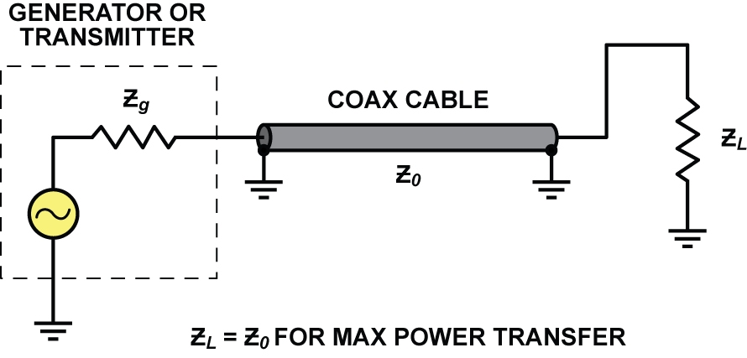
Figure 1

With this condition, maximum power transfer will occur. And the driving circuit will see an impedance equal to Zo. The SWR will be 1.

If there is a mismatch between the cable Zo and the load impedance, maximum power transfer will not occur. Furthermore, standing waves will develop along the line increasing losses. The load will no longer see the correct impedance.

If the load on the cable is not equal to Zo, the driving circuit will see some complex impedance (R ± jX). The cable will actually transform the actual load impedance to some other complex value depending on the length of the cable. Standing waves will develop and considerable signal strength will be lost in the cable.

Standing waves are variations of voltage and current along a transmission line. These patterns are produced by reflections of the signal from the load that is not equal to the Zo of the cable. The reflected signal represents a loss of signal to the load. The SWR is defined as the ratio of the maximum and minimum voltage variations along the line. When the load matches the cable Zo, the voltage variations are constant and the SWR value will be some value greater than 1. SWR can be computed as the ratio of the load impedance to Zo (SWR = Z_{L}/Zo or Zo/Z_{L}). SWR is always a value equal to or greater than 1, with 1 being the ideal for a matched condition.

In this lab exercise, you will demonstrate the proper matched conditions of a coax transmission line. You will also show the results of mismatched loads by measuring SWR, cable attenuation and complex impedance.

Task
In this experiment, you will measure coax cable impedance, SWR and attenuation by using an instrument known as an SWR analyzer. See Figure 2.

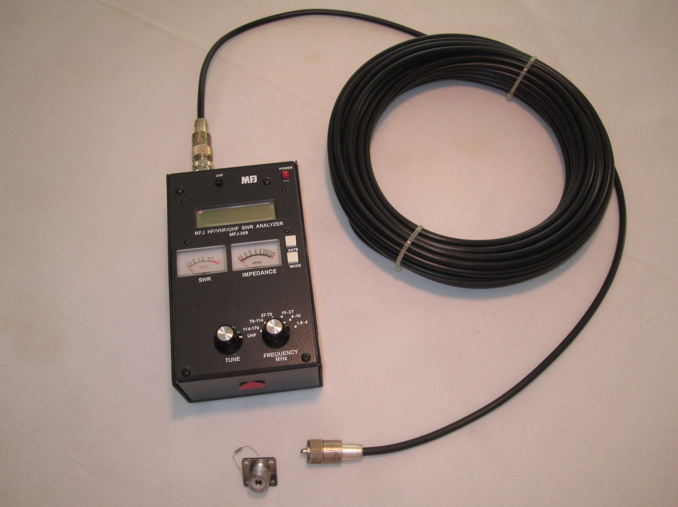
Figure 2: The MFJ-269 SWR Analyzer on the left is connected to 100 feet of RG-8x coax cable. The UHF cable connector is attached to the Analyzer with an UHF to N adapter. Note the SO-269 UHF connector in the foreground with load resistor.

This instrument is widely used especially in antenna design, construction, and installation and troubleshooting. You will measure SWR, cable attenuation and complex load impedance to determine if the cable connections are appropriate for the application or to perform troubleshooting procedures on a defective system.

Performance (Part 1): Impedance and SWR Measurement
1. Read the MFJ-269 instruction manual to familiarize yourself with its functions, capabilities, controls, displays and connections.
2. Perform a web search to find the specifications and characteristics of the coax cable you are using. Determine Zo and attenuation.
3. Construct a load for the cable by soldering a 51 ohm resistor to the bottom of a SO-239 coax connector as shown in Figure 3. (Note: A 47 or 56 ohm resistor will work just as well.)

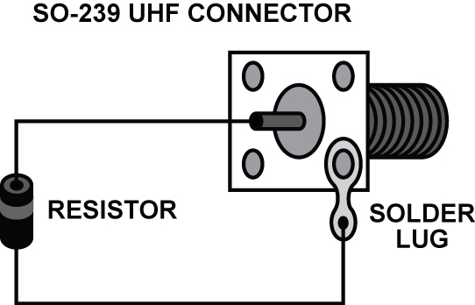
Figure 3

4. Connect one end of the coax cable with it PL-259 connector to the SO-239 connector.
5. Given the cable and the load resistance (R_{L}) value, calculate the value of the SWR you will measure.
6. Connect the N to UHF adapter to the N-connector on the MFJ-269.
7. Connect the other end of the coax cable to the UHF adapter.
8. Turn on the MFJ-269. Set the band switch to the 4 - 10 MHz range. Tune the frequency to 5 MHz.
9. Read the impedance and SWR from the MFJ-269 LCD display.
10. How do your measurements compare to your calculated values? Explain any differences.
11. Turn off the MFJ-269.
12. Unsolder the 51 ohm resistor and install a 27 ohm resistor in its place.
13. Turn on the MFJ-269. Repeat steps 5, 9 through 11.
14. Remove the 27 ohm resistor and replace it with a 120 ohm resistor.
15. Turn on the MFJ-269. Repeat steps 5, 9 through 11.

Performance (Part 2): Cable Attenuation
16. Determine the exact type of the coax cable you are working with. Then verify its exact length by measuring it. Note the length in feet.
17. Search the Internet for attenuation figures for the type of cable you are using. Determine the loss per foot in dB at 10 MHz and 50 MHz from tables or curves provided in data sheets or other sources.
(e.g., http://www.qsl.net/w2va/coax.htm)
18. With the attenuation figures and the length of the cable calculate the total attenuation of your cable at 10 and 50 MHz.
19. Connect one end of the cable to the MFJ-269. Leave the other end of the cable open with nothing connected.
20. Power up the MFJ-269 and set the frequency to 10 MHz.
21. Press the Mode button on the MFJ-269 to display the measured attenuation.
22. Adjust the frequency of the MFJ-269 to 50 MHz.
23. Repeat steps 20 and 21.
24. Compare your calculated and measured values and account for any differences.

Performance (Part 3): Impedance Transformation
25. Solder 120-ohm resistor in series with a 68 pF ceramic capacitor and connect the combination as a load to the SO-239 coax connector. See Figure 4.

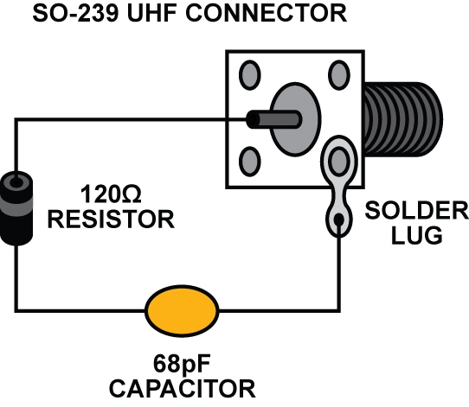
Figure 4

26. Connect the free end of the RG-8x cable to the SO-239 connector.
27. Calculate the impedance of the load at 5 MHz and express it in complex form
(R ± jX).
27. Turn on the MFJ-269 and set the frequency to 5 MHz. Note the impedance and SWR.
28. Explain why the measured value and actual values are different.
29. Is there any way to determine what impedance the generator will see given the actual load impedance, the frequency of operation, cable length and velocity factor?

Questions
Use your textbook, class notes, online references or any other sources to answer these questions.
1. The ideal SWR is
a. 0
b. 1
c. <2
d. Infinite
2. What value of load resistance will produce a maximum power transfer on an RG-6/U coax cable?
3. How will cable length affect SWR if the load impedance is matched to the cable impedance?
4. For a given necessary length, how can cable attention be reduced?
5. What is the generally accepted maximum SWR value for best power transfer to the load?

Deliverable(s)
The student should prepare a lab report in the form of calculations to problems and expression of measured values referenced to each of the steps above where that information is asked. All questions should be answered and referenced to the appropriate step number.

Grading
Your instructor will let you know how this lab will be graded.

