Maritime Industry Pathway Exploration Project
Materials:
Power Point presentation, a laptop computer for each group (or individual) with internet access, career plan worksheet, education plan worksheet, imported household items for table tops, written scenarios for each audience participant or group, website resources. It is suggested to have a link for each online resource placed on the desktop of each pc/laptop temporarily for easy access (handout attached).

Introduction:
Greetings, we are excited to talk to you about the fantastic maritime industry that hides right under our noses in Hampton Roads! Locally, there are at least 20 employers that hire in maritime trades such as coatings/painting, crane operation, pipefitting, welding, shipfitting, and engineering that earn from $50,000 to over $100,000 a year! With the current average age of a maritime worker hovering around 55-years of age, the industry is forecasting an immediate need for new maritime workers. “Stow away” with us to learn how to support the armed forces and meet the needs of worldwide goods and services!

Task:
Use the information and electronic resources provided to complete either a written education plan, or a written career plan (templates attached). This plan will serve as your map to the career pathway of your choice. At the end of the activity, the learner will have a complete picture for one or more occupations in the maritime industry, or the beginning steps to pursue education and training for a maritime career pathway.

Online Resources:
- Virginia Education Wizard (www.vawizard.org)
- Virginia Workforce Connection (www.vawc.virginia.gov)
- O-net Online (www.onetonline.org)
- Career One-stop (www.careeronestop.org)
- SMART Center Website (www.maritime-technology.org)
- Employer Websites (to search job openings and apprenticeships)

Huntington Ingalls Industries
Ocean Marine
Norfolk Naval Shipyard
Oceaneering International
General Dynamics
BAE Systems
Virginia Port Authority
AMSEC
Colonna’s Shipyard
Newport News Shipbuilding
Lyon Shipyard
Northrop Grumman
Mills Marine
CSX
Norfolk Southern
Tecnico
U.S. Coast Guard
CP&O, LLC
Maersk
CDI Marine

Process:
- Icebreaker - place common imported household items of use on each table. This will grab the learner’s visual interest. As the presentation begins, the audience will be asked to define what these items all have in common. Once basic responses have been given, the defining answer is: “all of these items arrived via some form of maritime transportation (seagoing, ports and logistics, pleasure craft and marinas, and shipbuilding and ship repair), etc.”

- Scenarios - Different scenarios have being written and placed under each item used in the icebreaker. Have a volunteer from each table stand up to read/represent the scenario. Because the learner will be playing a role, they can see how each person reflected in the scenarios could relate to them. The scenarios include:

A) A recent high-school graduate (relevant to the learner’s future goals)
“I graduated from high school last month and I don’t know what I want to do. I don’t want to spend 4 years in college and owe a bunch of money. I want go to work and earn money, but my parents want me to go to school. What should I do?”

B) A veteran with some college credit (relevant to the learner’s past experience)
“I completed a few college classes, and want to use the career I had in the military. How do I transition my skills and education into a stable career that will support my family?”

C) A dislocated worker who is changing careers (urgent because of the need for a timely solution)
This is the 2nd time I have lost my job due to a reduction in workforce. I don’t have a college degree, but I want to enter a new field that I enjoy, that makes a difference in the world and has increased job security. What can I do that is local and in demand?”

D) Scenarios could be expanded to include any variables and context.

- To transition, each person with the scenario can go back to their table and join their group to begin using the resources explained in the PowerPoint to research and complete the career or education worksheet (explained below in detail).

- The PowerPoint presentation (attached) is a general overview of the occupations, employers and examples of career pathways in the maritime industry.

- Use the Virginia Education Wizard (www.vawizard.org) to perform a basic assessment measuring skills, values and interests. Each individual (or group) will click on the “Create an Account” link at the top right-hand side of the screen. Once they create an account, they will click on “Career Assessment” and start the Interest Assessment. After the Interest Assessment is completed, they will click on “Assess Skills” to complete the second assessment. The third and final assessment is the “Assess Values”. After all three have been completed, they can click on the “Combined Assessment Results” on the right to view their selected Career Clusters and careers by education level (less than 2-year degree, 2-year degree, 4-year degree, or 4-year degree or higher). Once the results are given, research careers via specific clusters such as “STEM”, or “Transportation, Distribution, and Logistics”, or click the “Careers by Cluster” link for a more general search. Also try searching the database for individual occupations by clicking the “Careers by Name” link, or by clicking the “Career Pathway Plans of Study” link.

- Within the individual occupation profile (sample attached) there is labor market information for education requirements, local Community Colleges and Four-Year Colleges that offer related training, possible apprenticeships, supply and demand, wage range, related occupations, and a scaled list of skills and their definitions needed for each position.
- If the learner is not satisfied with their results from the Virginia Education Wizard assessment, he or she may research labor market information on other sites such as the Virginia Workforce Connection (www.vawc.virginia.gov), O-net Online (www.onetonline.org), or Career One-stop (www.careeronestop.org).

- More specific information and resources regarding career pathways in maritime careers can be found on the SMART Center website (www.maritime-technology.org).

- Next, learners will be able to examine the following employers websites (via the links provided) for more information on maritime programs and maritime careers:

Huntington Ingalls Industries
Norfolk Naval Shipyard
Oceaneering International
General Dynamics
BAE Systems
Virginia Port Authority
AMSEC
Colonna’s Shipyard
Newport News Shipbuilding
Lyon Shipyard
Northrop Grumman
Mills Marine
CSX
Norfolk Southern
Tecnico
U.S. Coast Guard
CP&O, LLC
Maersk
Ocean Marine
CDI Marine

- Once the education or career plan is completed (either individually or as a group), the groups should return to their tables and await further instructions for completing either the education plan or career plan. This exercise will lead the learner through the process that takes them from unawareness to enlightenment at the end of a maritime career pathway. Participants will learn the global implications associated with a maritime career pathway.

Conclusion:
- Upon returning to tables, each group should spend time (amount to be determined by the instructor), developing a simple verbal presentation to explain their findings to the rest of the class (if desired, this could be expanded to include homework preparation and using the web-based resources to illustrate their findings in a formalized presentation).
- While developing the presentation, each group should devise two questions about their career plan or education plan to give to the audience as possible springboards for individual research into the maritime industry.
- Each group will choose a presenter to report the findings of the education or career plan, and present the two questions.
Evaluation:
The learners will be evaluated in the following areas:
- Did you complete the education or career plan for at least one occupation? (15 points)
- Did you develop a simple presentation to explain your findings to the other groups? (10 points)
- Did you come up with 2 questions to ask about the maritime industry within your group? (5 points)
- (This question depends on your audience-what is their take-away?)
- What educational program might you want to pursue? (College students/high school graduates)
- For what position do you want to apply? (College students/high school graduates)

Tags:
Shipyard, Shipbuilding, Marine, Maritime, Apprentice, Apprenticeship, Women in Maritime, Marine Electrician, Marine Welder, Marine Coating/ Painter, Pipefitter, Ship fitter, Marine Engineer, Logistics, Trade, Insulator, Millwright, Machinist, Patternmaker, Security, Railroad, CDL, Truck Driver, Cargo, Ship, Cluster, Career Pathway, Carrier, Diversity, Longshoreman, Shortshoreman, Stevedore, Virginia Education Wizard, Community College, College, Military, High School, Veteran, Transportation Jobs, Sheet Metal Worker, Maintenance, Fabricator, Rigger, Crane, Tower, Nuclear, Occupations, Labor Market Information Videos, Assessment, Distribution, Forklift, Freight, Port, Vessel, Harbor, Harbour, Shipping and Receiving, Industrial, Safety, OSHA, Diesel, Boat

Maritime Industry Education Plan:
- What are the top three maritime positions that interest you?

- What is the definition of an apprenticeship? How does it differ from a traditional program of study?

- Is this program an apprenticeship, or would you begin the process at a local community college/university/military branch (please list the name of the employer or educational institution or branch of the military)?

- What is the first step to begin this educational pathway (how do you apply)?

- How long will your training program take from start to finish?

- How will you pay for this program (employer/financial aid/apprenticeship)?

- What is the salary range for your chosen profession?

- Does this program allow you to work and go to school at the same?

- What certifications will this educational pathway allow you to obtain?

- Does each level of completion within the program allow you to build upon it, if you decide to do so?

- What other maritime occupations are related (list 2)?

- What are the 2 questions you have for the group presentation?
Maritime Industry Career Plan:
- What are the top three maritime positions that interest you?

- What is the definition of an apprenticeship? How does it differ from a traditional career?

- Is this program an apprenticeship, and if so, how do you apply for the position?

- What is the first step to begin this career pathway (how do you apply)?

- How long will your training program take from start to finish?

- What is the definition of this maritime career (what will you be doing)?

- What is the salary range for your chosen profession?

- What are the names of 3 local employers that hire for this position?

- What professional certifications will this position allow you to obtain?

- What are 3 new terms and their definitions that you learned in your research?

- Is this position in demand? Why or why not?

- What are the 2 questions you have for the group presentation?

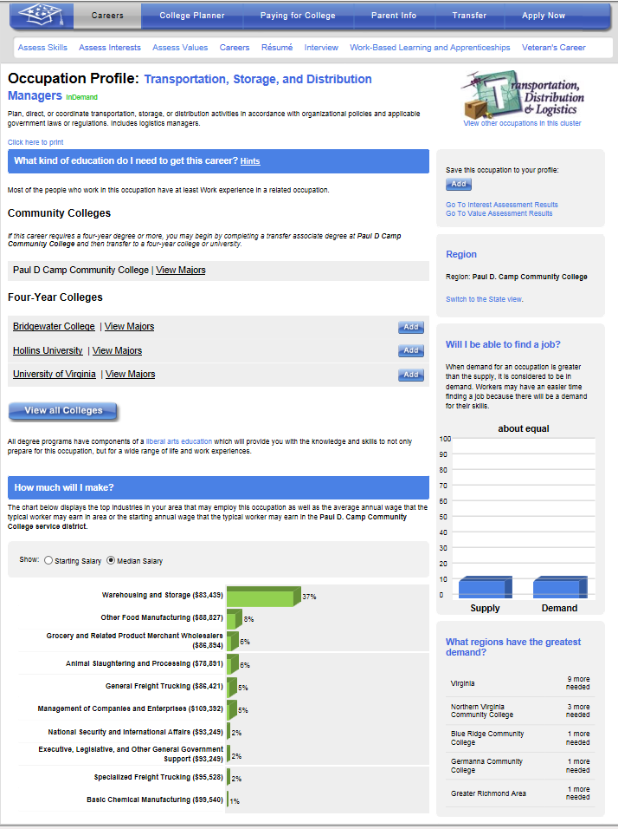

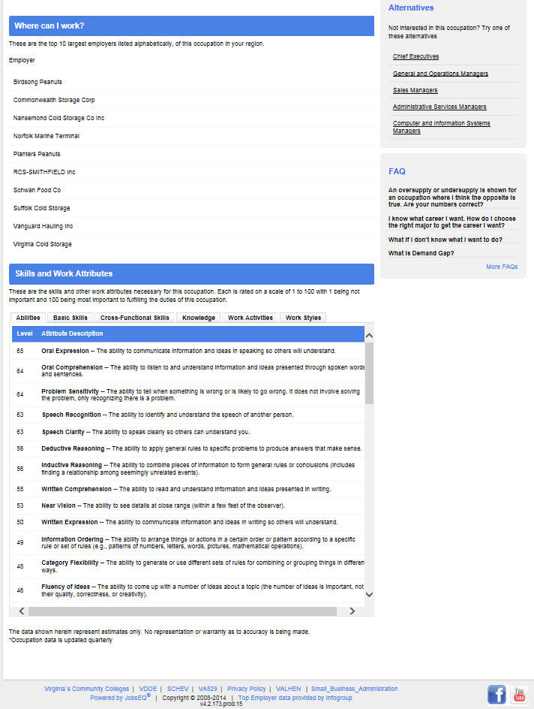
Online Resources for Maritime Careers
- Virginia Education Wizard (Online Career & College Planning Tool) (www.vawizard.org)
- Virginia Workforce Connection (Job Search and Labor Market Info) (www.vawc.virginia.gov)
- O-net Online (Career Exploration & Job Analysis) (www.onetonline.org)
- Career One-stop (Industry, Occupation, & Education) (www.careeronestop.org)
- SMART Center Website (www.maritime-technology.org)
- Employer Websites (to search job openings and apprenticeships)

Huntington Ingalls Industries (http://www.huntingtoningalls.com/careers/index)
Ocean Marine (http://www.oceanmarinellc.com/about/employment.html)
Norfolk Naval Shipyard (http://www.navsea.navy.mil/shipyards/norfolk/Careers/home.aspx)
Oceaneering International (http://www.oceaneering.com/careers/)
General Dynamics (http://www.generaldynamics.com/careers/)
BAE Systems (http://www.baesystems.jobs/)
Virginia Port Authority (https://employment.portofvirginia.com/applicants/jsp/shared/Welcome_css.jsp)
AMSEC (http://www.amsec.com/AMSEC_Web/Careers/Careers.html)
Colonna’s Shipyard (http://www.colonnaship.com/EMP_OPENINGS.html)
Newport News Shipbuilding (http://www.huntingtoningalls.com/careers/index)
Lyon Shipyard (http://lyonshipyard.com/employment/)
Northrop Grumman (http://www.northropgrumman.com/Careers/Pages/default.aspx)
Mills Marine (http://millsmarineshiprepair.com/employment.html)
CSX (http://csx.com/index.cfm/working-at-csx/)
Norfolk Southern (http://www.nscorp.com/content/nscorp/en/careers-at-norfolk-southern/career-paths.html)
Tecnico (http://tecnicocorp.com/employment/)
U.S. Coast Guard (http://www.uscg.mil/top/careers.asp)
CP&O, LLC (http://www.coopertsmith.com/cts webpages/Stevedoring.htm)
Maersk (http://www.maersk.com/Career/Pages/career.aspx)
CDI Marine (http://tbe.taleo.net/CH12/ats/careers/jobSearch.jsp?org=CDI&cws=1)
LOCAL REGISTERED APPRENTICESHIP PROGRAMS

BAE SYSTEMS
(757) 494-4292
www.thisismyclassroom.com/
Four-year ship repair program leading to a Master Journeryworker’s License, within the following professions: Sheet Metal Worker, Carpenter, Dock Master, Electrician, Inside Machinist, Outside Machinist, Pipefitter, Rigger, Shipfitter, and Welder.
STIHL, Inc.
www.stihlcareers.com
This four-year program offers a registered apprenticeship in Advanced Manufacturing Programs: Polymold Tech, Mechanic, and QA tech.
Newport News Shipbuilding/HII
(757) 534-4349
www.apprenticeschool.com
Apprentices begin their careers in one of 19 waterfront trades and complete foundational coursework taught by highly qualified Apprentice School faculty in the first year. Apprentices then become eligible for optional academic and occupational programs based on their performance in the first year. These programs include Advanced Shipyard Operations, Marine Design, Production Planning, Modeling and Simulation Analyst, Nuclear Test Technician and Cost Estimation. Criteria for selection includes: academic grades, craft performance, attendance, personal interest, and aptitude for the work.
Norfolk Naval Shipyard
(757) 396-4777
www.navsea.navy.mil/shipyards/norfolk/Careers/Apprentice.aspx
Four-year ship repair program in occupational fields such as: Welder, Pipefitter, Electrician, Machinist, Rigger, Fabric Worker, Metals Inspectors, and Shipfitter.
Oceaneering International, Inc.
(757) 545-2200
www.oceaneering.com/careers
The Oceaneering International, Inc. Apprentice Program is a four year program which will utilize on-the-job trades training and academic related instruction to graduate journeyman level craftsmen (Journeyworker's license and maritime trade certification) in the following trades: Electrician, Inside Machinist, Outside Machinist, Pipefitter, Shipfitter and Welder.
American Maritime Holdings
(757) 961-9311
www.americanmaritimeholdings.com/apprenticeships/
AMH is a 4 year, Maritime Ship Building and Repair Industry Apprenticeship program leading to journeymen level of certification in the following trades: Shipfitting, Pipefitting, Marine Electrician, Machinist, Welder, Rigger, Painter and Sheetmetalist. This includes OJT, mentorship and possibilities for advanced academic training.
Colonna’s Shipyard Inc.
(757) 545-2414
http://www.colonnaship.com/
Four-year ship repair program leading to a Journeyworker’s License and Maritime Technologies certification within the following trades: Inside and Outside Machinist, Welder, Shipfitter, Pipefitter, Electrician, Rigger, Carpenter, and Painter.
Thermo-Trol Systems, Inc.
(757) 428-4030
www.thermo-trol.com
Four-year program to become an HVAC (Heating, Ventilation, and Air Conditioning) Journeyworker Mechanic with DDC (Direct Digital Controls).
Colonial Webb Contractors
(804) 916-1400
www.colonialwebb.com
Four-year program to become an HVAC (Heating,Ventilation, and Air Conditioning) Journeyworker Mechanic.
CDI Marine
(757) 397-8000
www.cdi-marine.com
Four-year program in ship repair and alterations leading to journeyworker’s license in the maritime trades, specializing in marine electrical and mechanical contracts.
AMSEC
(757) 226-1274
www.amsec.com
Four-year program in ship repair, modification, and ship design leading to journeyworker’s license and maritime trade certification.
Collins Machine Works
(757) 399-7777
www.collinsmachine.net
Four-year program as machinists and welders using computer numerically controlled machinery leading to journeyworker’s license and maritime trade certification.
NAVFAC
(757) 445-4485
Naval Facilities Engineering Command
http://www.navfac.navy.mil/
Four-year Program to journeyworker level within the following trades: Electrician, High Voltage Electrician, Sheet Metal Mechanic, Plumber, Pipefitter, Air Conditioning Equipment Mechanic, Heavy Mobile Equipment Mechanic, and Automotive Mechanic.
Auxiliary Systems
(757) 623-5674
www.auxsysinc.com
Four-year program to journeyworker level within the marine electrical and marine mechanical trades.

Maritime Career Pathway
Consider College
Career Studies Certificates are available at your local community college in the following:
Marine Electrical
Marine Mechanical
Marine Diesel
Marine Welding
Maritime Technologies

Ready for a degree?
Maritime Logistics
Maritime Technologies
Business
High School Graduate
Put Your Experience to Work
Already have experience? Consider a national industry credential:
Journeyman –Craftsman Card (DOL)
Certified Welder (AWS)
Certified Boat, Yacht, Marinas (ABYC)
Manufacturing Cert (MSSC)
Or complete a short non-credit program offered by the community college (i.e. Marine Welding, Marine Electrician, Marine Coatings, Maritime Logistics)
Experienced worker
Consider an Apprenticeship
Earn while you learn! Earn certificates, degrees or certifications while you work.
Associate’s degrees can be earned in:
Business Administration
Engineering (Mechanical, Electrical, or Computer)
Engineering Technology (Mechanical, Electrical, or Technical Studies)
Bachelor’s degrees and PhDs can be earned in:
Engineering (Mechanical or Electrical)
military veteran
Continuing Education
You can work full-time and take college courses at a 4-year college to earn your Bachelor’s or Master’s degree. Fields include:
Applied Science
Engineering Technologies
Maritime Logistics
Leadership
Or consider a Maritime Academy:
4-year institution which yields a Bachelor of Science degree and a license as a Third Mate or Third Assistant Engineer

college Graduate
CAREER OPPORTUNITIES
Entry-Level Worker
0 – 2 years
$14 - $18/hr
Technician/ Specialist/ Operator
2 - 6 years
$17 - $28/hr
Manager/ Supervisor/ Engineer/ Inspector
5 - 20 years
$60 – 92K/yr
Chief Engineer/ Captain
15+ years
$120 – 190K/yr
EDUCATION & TRAINING

