Illustrations of Interconnectedness in Ecosystems

Author contact information

Wynn W. Cudmore, Ph.D., Principal Investigator
Northwest Center for Sustainable Resources
Chemeketa Community College
P.O. Box 14007
Salem, OR 97309
E-mail: wynn.cudmore@chemeketa.edu
Phone: 503-399-6514

Published 2009
DUE # 0455446

NCSR curriculum modules are designed as comprehensive instructions for students and supporting materials for faculty. The student instructions are designed to facilitate adaptation in a variety of settings. In addition to the instructional materials for students, the modules contain separate supporting information in the "Notes to Instructors" section. The modules also contain other sections which contain additional supporting information such as a “Glossary” and “Suggested Resources.”

The PowerPoint slides associated with this module are the property of the Northwest Center for Sustainable Resources (NCSR). Those containing text may be reproduced and used for any educational purpose. Slides with images may be reproduced and used without prior approval of NCSR only for educational purposes associated with this module. Prior approval must be obtained from NCSR for any other use of these images. Permission requests should be made to ncsradm@chemeketa.edu.

Acknowledgements

We thank NCSR administrative assistant, Liz Traver, for the review, graphic design and layout of this module. While errors in content should be attributed to the author, accolades on the professional appearance of the module should be sent in her direction.
Table of Contents

Illustrations of Interconnectedness in Ecosystems - Module Description 4

Illustrations of Interconnectedness in Ecosystems 5

Introduction 5

Objectives 6

Procedure 6

Notes to Instructors 7

Resources 8

Introductory Activity I – The Recovery of Channel Island Foxes 9
Introduction 9
History 9
Current ownership and management 9
What do you think should be done? 9
What is being done, by whom, and why? 10
Questions 10
Resources 11
Assessment 11

Introductory Activity II – Pollination of New Zealand Mistletoes 12
Introduction 12
Procedure 12
Resources 12
Assessment 15

Additional Interconnectedness Descriptions and Resources 17
1. Salmon and the Forest 17
2. The Introduction of Nile Perch and Water Hyacinth into Lake Victoria, Uganda 20
3. Wolves in Yellowstone National Park 23
4. Cougars in Zion National Park 26
5. Borneo - Operation Cat Drop 27
6. Flathead Lake, Montana – Introduction of Mysis Shrimp and Kokanee Salmon 28
7. Dust from Lake Chad, Nigeria 30
8. The Role of Large Vertebrates in Seed Dispersal and Germination 32
9. Intertidal and Near-shore Marine Ecosystems – Sea Urchins, Sea Otters and Killer Whales 34
10. Ecosystem Consequences of the Decline of Atlantic Cod 36
11. Fishing Down the Food Web 37
12. Chesapeake Bay – Striped Bass Diseases 39
13. Strangler Figs, Bats and the Brazil Nut Tree 40

ILLUSTRATIONS OF INTERCONNECTEDNESS IN ECOSYSTEMS –

MODULE DESCRIPTION

This module introduces the idea of interconnectedness among ecosystem components and describes a number of scenarios that illustrate the concept. Interconnectedness is a fundamental ecological concept, a common theme in natural resource/environmental science programs and a foundational component of ecosystem-based management of natural resources. Two introductory activities require students to diagram ecosystem interconnections. Brief descriptions of 13 additional scenarios are provided, along with references to and descriptions of supporting video, print and web-based resources.

ILLUSTRATIONS OF INTERCONNECTEDNESS IN ECOSYSTEMS

“When we try to pick out anything by itself, we find it is hitched to everything
else in the universe.”

John Muir 1911
My First Summer in the Sierra

INTRODUCTION

The concept of interconnectedness, the idea that linkages exist among ecosystem components, is a fundamental ecological concept and a foundational component of ecosystem-based management of natural resources. The existence of interconnectedness explains why when changes are made in one part of the ecosystem, other components are affected, often in unexpected ways. Botkin and Keller (2007) label the concept “environmental unity” and use it to explain why one can never do “just one thing.” Ecosystem components are connected in intricate and often unanticipated ways. The result is a woven fabric such that when one strand is pulled, others, that at first glance may not appear to be connected, begin to show an effect.

The idea of the existence of linkages between ecosystem components is not a new one. The concept was understood nearly 100 years ago by naturalist John Muir, as indicated by the quote above. The writings of Aldo Leopold in the 1940s and 1950s also clearly show an understanding of the concept. In A Sand County Almanac, for example, Leopold comments on the impacts of excessive browsing by deer as a result of extirpation of wolves. Later, in Round River while describing his evolving views on wildlife management, he states that “saving all the parts is the first rule of intelligent tinkering.”

However, it is only in recent years that the concept has become fundamental to the way that we manage natural resources. Our efforts to maintain streams that provide suitable habitat for salmon and trout in streams of the Pacific Northwest will serve as an example. Water temperature is among the more important characteristics of a salmon stream and is influenced by a number of interrelated factors at several spatial and temporal scales. For example, the width and quality of the riparian zone provides shading and a cooling effect on the water. Trees that fall into the stream form natural dams that influence flow patterns creating pools and riffles and provide additional shading. Temperature is also influenced by the amount of incoming solar radiation and the source of water (runoff vs. springs). Turbidity influences stream temperature as more incoming solar radiation is intercepted and absorbed. Turbidity levels are affected by land uses in the watershed such as urban development, logging and agricultural practices. Stream temperature varies with stream flow, which changes both with time and position in the watershed. Due to the interconnected nature of ecosystems, managing a stream to meet a particular temperature benchmark can be complicated business. Management activities may include working with landowners to establish riparian buffer zones, adding logs to streams and introducing low-till agricultural practices to reduce sediment flow into streams.

Modern natural resource management is based on an understanding of ecosystems (“ecosystem-based management”) and recognizes the interconnectedness that exists between ecosystem components. It is hoped that by having a more complete understanding of how ecosystems function we will experience fewer surprises, such as some of those illustrated by the examples described below.

This module includes two introductory activities that may be used to introduce the concept of interconnectedness and to illustrate how the concept may be applied to natural resource management. Then, several additional scenarios that illustrate interconnectedness are briefly described. These were selected to provide instructors with a broad array of choices that may be used as lecture support to present the concept and to insert where most appropriate in their courses. For each scenario, the relationship between ecosystem components is described and, where available, a recent video production is cited that may be used to introduce the scenario. A detailed account of the content of the video production is also included. Supporting print and web resources are also provided that can be used by instructors to elaborate on the descriptions given here. Most are also suitable to assign as student reading.

OBJECTIVES

Upon completion of this activity students should be able to:

1. Describe the concept of interconnectedness and its relationship to natural resource management

2. Describe examples of scenarios that illustrate the concept of interconnectedness

PROCEDURE

1. Students are introduced to the concept of interconnectedness.

2. Students view a video or read an article that describes a well-documented scenario illustrating the concept.

3. Students may diagram the interrelationships between the various components of the scenario using arrows to indicate linkages.

4. The nature of the relationships that exist between ecosystem components may be further described by labeling arrows with various descriptors. Some examples include:

- “+” (positive) or “-“ (negative) indicting a positive or negative influence of “A” on “B”
- “predation”, “herbivory”, “pollination”, “competition” indicating the nature of the relationship between “A” and “B”

See Introductory Activity - The Recovery of Channel Island Foxes for an illustration.

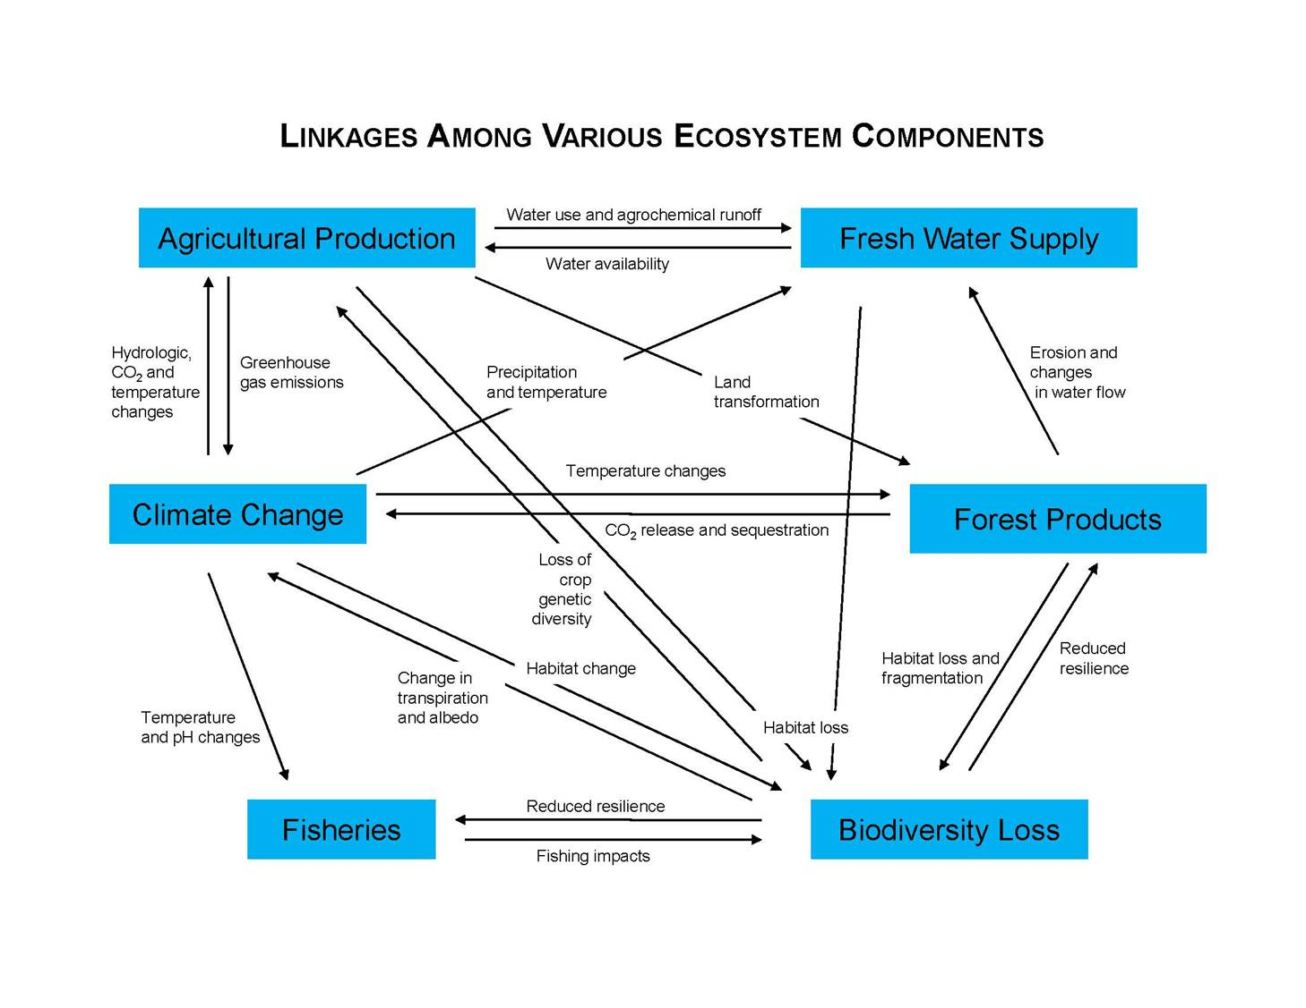

NOTES TO INSTRUCTORS

The diagram above illustrates the linkages that exist among various ecosystem components with an emphasis on those that provide goods and services to humans. It provides a useful context for the illustrations of interconnectedness described in this module and could be used to introduce the concept. Discussion of an example or two of what is represented by the arrows in the diagram should be sufficient for students to understand the diagram. For example:

Agricultural production places demands on both water quantity and quality. Extractions from natural waterways for irrigation and watering livestock reduces the availability of water for other purposes, such as municipal use or fish habitat. Runoff from agricultural fields and confined feeding operations may include agrochemicals such as fertilizers and pesticides potentially impacting water quality. The availability of fresh water also impacts agricultural production. If irrigation water is not readily available, for example, agricultural production maybe limited or different crops must be selected.

The original authors (Ayensu, et al., 1999) contend that growing demands on natural resources (represented by the rectangular boxes in the diagram) can no longer be met by exploiting untapped resources. Rather, we are at a point that trade-offs must be made for ecosystem goods and services. For example, a country may increase its potential for food production by converting forest lands into agricultural lands, but by doing so decreases the supply of goods and services produced by forests. In some cases, these newly acquired goods and services may be of lesser value than those provided by the original ecosystem. Clean water, timber production, flood control and biodiversity provided by forests, for example, may actually be of greater value than the agricultural goods that are produced.

In today’s world of tradeoffs between natural resources, traditional approaches to natural resource management where resources were managed independent of one another are insufficient. A more integrated approach, such as ecosystem-based management, that recognizes these linkages and the interdependence of natural resources is needed.

RESOURCES

Ayensu, E., et al. 1999. International ecosystem assessment. Science 286:685-686.

Botkin, D. and E. Keller. 2007. Environmental Science: Earth as a Living Planet.
6th ed. John Wiley and Sons, Inc. New York. 668 pp.

Muir, J. 1911. My First Summer in the Sierra. Houghton Mifflin Co, Boston, MA. 419 pp.

Leopold, A. 1949. A Sand County Almanac and Sketches from Here and There. Oxford University Press, New York

Leopold, A. 1953. Round River: From the Journals of Aldo Leopold. Oxford University Press, New York

INTRODUCTORY ACTIVITY I – The Recovery of Channel Island Foxes

INTRODUCTION

Due to their rich biological diversity, the Channel Islands off the southern California coast are sometimes called the “Galapagos of North America”. Santa Cruz, the largest of the Channel Islands, for example, harbors more than 1000 plant and animal species including 12 endemics found nowhere else on Earth. Santa Cruz Island has never been connected to the mainland and due to this isolation, its species evolved distinct genetics. Its endemic fauna includes a scrub jay that is larger and bluer than its mainland relative and the Santa Cruz Island fox, which is less than half the size of its closest relative, the mainland gray fox.

HISTORY

In the mid-1800s European settlers introduced domestic livestock, dominated by pigs and sheep, which escaped and bred on their own in the wild and became feral. Since there were no predators on the island, they eventually overran the island, disturbing vegetation and causing widespread erosion and landslides. Several plant species on the island are threatened with extinction including lacepod, barberry, and bush mallow, and at least one plant species has gone extinct (the Santa Cruz monkey flower). Beginning in the 1950s, a resident bald eagle population on the island also declined due to DDT contamination. DDT was developed as a wide-spectrum pesticide in the 1940s, but has been shown to contribute to the decline of top predators due to a phenomenon known as biological magnification. Raptors such as eagles and hawks are particularly susceptible as it alters calcium metabolism resulting in egg shell thinning and decreased nesting success. A close relative, the golden eagle from the mainland, filled this ecological void on the islands. The golden eagle population was supported by feral pigs, but they also fed on the native Santa Cruz foxes driving their numbers down. While bald eagles target carrion and fish, golden eagles eat primarily small to medium-sized mammals. The fox population declined from 1500 individuals in the early 1990s to a low of less than 100 in 2002. In 2004, four Channel Island fox populations were listed as “endangered”; two others (San Miguel Island foxes and Santa Rosa Island foxes) went extinct in the wild.

Thus, with the disappearance of the bald eagle, a series of events was initiated.

CURRENT OWNERSHIP AND MANAGEMENT

The National Park Service manages four of the Channel Islands and about 25% of Santa Cruz Island. The Nature Conservancy (a private environmental organization) manages the remainder of Santa Cruz Island as the result of a bequest in 1987.

WHAT DO YOU THINK SHOULD BE DONE?

Assume that the management goal is to return Santa Cruz Island to the ecosystem
that was present prior to the intervention of European settlers in the 1800s. Based only on the
information presented above, outline the steps that you think should be taken to meet this
management goal. Do this before reading the account below of what steps have been taken by
those organizations responsible for management of the island.
WHAT IS BEING DONE, BY WHOM AND WHY?

1. Biologists from the National Park Service and the Nature Conservancy have imported 61 bald eagles that were raised in Alaska and the San Francisco Zoo. The birds are first acclimatized to their new environment in enclosures for several months. They are then released and it is hoped that when they reach maturity they will establish nest sites, begin raising young and displace the golden eagles. Thirty bald eagles currently (2006) occupy the island and the first successful nesting occurred in spring 2006. Nests are electronically monitored by biologists. Money for this recovery effort comes from a 2002 court settlement with chemical companies over DDT contamination. DDT levels have apparently declined as evidenced by the return of brown pelicans to the site.

2. In 2002, 10 pairs of foxes (of the 100 left) were brought into captivity for a captive breeding program. The program has produced 75 pups since 2002 and releases began in 2002 (3 in 2002, 9 in 2003). Five became prey to golden eagles, so the remaining four were brought back into captivity. In 2005 and early 2006, more than 20 foxes were killed by golden eagles.

3. There have been some efforts to remove golden eagles from the island. A total of 44 golden eagles have been trapped, and transported to eastern Sierra Nevada and none have returned. In summer 2006, 18 foxes were released (the first in two years) and none have been killed by golden eagles.

4. A pig eradication program was also established in 2005 to remove feral pigs from the island. The goal of the $5 million program was to eliminate all feral pigs by the end of 2006. Park Service and Nature Conservancy biologists claim that removal of the pigs is required to restore the ecosystem to its previous condition and to allow the recovery of natural biodiversity including species that occur nowhere else on Earth. Despite, animal rights groups objection to the “pig slaughter”, feral pigs have now been removed from the island.

QUESTIONS

1. Diagram the interactions that existed between the following components of the Santa Cruz Island ecosystem from 1850-1990. Use arrows to illustrate connectedness, declines and increases.

feral pigs feral sheep DDT contamination endemic plants
bald eagles golden eagles Santa Cruz fox

2. Diagram the interactions that exist reflecting the actions taken by the Nature Conservancy and National Park Service on Santa Cruz Island.

3. How do your suggestions compare to those taken by the Nature Conservancy and National Park Service on Santa Cruz Island?

4. Are there any aspects of the plan that you disapprove of? Why?

5. Do you think the program will be successful? What do you think the natural biodiversity of the island will look like in 50 years? In 150 years?
RESOURCES

Conover, A. and A. Curry. 2004. Fighting for foxes. Smithsonian Oct. 2004:66-71.

Courchamp, F., et al. 2003. Removing protected populations to save endangered species. Science 302:1532.

Little, J.B. 2006. Restoration takes flight – Ecological triage brings island back from the brink of collapse. Nature Conservancy Magazine 56(4):20-33.

Roemer, G.W., C.J. Donlan and F. Courchamp. 2002. Golden eagles, feral pigs, and insular carnivores: How exotic species turn native predators into prey. Proc. Nat. Acad. Sci. 99:791-796.

ASSESSMENT

The scenario described above may be used to supplement lectures or laboratories. Alternatively, it may be developed as a more interactive activity by incorporating questions that students may respond to or discuss in small groups. Students may also summarize interactions with diagrams. An example of a diagram that illustrates the interaction between ecosystem components on Santa Cruz Island is offered as a model.
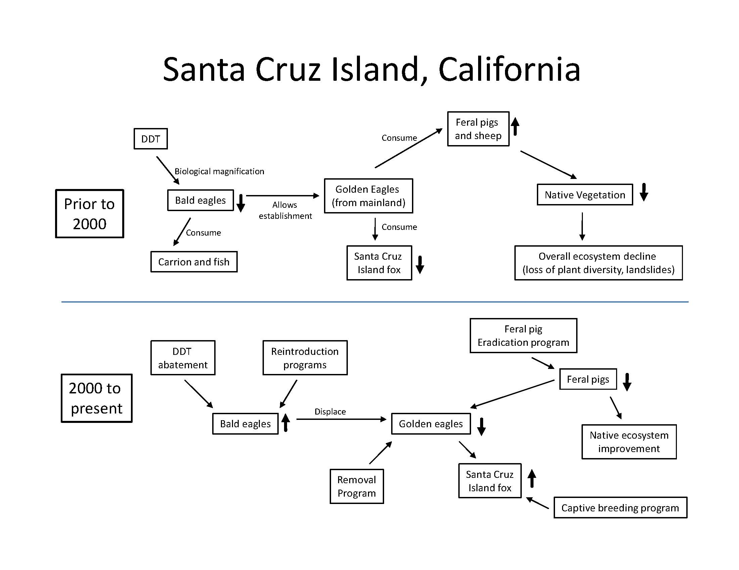

INTRODUCTORY ACTIVITY II – Pollination of New Zealand Mistletoes

INTRODUCTION

The following activity is based on a short article published in Natural History that describes some recent research on the pollination and dispersal of mistletoe in the southern beech forests of New Zealand. The article describes a complex relationship between native mistletoes, their host tree, their native bird and insect pollinators and introduced mammalian predators.

PROCEDURE

Students should read the article prior to the activity and then respond to the questions on the following handout. Alternatively, the questions may be discussed and answered by students in small groups. The activity requires 45-60 minutes including time to read the article.

RESOURCES

Botkin, D. and E. Keller. 2007. Environmental Science: Earth as a Living Planet. 6th ed. John Wiley and Sons, Inc. New York. 668 pp.

Sessions, L.A. 2000. A floral twist of fate. Natural History 109(7):38-43.

Interconnectedness Activity
Student handout

A Floral Twist of Fate

The idea that the various components of ecosystems are connected to each other is a dominant theme in Environmental Science. The concept is often referred to as "interconnectedness" or "environmental unity" (Botkin and Keller, 2007). Throughout the term we will discuss a number of examples of interconnectedness and, especially, some of the consequences of unanticipated connections. The following exercise will give you some practice in the identification of connections. It will also provide some insight into the approach that scientists take in answering a question.

Before completing this exercise, read the article, "A floral twist of fate" by Laura Sessions.

1. Two observations made by scientists in New Zealand prior to the time the study began form the basis for this study. What were they?

A.

B.

2. What do you think is the main question to be addressed by this study?

3. What pertinent observations were made by the researchers that provided some insight into the question you have phrased in #2?

4. What is the primary conclusion drawn from this study?

5. Below each of the following categories of "players" in this ecosystem, list the species that belong to that category. Use common names and, if given, properly written scientific names.

Native mistletoes Native nectar-eating birds Native fruit-eating birds

Introduced birds Native bees Exotic bees Introduced mammals

6. Illustrate the various connections that are now known between these categories of species by connecting related species with arrows. Arrows should be pointed towards the species that is being affected.

7. On each arrow indicate the nature of the relationship (e.g., "predation", "pollination", "seed dispersal", etc.)

ASSESSMENT

See key below.

1. Two observations made by scientists in New Zealand prior to the time the study began form the basis for this study. What were they?

A. Unlike most flowers, red mistletoe petals are fused at the top and detach at the base. This makes nectar and pollen unavailable to pollinators.

B. Mistletoe flowers mature and fall to ground unopened, forming red piles on the forest floor.

2. What do you think is the main question to be addressed by this study?

Why would a plant produce hundreds of flowers that remain inaccessible to pollinators?

3. What pertinent observations were made by the researchers that provided some insight into the question you have phrased in #2?

- Fallen mistletoe flowers with fused petals and stigma sealed inside the flower, hidden from pollinators
- Foraging behavior of the tui, a native nectar-eating bird, opening flower and pollen release
- Some solitary bees occasionally are able to open flowers and harvest pollen

4. What are the primary conclusions drawn from this study?

- Red and scarlet mistletoe are dependent on a few bird and insect species for pollination and seed dispersal
- Predation by introduced land mammals has resulted in a decline in native birds including those required by mistletoes for pollination and dispersal

5. Below each of the following categories of "players" in this ecosystem, list the species that belong to that category. Use common names and, if given, properly written scientific names.

Native mistletoes Native nectar-eating birds Native fruit-eating birds
Red mistletoe Tui Honeyeater
Scarlet mistletoe Bellbird Waxeye
Yellow mistletoe Stitchbird

Introduced birds Native bees Exotic bees Introduced mammals
Blackbirds Hylaeus agilis Honeybees Rats Cats
Finches Leioproctus spp. Wasps Stoats Possums
Ferrets
6. Illustrate the various connections that are now known between these categories of species by connecting related species with arrows. Arrows should be pointed towards the species that is being affected.

- See diagram below

7. On each arrow indicate the nature of the relationship (e.g., "predation", "pollination", "seed dispersal", etc.)

- See diagram below

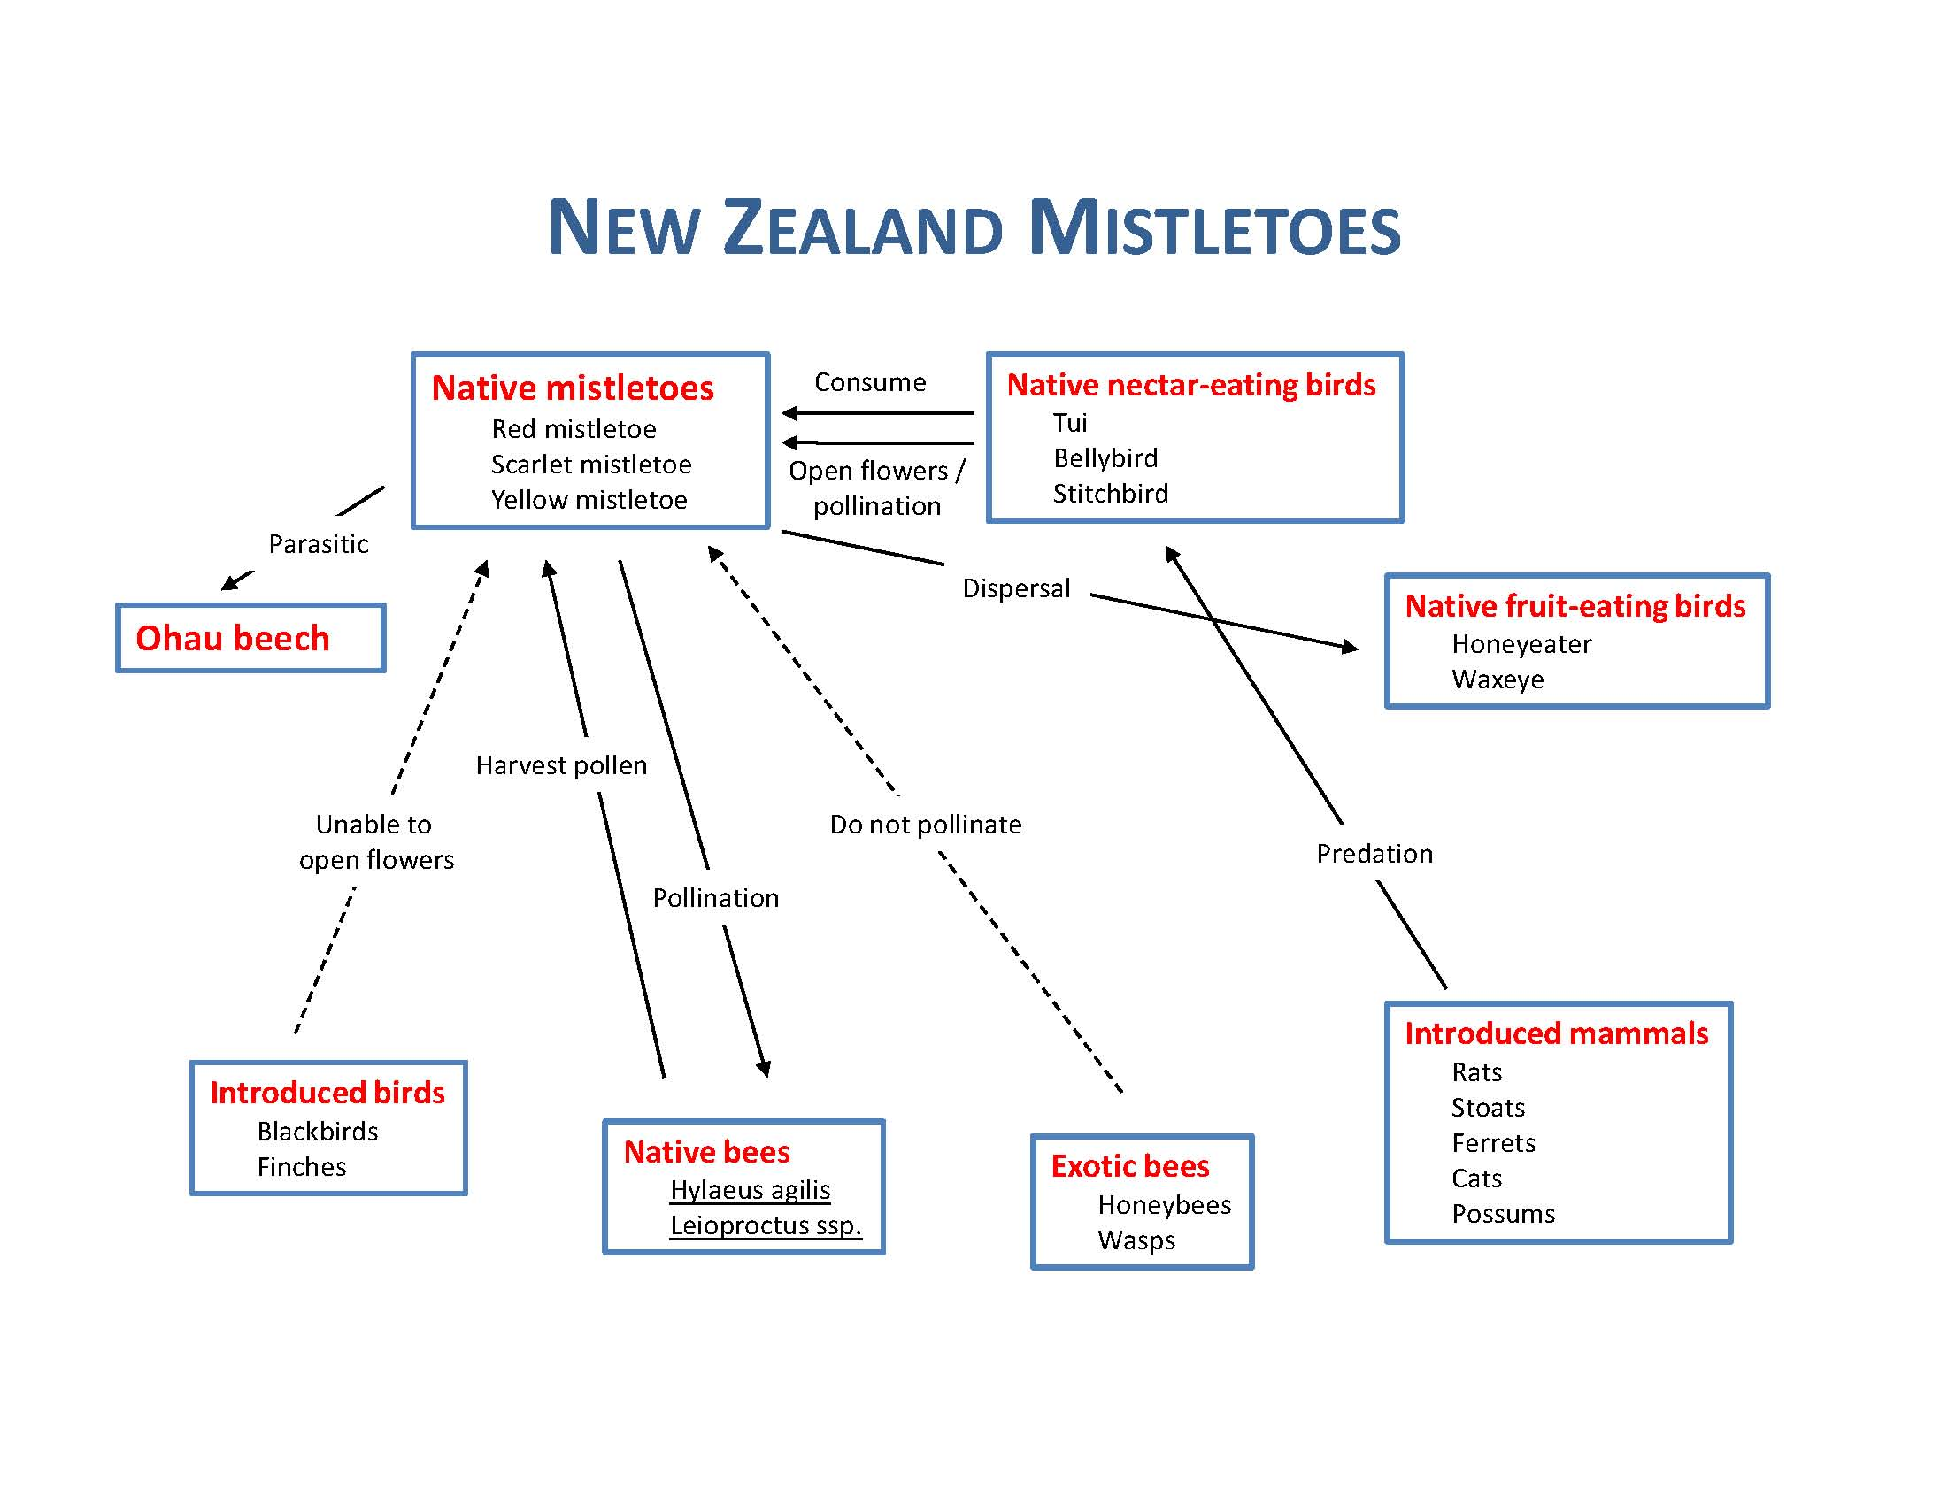

ADDITIONAL INTERCONNECTEDNESS DESCRIPTIONS AND RESOURCES

In recent years, a number of excellent video productions have been produced that illustrate interconnectedness in ecosystems. Several of these have been selected to provide instructors with a broad array of choices that may be used as lecture support to present the concept. For each scenario, the relationship between ecosystem components is described and, where available, a recent video production is cited that may be used to introduce the scenario. A detailed account of the content of the video production is also included. Supporting print and web resources are provided that can be used by instructors to elaborate on the descriptions given here. Most are also suitable to assign as student reading.

1. Salmon and the Forest

This complex relationship occurs as a result of the flow of nutrients from the ocean into forested ecosystems. The conventional direction of nutrient flow is downstream as nutrients from the watershed make their way to the ocean. Recent research, however, has shown that nutrients can “flow uphill.”

REFERENCE VIDEO

The Salmon Forest. 2000. The Nature of Things, Canadian Broadcasting Company. DVD.
52 min.

Bullfrog Films
Olney, PA 19547
610-779-8226
www.bullfrogfilms.com

NOTES FROM VIDEO
(this segment is approximately 30 minutes long)

On the north coast of British Columbia, water links life on land together. A recent discovery has connected this temperate rainforest with the ocean.

In late summer, salmon (chum and pink salmon) return from ocean to freshwater streams to spawn. Millions of salmon (over 3000 different races) return to ideal bear habitat.

Commercial fishing, excessive logging and global climate change have reduced salmon numbers to far below historic levels.

Females lay eggs (>1000 eggs/female) in a gravel nest called a redd, fertilized by males. Few fertilized eggs will survive – many are consumed by Bonaparte’s gulls (an important source of fat and protein).

Salmon make diversity and abundance of life in these forests possible. Grizzly bears search for eggs, ravens scavenge eggs at low water. Coastal bears grow larger, mature earlier and have larger litters than inland bears. Until the 1960s federal fisheries managers killed bears found in spawning streams. It is now known that bears have little impact on salmon reproduction.

After spawning, salmon die and their decomposed bodies are covered with bacteria, fungi and algae, which provide a food base for insect larvae (e.g., caddis flies), which may ultimately feed small salmon hatchlings and other stream species such as the dipper. On the north coast of British Columbia over 35 species of birds and mammals are fed by salmon. Salmon are therefore thought to be a “keystone species” and the forest in this area is locally known as the “Great Bear Rainforest”.

Since 1992, Tom Reimchen, a biologist with the University of Victoria, has studied the role of salmon carcasses on the forest floor. Daylight observations did not show much feeding behavior, but nighttime observations with night viewing equipment suggested that 80-90% of bear foraging occurs at night.

At night there are no visual cues, so bears are not aggressive towards each other or researchers. Each bear takes approximately 700 salmon during the salmon spawning season and most are post-reproductive. Most salmon are taken up to 100 m into forest. Crows and ravens also consume the salmon carcasses.

As part of the study, decomposing carcasses were weighed and it was found that 945 kg/ha of salmon were eaten, but 4000 kg/ha were left behind.

Over a period of about 7 days, insect larvae (especially flies) burrow into and “process” the carcass. Only the bones remain. Insect larvae (maggots) are an important food source for a wide variety of forest animals including toads, rove beetles and ground beetles.

Nutrients in the salmon carcasses are also utilized by trees and other plants representing a major nutrient transfer. One isotope of nitrogen (¹⁵N) is rare in terrestrial environments, but common in the ocean as it gets concentrated in the food chain. Salmon-derived nitrogen can therefore be tracked in terrestrial ecosystems. Salmon have elevated levels of ¹⁵N since they are at a high trophic level.

Analysis of nitrogen uptake by trees is studied by coring trees. Over 550 cores were taken from western hemlock trees and it was found that 10-20% of all nitrogen used by trees had its origin in salmon. For some trees, up to 55% was from salmon. Nitrogen from the ocean is delivered in a single yearly pulse during salmon migration.

Future studies will examine growth rings of trees to see if tree growth may reflect salmon populations. This relationship illustrates the movement of nitrogen back into terrestrial ecosystems from marine ecosystems.

Dramatic declines in the number of salmon this century have resulted in a decline in the abundance and diversity of coastal forests.
NOTES TO INSTRUCTORS

The role of salmon in terrestrial ecosystems provides an excellent and interesting example of interconnectedness in ecosystems, in this case, a connection between marine and terrestrial ecosystems. The Scientific American summary article (cited below) is the best choice to assign as student reading. In addition to the video described above, diagrams that illustrate the various relationships are available in Gende and Quinn (2006) and Cederholm, et al.(2000).

Over 140 species of marine mammals, birds, fish and invertebrates are now known to forage on salmon (Cederholm, et al., 2000). Since the life history of salmon encompasses such a wide variety of habitats, complex nutrient linkages are established that include freshwater, estuarine, continental shelf, and open oceanic species. Tree growth has been shown to be up to 2.5 times faster in areas with salmon carcasses when compared to adjacent control sites without salmon. The wide geographical distribution of the influence of one group of species may be unprecedented.

An understanding of the role of salmon in nutrient cycling in stream and forest ecosystems has led to some changes in natural resource management practices. For example, in many rivers throughout the Pacific Northwest, excess salmon carcasses from hatcheries are now distributed in river systems to help compensate for salmon declines in those areas.

RESOURCES

Cederholm, C.J. et al. 2000. Pacific salmon and wildlife – Ecological contexts, relationships and implications for management. Special edition Technical Report, prepared for Johnson, D.H. and T.A. O’Neil, Wildlife–habitat relationships in Oregon and Washington, Washington Department of Fish and Wildlife, Olympia,Washington.

Gende, S.M. and T.P. Quinn. 2006. The fish and the forest. Sci. Am. Aug 2006:84-89.

Gende, S.M., R.T. Edwards, M.F. Willson and M.S. Wipfli. 2002. Pacific salmon in aquatic and terrestrial ecosystems. BioScience 52(10):917-928.

Gende, S.M., T.P. Quinn, M.F. Willson, R. Heintz and T.M. Scott. 2004. Magnitude and fate of salmon-derived nutrients and energy in a coastal stream ecosystem. Journal of Freshwater Ecology 19(1):149-160.

Hocking, M.D. and T.E. Reimchen. 2002. Salmon-derived nitrogen in terrestrial invertebrates from coniferous forests of the Pacific Northwest. BioMed. Central Ecology 2:4.
www.biomedcentral.com/1472-6785/2/4

Reimchen, T.E. 2004. Marine and terrestrial ecosystem linkages: The major role of salmon and bears to riparian communities. Botanical Electronic News No. 328.
www.ou.edu/cas/botany-micro/ben/ben328.html

Stockner, J.G. (ed.). 2003. Nutrients in salmonid ecosystems: Sustaining production and biodiversity. American Fisheries Society.

2. The Introduction of Nile Perch and Water Hyacinth into Lake Victoria, Uganda

REFERENCE VIDEO

Strange Days on Planet Earth. 2004. Volume 1, Episode1 – Invaders. National Geographic Television and Film. Vulcan Productions, Inc. 60 min.
www.nationalgeographic.com

NOTES FROM VIDEO
(this segment is approximately 15 minutes long)

Lake Victoria, Uganda is the world’s largest tropical lake. Human health threats have been linked to an invasive species.

The Nile crocodile is highly feared as a predator of humans in Uganda. In recent years, there have been increased reports of attacks on humans despite no increase in the number of crocodiles. Human diseases such as dysentery, schistosomiasis, and malaria have also been increasing.

The Nile perch was intentionally introduced to Lake Victoria 50 years ago to create a commercial fishery. The lake is habitat to over 200 species of endemic fish (mostly cichlids) found only in Lake Victoria. A mass extinction of cichlids resulted due to predation by the Nile perch. Also, the development of a fishing industry has resulted in more time spent on the lake and therefore, more crocodile-human contact (and a greater risk of predation).

Additionally, in the 1960s the water hyacinth (native to South America) was introduced to waterways above Lake Victoria. The species escaped downstream and in 1989 the first individuals were spotted in Lake Victoria. Seven years later, 80% of the shoreline was covered with water hyacinth and the species had nearly completely clogged the lake. The result was a disaster for fishermen as getting to fishing grounds became more difficult.

Also, rotting vegetation and stagnant ponds were created by the water hyacinth and water used for drinking was fouled. This resulted in an increase of water-borne human diseases such as dysentery. Habitat for aquatic snails also increased along the margins of the lake. These snails are intermediate hosts for schistosomiasis, a parasitic disease of humans. Stagnant pools provided breeding sites for mosquitoes, which are vectors for malaria.

In its native Brazil, water hyacinth is controlled by natural herbivores, which unfortunately did not make the trip to Lake Victoria. Recently, weevils (herbivorous beetles) are being introduced as a biological control agent. We have learned that biological control introductions must be done with great caution as there have been many spectacular failures of intentional and unintentional introductions (e.g., rats, monitor lizards, cane toads, domestic cats).

Fishermen are helping to spread weevil-infested water hyacinth. The action of weevil larvae and adults is illustrated. Biological control program is working – water hyacinth is declining sharply with observable results in only 5 years. Impacts on humans are also reduced.

There are other examples of introduced species that we have still not brought under control such as Asian tiger mosquitoes, the brown tree snake, fire ants, and “killer bees”.

NOTES TO INSTRUCTORS

NCSR’s Human Impacts module includes a pair of satellite photos (1995 and 2001) that show the decline in water hyacinth on Lake Victoria since the introduction of weevils as a biological control agent. This image could be used to supplement the discussion of this example of interconnectedness. These images and their description follows:
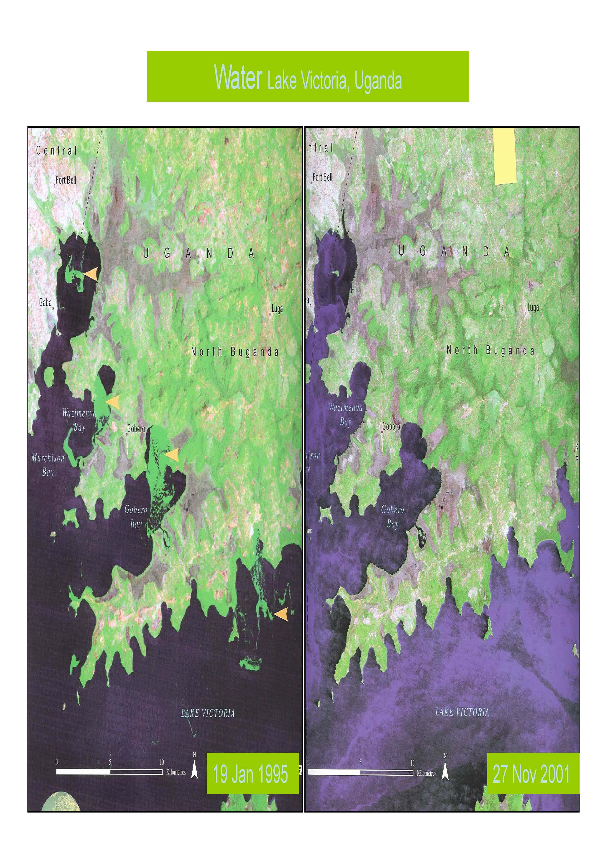

Lake Victoria is the second largest freshwater lake in the world. The effects of the unintentional introduction of water hyacinth can be seen in the 1995 image. Yellow arrows point to areas of particularly heavy infestation. This floating aquatic plant disrupted transportation and fishing activities in the region, clogged water intake pipes for municipal water and created habitat for disease-causing mosquitoes and other insects. In 1994, the Lake Victoria Environmental Management Project was formed to address the water hyacinth problem. Mechanical removal was attempted unsuccessfully. The intentional introduction of natural insect predators of water hyacinth has led to more success as the 2001 image illustrates.

Environmental Impacts – Invasive species such as water hyacinth frequently compete with native species for resources. The result can be the decline and even extinction of native species. Introduced species are second only to habitat loss as a cause for biodiversity loss. Lake Victoria is also the venue for one of the most celebrated cases of species loss due to species introduction. The Nile Perch was intentionally introduced for game and commercial exploitation. A voracious predator, it consumed many native fish in the lake including a number of native, endemic cichlids which are apparently now extinct. Note that the solution in the water hyacinth case also involved the introduction of an exotic species. Only time will tell if this creates a long-term solution or perhaps another unforeseen problem.

Social Impacts – Water hyacinth has contributed to economic harm to shipping and fishing industries as well as increased disease rates among those who live nearby.

In more recent years it appears that overfishing of the Nile perch has resulted in the decline of large, mature individuals of this species. Some native fish species that had been in decline have apparently enjoyed a resurgence as a result. Balwira, et al (2003) note that this illustrates an unusual situation where excessive harvesting of a natural resource may be enhancing native biodiversity.

RESOURCES

Balwira, J.S., et al. 2003. Biodiversity and fishery sustainability in the Lake Victoria Basin: An unexpected marriage. BioScience 53(8): 703-715.

Pringle. R.M. 2005. The origins of the Nile Perch in Lake Victoria. BioScience 55(9):780-787.

3. Wolves in Yellowstone National Park

REFERENCE VIDEO

Strange Days on Planet Earth. 2004. Episode #3 – Predators. National Geographic
Television and Film. Vulcan Productions, Inc.
www.nationalgeographic.com

NOTES FROM VIDEO
(this segment is approximately 20 minutes long):

In 1996, hydrologist Bob Beschta observes the Lamar River in Yellowstone National Park in chaos – soil erosion and widening are evident. Historical photo from the early 1900s shows fully vegetated riparian zone (willows).

Why is modern Yellowstone so different?

150 years ago – large carnivores (mountain lions, wolves) and herbivores (bison, beaver) were abundant
1990s – beavers are rare, songbirds are in decline and riparian trees are missing
In 1954 vs. 1992 aerial photo comparison, fewer aspen are seen among conifers.

How could a forest disappear in the middle of a protected National Park?

Eric Larsen (University of Washington) and Bill Ripple (Oregon State University) propose possible causes:

1. Climate change – apparently not, because outside the park aspen is doing fine
2. Fire suppression – aspen thrives after a fire, but 1988 fire produced few large trees

Researchers count growth rings in about 100 trees and find no mid-aged trees (most are at least 70 years old); aspen apparently stopped reproducing in the 1930s.

Predator removal begins in 1800s and by 1930s removal of wolves in Yellowstone National Park was completed. Between 1883 and 1917 more than 100,000 wolves were killed in Montana and Wyoming alone. In the 1970’s wolves were listed as endangered under the Endangered Species Act.

Biologist Doug Smith of the Yellowstone Wolf Project asks, “What has been the effect of predator removal?”

Removal of wolves is related to decline of aspen.

In 1995, 31 gray wolves were re-introduced into Yellowstone National Park (a controversial decision). Wolves are able to prey on large mammals (elk) by hunting in packs. There are 14 packs now in Yellowstone National Park and the number is increasing.
The importance of wolves to the Yellowstone ecosystem is illustrated:
1) Every “wolf kill” becomes an epicenter for several species (bears, eagles, etc.) including scavengers (ravens, crows, magpies, insects).
2) By killing elk, wolves may be reshaping the Yellowstone ecosystem. Elk spend less time eating willow, allowing willow to grow.

The river ecosystem is improving. Beaver appear as willows return (beaver feed on willow and use willow as construction material). Original survey conducted in 1996 found no beaver colonies – first beavers seen in decades.

By putting back one part of system the entire system benefits.

Anti-wolf sentiment is expressed by ranchers (Marina Smith).
USFWS biologist Joe Fontaine acts as mediator; tracks and eliminates problem wolves. His position requires dealing more with people than wildlife.

Yellowstone case requires “thinking of old adversaries in a new way”.

NOTES TO INSTRUCTORS

This interconnections example, as well as a number of others in this module, describes what ecologists now call a trophic cascade. Trophic cascades occur when predators in a food web suppress the abundance of their prey, thereby releasing the next lower trophic level from predation. If the intermediate trophic level is an herbivore, then plants are released from herbivory. In recent times, the existence of trophic cascades has become most obvious when human-caused reductions in population levels of predators result in impacts that are seen throughout the ecosystem. Over-harvesting of large predators such as cougars or wolves, for example, may result in population increases of herbivorous ungulates such as deer or elk. Excessive browsing by these herbivores may result in the loss of vegetation, which has implications for other species and may impact important ecosystem processes such as ecological succession or nutrient cycling. For most ecosystems, scientists are only now beginning to unravel the complex ways in which ecosystem components are connected.

Studies conducted since the successful reintroduction of wolves into Yellowstone National Park in the mid-1990s have reinforced our understanding of the central role that wolves play in the Greater Yellowstone Ecosystem. As their numbers have increased, a top-down trophic cascade has occurred that includes the following changes:

- Altered patterns of herbivory by deer and elk
- Declining coyote and elk populations
- Increased pronghorn antelope populations (since coyotes prey heavily on young pronghorn)
- New recruitment of woody species such as willow, aspen and cottonwood
- Increases in the number of beaver colonies

The impacts of wolves on ecosystems has also been studied extensively in Isle Royale National Park in northern Michigan where wolves feed primarily on moose. After elimination in the late 1800s, wolves re-established themselves in the 1940s by crossing the ice of Lake Superior. During the “wolf-free era”, moose populations became overabundant but then declined as wolves became re-established. When wolf populations crashed in the 1980s due to canine parvovirus (unintentionally introduced by humans) moose populations grew until catastrophic starvation and a severe winter in 1996 caused populations to crash. Since moose browse heavily on coniferous trees, the rise and fall of the moose population (and indirectly, the rise and fall of the wolf population) is reflected in the growth rings of balsam fir trees. Wide annual rings are seen when moose populations are low (and wolf populations are high) and narrow annual rings are seen when moose populations are high (and wolf populations are low). Other ecosystem components are also impacted. The relative abundance of coniferous and deciduous trees is also influenced by moose browsing. This impacts the composition of decomposing litter and, as a result, nutrient cycling in the soil. Further details and graphs that clearly illustrate the relationships described above can be found in McLaren and Peterson (1994) and Smith, et al. (2003).

RESOURCES

In the Valley of the Wolves. 2007. NATURE, PBS video 60 min.

Beschta, R.L. 2003. Cottonwoods, elk and wolves in the Lamar Valley of Yellowstone National Park. Ecol. Applications 13:1295-1309.

McLaren, B.E. and R.O. Peterson. 1994. Wolves, moose, and tree rings on Isle Royale. Science 266:1555-1558.

Ripple, W.J. and R.L. Beschta. 2004. Wolves and the ecology of fear: Can predation risk structure ecosystems? BioScience 54(8):755-766.

Ripple, W.J. and R.L. Beschta. 2005. Linking wolves and plants: Aldo Leopold on
trophic cascades. BioScience 55:613-621.

Smith, D.W., et al. 2003. Yellowstone after wolves. BioScience 53:330-340.

Trophic Cascades Program. College of Forestry, Oregon State University, Corvallis, Oregon
www.cof.orst.edu/cascades

This research and education program at Oregon State University examines the role of predators
in structuring ecological communities. The web site describes current research in this area and
provides a number of resources that could be used to illustrate the concept of trophic cascades.

4. Cougars in Zion National Park

Studies similar to those on the impacts of predators on ecosystem structure and function in Yellowstone National Park have been conducted in Zion National Park in southern Utah. Like the changes in Yellowstone described in the previous example, researchers found that with fewer numbers of cougars, cottonwoods decline, stream banks erode and there is a decline in overall biological diversity. Wetland plants, wildflowers, amphibians, lizards and butterflies all occurred at lower densities in areas where cougars were rare as compared to areas where cougars were common (Ripple and Beschta, 2006).

In addition to detailed descriptions of the research, the resources below include photographs, diagrams of ecosystem structure with and without cougars and video segments.

RESOURCES

Jaffe, E. 2006. It all falls down – A plummeting cougar population alters the ecosystem at
Zion National Park. Smithsonian Magazine
www.smithsonianmagazine.com/issues/2006/december/cougar.php

The Leopold Project
www.cof.orst.edu/leopold/cougars/

Oregon State University – Terra Research Communications, Corvallis, Oregon
http://oregonstate.edu/terra/multimedia.html#alert_video

Ripple, W.J. and R.L. Beschta. 2006. Linking a cougar decline, trophic cascade, and
catastrophic regime shift in Zion National Park. Biol. Conserv. 133:397-408.

5. Borneo - Operation Cat Drop

In the 1950s, the Dayak people of Borneo suffered from a high rate of malaria. The World Health Organization, in an effort to address the problem, decided to spray a newly developed broad-spectrum insecticide, DDT, to reduce the population of the known vector of the disease – mosquitoes. The effort seemed to work – mosquitoes declined and the malaria outbreak subsided soon afterwards. In a classic case of “unintended consequences” however, the action taken by the WHO resulted in an expanding web of side effects.

In addition to killing mosquitoes, DDT also killed a parasitic wasp that was apparently keeping a thatch-eating caterpillar population in check. With the unintentional removal of the parasitic wasps, the caterpillar population flourished and the roofs on villagers homes began to deteriorate.

But, the unintended consequences did not stop there. Geckoes, common co-habitants in villagers homes, consumed insects sprayed by DDT and through the process of biological magnification, concentrated DDT in their tissues. These toxic geckoes were consumed by house cats which concentrated DDT in their tissues even further. The house cat population crashed, removing a significant control on rat populations. Rat populations increased and along with them, two human diseases carried by rats – typhus and sylvatic plague.

The “cure” had rapidly become worse than the “disease” and the WHO sought a solution to the problem it had unwittingly created. The solution came to be known as Operation Cat Drop – 14,000 live cats were parachuted into Borneo by the British Royal Air Force and released to control rat populations. The rat population declined in short order and along with it, the risk of typhus and sylvatic plague.

This scenario serves as a powerful reminder of the intricate connections between elements of an ecosystem and the unintended consequences that can occur when these interconnections are not well-understood or taken into account in our actions.

RESOURCES

Cheng, F.Y. 1963. Deterioration of thatch roofs by moth larvae after house spraying in
the course of a malaria eradication program in North Borneo. Bull. WHO 28:136-137.

Conway, G.R. 1969. Ecological aspects of pest control in Malaysia, pp. 467-488 in Farvar, M.T. and J.P. Milton, eds. The careless Technology. Natural History Press, New York, NY.

Harrison, T. 1965. Operation cat drop. Animals 5:512-513.

Hawken, P., A. Lovins and L.H. Lovins. 1999. Natural capitalism. Little, Brown and
Company, Boston, MA.

6. Flathead Lake, Montana – Introduction of Mysis Shrimp and Kokanee Salmon

Often, the degree of interconnectedness that exists in ecosystems does not become apparent until the system is disturbed. In this example, the intentional introduction of a non-native species provided just such a disturbance. The result was a series of unanticipated events that has had far-reaching ecological and economic consequences.

REFERENCE VIDEO

Strangers in Our Waterways. 1994. OSU Extension Service. VTP 023. Department of Agricultural Communications, Oregon State University, Corvallis, Oregon. 28 min. Color

NOTES FROM VIDEO
(this segment is approximately 10 minutes long)

In 1916, kokanee salmon were introduced into Flathead Lake, Montana, the largest natural freshwater lake in western U.S. The species flourished and supported a popular recreational fishery. By the 1950s dead salmon carcasses were common along the lake’s margin, where they provided food for a number of species including bald eagles. Salmon spend 3-4 years in the lake and then migrate to streams to spawn.

Mysis (opossum) shrimp were introduced upstream in the mid-1970s to provide food for fish, but they soon migrated to Flathead Lake and became super-abundant in the lake by 1984-85 (densities of 120/m²). Salmon counts in MacDonald Creek had averaged 100,000 per year (and up to 400,000 per year), but by 1987 only 330 salmon were counted and by 1988-89 no salmon were counted. The population has not recovered despite restocking efforts.

Why did salmon numbers decline?

1. Kokanee salmon and mysis shrimp are not in the same place at the same time. Mysis are typically in deeper water while kokanee are in shallows. Mysis only feed at the surface at night when kokanee are not active.

2. Both kokanee and mysis shrimp eat zooplankton. The mysis shrimp out-competed the kokanee.

With the decline of the kokanee, other species were also impacted (e.g., eagles, which had relied on kokanee as an important seasonal food source).

NOTES TO INSTRUCTORS:

According to Stanford and Poole (1996), in addition to the effects described in the video, the following sequence of events also occurred:

In mid-70's fisheries managers introduced Mysis relicta (the non-native opossum shrimp) into Flathead Lake to artificially boost kokanee salmon production. The action caused a trophic cascade in the food web:

1. shrimp out competed the kokanee for zooplankton food source
2. the kokanee salmon fishery collapsed
3. large numbers of eagles and bears that fed on salmon emigrated
4. the explosion of the Mysis shrimp population allowed for an increase of non-native lake trout (which feed at greater depths than kokanee and were able to exploit this new food resource)
5. the lake trout out-competed native bull trout (char) which is now a federally threatened species

Interestingly, there was much scientific information available that suggested Mysis shrimp, if introduced, would NOT boost salmon production. Unfortunately, this information was not fully integrated into the management plan.

A diagram that illustrates the relationship is available on p. 230 in Primack, 2006. (cited below).

RESOURCES

Primack, R.B. 2006. Essentials of conservation biology, 4th ed. Sinauer Associates, Inc. Sunderland, MA 585 pp.

Spencer, C.N., et al. 1991. Shrimp stocking, salmon collapse, and eagle displacement: cascading interactions in the food web of a large aquatic ecosystem. BioScience 41:14-21.

Stanford, J. and Poole. 1996. A protocol for ecosystem management. Ecological Applications 6(3):741-744.

7. Dust from Lake Chad, Nigeria

This interconnections example is an illustration of global climate change and an increase in the incidence of human disease. It illustrates large-scale interconnections.

REFERENCE VIDEO

Strange Days on Planet Earth. 2004. Volume 1, Episode 2 - The One Degree Factor. National Geographic Television and Film. Vulcan Productions, Inc. 60 min. Color
www.nationalgeographic.com

NOTES FROM VIDEO
(this segment is approximately 15 minutes long)

On the Caribbean island of Trinidad the surprising rise of human diseases alarms clinicians. This may be added to other problems associated with increased temperatures associated with global climate change. Asthma, for example, is now a common problem in Trinidad.

On the U.S. Virgin Islands the transformation of coral reefs and the appearance of diseases on coral has been documented over the past two decades. Sea fans have become ragged and corals have lost color and declined. Coral reef fish have declined as a result.

What is the cause and why is this occurring now?

Dust from thousands of miles away appears to be the answer. Lake Chad, Nigeria has been reduced to 1/20th of its former area over a period of only 50 years. This change is due to drought possibly aggravated by climate change. Lake Chad’s shoreline has retreated exposing bare soil. The local fishing industry is also in decline.

The cause of the drought is uncertain, but more dust is being blown to the Americas where it becomes a prime suspect for the cause of asthma. Researchers are looking at the relationship between asthma incidence and dust records and there appears to be a positive correlation.

Sea fan disease – researchers are looking for harmful pathogens being carried by dust particles. Aspergillus fungus is identified as a likely cause for sea fan disease. The first sample taken in the Caribbean during an African dust storm found Aspergillus fungal spores. Sampling effort is expanding.

Dust has been blowing across the Atlantic for millennia, so why are we seeing these problems now?

This question is being studied by the National Center for Atmospheric Research in Colorado.
The North Atlantic Oscillation (NAO) propels storms across sea. The relative strength of high and low pressure systems fluctuates with seasons. Since the 1980s and 1990s the NAO tended to be in intense phase (for the past 20-30 years). The system is stuck in the “intense position.”

Computer models predict that the cause is CO₂ increase and resulting temperature increase. Indian Ocean temperatures have been increasing most rapidly and more rainfall over the Indian Ocean is reinforcing the energy of the NAO.

The situation illustrates large-scale linkages between distant ecosystems.

NOTES TO INSTRUCTORS

The article cited below provides more of the data that are used to support the hypothesis that the transport of dust from Africa and Asia is contributing significantly to the decline of coral reefs and an increase in the incidence of human diseases.

RESOURCE

Garrison, V.H., et al. 2003. African and Asian dust: From desert soils to coral reefs. BioScience 53(5):469-480

8. The Role of Large Vertebrates in Seed Dispersal and Germination

Interconnectedness between elements of an ecosystem are often in place as a result of the co-evolution of plants and their animal dispersers. In the typical scenario, plants attract large animals with a succulent fruit or some other nutrient source and their seeds are dispersed as a result. In some cases, the relationship may be so species-specific that the loss of one member of the partnership would seem to spell certain demise for the other. The following two examples have been proposed to illustrate this type of relationship.

REFERENCE VIDEO

The Seedy Side of Plants. 1999. NATURE – PBS – Thirteen/WNET, New York. 60 min.

NOTES FROM VIDEO
(this segment is approximately 10 minutes long)

For large vertebrate animals during the dry season in Africa, water is a precious commodity. Both herbivores and carnivores gather at watering holes to obtain this limited resource. One species, the aardvark, is able to acquire this resource while reducing its risk for predation. In Africa, the fruit of a melon-like plant develops underground as a “water tank filled with seeds”. Soon after fertilization, the female flower drills into the soil and develops into a subterranean melon at three feet of depth. As the dry season approaches, the above-ground portion of the plant deteriorates and disappears. There is no evidence of the plant above ground. Aardvarks are able to detect the scent of the underground melon percolating up through the soil. They have both the sensory skills and digging equipment to exploit this resource. After traveling through aardvark’s digestive tract, the animal defecates and buries the feces. Some of the seeds germinate and a new generation of plants is established. The relationship appears to be species specific.

The Calvaria tree once covered the island nation of Mauritius in the Indian Ocean off the coast of Africa. Large trees that are approximately 300 years old can still be found and although they still produce fruit, none of these fruit germinate. Fruit eaters are found on the island, but none eat calvaria fruit. Why? In 1598, Dutch explorers visited the island and plundered many of the island’s resources. Mammals and large flightless birds had no natural predators and were easy prey for the Dutch colonists. Several species were driven to extinction – e.g., flightless birds, parrots, lizards. The most famous of these was a large, flightless pigeon called the dodo. It has been hypothesized that the extinction of the dodo resulted in the lack of germination of Calvaria seeds, possibly resulting in its ultimate extinction. Dodo’s were the only animals large enough to consume calvaria fruit and by passing through the digestive tract, the seeds were chemically and physically processed in preparation for germination. Lacking this preparation, calvaria seeds do not germinate, resulting in the current situation.

NOTES TO INSTRUCTORS

In the mid-1970’s it was believed that there were only 13 individual calvaria (Sideroxylon grandiflorum, also known as tambalacoque trees) left on Mauritius. All specimens were approximately 300 years old and these individuals did not appear to be reproducing. Temple (1977) hypothesized that the species was doomed to extinction because germination required the abrasion of the endocarp (the thick inner wall of the fruit) caused by a pass through the digestive tract of the dodo (Raphus cucullatus). With the extinction of the dodo in 1681, this relationship had been severed. To test his hypothesis, Temple force-fed 17 calvaria pits to turkeys. Three of these seeds germinated.

In recent years, the calvaria-dodo relationship has been called into question. Various authors (summarized in Herhey 2004) have challenged Temple’s hypothesis and his application of the scientific method to test the hypothesis. They note that:
- Tambalacoque seeds will germinate without abrasion by splitting along a fracture line much like a peach or walnut seed
- Several hundred tambalacoque trees are now known to exist, some less than 300 years old
- Several other factors have contributed to the decline of the tambalacoque tree such as deforestation and consumption by introduced herbivores such as deer, pigs and monkeys
- Fungal diseases may be contributing to the decline much like they have caused the decline of American chestnut
- Species on Mauritius other than dodos (e.g., tortoises, parrots) may have consumed tambalacoque seeds
- Temple’s experiment lacks a control (i.e., a group of tambalacoque seeds that were not fed to turkeys)

Therefore, the relationship between the dodo and the tambalacoque tree may not be as absolute as originally described by Temple in 1977. Nevertheless, the story serves as a good example of how science attempts to explain observable phenomena and how these explanations must be able to withstand scrutiny over time.

RESOURCES

Herhey, D.R. 2004. The widespread misconception that the Tambalacoque or Calvaria tree absolutely required the Dodo bird for its seeds to germinate. Plant Science Bulletin 50(4):7-12.
www.botany.org/PlantScienceBulletin/psb-2004-50-4.php

Temple, S.A. 1977. Plant-animal mutualism: Co-evolution with dodo leads to near extinction of plant. Science 197:885-886.

Temple, S.A. 1979. The dodo and the tambalacoque tree. Science 203:1364.

9. Intertidal and Near-shore Marine Ecosystems – Sea Urchins, Sea Otters and Killer Whales

REFERENCE VIDEO

Natural Connections . 2000. Segment #3 - Tidepools in Washington and Keystone Species. Howard Rosen Productions. 46 min. Color

Bullfrog Films, Olney, PA 19547
610-779-8226
www.bullfrogfilms.com

NOTES FROM VIDEO
(this segment is approximately 6 minutes long)

Tatush Island off Washington Coast is owned by the Makah Nation.
Diversity in tidepools rivals that of tropical rainforests.
Site is location of longest ongoing study of one area by a single scientist (30 years) by University of Washington zoologist, Dr. Robert Paine.
Most of his research centers around examinations of interconnections among species.
Intertidal communities are structured such that "no one species takes it all".
Disturbance is a regular feature due to waves and storms

Some species are critically important to ecosystem function ("keystone species")

Some examples include:

1. The sea star - mussel relationship is illustrated in a 1970-95 sea star removal experiment where sea stars were removed. Mussels crowded out most other species. Where sea stars were allowed to stay, diversity was retained.

2. The kelp beds–sea urchins–sea otter relationship is described. The loss of sea otters resulted in simplified, weakened system.

NOTES TO INSTRUCTORS:

Otters were once widely distributed along the Pacific Coast but were hunted to near extinction in 1700's and 1800's due to the fur trade. Small populations survived (approximately 4000 in 1996) in 2 areas – the Aleutian Islands off the Alaska coast and the north coast of California. In California they are seen as competitors for abalone and, more recently, the sea urchin fishery which markets sea urchin gonads to Japan. Sea otters control sea urchin populations. Sea urchins eat kelp by cutting it off at the base. Kelp "forests" support many invertebrate and vertebrate species; therefore, sea otters indirectly increase the diversity of the ecosystem (i.e., a keystone species).

Recent studies (Estes, et al. 1998) have documented the stalled recovery of Alaska populations and attributed this to increased killer whale populations. Elevated sea urchin populations and decline of kelp beds have resulted. Diagrams and graphs of data in the article illustrate the relationship.

Evidence:
- Killer whale attacks on sea otters have been observed since 1991 (none were previously witnessed)
- Sea otter populations in areas inaccessible to killer whales are stable
- Computer modeling of death rates by predation match observed attacks and other causes of mortality (disease, toxins, starvation) do not seem to be likely causes of mortality since beached carcasses are not commonly seen

The population size of killer whales in the Aleutian chain is unknown, but observed declines could be caused by as few as 3.7 killer whales (based on consumption of 1825 otters per year). Strikingly rapid changes in kelp forest have been observed (see graphs in Estes, et al., 1998).

Sea otters and killer whales have co-existed in the area for thousands of years. Why would the situation appear now? The most likely cause is a shift in the prey base of killer whales. Steller sea lions and harbor seal populations in the area have collapsed across the western North Pacific (began in 1970s and decline peaked in 1980s). The most likely cause relates to the abundance and changed species composition of their prey. Fish-eating birds have been in decline in the area over the same time period. Declining fish stocks are due to some combination of over-fishing and increased ocean temperatures. Note that these are off-shore, oceanic changes and the situation represents a link between off-shore and near-shore ecosystems. Therefore, this is a good example illustrating interconnectedness of both species and ecosystems.

RESOURCES

Botkin, D. and E. Keller. 2007. Environmental Science: Earth as a Living Planet. 6th ed. John Wiley and Sons, Inc. New York. 668 pp.

Estes, J.A., et al. 1998. Killer whale predation on sea otters linking oceanic and nearshore ecosystems. Science 282:473-476.

Halpern, B.S., K. Cottenie and B.R. Broitman. 2006. Strong top-down control in southern California kelp forest ecosystems. Science 312:1230-1232.

Jackson, J.B.C., et al. 2001. Historical overfishing and the recent collapse of coastal ecosystems. Science 293:629-637.

10. Ecosystem Consequences of the Decline of Atlantic Cod

The decline of one species (particularly a top predator such as cod) can have impacts that reverberate throughout the ecosystem in a domino-like fashion (i.e., a “trophic cascade”). Data provided by Frank, et al. (2005) illustrate evidence for just such an event that involves cod, seals, crabs, small pelagic fish and zooplankton. The first graph illustrates declines in groundfish (mostly cod) biomass due largely to overfishing. Gray seal populations show a corresponding increase. Seals feed on many of the same species as cod, and these species (pelagic fish, shrimp and crabs) all show increases over the same time period. Increased food availability has apparently resulted in an increase in gray seal population levels. In addition, it has recently been demonstrated that gray seals are significant predators of cod, accounting for 21% of cod mortality since 1993. This may be contributing to the slow recovery of cod despite decreased fishing pressure. Studies such as these enhance our understanding of the interconnections between marine ecosystem components and point out the potential hazard of species-level only management.

In addition to providing strong evidence for top-down control of this oceanic food web, there is also evidence that the strength of this interaction is related to ocean temperature. For reasons not completely understood, cooler temperatures apparently weaken the interaction, while warmer temperatures strengthen it. Thus, both overfishing and global climate change have the potential to influence the trophic relationships in this oceanic ecosystem.

For additional details on this topic, see NCSR module, Decline of the Atlantic Cod.

RESOURCES

Frank, K.T., B. Petrie, J.S. Choi and W.C. Leggett. 2005. Trophic cascades in a formerly cod-
dominated ecosystem. Science 308: 1621-1623.

Trzcinski, M.K., R. Mohn and W.D. Bowen. 2006. Continued decline of an Atlantic cod
population: How important is gray seal predation? Ecol. Applic. 16(6):2276-2292.

Worm, B. and R.A. Myers. 2003. Meta-analysis of cod-shrimp interactions reveals top-down
control in oceanic food webs. Ecology 84:162-173.

11. Fishing Down the Food Web

REFERENCE VIDEO

Strange Days on Planet Earth. 2004. Episode #3 – Predators. National Geographic Television and Film. Vulcan Productions, Inc.
www.nationalgeographic.com

NOTES FROM VIDEO
(this segment is approximately 20 minutes long)

Marine predators are not as well-studied as freshwater and terrestrial predators. Do predators of the ocean control the marine ecosystem? Can missing predators be brought back? Research is underway.

Discovery Bay, Jamaica in the 1970s - coral reefs were intact:
Top predators – sharks, snappers, groupers, jacks
Herbivores – surgeon fish, parrot fish and other herbivorous fish

Current coral reefs are dying – covered/smothered with algae. Why?

Researchers are looking at the geology of reefs to see if this has happened before. By coring sections of the reef, a 1000-year record of reef composition is obtained. Until 1980, the reef is healthy for 1000 years. Then, algae take over. Coral stops growing – something has happened in the last few decades.

Is pollution the cause? Apparently, water quality is not an issue here.

Daniel Pauly, a fisheries biologist with the University of British Columbia, looks for an alternative explanation in the fish market. Only small fish are available for sale in the Jamaican fish market. With the lack of large, predatory fish, small fish are now considered normal. This is an example of “shifting baselines”.

The impact of fishing is described – 90% of large fish have been eliminated in the last 40-50 years. Big groupers were the first to disappear. Until the 1970s off-shore banks were rarely fished. By “fishing down the food web” first predators are depleted, then herbivores (grazers) which, would ordinarily keep algae in check. Only urchins remained and when disease eliminated the urchins, algae populations increased.

Coral reefs on St. Lucia are healthier.

Fishermen must travel further now to find large fish at greater risk to themselves.

Will big fish ever return to the closer reefs?

Jamaican government supported a new experiment that began in the mid-1990s. Marine reserves – a network of zones closed to fishing – were established and monitored. Prior, fish always had natural refuges because most fishing gear could not reach them. But, with improved technology these natural refuges disappeared. Scientists are monitoring the ecosystem in marine reserves and looking for interactions among species.
Smaller predators are returning and some fish populations have tripled in a few years; large groupers are returning. Beyond the boundaries of the marine reserves, fishermen are catching some large fish.

Predators are a force that keeps ecosystems strong. Long ago, we had an “us vs. them” mindset. Now we are asking, “Can we live without them?”

RESOURCES

Myers, R.A. and B. Worm. 2003. Rapid worldwide depletion of predatory fish communities. Nature 423:280-283.

Pauly, D. and R. Watson. 2003. Counting the last fish. Sci. Am. (July 2003): 43-47.

12. Chesapeake Bay – Striped Bass Diseases

This example of interconnectedness examines the relationship between the striped bass, an important East Coast marine fish that supports both a recreational and commercial fishery, and water quality in Chesapeake Bay.

REFERENCE VIDEO

Strange Days on Planet Earth II. 2008. Episode #2 - Dirty Secrets National Geographic Television and Film.
www.nationalgeographic.com

NOTES FROM VIDEO
(this segment is approximately 10 minutes long)

Chesapeake Bay in Maryland supports one of the most important East Coast fish species – the striped bass. Recently, over half of those fish examined show both internal and external symptoms of mycobacteriosis, a disease caused by a bacterium commonly seen in aquaculture, but not previously known from this species.

Stripers may be acting as a “canary in the coal mine” in the third largest estuary in the world. In summer, dissolved oxygen levels decline in the bay as a result of phytoplankton blooms followed by rapid decomposition. Oxygen is consumed during decomposition causing dissolved oxygen levels to crash. During the summer, striped bass typically retreat into deeper, cooler refuges to escape high water temperatures. However, in the current situation, oxygen levels in the deeper waters are too low and fish are forced to go into warmer, shallower water. The higher temperatures increase stress and make them more susceptible to diseases including mycobacteriosis.

Why are phytoplankton increasing?

Cultural eutrophication caused by increased use of chemical fertilizers appears to be the primary cause. Agricultural runoff has caused the development of a “dead zone.” This scenario is common with over 300 “dead zones” identified worldwide and the number is increasing.

Solutions include providing incentives for farmers to reduce fertilizer application and the restoration of wetlands, which have the ability to absorb excess nutrients in runoff.

RESOURCES

Powledge, F. 2005. Chesapeake Bay restoration: A model of what? BioScience 55(12):1032- 1038.

Russell, D. 2005. Striper wars – an American fish story. Island Press/Shearwater Books. Washington, D.C. 358 pp.

13. Strangler Figs, Bats and the Brazil Nut Tree

REFERENCE VIDEO

The Seedy Side of Plants. 1999 NATURE – PBS – Thirteen/WNET, New York 60 min. Color
www.thirteen.org

NOTES FROM VIDEO
(this segment is approximately 5 minutes long)

The strangler fig is a plant parasite that climbs rainforest trees. The fruit attracts bats with the sweet smell of figs. Predators such as snakes are attracted to the animals that consume strangler figs. Fruit are carried off and eaten some distance away to avoid predation. A sticky feces is produced that contains strangler fig seeds. Most of the seeds are broken down by microscopic herbivores, but a few germinate on the host tree. The roots of the strangler fig infiltrate host tissues and the roots gradually grow to the ground. The roots and stems encase the host tree and thicken forming a “lethal straight jacket”, ultimately killing the host tree.

REFERENCE VIDEO

Deep Jungle. 2005 NATURE – PBS - Thirteen/WNET, New York Co-produced by Granada Wild and Thirteen/WNET 180 min. Color
www.thirteen.org

Includes three programs:

- “New Frontiers”
- “Monsters of the Forest”
- “The Beast Within”

A 3-minute segment in Chapter 5 of Program 2 shows through time-lapse photography the growth of a strangler fig around a Brazil nut tree. The roots take a suffocating grip and choke the tree. Over time the host tree dies and disintegrates leaving a “hollow fig tree”.

The complexity of this relationship can be further expanded by including the ecology of the Brazil nut tree, which is described in Program #2 (summarized below).

NOTES FROM VIDEO
(this segment is approximately 50 minutes long)

The Brazil nut tree is dominant in Amazon rainforests reaching 160 feet in height. The species reproduces only in virgin rainforests. What is the connection between tree and the surrounding forest?

On Barro Colorado Island, Panama the Smithsonian Institute uses a high-tech outdoor lab to monitor the rainforest. Small plots are under constant surveillance.

An animation of the tree’s growth and development is shown. The rock-hard pod of a Brazil nut falls to the forest floor with the weight of a cannon ball. Nothing in the Amazon has the size or force to crush the pod and expose the seeds. Researchers open a pod and attach a magnet to each seed within the pod to follow the movement of the seeds. Individual nuts are tracked with a metal detector. It is discovered that a small mammal, the agouti, opens the pod with chisel-like teeth. Most germinate in the shade where seedlings can go dormant for decades waiting for a disturbance to open up the canopy.

In 1532, Spanish Conquistadors came to the Amazon for gold. The Spanish invaders were the first to bring steel to tropical rainforests and with steel tools were more easily able to cut rainforest trees. With a more open forest canopy, Brazil nut trees increased reproduction and success. Each clearing explodes into life and the Brazil nut tree becomes the center of a complex ecosystem.

One Brazil nut tree may hold thousands of species. Also, giant trees generate their own climate producing clouds and rain (>200 days per year with rain). Trees and other vegetation soak up 50% while the remaining 50% goes to the river. High rainfall results in more diversity in tropical rainforests. During big storms and floods the forest may be 30 feet under water. Hatchet fish and arawana are shown leaping for spiders.

Brazil nut pods make miniature ponds that are used by poison arrow frogs and mosquitoes as breeding sites. Frog tadpoles eat the mosquito larvae and dragonfly larvae eat the tadpoles. Thousands of species are associated with the Brazil nut tree.

Why does the Brazil nut tree only bear fruit in virgin forests?

Researcher David Kline, studies rainforest bees to find the answer. He climbs into the canopy to find which bees pollinate the Brazil nut tree flowers by using an chemical to attract the bees. The bees fly over a mile to a fragrant orchid to collect scent. Male bees will not attract females until it has the scent of this orchid. No orchid – no reproduction – no bees – no Brazil nut reproduction. Therefore, Brazil nut needs intact forest with several components intact to survive.

Brazil nut trees may live for over 500 years.

